Appendix
Appendix 1:(Search Strategy and detailed records.)
COCHRANE LIBRARY
#1: acupuncture ( ti, ab, kw)
#2: acupuncture therapy (ti, ab, kw)
#3: #1 or #2
#4: Bell’s palsy ( ti, ab, kw)
#5: facial paralysis ( ti, ab, kw)
#6: idiopathic facial paralysis ( ti, ab, kw)
#7: herpetic Facial Paralysis ( ti, ab, kw)
#8: #4 or #5 or #6 or #7
#9: #3 and #8 in Trials.
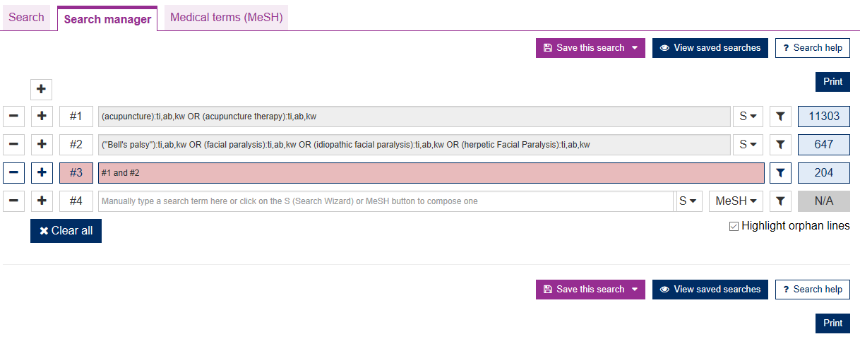
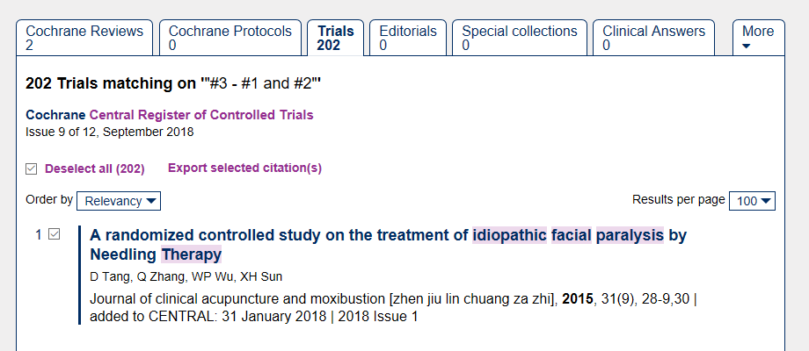

EMBASE
#1: acupuncture (ab, ti)
#2: acupuncture therapy (ab, ti)
#3: #1 OR#2
#4: bell palsy ( ab, ti)
#5: facial paralysis ( ab, ti)
#6: idiopathic facial paralysis (ab, ti)
#7: ‘herpetic facial paralysis (ab, ti)
#8: #4 OR#5 OR#6 OR#7
#9: #3 AND #8
#10: #9 AND ([controlled clinical trial]/lim OR [randomized controlled trial]/lim).
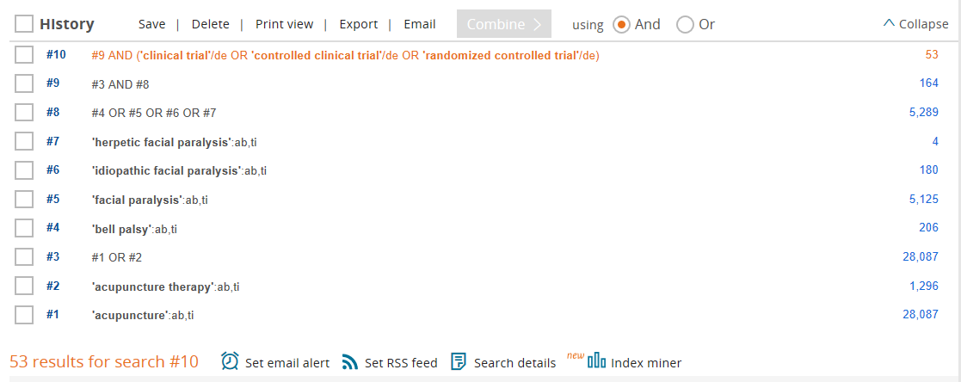
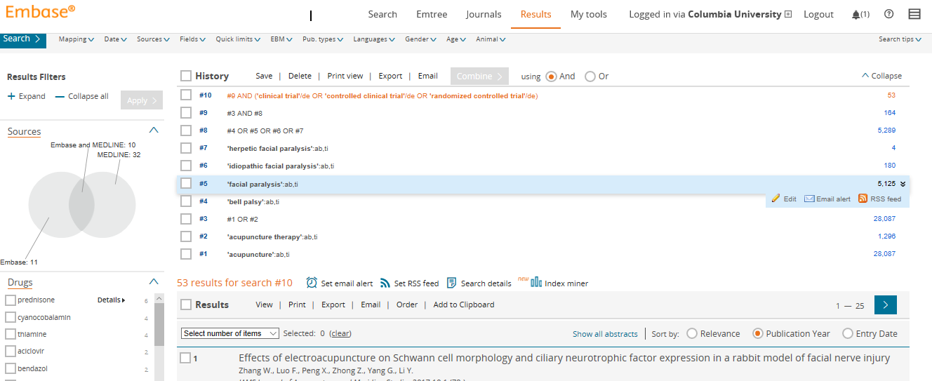

Pubmed
#1: acupuncture [Title/Abstract]
#2: acupuncture therapy [Title/Abstract]
#3: #1 OR #2
#4: Bell’s palsy [Title/Abstract]
#5: facial paralysis [Title/Abstract]
#6: idiopathic facial paralysis [Title/Abstract]
#7: herpetic Facial Paralysis [Title/Abstract]
#8: #4 OR #6 OR #7
#9: #3 OR #8
#10: humans [Me SH Terms]
#11: clinical trials as topic [Me SH Terms]
#12: trial [Title/Abstract]
#13: randomly [Title/Abstract]
#14: Placebo [Title/Abstract]
#15: Randomized [Title/Abstract]
#16: Controlled Trial[Publication Type]
#17: Randomized Controlled Trial[Publication Type]
#18: #12 OR #13 OR #14 OR #15 OR #16 OR #17
#19:#9 AND #10 AND #18
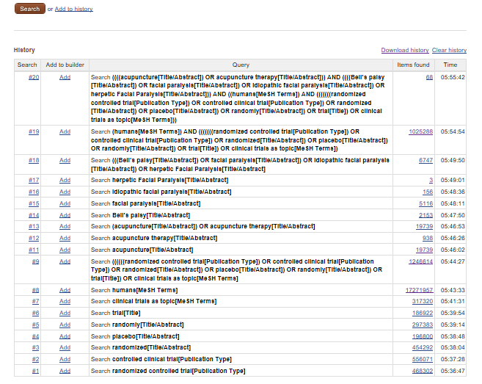
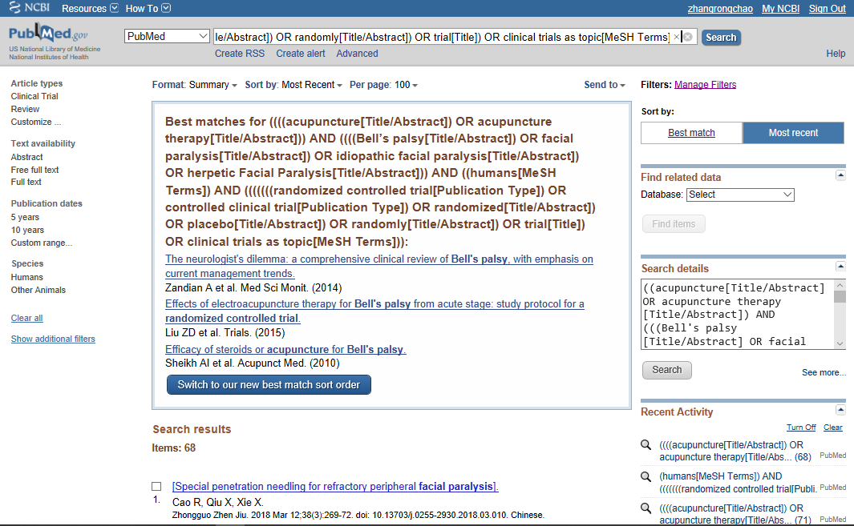

Appendix 2. Subgroup analysis
(1) cure rate
Acupuncture and moxibustion
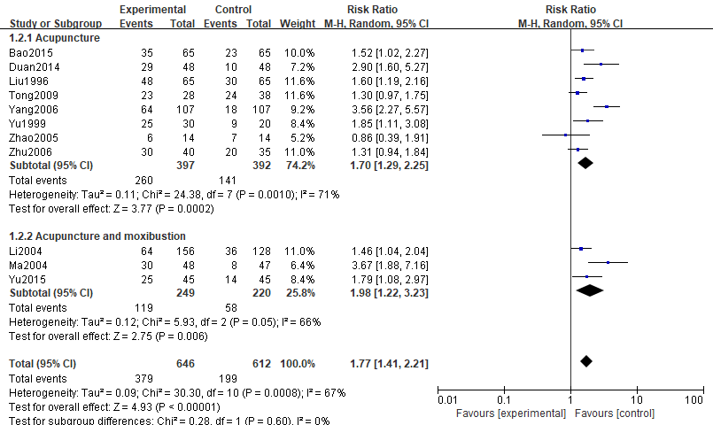
Types of medication
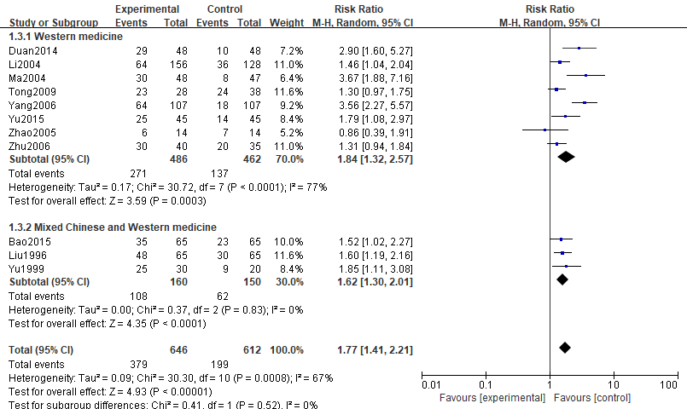
Publication time
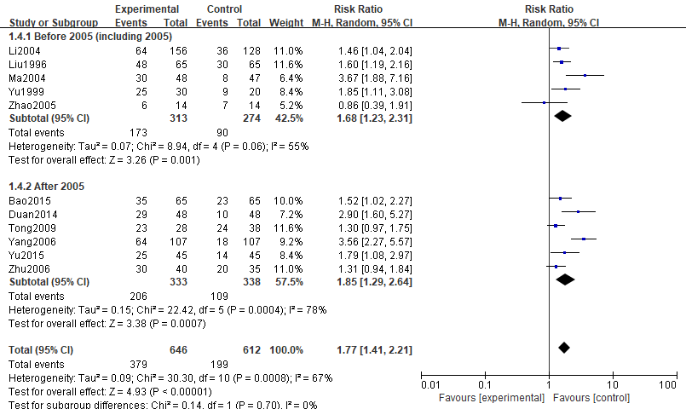
Sample size
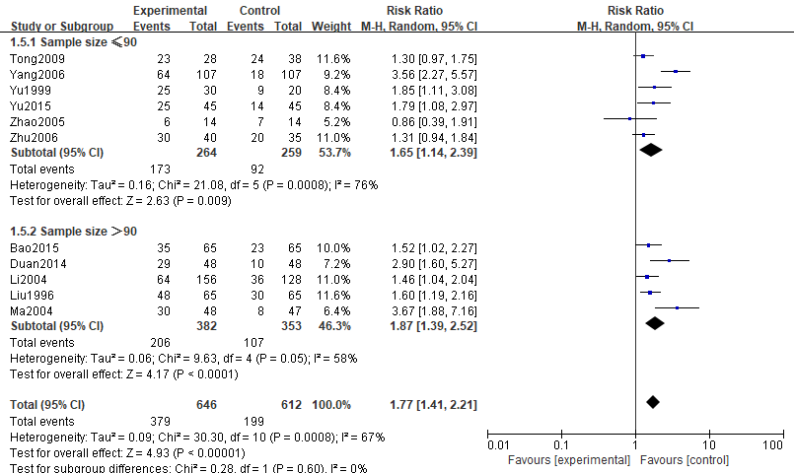

(2)Effective
Acupuncture and moxibustion
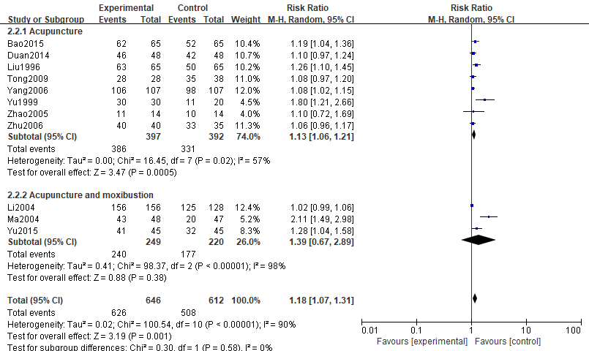
Types of medication
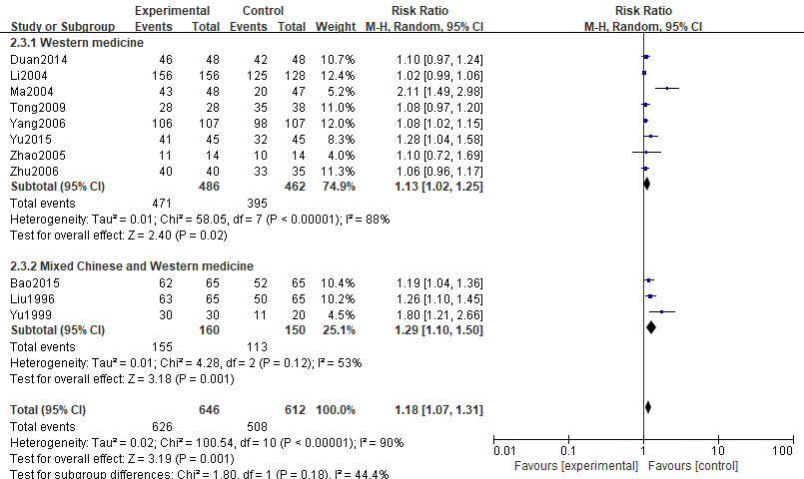
Publication time
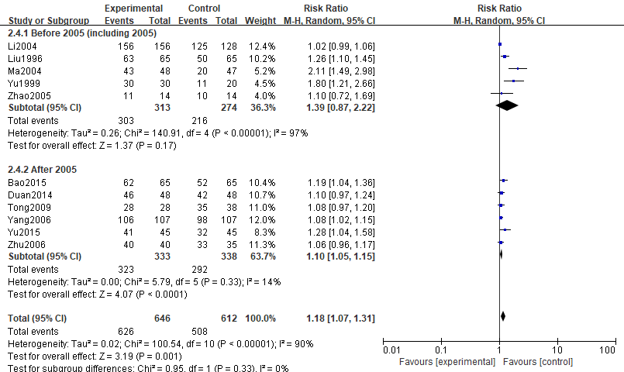
Sample size
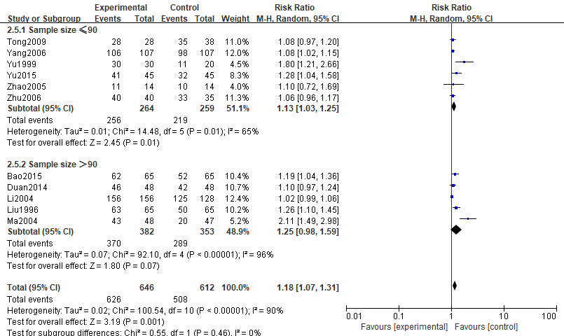
Appendix 3.data sheet
study | years | cure1 | not-cure1 | cure2 | not-cure2
Bao | 2015 | 35 | 30 | 23 | 42
Duan | 2014 | 29 | 19 | 10 | 38
Li | 2004 | 64 | 92 | 36 | 92
Liu | 1996 | 48 | 17 | 30 | 35
Ma | 2004 | 30 | 18 | 8 | 39
Tong | 2009 | 23 | 5 | 24 | 14
Yang | 2006 | 64 | 43 | 18 | 89
Yu | 1999 | 25 | 5 | 9 | 11
Yu | 2015 | 25 | 20 | 14 | 31
Zhao | 2005 | 6 | 8 | 7 | 7
Zhu | 2006 | 30 | 10 | 20 | 15

study | years | effective1 | not-effective1 | effective2 | not-effective2
Bao | 2015 | 62 | 3 | 52 | 13
Duan | 2014 | 46 | 2 | 42 | 6
Li | 2004 | 156 | 0 | 125 | 3
Liu | 1996 | 63 | 2 | 50 | 15
Ma | 2004 | 43 | 5 | 20 | 27
Tong | 2009 | 28 | 0 | 35 | 3
Yang | 2006 | 106 | 1 | 98 | 9
Yu | 1999 | 30 | 0 | 11 | 9
Yu | 2015 | 41 | 4 | 32 | 13
Zhao | 2005 | 11 | 3 | 10 | 4
Zhu | 2006 | 40 | 0 | 33 | 2

