Supplemental Table 1. Details about the data sets used in this study

Patient data | Samples | Platform | Accession number | Reference
Cristescu | 300 | Affymetrix Human Genome U133 Plus 2.0 Array | GSE62254 | PMID: 25894828
Lee | 277 | Illumina HumanRef-8 WG-DASL v3.0 | GSE26253 | PMID: 24598828
Yong | 433 | Illumina HumanHT-12 V3.0 expression beadchip | GSE84437 | PMID: 29567071

Supplemental Table 2. Patients’ immune risk stratification

ID | Cohort | Risk groups | Risk score
GSM1523727 | GSE62254 | Low Immune Risk | -0.782754772
GSM1523728 | GSE62254 | Low Immune Risk | -0.747774407
GSM1523729 | GSE62254 | Low Immune Risk | -0.485901852
GSM1523744 | GSE62254 | Low Immune Risk | -0.377455022
GSM1523745 | GSE62254 | High Immune Risk | 0.099174718
GSM1523746 | GSE62254 | High Immune Risk | 0.512530148
GSM1523747 | GSE62254 | High Immune Risk | 0.603793182
GSM1523748 | GSE62254 | High Immune Risk | 0.11772437
GSM1523765 | GSE62254 | Low Immune Risk | -0.305106095
GSM1523768 | GSE62254 | High Immune Risk | 0.150903814
GSM1523769 | GSE62254 | Low Immune Risk | -0.227181122
GSM1523770 | GSE62254 | Low Immune Risk | -0.549702468
GSM1523771 | GSE62254 | High Immune Risk | 0.865956386
GSM1523772 | GSE62254 | High Immune Risk | 0.698407288
GSM1523773 | GSE62254 | High Immune Risk | 1.298863256
GSM1523774 | GSE62254 | High Immune Risk | 0.68226015
GSM1523775 | GSE62254 | Low Immune Risk | -0.394375678
GSM1523776 | GSE62254 | Low Immune Risk | -0.710649073
GSM1523777 | GSE62254 | Low Immune Risk | -0.244251243
GSM1523778 | GSE62254 | High Immune Risk | 0.319307358
GSM1523779 | GSE62254 | Low Immune Risk | -0.804031591
GSM1523780 | GSE62254 | Low Immune Risk | -0.858569288
GSM1523781 | GSE62254 | High Immune Risk | 1.010304487
GSM1523782 | GSE62254 | Low Immune Risk | -0.146509358
GSM1523783 | GSE62254 | High Immune Risk | 0.176436397
GSM1523784 | GSE62254 | Low Immune Risk | 0.039794027
GSM1523785 | GSE62254 | Low Immune Risk | -0.247099153
GSM1523786 | GSE62254 | High Immune Risk | 0.221392896
GSM1523787 | GSE62254 | Low Immune Risk | -0.516386675
GSM1523788 | GSE62254 | High Immune Risk | 0.4401541
GSM1523789 | GSE62254 | High Immune Risk | 0.325104208
GSM1523790 | GSE62254 | Low Immune Risk | -0.713036922
GSM1523791 | GSE62254 | Low Immune Risk | -0.97884871
GSM1523792 | GSE62254 | Low Immune Risk | -0.056192146
GSM1523793 | GSE62254 | High Immune Risk | 0.148240374
GSM1523794 | GSE62254 | High Immune Risk | 0.185270117
GSM1523795 | GSE62254 | Low Immune Risk | -0.110137333
GSM1523796 | GSE62254 | High Immune Risk | 0.438540773
GSM1523797 | GSE62254 | Low Immune Risk | -0.313316287
GSM1523798 | GSE62254 | High Immune Risk | 0.124632397
GSM1523799 | GSE62254 | High Immune Risk | 0.616844112
GSM1523800 | GSE62254 | Low Immune Risk | -0.144123566
GSM1523801 | GSE62254 | Low Immune Risk | -0.908332593
GSM1523802 | GSE62254 | Low Immune Risk | -0.613133062
GSM1523803 | GSE62254 | High Immune Risk | 0.121640759
GSM1523804 | GSE62254 | Low Immune Risk | -0.00740765
GSM1523805 | GSE62254 | High Immune Risk | 0.256423336
GSM1523806 | GSE62254 | High Immune Risk | 0.141490494
GSM1523807 | GSE62254 | Low Immune Risk | -0.328325337
GSM1523808 | GSE62254 | Low Immune Risk | -0.130128847
GSM1523809 | GSE62254 | Low Immune Risk | -0.438256704
GSM1523810 | GSE62254 | Low Immune Risk | -0.480452696
GSM1523811 | GSE62254 | Low Immune Risk | -0.465310861
GSM1523812 | GSE62254 | Low Immune Risk | -0.124598736
GSM1523813 | GSE62254 | Low Immune Risk | -0.240808431
GSM1523814 | GSE62254 | High Immune Risk | 0.596175337
GSM1523815 | GSE62254 | High Immune Risk | 0.466975104
GSM1523816 | GSE62254 | Low Immune Risk | -0.110764405
GSM1523817 | GSE62254 | High Immune Risk | 1.069701256
GSM1523818 | GSE62254 | Low Immune Risk | -0.506312223
GSM1523819 | GSE62254 | High Immune Risk | 0.557572825
GSM1523820 | GSE62254 | High Immune Risk | 0.635654139
GSM1523821 | GSE62254 | Low Immune Risk | -1.202351757
GSM1523822 | GSE62254 | Low Immune Risk | -0.275289213
GSM1523823 | GSE62254 | Low Immune Risk | -0.669675937
GSM1523824 | GSE62254 | Low Immune Risk | -0.579425367
GSM1523825 | GSE62254 | High Immune Risk | 0.104681385
GSM1523826 | GSE62254 | High Immune Risk | 0.102147407
GSM1523827 | GSE62254 | High Immune Risk | 0.132852108
GSM1523828 | GSE62254 | High Immune Risk | 0.387734453
GSM1523829 | GSE62254 | Low Immune Risk | -0.223100748
GSM1523830 | GSE62254 | Low Immune Risk | -0.640466849
GSM1523831 | GSE62254 | High Immune Risk | 0.78219156
GSM1523832 | GSE62254 | High Immune Risk | 0.179550292
GSM1523833 | GSE62254 | High Immune Risk | 0.244649779
GSM1523834 | GSE62254 | High Immune Risk | 0.272600214
GSM1523835 | GSE62254 | High Immune Risk | 0.544429678
GSM1523836 | GSE62254 | High Immune Risk | 0.145819343
GSM1523837 | GSE62254 | Low Immune Risk | -0.0596835
GSM1523838 | GSE62254 | Low Immune Risk | -0.313412027
GSM1523839 | GSE62254 | High Immune Risk | 0.086690575
GSM1523840 | GSE62254 | High Immune Risk | 0.591642112
GSM1523841 | GSE62254 | High Immune Risk | 0.117342878
GSM1523842 | GSE62254 | High Immune Risk | 0.240728294
GSM1523843 | GSE62254 | Low Immune Risk | -0.383328831
GSM1523844 | GSE62254 | High Immune Risk | 0.374478954
GSM1523845 | GSE62254 | High Immune Risk | 0.395457526
GSM1523846 | GSE62254 | Low Immune Risk | -0.153648583
GSM1523847 | GSE62254 | Low Immune Risk | -0.776445569
GSM1523848 | GSE62254 | Low Immune Risk | -0.286040289
GSM1523849 | GSE62254 | High Immune Risk | 0.476779758
GSM1523850 | GSE62254 | High Immune Risk | 0.357913487
GSM1523851 | GSE62254 | Low Immune Risk | -0.896896458
GSM1523852 | GSE62254 | Low Immune Risk | -0.268957513
GSM1523853 | GSE62254 | Low Immune Risk | -0.436171817
GSM1523854 | GSE62254 | Low Immune Risk | -0.087772807
GSM1523855 | GSE62254 | High Immune Risk | 0.34887379
GSM1523856 | GSE62254 | Low Immune Risk | 0.006807974
GSM1523857 | GSE62254 | High Immune Risk | 0.705615933
GSM1523858 | GSE62254 | High Immune Risk | 1.7081453
GSM1523859 | GSE62254 | High Immune Risk | 0.356444323
GSM1523860 | GSE62254 | Low Immune Risk | -0.903078027
GSM1523861 | GSE62254 | Low Immune Risk | -0.185112444
GSM1523862 | GSE62254 | High Immune Risk | 0.797356495
GSM1523863 | GSE62254 | Low Immune Risk | -0.846644057
GSM1523864 | GSE62254 | Low Immune Risk | -0.554971749
GSM1523865 | GSE62254 | Low Immune Risk | -0.186670375
GSM1523866 | GSE62254 | High Immune Risk | 0.171498052
GSM1523867 | GSE62254 | Low Immune Risk | -0.342151803
GSM1523868 | GSE62254 | High Immune Risk | 0.235812106
GSM1523869 | GSE62254 | Low Immune Risk | -0.456108653
GSM1523870 | GSE62254 | Low Immune Risk | -0.957066862
GSM1523871 | GSE62254 | Low Immune Risk | -0.627180173
GSM1523872 | GSE62254 | Low Immune Risk | -0.262701339
GSM1523873 | GSE62254 | Low Immune Risk | -0.528396835
GSM1523874 | GSE62254 | High Immune Risk | 0.159307665
GSM1523875 | GSE62254 | High Immune Risk | 0.900659912
GSM1523876 | GSE62254 | Low Immune Risk | -0.572141733
GSM1523877 | GSE62254 | High Immune Risk | 0.285805542
GSM1523878 | GSE62254 | Low Immune Risk | -0.269242272
GSM1523879 | GSE62254 | Low Immune Risk | -0.708979665
GSM1523880 | GSE62254 | Low Immune Risk | -1.290754504
GSM1523881 | GSE62254 | Low Immune Risk | -0.427806528
GSM1523882 | GSE62254 | Low Immune Risk | -0.61195069
GSM1523883 | GSE62254 | Low Immune Risk | -0.264026272
GSM1523884 | GSE62254 | High Immune Risk | 0.117003678
GSM1523885 | GSE62254 | Low Immune Risk | -0.905563031
GSM1523886 | GSE62254 | High Immune Risk | 0.315472351
GSM1523887 | GSE62254 | Low Immune Risk | -0.139023246
GSM1523888 | GSE62254 | Low Immune Risk | -0.904155967
GSM1523889 | GSE62254 | Low Immune Risk | -0.455933185
GSM1523890 | GSE62254 | Low Immune Risk | -0.35423612
GSM1523891 | GSE62254 | High Immune Risk | 0.56601942
GSM1523892 | GSE62254 | Low Immune Risk | -0.270773461
GSM1523893 | GSE62254 | High Immune Risk | 0.135285935
GSM1523894 | GSE62254 | Low Immune Risk | -0.029129643
GSM1523895 | GSE62254 | Low Immune Risk | 0.048638166
GSM1523896 | GSE62254 | Low Immune Risk | -0.245301657
GSM1523897 | GSE62254 | Low Immune Risk | -0.756812797
GSM1523898 | GSE62254 | Low Immune Risk | -0.392456079
GSM1523899 | GSE62254 | Low Immune Risk | -0.619102373
GSM1523901 | GSE62254 | Low Immune Risk | -1.06617093
GSM1523903 | GSE62254 | High Immune Risk | 0.359677163
GSM1523904 | GSE62254 | Low Immune Risk | -0.138564086
GSM1523905 | GSE62254 | Low Immune Risk | -0.248781498
GSM1523906 | GSE62254 | Low Immune Risk | -0.18971059
GSM1523908 | GSE62254 | Low Immune Risk | -0.51901442
GSM1523909 | GSE62254 | Low Immune Risk | -0.460135817
GSM1523910 | GSE62254 | Low Immune Risk | -0.685683624
GSM1523911 | GSE62254 | Low Immune Risk | -0.743781165
GSM1523918 | GSE62254 | High Immune Risk | 0.785509101
GSM1523919 | GSE62254 | Low Immune Risk | -0.055416302
GSM1523920 | GSE62254 | High Immune Risk | 0.235453111
GSM1523921 | GSE62254 | Low Immune Risk | -1.150385382
GSM1523922 | GSE62254 | High Immune Risk | 0.296427535
GSM1523923 | GSE62254 | Low Immune Risk | -0.398580092
GSM1523924 | GSE62254 | Low Immune Risk | -0.023678561
GSM1523925 | GSE62254 | High Immune Risk | 0.277360843
GSM1523926 | GSE62254 | Low Immune Risk | -0.696052241
GSM1523927 | GSE62254 | Low Immune Risk | -0.296796807
GSM1523928 | GSE62254 | High Immune Risk | 0.79787814
GSM1523929 | GSE62254 | Low Immune Risk | -0.673044293
GSM1523930 | GSE62254 | Low Immune Risk | -0.239223426
GSM1523931 | GSE62254 | Low Immune Risk | -0.905628598
GSM1523932 | GSE62254 | High Immune Risk | 0.148260425
GSM1523933 | GSE62254 | Low Immune Risk | -0.100018907
GSM1523934 | GSE62254 | Low Immune Risk | -0.062789777
GSM1523935 | GSE62254 | High Immune Risk | 0.331143325
GSM1523936 | GSE62254 | High Immune Risk | 0.340930643
GSM1523937 | GSE62254 | Low Immune Risk | -0.508416393
GSM1523938 | GSE62254 | High Immune Risk | 1.160768078
GSM1523939 | GSE62254 | High Immune Risk | 1.337384675
GSM1523940 | GSE62254 | High Immune Risk | 0.396112021
GSM1523941 | GSE62254 | Low Immune Risk | -0.12317165
GSM1523942 | GSE62254 | Low Immune Risk | -0.48369873
GSM1523943 | GSE62254 | Low Immune Risk | -0.12645178
GSM1523944 | GSE62254 | Low Immune Risk | -0.31611629
GSM1523945 | GSE62254 | High Immune Risk | 0.528791318
GSM1523946 | GSE62254 | High Immune Risk | 0.156160965
GSM1523947 | GSE62254 | Low Immune Risk | -0.904529705
GSM1523948 | GSE62254 | High Immune Risk | 0.643305052
GSM1523949 | GSE62254 | High Immune Risk | 1.06760915
GSM1523950 | GSE62254 | Low Immune Risk | -0.223447216
GSM1523951 | GSE62254 | Low Immune Risk | -0.240568071
GSM1523952 | GSE62254 | Low Immune Risk | -0.266102385
GSM1523953 | GSE62254 | Low Immune Risk | -0.096762896
GSM1523954 | GSE62254 | Low Immune Risk | -0.745872524
GSM1523955 | GSE62254 | High Immune Risk | 0.663164169
GSM1523956 | GSE62254 | High Immune Risk | 0.930595578
GSM1523957 | GSE62254 | Low Immune Risk | -0.629546919
GSM1523958 | GSE62254 | Low Immune Risk | -0.091148028
GSM1523959 | GSE62254 | Low Immune Risk | -0.306669156
GSM1523960 | GSE62254 | Low Immune Risk | -0.509397476
GSM1523961 | GSE62254 | Low Immune Risk | -0.569757309
GSM1523962 | GSE62254 | High Immune Risk | 0.809359801
GSM1523963 | GSE62254 | High Immune Risk | 0.094374838
GSM1523964 | GSE62254 | Low Immune Risk | -0.666261475
GSM1523965 | GSE62254 | High Immune Risk | 0.299506421
GSM1523966 | GSE62254 | High Immune Risk | 0.159241142
GSM1523967 | GSE62254 | High Immune Risk | 0.334912613
GSM1523968 | GSE62254 | High Immune Risk | 1.223427788
GSM1523969 | GSE62254 | High Immune Risk | 0.353589072
GSM1523970 | GSE62254 | High Immune Risk | 0.588664201
GSM1523971 | GSE62254 | High Immune Risk | 1.176854934
GSM1523972 | GSE62254 | High Immune Risk | 0.851292836
GSM1523973 | GSE62254 | Low Immune Risk | 0.008682297
GSM1523974 | GSE62254 | High Immune Risk | 0.222433519
GSM1523975 | GSE62254 | High Immune Risk | 0.452523171
GSM1523976 | GSE62254 | High Immune Risk | 0.388822958
GSM1523977 | GSE62254 | High Immune Risk | 1.039636284
GSM1523978 | GSE62254 | Low Immune Risk | -0.191863707
GSM1523979 | GSE62254 | Low Immune Risk | -0.747553907
GSM1523980 | GSE62254 | High Immune Risk | 0.322768073
GSM1523981 | GSE62254 | High Immune Risk | 0.649016561
GSM1523982 | GSE62254 | High Immune Risk | 0.736657312
GSM1523983 | GSE62254 | Low Immune Risk | -0.044247857
GSM1523984 | GSE62254 | High Immune Risk | 0.831047051
GSM1523985 | GSE62254 | Low Immune Risk | -0.123783327
GSM1523986 | GSE62254 | Low Immune Risk | -0.259658137
GSM1523987 | GSE62254 | High Immune Risk | 0.132873591
GSM1523988 | GSE62254 | High Immune Risk | 1.311047178
GSM1523989 | GSE62254 | High Immune Risk | 0.467917837
GSM1523990 | GSE62254 | High Immune Risk | 0.865976985
GSM1523991 | GSE62254 | Low Immune Risk | -0.100920383
GSM1523992 | GSE62254 | Low Immune Risk | -0.070721521
GSM1523993 | GSE62254 | High Immune Risk | 0.073214635
GSM1523994 | GSE62254 | Low Immune Risk | -0.146072105
GSM1523995 | GSE62254 | High Immune Risk | 0.289239242
GSM1523996 | GSE62254 | High Immune Risk | 0.169230043
GSM1523997 | GSE62254 | Low Immune Risk | -0.150574545
GSM1523998 | GSE62254 | High Immune Risk | 0.22538929
GSM1523999 | GSE62254 | Low Immune Risk | -0.059661671
GSM1524000 | GSE62254 | Low Immune Risk | -0.160595289
GSM1524001 | GSE62254 | High Immune Risk | 0.400798735
GSM1524002 | GSE62254 | Low Immune Risk | -0.610180619
GSM1524003 | GSE62254 | Low Immune Risk | -0.575771598
GSM1524004 | GSE62254 | Low Immune Risk | -0.219645425
GSM1524005 | GSE62254 | High Immune Risk | 0.122641018
GSM1524006 | GSE62254 | High Immune Risk | 1.411146873
GSM1524007 | GSE62254 | High Immune Risk | 0.42900541
GSM1524008 | GSE62254 | Low Immune Risk | 0.02439134
GSM1524009 | GSE62254 | High Immune Risk | 0.315950736
GSM1524010 | GSE62254 | High Immune Risk | 0.562336863
GSM1524011 | GSE62254 | Low Immune Risk | 0.042393907
GSM1524012 | GSE62254 | Low Immune Risk | -0.151681985
GSM1524013 | GSE62254 | High Immune Risk | 0.209732063
GSM1524014 | GSE62254 | Low Immune Risk | 0.042990093
GSM1524015 | GSE62254 | High Immune Risk | 0.921154441
GSM1524016 | GSE62254 | Low Immune Risk | -0.118463974
GSM1524017 | GSE62254 | Low Immune Risk | -0.682257263
GSM1524018 | GSE62254 | Low Immune Risk | -0.289914284
GSM1524019 | GSE62254 | Low Immune Risk | -0.057619408
GSM1524020 | GSE62254 | Low Immune Risk | -0.065128832
GSM1524021 | GSE62254 | High Immune Risk | 0.172453703
GSM1524022 | GSE62254 | High Immune Risk | 0.421952438
GSM1524023 | GSE62254 | Low Immune Risk | -0.459255059
GSM1524024 | GSE62254 | Low Immune Risk | -0.128707389
GSM1524025 | GSE62254 | Low Immune Risk | -0.057209904
GSM1524026 | GSE62254 | High Immune Risk | 0.317962508
GSM1524027 | GSE62254 | High Immune Risk | 0.173366136
GSM1524028 | GSE62254 | High Immune Risk | 0.301478723
GSM1524029 | GSE62254 | High Immune Risk | 1.30764883
GSM1524030 | GSE62254 | High Immune Risk | 1.501743316
GSM1524031 | GSE62254 | Low Immune Risk | -0.412326377
GSM1524032 | GSE62254 | Low Immune Risk | 0.0309801
GSM1524033 | GSE62254 | Low Immune Risk | -0.48837142
GSM1524034 | GSE62254 | High Immune Risk | 0.3708202
GSM1524035 | GSE62254 | High Immune Risk | 0.718939105
GSM1524036 | GSE62254 | Low Immune Risk | -0.001845669
GSM1524037 | GSE62254 | High Immune Risk | 0.236802794
GSM1524038 | GSE62254 | Low Immune Risk | 0.05558854
GSM1524039 | GSE62254 | High Immune Risk | 0.209262405
GSM1524040 | GSE62254 | Low Immune Risk | -0.251638116
GSM1524041 | GSE62254 | Low Immune Risk | -0.452812565
GSM1524042 | GSE62254 | High Immune Risk | 0.448506669
GSM1524043 | GSE62254 | Low Immune Risk | -0.434507422
GSM1524044 | GSE62254 | Low Immune Risk | 0.049487528
GSM1524045 | GSE62254 | Low Immune Risk | -0.633244591
GSM1524046 | GSE62254 | High Immune Risk | 0.073093712
GSM1524047 | GSE62254 | Low Immune Risk | -0.333764888
GSM1524048 | GSE62254 | Low Immune Risk | -0.131612173
GSM1524049 | GSE62254 | Low Immune Risk | -0.364158102
GSM1524050 | GSE62254 | Low Immune Risk | -0.197181335
GSM1524051 | GSE62254 | Low Immune Risk | -0.324554075
GSM1524052 | GSE62254 | High Immune Risk | 0.923843232
GSM1524053 | GSE62254 | Low Immune Risk | -0.561743581
GSM1524054 | GSE62254 | Low Immune Risk | -0.755006229
GSM1524055 | GSE62254 | High Immune Risk | 0.113714545
GSM1524056 | GSE62254 | High Immune Risk | 0.876987185
GSM1524057 | GSE62254 | High Immune Risk | 1.520443968
GSM1524058 | GSE62254 | Low Immune Risk | -0.097452224
GSM1524059 | GSE62254 | Low Immune Risk | -0.001837655
GSM1524060 | GSE62254 | Low Immune Risk | 0.045298553
GSM1524061 | GSE62254 | Low Immune Risk | -0.848033959
GSM1524062 | GSE62254 | High Immune Risk | 1.24521843
GSM1524068 | GSE62254 | Low Immune Risk | -0.877806541
GSM1524069 | GSE62254 | Low Immune Risk | -0.890781889
GSM1524070 | GSE62254 | Low Immune Risk | 0.055644656
GSM1524071 | GSE62254 | Low Immune Risk | -0.123226201
GSM1524072 | GSE62254 | Low Immune Risk | -0.00357315
GSM644674 | GSE26253 | Low Immune Risk | -0.115078972
GSM644675 | GSE26253 | Low Immune Risk | -0.097893159
GSM644676 | GSE26253 | High Immune Risk | 0.351254192
GSM644677 | GSE26253 | Low Immune Risk | -0.083854402
GSM644678 | GSE26253 | Low Immune Risk | -0.890591554
GSM644679 | GSE26253 | Low Immune Risk | -0.821566434
GSM644680 | GSE26253 | Low Immune Risk | -0.372841494
GSM644681 | GSE26253 | High Immune Risk | 0.635950489
GSM644682 | GSE26253 | Low Immune Risk | -0.037259358
GSM644683 | GSE26253 | Low Immune Risk | -0.137168249
GSM644684 | GSE26253 | Low Immune Risk | 0.024735804
GSM644685 | GSE26253 | Low Immune Risk | -0.491956819
GSM644686 | GSE26253 | High Immune Risk | 0.298117263
GSM644687 | GSE26253 | High Immune Risk | 0.315564507
GSM644688 | GSE26253 | Low Immune Risk | -0.400785132
GSM644689 | GSE26253 | Low Immune Risk | -0.984994602
GSM644690 | GSE26253 | Low Immune Risk | -0.291461867
GSM644691 | GSE26253 | Low Immune Risk | -0.364222295
GSM644692 | GSE26253 | Low Immune Risk | -0.240825548
GSM644693 | GSE26253 | Low Immune Risk | -0.041887202
GSM644694 | GSE26253 | Low Immune Risk | -0.134485272
GSM644695 | GSE26253 | Low Immune Risk | -0.406119887
GSM644696 | GSE26253 | Low Immune Risk | -0.094365715
GSM644697 | GSE26253 | High Immune Risk | 0.080265115
GSM644698 | GSE26253 | Low Immune Risk | -0.712099121
GSM644699 | GSE26253 | Low Immune Risk | -0.087622968
GSM644700 | GSE26253 | Low Immune Risk | -0.185078093
GSM644701 | GSE26253 | Low Immune Risk | 0.008779376
GSM644702 | GSE26253 | High Immune Risk | 0.104394365
GSM644703 | GSE26253 | Low Immune Risk | -0.356007416
GSM644704 | GSE26253 | High Immune Risk | 0.079694434
GSM644705 | GSE26253 | High Immune Risk | 0.171898459
GSM644706 | GSE26253 | Low Immune Risk | -0.182274975
GSM644707 | GSE26253 | Low Immune Risk | -0.025903868
GSM644708 | GSE26253 | Low Immune Risk | -0.192695798
GSM644709 | GSE26253 | Low Immune Risk | -0.074503695
GSM644710 | GSE26253 | Low Immune Risk | -0.697869617
GSM644711 | GSE26253 | Low Immune Risk | -0.169717023
GSM644712 | GSE26253 | High Immune Risk | 0.130338053
GSM644713 | GSE26253 | Low Immune Risk | -0.248751779
GSM644714 | GSE26253 | High Immune Risk | 0.155559246
GSM644715 | GSE26253 | Low Immune Risk | -0.093909771
GSM644716 | GSE26253 | Low Immune Risk | 0.043298954
GSM644717 | GSE26253 | High Immune Risk | 0.096158473
GSM644718 | GSE26253 | High Immune Risk | 0.197858091
GSM644719 | GSE26253 | High Immune Risk | 0.233470704
GSM644720 | GSE26253 | High Immune Risk | 0.232501255
GSM644721 | GSE26253 | Low Immune Risk | -0.593471199
GSM644722 | GSE26253 | High Immune Risk | 0.141179705
GSM644723 | GSE26253 | Low Immune Risk | -0.123100989
GSM644724 | GSE26253 | Low Immune Risk | -0.178814781
GSM644725 | GSE26253 | Low Immune Risk | -0.01135007
GSM644726 | GSE26253 | Low Immune Risk | 0.071628207
GSM644727 | GSE26253 | Low Immune Risk | -0.117528017
GSM644728 | GSE26253 | High Immune Risk | 0.210448164
GSM644729 | GSE26253 | Low Immune Risk | -0.174001679
GSM644730 | GSE26253 | High Immune Risk | 0.241773903
GSM644731 | GSE26253 | Low Immune Risk | -0.0757179
GSM644732 | GSE26253 | Low Immune Risk | 0.021551491
GSM644733 | GSE26253 | Low Immune Risk | -0.536386906
GSM644734 | GSE26253 | Low Immune Risk | -0.086040802
GSM644735 | GSE26253 | Low Immune Risk | -1.095578619
GSM644736 | GSE26253 | Low Immune Risk | -0.423411325
GSM644737 | GSE26253 | Low Immune Risk | -0.661571591
GSM644738 | GSE26253 | Low Immune Risk | -0.174756795
GSM644739 | GSE26253 | Low Immune Risk | -0.135973066
GSM644740 | GSE26253 | Low Immune Risk | -0.058576
GSM644741 | GSE26253 | Low Immune Risk | -0.202172598
GSM644742 | GSE26253 | Low Immune Risk | -0.092646875
GSM644743 | GSE26253 | Low Immune Risk | -0.421388523
GSM644744 | GSE26253 | Low Immune Risk | -0.113361084
GSM644745 | GSE26253 | Low Immune Risk | -0.299139415
GSM644746 | GSE26253 | Low Immune Risk | -0.392206581
GSM644747 | GSE26253 | Low Immune Risk | -0.477627729
GSM644748 | GSE26253 | High Immune Risk | 0.147826086
GSM644749 | GSE26253 | High Immune Risk | 0.102240264
GSM644750 | GSE26253 | Low Immune Risk | -0.461112242
GSM644751 | GSE26253 | High Immune Risk | 0.132369993
GSM644752 | GSE26253 | High Immune Risk | 0.383191881
GSM644753 | GSE26253 | Low Immune Risk | 0.005995936
GSM644754 | GSE26253 | High Immune Risk | 0.171320234
GSM644755 | GSE26253 | High Immune Risk | 0.195429181
GSM644756 | GSE26253 | High Immune Risk | 0.276690291
GSM644757 | GSE26253 | High Immune Risk | 0.151803035
GSM644758 | GSE26253 | Low Immune Risk | -0.011351099
GSM644759 | GSE26253 | High Immune Risk | 0.716255265
GSM644760 | GSE26253 | Low Immune Risk | -0.222278175
GSM644761 | GSE26253 | High Immune Risk | 0.808207623
GSM644762 | GSE26253 | Low Immune Risk | -0.571428614
GSM644763 | GSE26253 | Low Immune Risk | -0.644223169
GSM644764 | GSE26253 | High Immune Risk | 0.132914157
GSM644765 | GSE26253 | Low Immune Risk | -0.004515913
GSM644766 | GSE26253 | High Immune Risk | 0.087919144
GSM644767 | GSE26253 | Low Immune Risk | -0.231281883
GSM644768 | GSE26253 | Low Immune Risk | -0.056641801
GSM644769 | GSE26253 | High Immune Risk | 0.09015415
GSM644770 | GSE26253 | Low Immune Risk | -0.407590781
GSM644771 | GSE26253 | Low Immune Risk | -0.217552626
GSM644772 | GSE26253 | Low Immune Risk | -0.002718459
GSM644773 | GSE26253 | High Immune Risk | 0.240687914
GSM644774 | GSE26253 | Low Immune Risk | -0.267187772
GSM644775 | GSE26253 | High Immune Risk | 0.194358834
GSM644776 | GSE26253 | Low Immune Risk | -0.210209072
GSM644777 | GSE26253 | High Immune Risk | 0.212252154
GSM644778 | GSE26253 | Low Immune Risk | -0.66236084
GSM644779 | GSE26253 | Low Immune Risk | -0.149596792
GSM644780 | GSE26253 | High Immune Risk | 0.266832874
GSM644781 | GSE26253 | Low Immune Risk | -0.299746776
GSM644782 | GSE26253 | Low Immune Risk | -0.101005219
GSM644783 | GSE26253 | Low Immune Risk | -0.211429704
GSM644784 | GSE26253 | Low Immune Risk | -0.070638818
GSM644785 | GSE26253 | Low Immune Risk | -0.45325945
GSM644786 | GSE26253 | Low Immune Risk | 0.024870628
GSM644787 | GSE26253 | High Immune Risk | 0.390392099
GSM644788 | GSE26253 | Low Immune Risk | -0.267186221
GSM644789 | GSE26253 | Low Immune Risk | -0.237289956
GSM644790 | GSE26253 | Low Immune Risk | 0.035024645
GSM644791 | GSE26253 | Low Immune Risk | -0.06069097
GSM644792 | GSE26253 | Low Immune Risk | -0.449859668
GSM644793 | GSE26253 | High Immune Risk | 0.394435347
GSM644794 | GSE26253 | Low Immune Risk | -0.055313318
GSM644795 | GSE26253 | High Immune Risk | 0.25848168
GSM644796 | GSE26253 | Low Immune Risk | -0.179808657
GSM644797 | GSE26253 | High Immune Risk | 0.43172372
GSM644798 | GSE26253 | Low Immune Risk | 0.039578048
GSM644799 | GSE26253 | Low Immune Risk | -0.173845999
GSM644800 | GSE26253 | Low Immune Risk | -0.507522877
GSM644801 | GSE26253 | High Immune Risk | 0.119989811
GSM644802 | GSE26253 | Low Immune Risk | -0.179053753
GSM644803 | GSE26253 | High Immune Risk | 0.25070819
GSM644804 | GSE26253 | Low Immune Risk | -0.081782939
GSM644805 | GSE26253 | Low Immune Risk | 0.054921024
GSM644806 | GSE26253 | High Immune Risk | 0.401240326
GSM644807 | GSE26253 | High Immune Risk | 0.764224558
GSM644808 | GSE26253 | Low Immune Risk | -0.361670356
GSM644809 | GSE26253 | Low Immune Risk | -0.326636917
GSM644810 | GSE26253 | Low Immune Risk | -0.567946051
GSM644811 | GSE26253 | Low Immune Risk | -0.248561925
GSM644812 | GSE26253 | Low Immune Risk | -0.189223
GSM644813 | GSE26253 | High Immune Risk | 0.204851998
GSM644814 | GSE26253 | High Immune Risk | 0.136453352
GSM644815 | GSE26253 | High Immune Risk | 0.534520997
GSM644816 | GSE26253 | Low Immune Risk | -0.036490401
GSM644817 | GSE26253 | High Immune Risk | 0.354706242
GSM644818 | GSE26253 | High Immune Risk | 0.787940018
GSM644819 | GSE26253 | High Immune Risk | 0.933847012
GSM644820 | GSE26253 | Low Immune Risk | -0.250661394
GSM644821 | GSE26253 | High Immune Risk | 0.79804222
GSM644822 | GSE26253 | High Immune Risk | 0.231749305
GSM644823 | GSE26253 | High Immune Risk | 0.477401057
GSM644824 | GSE26253 | High Immune Risk | 0.406223893
GSM644825 | GSE26253 | High Immune Risk | 0.463908454
GSM644826 | GSE26253 | High Immune Risk | 0.44111751
GSM644827 | GSE26253 | High Immune Risk | 0.473691591
GSM644828 | GSE26253 | High Immune Risk | 0.643629626
GSM644829 | GSE26253 | Low Immune Risk | -0.001030345
GSM644830 | GSE26253 | Low Immune Risk | -0.03681708
GSM644831 | GSE26253 | Low Immune Risk | -0.270339681
GSM644832 | GSE26253 | Low Immune Risk | -0.339298003
GSM644833 | GSE26253 | Low Immune Risk | -0.119129588
GSM644834 | GSE26253 | Low Immune Risk | 0.004810749
GSM644835 | GSE26253 | High Immune Risk | 1.21008849
GSM644836 | GSE26253 | High Immune Risk | 0.246966533
GSM644837 | GSE26253 | High Immune Risk | 0.47951795
GSM644838 | GSE26253 | High Immune Risk | 0.078767633
GSM644839 | GSE26253 | High Immune Risk | 0.902900365
GSM644840 | GSE26253 | High Immune Risk | 0.407792898
GSM644841 | GSE26253 | Low Immune Risk | 0.002413417
GSM644842 | GSE26253 | High Immune Risk | 0.11276684
GSM644843 | GSE26253 | Low Immune Risk | -0.076327472
GSM644844 | GSE26253 | Low Immune Risk | -0.11174057
GSM644845 | GSE26253 | Low Immune Risk | -0.050299018
GSM644846 | GSE26253 | High Immune Risk | 0.202884174
GSM644847 | GSE26253 | Low Immune Risk | -0.594513986
GSM644848 | GSE26253 | High Immune Risk | 0.634005924
GSM644849 | GSE26253 | High Immune Risk | 0.279364975
GSM644850 | GSE26253 | High Immune Risk | 0.301911274
GSM644851 | GSE26253 | High Immune Risk | 0.235772077
GSM644852 | GSE26253 | High Immune Risk | 0.420786962
GSM644853 | GSE26253 | High Immune Risk | 0.076517949
GSM644854 | GSE26253 | High Immune Risk | 0.713783748
GSM644855 | GSE26253 | High Immune Risk | 0.453761086
GSM644856 | GSE26253 | High Immune Risk | 0.403136794
GSM644857 | GSE26253 | Low Immune Risk | -0.044095448
GSM644858 | GSE26253 | Low Immune Risk | -0.012880264
GSM644859 | GSE26253 | Low Immune Risk | -0.123024537
GSM644860 | GSE26253 | High Immune Risk | 0.177184784
GSM644861 | GSE26253 | High Immune Risk | 0.251474981
GSM644862 | GSE26253 | Low Immune Risk | -0.165494732
GSM644863 | GSE26253 | High Immune Risk | 0.616337106
GSM644864 | GSE26253 | High Immune Risk | 0.318668745
GSM644865 | GSE26253 | Low Immune Risk | -0.182043574
GSM644866 | GSE26253 | Low Immune Risk | -0.064107723
GSM644867 | GSE26253 | Low Immune Risk | -0.040397784
GSM644868 | GSE26253 | Low Immune Risk | -0.716680625
GSM644869 | GSE26253 | Low Immune Risk | 0.046878892
GSM644870 | GSE26253 | Low Immune Risk | -0.19968737
GSM644871 | GSE26253 | Low Immune Risk | 0.024062848
GSM644872 | GSE26253 | Low Immune Risk | -0.098183832
GSM644873 | GSE26253 | High Immune Risk | 0.427447089
GSM644874 | GSE26253 | High Immune Risk | 0.319181109
GSM644875 | GSE26253 | Low Immune Risk | -0.419798228
GSM644876 | GSE26253 | Low Immune Risk | -0.712260655
GSM644877 | GSE26253 | Low Immune Risk | -0.061462449
GSM644878 | GSE26253 | Low Immune Risk | -0.549459867
GSM644879 | GSE26253 | Low Immune Risk | -0.416221571
GSM644880 | GSE26253 | Low Immune Risk | -0.411502481
GSM644881 | GSE26253 | Low Immune Risk | -0.552445221
GSM644882 | GSE26253 | Low Immune Risk | -0.200528307
GSM644883 | GSE26253 | High Immune Risk | 0.1061982
GSM644884 | GSE26253 | High Immune Risk | 0.458497453
GSM644885 | GSE26253 | High Immune Risk | 0.380903258
GSM644886 | GSE26253 | Low Immune Risk | -0.134240844
GSM644887 | GSE26253 | High Immune Risk | 0.656148943
GSM644888 | GSE26253 | High Immune Risk | 0.094795568
GSM644889 | GSE26253 | High Immune Risk | 0.289421292
GSM644890 | GSE26253 | Low Immune Risk | 0.05001525
GSM644891 | GSE26253 | Low Immune Risk | -0.299694448
GSM644892 | GSE26253 | Low Immune Risk | 0.005858701
GSM644893 | GSE26253 | Low Immune Risk | 0.032803005
GSM644894 | GSE26253 | Low Immune Risk | -0.258312514
GSM644895 | GSE26253 | Low Immune Risk | -0.06921457
GSM644896 | GSE26253 | Low Immune Risk | -0.360684968
GSM644897 | GSE26253 | Low Immune Risk | 0.021566142
GSM644898 | GSE26253 | Low Immune Risk | 0.047183317
GSM644899 | GSE26253 | Low Immune Risk | -0.077231964
GSM644900 | GSE26253 | High Immune Risk | 0.654011823
GSM644901 | GSE26253 | High Immune Risk | 0.103391298
GSM644902 | GSE26253 | High Immune Risk | 0.097079068
GSM644903 | GSE26253 | Low Immune Risk | 0.015084506
GSM644904 | GSE26253 | Low Immune Risk | -0.372668919
GSM644905 | GSE26253 | Low Immune Risk | -0.02180131
GSM644906 | GSE26253 | High Immune Risk | 0.24563872
GSM644907 | GSE26253 | High Immune Risk | 0.347659891
GSM644908 | GSE26253 | Low Immune Risk | -0.028397967
GSM644909 | GSE26253 | High Immune Risk | 0.185506713
GSM644910 | GSE26253 | Low Immune Risk | -0.043595768
GSM644911 | GSE26253 | High Immune Risk | 0.116220049
GSM644912 | GSE26253 | Low Immune Risk | -0.00194195
GSM644913 | GSE26253 | High Immune Risk | 0.141827487
GSM644914 | GSE26253 | Low Immune Risk | 0.066968351
GSM644915 | GSE26253 | Low Immune Risk | -0.177533628
GSM644916 | GSE26253 | Low Immune Risk | -0.225049357
GSM644917 | GSE26253 | High Immune Risk | 0.086527278
GSM644918 | GSE26253 | High Immune Risk | 0.268335898
GSM644919 | GSE26253 | High Immune Risk | 0.504427028
GSM644920 | GSE26253 | Low Immune Risk | -0.122915281
GSM644921 | GSE26253 | Low Immune Risk | -0.363669944
GSM644922 | GSE26253 | High Immune Risk | 0.150497981
GSM644923 | GSE26253 | Low Immune Risk | -0.181568286
GSM644924 | GSE26253 | Low Immune Risk | 0.047217105
GSM644925 | GSE26253 | High Immune Risk | 0.493960047
GSM644926 | GSE26253 | Low Immune Risk | 0.066060251
GSM644927 | GSE26253 | Low Immune Risk | -0.008851676
GSM644928 | GSE26253 | Low Immune Risk | -0.015923223
GSM644929 | GSE26253 | High Immune Risk | 0.300550157
GSM644930 | GSE26253 | High Immune Risk | 0.122284775
GSM644931 | GSE26253 | High Immune Risk | 0.087604389
GSM644932 | GSE26253 | Low Immune Risk | -0.248922657
GSM644933 | GSE26253 | Low Immune Risk | 0.044547684
GSM644934 | GSE26253 | Low Immune Risk | -0.225753121
GSM644935 | GSE26253 | Low Immune Risk | 0.043819393
GSM644936 | GSE26253 | High Immune Risk | 0.151205673
GSM644937 | GSE26253 | Low Immune Risk | -0.093976726
GSM644938 | GSE26253 | Low Immune Risk | -0.286005056
GSM644939 | GSE26253 | High Immune Risk | 0.205615419
GSM644940 | GSE26253 | Low Immune Risk | -0.016757352
GSM644941 | GSE26253 | High Immune Risk | 0.381418306
GSM644942 | GSE26253 | Low Immune Risk | -0.18466942
GSM644943 | GSE26253 | High Immune Risk | 0.229199305
GSM644944 | GSE26253 | Low Immune Risk | -0.330177691
GSM644945 | GSE26253 | High Immune Risk | 0.407828291
GSM644946 | GSE26253 | High Immune Risk | 0.151661187
GSM644947 | GSE26253 | Low Immune Risk | -0.149669905
GSM644948 | GSE26253 | High Immune Risk | 0.213960004
GSM644949 | GSE26253 | High Immune Risk | 0.328242001
GSM644950 | GSE26253 | Low Immune Risk | -0.190182028
GSM2235556 | GSE84437 | High Immune Risk | 0.308670212
GSM2235557 | GSE84437 | High Immune Risk | 0.385419059
GSM2235558 | GSE84437 | High Immune Risk | 0.092099961
GSM2235559 | GSE84437 | High Immune Risk | 0.69603123
GSM2235560 | GSE84437 | High Immune Risk | 0.624491139
GSM2235561 | GSE84437 | High Immune Risk | 0.344667627
GSM2235562 | GSE84437 | Low Immune Risk | 0.010081791
GSM2235563 | GSE84437 | Low Immune Risk | -0.009604287
GSM2235564 | GSE84437 | Low Immune Risk | -0.442300832
GSM2235565 | GSE84437 | High Immune Risk | 0.895878165
GSM2235566 | GSE84437 | High Immune Risk | 0.763344639
GSM2235567 | GSE84437 | High Immune Risk | 0.503756417
GSM2235568 | GSE84437 | High Immune Risk | 0.701571923
GSM2235569 | GSE84437 | Low Immune Risk | -0.295356989
GSM2235570 | GSE84437 | High Immune Risk | 0.407808711
GSM2235571 | GSE84437 | Low Immune Risk | -0.103123269
GSM2235572 | GSE84437 | High Immune Risk | 0.310451115
GSM2235573 | GSE84437 | High Immune Risk | 0.380209653
GSM2235574 | GSE84437 | High Immune Risk | 0.436131665
GSM2235575 | GSE84437 | High Immune Risk | 0.7635744
GSM2235576 | GSE84437 | Low Immune Risk | -0.456970911
GSM2235577 | GSE84437 | High Immune Risk | 0.774878545
GSM2235578 | GSE84437 | Low Immune Risk | -0.504063337
GSM2235579 | GSE84437 | Low Immune Risk | -0.230001928
GSM2235580 | GSE84437 | High Immune Risk | 0.378510816
GSM2235582 | GSE84437 | Low Immune Risk | 0.026766483
GSM2235584 | GSE84437 | Low Immune Risk | -0.092485498
GSM2235585 | GSE84437 | High Immune Risk | 0.123371404
GSM2235586 | GSE84437 | High Immune Risk | 0.33638072
GSM2235587 | GSE84437 | High Immune Risk | 0.471313506
GSM2235588 | GSE84437 | High Immune Risk | 1.143350963
GSM2235589 | GSE84437 | Low Immune Risk | -0.3048369
GSM2235593 | GSE84437 | Low Immune Risk | -0.346686011
GSM2235595 | GSE84437 | High Immune Risk | 0.21326722
GSM2235596 | GSE84437 | High Immune Risk | 0.522059887
GSM2235597 | GSE84437 | Low Immune Risk | -0.563974687
GSM2235598 | GSE84437 | High Immune Risk | 0.300602647
GSM2235599 | GSE84437 | Low Immune Risk | -0.165698387
GSM2235600 | GSE84437 | High Immune Risk | 0.216725574
GSM2235601 | GSE84437 | High Immune Risk | 0.712719729
GSM2235602 | GSE84437 | Low Immune Risk | -0.243441802
GSM2235603 | GSE84437 | High Immune Risk | 0.445391743
GSM2235604 | GSE84437 | Low Immune Risk | -0.37981257
GSM2235605 | GSE84437 | High Immune Risk | 0.213180437
GSM2235606 | GSE84437 | High Immune Risk | 0.292271451
GSM2235607 | GSE84437 | High Immune Risk | 0.399866169
GSM2235608 | GSE84437 | Low Immune Risk | -0.449272958
GSM2235609 | GSE84437 | High Immune Risk | 0.407095071
GSM2235610 | GSE84437 | High Immune Risk | 0.645806894
GSM2235611 | GSE84437 | High Immune Risk | 0.302192322
GSM2235612 | GSE84437 | High Immune Risk | 0.524326705
GSM2235613 | GSE84437 | High Immune Risk | 0.129851022
GSM2235614 | GSE84437 | Low Immune Risk | -0.317840833
GSM2235615 | GSE84437 | High Immune Risk | 0.102632953
GSM2235616 | GSE84437 | Low Immune Risk | -0.170471045
GSM2235617 | GSE84437 | Low Immune Risk | -0.286168524
GSM2235618 | GSE84437 | Low Immune Risk | -0.334264967
GSM2235619 | GSE84437 | High Immune Risk | 0.419748937
GSM2235620 | GSE84437 | Low Immune Risk | -0.076436669
GSM2235621 | GSE84437 | High Immune Risk | 0.613636927
GSM2235622 | GSE84437 | High Immune Risk | 0.320212231
GSM2235623 | GSE84437 | Low Immune Risk | -0.713970089
GSM2235624 | GSE84437 | High Immune Risk | 0.181313735
GSM2235625 | GSE84437 | High Immune Risk | 0.671252324
GSM2235626 | GSE84437 | High Immune Risk | 0.562069294
GSM2235627 | GSE84437 | High Immune Risk | 0.488544179
GSM2235628 | GSE84437 | High Immune Risk | 0.401261162
GSM2235629 | GSE84437 | High Immune Risk | 0.529155266
GSM2235630 | GSE84437 | High Immune Risk | 0.305007037
GSM2235631 | GSE84437 | High Immune Risk | 0.121742092
GSM2235632 | GSE84437 | Low Immune Risk | -0.335877216
GSM2235633 | GSE84437 | High Immune Risk | 0.610291952
GSM2235634 | GSE84437 | High Immune Risk | 0.28037505
GSM2235635 | GSE84437 | Low Immune Risk | -0.203548651
GSM2235636 | GSE84437 | High Immune Risk | 0.644148004
GSM2235637 | GSE84437 | Low Immune Risk | -0.548553494
GSM2235695 | GSE84437 | Low Immune Risk | 0.056107493
GSM2235696 | GSE84437 | Low Immune Risk | -0.855206546
GSM2235697 | GSE84437 | High Immune Risk | 0.40252997
GSM2235698 | GSE84437 | High Immune Risk | 0.172375706
GSM2235699 | GSE84437 | High Immune Risk | 0.165159074
GSM2235700 | GSE84437 | Low Immune Risk | -0.277031011
GSM2235701 | GSE84437 | Low Immune Risk | -1.079877358
GSM2235702 | GSE84437 | Low Immune Risk | 0.062212353
GSM2235703 | GSE84437 | Low Immune Risk | -0.057429796
GSM2235704 | GSE84437 | Low Immune Risk | -0.016515341
GSM2235705 | GSE84437 | High Immune Risk | 0.092039556
GSM2235706 | GSE84437 | High Immune Risk | 0.2069076
GSM2235707 | GSE84437 | Low Immune Risk | -0.853333657
GSM2235708 | GSE84437 | Low Immune Risk | -0.733956822
GSM2235709 | GSE84437 | Low Immune Risk | -0.798116514
GSM2235710 | GSE84437 | High Immune Risk | 0.828656781
GSM2235711 | GSE84437 | Low Immune Risk | -0.58413494
GSM2235712 | GSE84437 | High Immune Risk | 0.289133795
GSM2235713 | GSE84437 | Low Immune Risk | 0.065081895
GSM2235714 | GSE84437 | Low Immune Risk | -0.464172555
GSM2235715 | GSE84437 | Low Immune Risk | -1.335424495
GSM2235716 | GSE84437 | High Immune Risk | 0.837160175
GSM2235717 | GSE84437 | Low Immune Risk | -0.541527888
GSM2235718 | GSE84437 | Low Immune Risk | -0.22902186
GSM2235719 | GSE84437 | Low Immune Risk | -0.40824307
GSM2235720 | GSE84437 | High Immune Risk | 0.144236656
GSM2235721 | GSE84437 | Low Immune Risk | -0.267186851
GSM2235722 | GSE84437 | Low Immune Risk | -0.693423844
GSM2235723 | GSE84437 | High Immune Risk | 0.341061817
GSM2235724 | GSE84437 | Low Immune Risk | -0.144326562
GSM2235725 | GSE84437 | Low Immune Risk | -0.484697754
GSM2235726 | GSE84437 | Low Immune Risk | -0.024456576
GSM2235727 | GSE84437 | Low Immune Risk | -0.303040694
GSM2235728 | GSE84437 | Low Immune Risk | -0.066804596
GSM2235729 | GSE84437 | Low Immune Risk | -0.051990244
GSM2235730 | GSE84437 | Low Immune Risk | -0.824232389
GSM2235731 | GSE84437 | Low Immune Risk | -1.897176623
GSM2235732 | GSE84437 | Low Immune Risk | -0.415342379
GSM2235733 | GSE84437 | Low Immune Risk | -0.178057168
GSM2235734 | GSE84437 | Low Immune Risk | -0.052679931
GSM2235735 | GSE84437 | Low Immune Risk | -0.228364707
GSM2235736 | GSE84437 | High Immune Risk | 1.042371552
GSM2235737 | GSE84437 | High Immune Risk | 0.091713771
GSM2235738 | GSE84437 | Low Immune Risk | -1.119019817
GSM2235739 | GSE84437 | Low Immune Risk | -0.492585751
GSM2235740 | GSE84437 | Low Immune Risk | -0.673037482
GSM2235741 | GSE84437 | High Immune Risk | 0.699635652
GSM2235742 | GSE84437 | Low Immune Risk | -0.00539133
GSM2235743 | GSE84437 | Low Immune Risk | -0.196344512
GSM2235744 | GSE84437 | Low Immune Risk | 0.051794186
GSM2235745 | GSE84437 | Low Immune Risk | -0.312777111
GSM2235746 | GSE84437 | Low Immune Risk | -0.561382869
GSM2235747 | GSE84437 | Low Immune Risk | -0.713247729
GSM2235748 | GSE84437 | Low Immune Risk | -0.03267366
GSM2235749 | GSE84437 | High Immune Risk | 0.860746796
GSM2235750 | GSE84437 | High Immune Risk | 0.521689929
GSM2235751 | GSE84437 | Low Immune Risk | -0.73229862
GSM2235752 | GSE84437 | Low Immune Risk | -0.470201661
GSM2235753 | GSE84437 | High Immune Risk | 0.616934345
GSM2235754 | GSE84437 | Low Immune Risk | -0.34702712
GSM2235755 | GSE84437 | High Immune Risk | 0.67114366
GSM2235756 | GSE84437 | High Immune Risk | 0.630023481
GSM2235757 | GSE84437 | High Immune Risk | 0.228187069
GSM2235758 | GSE84437 | High Immune Risk | 0.41422175
GSM2235759 | GSE84437 | High Immune Risk | 0.32678681
GSM2235760 | GSE84437 | Low Immune Risk | -0.068544596
GSM2235761 | GSE84437 | High Immune Risk | 0.340883405
GSM2235762 | GSE84437 | Low Immune Risk | -0.368163878
GSM2235763 | GSE84437 | Low Immune Risk | -0.132125785
GSM2235764 | GSE84437 | High Immune Risk | 0.109080215
GSM2235765 | GSE84437 | High Immune Risk | 0.588777796
GSM2235766 | GSE84437 | Low Immune Risk | 0.006543933
GSM2235767 | GSE84437 | High Immune Risk | 1.099254133
GSM2235768 | GSE84437 | Low Immune Risk | -0.458883985
GSM2235769 | GSE84437 | High Immune Risk | 0.245924213
GSM2235770 | GSE84437 | High Immune Risk | 0.090436556
GSM2235771 | GSE84437 | High Immune Risk | 0.316400293
GSM2235772 | GSE84437 | High Immune Risk | 0.25416694
GSM2235773 | GSE84437 | High Immune Risk | 0.369317406
GSM2235774 | GSE84437 | High Immune Risk | 0.217715009
GSM2235775 | GSE84437 | High Immune Risk | 0.334500299
GSM2235776 | GSE84437 | High Immune Risk | 0.488407962
GSM2235777 | GSE84437 | Low Immune Risk | -0.013932511
GSM2235778 | GSE84437 | Low Immune Risk | -0.184757768
GSM2235779 | GSE84437 | Low Immune Risk | -0.891769269
GSM2235780 | GSE84437 | Low Immune Risk | -0.161756796
GSM2235781 | GSE84437 | Low Immune Risk | -0.048988275
GSM2235782 | GSE84437 | High Immune Risk | 0.136877914
GSM2235783 | GSE84437 | High Immune Risk | 0.436787783
GSM2235784 | GSE84437 | Low Immune Risk | -1.109087929
GSM2235785 | GSE84437 | Low Immune Risk | -0.345707423
GSM2235786 | GSE84437 | High Immune Risk | 0.926960666
GSM2235787 | GSE84437 | High Immune Risk | 0.471642805
GSM2235788 | GSE84437 | Low Immune Risk | -0.587180852
GSM2235789 | GSE84437 | Low Immune Risk | -0.900188475
GSM2235790 | GSE84437 | Low Immune Risk | -0.195912513
GSM2235791 | GSE84437 | High Immune Risk | 0.426364846
GSM2235792 | GSE84437 | Low Immune Risk | -0.386353134
GSM2235793 | GSE84437 | High Immune Risk | 0.318350598
GSM2235794 | GSE84437 | Low Immune Risk | -0.157339906
GSM2235795 | GSE84437 | High Immune Risk | 0.585687665
GSM2235796 | GSE84437 | High Immune Risk | 0.208543661
GSM2235797 | GSE84437 | Low Immune Risk | -0.713055126
GSM2235798 | GSE84437 | Low Immune Risk | -0.354827699
GSM2235799 | GSE84437 | Low Immune Risk | -0.459046057
GSM2235800 | GSE84437 | Low Immune Risk | 0.066305447
GSM2235801 | GSE84437 | High Immune Risk | 0.35351939
GSM2235802 | GSE84437 | Low Immune Risk | -0.594960768
GSM2235803 | GSE84437 | Low Immune Risk | -0.865763801
GSM2235804 | GSE84437 | High Immune Risk | 0.421970112
GSM2235805 | GSE84437 | High Immune Risk | 0.631184475
GSM2235806 | GSE84437 | Low Immune Risk | 0.071951781
GSM2235807 | GSE84437 | Low Immune Risk | -0.037590752
GSM2235808 | GSE84437 | Low Immune Risk | -0.233686984
GSM2235809 | GSE84437 | Low Immune Risk | -0.433705735
GSM2235810 | GSE84437 | Low Immune Risk | -0.718550276
GSM2235811 | GSE84437 | Low Immune Risk | -0.146481331
GSM2235812 | GSE84437 | Low Immune Risk | -0.247958713
GSM2235813 | GSE84437 | High Immune Risk | 0.143842794
GSM2235814 | GSE84437 | Low Immune Risk | 0.040583301
GSM2235815 | GSE84437 | Low Immune Risk | -0.895988657
GSM2235816 | GSE84437 | Low Immune Risk | -0.101034154
GSM2235817 | GSE84437 | High Immune Risk | 0.221462038
GSM2235818 | GSE84437 | Low Immune Risk | -0.710635843
GSM2235819 | GSE84437 | High Immune Risk | 0.262434153
GSM2235820 | GSE84437 | High Immune Risk | 0.315408604
GSM2235821 | GSE84437 | Low Immune Risk | -0.551778816
GSM2235822 | GSE84437 | High Immune Risk | 1.01119888
GSM2235823 | GSE84437 | High Immune Risk | 0.407410914
GSM2235824 | GSE84437 | High Immune Risk | 0.536603265
GSM2235825 | GSE84437 | High Immune Risk | 0.497486089
GSM2235826 | GSE84437 | High Immune Risk | 0.161791758
GSM2235827 | GSE84437 | High Immune Risk | 0.576477128
GSM2235828 | GSE84437 | Low Immune Risk | -0.107204231
GSM2235829 | GSE84437 | Low Immune Risk | -0.975190966
GSM2235830 | GSE84437 | Low Immune Risk | -0.405912932
GSM2235831 | GSE84437 | Low Immune Risk | -0.09514336
GSM2235837 | GSE84437 | High Immune Risk | 0.968748031
GSM2235838 | GSE84437 | High Immune Risk | 0.877607881
GSM2235839 | GSE84437 | Low Immune Risk | 0.007746875
GSM2235840 | GSE84437 | High Immune Risk | 0.633383987
GSM2235841 | GSE84437 | High Immune Risk | 0.17262445
GSM2235842 | GSE84437 | Low Immune Risk | 0.001223079
GSM2235843 | GSE84437 | High Immune Risk | 0.130857611
GSM2235844 | GSE84437 | Low Immune Risk | -0.403981592
GSM2235845 | GSE84437 | High Immune Risk | 0.262962227
GSM2235846 | GSE84437 | High Immune Risk | 0.140580994
GSM2235847 | GSE84437 | Low Immune Risk | -0.323241775
GSM2235848 | GSE84437 | High Immune Risk | 0.821983371
GSM2235849 | GSE84437 | High Immune Risk | 0.090525608
GSM2235850 | GSE84437 | Low Immune Risk | -0.095460874
GSM2235851 | GSE84437 | Low Immune Risk | -0.716408776
GSM2235852 | GSE84437 | High Immune Risk | 0.344122131
GSM2235853 | GSE84437 | Low Immune Risk | -0.596197741
GSM2235854 | GSE84437 | Low Immune Risk | -0.005562275
GSM2235855 | GSE84437 | Low Immune Risk | -0.268646591
GSM2235862 | GSE84437 | Low Immune Risk | -0.318351473
GSM2235863 | GSE84437 | High Immune Risk | 0.51427559
GSM2235864 | GSE84437 | High Immune Risk | 0.146842505
GSM2235865 | GSE84437 | High Immune Risk | 0.211839621
GSM2235866 | GSE84437 | High Immune Risk | 0.092399956
GSM2235867 | GSE84437 | Low Immune Risk | -0.316157469
GSM2235878 | GSE84437 | High Immune Risk | 0.26578451
GSM2235879 | GSE84437 | High Immune Risk | 0.425043625
GSM2235880 | GSE84437 | High Immune Risk | 0.281339134
GSM2235881 | GSE84437 | High Immune Risk | 0.306783361
GSM2235882 | GSE84437 | High Immune Risk | 0.336418229
GSM2235883 | GSE84437 | High Immune Risk | 0.433792962
GSM2235884 | GSE84437 | High Immune Risk | 0.387448342
GSM2235885 | GSE84437 | Low Immune Risk | -0.135978377
GSM2235886 | GSE84437 | Low Immune Risk | -0.048787973
GSM2235887 | GSE84437 | High Immune Risk | 0.478498501
GSM2235888 | GSE84437 | Low Immune Risk | -0.114838531
GSM2235889 | GSE84437 | Low Immune Risk | -0.410117312
GSM2235899 | GSE84437 | High Immune Risk | 0.492828152
GSM2235900 | GSE84437 | Low Immune Risk | -0.003921649
GSM2235901 | GSE84437 | High Immune Risk | 0.448504647
GSM2235902 | GSE84437 | High Immune Risk | 0.938275924
GSM2235903 | GSE84437 | Low Immune Risk | -0.158334248
GSM2235904 | GSE84437 | High Immune Risk | 0.420779993
GSM2235905 | GSE84437 | Low Immune Risk | 0.013469942
GSM2235906 | GSE84437 | Low Immune Risk | -0.233269795
GSM2235907 | GSE84437 | Low Immune Risk | -0.651381308
GSM2235908 | GSE84437 | High Immune Risk | 0.205669423
GSM2235909 | GSE84437 | High Immune Risk | 0.102232246
GSM2235910 | GSE84437 | Low Immune Risk | 0.020392993
GSM2235921 | GSE84437 | Low Immune Risk | -0.127146544
GSM2235922 | GSE84437 | Low Immune Risk | -0.105508289
GSM2235923 | GSE84437 | High Immune Risk | 0.223481996
GSM2235924 | GSE84437 | Low Immune Risk | -0.411178528
GSM2235925 | GSE84437 | Low Immune Risk | 0.037729781
GSM2235926 | GSE84437 | Low Immune Risk | -0.075078616
GSM2235927 | GSE84437 | High Immune Risk | 0.183938127
GSM2235928 | GSE84437 | Low Immune Risk | 0.01898633
GSM2235929 | GSE84437 | High Immune Risk | 1.074609233
GSM2235930 | GSE84437 | High Immune Risk | 0.404528038
GSM2235931 | GSE84437 | Low Immune Risk | -0.038602619
GSM2235932 | GSE84437 | Low Immune Risk | -0.685384387
GSM2235933 | GSE84437 | High Immune Risk | 0.443864957
GSM2235934 | GSE84437 | Low Immune Risk | -0.534887951
GSM2235935 | GSE84437 | High Immune Risk | 0.088457932
GSM2235936 | GSE84437 | Low Immune Risk | -0.481179278
GSM2235937 | GSE84437 | Low Immune Risk | -0.785327754
GSM2235938 | GSE84437 | Low Immune Risk | -0.628459955
GSM2235939 | GSE84437 | High Immune Risk | 0.542442513
GSM2235940 | GSE84437 | High Immune Risk | 0.22211753
GSM2235941 | GSE84437 | Low Immune Risk | -0.701030155
GSM2235942 | GSE84437 | Low Immune Risk | -0.715119178
GSM2235943 | GSE84437 | Low Immune Risk | -0.400046214
GSM2235944 | GSE84437 | High Immune Risk | 0.703522023
GSM2235945 | GSE84437 | High Immune Risk | 0.732700167
GSM2235946 | GSE84437 | High Immune Risk | 0.499966288
GSM2235947 | GSE84437 | Low Immune Risk | -0.702421402
GSM2235948 | GSE84437 | High Immune Risk | 1.144548567
GSM2235949 | GSE84437 | Low Immune Risk | -0.6191775
GSM2235950 | GSE84437 | High Immune Risk | 1.251386867
GSM2235951 | GSE84437 | High Immune Risk | 0.882672732
GSM2235952 | GSE84437 | Low Immune Risk | -0.970434209
GSM2235953 | GSE84437 | High Immune Risk | 0.363617092
GSM2235954 | GSE84437 | Low Immune Risk | -0.388318893
GSM2235955 | GSE84437 | High Immune Risk | 0.254389105
GSM2235956 | GSE84437 | Low Immune Risk | -0.781129354
GSM2235957 | GSE84437 | Low Immune Risk | -0.650205862
GSM2235958 | GSE84437 | High Immune Risk | 0.879298833
GSM2235959 | GSE84437 | Low Immune Risk | -0.083752264
GSM2235960 | GSE84437 | Low Immune Risk | -1.394277545
GSM2235961 | GSE84437 | High Immune Risk | 0.543508361
GSM2235962 | GSE84437 | Low Immune Risk | -0.236486846
GSM2235963 | GSE84437 | Low Immune Risk | -0.448214529
GSM2235964 | GSE84437 | Low Immune Risk | -0.070999406
GSM2235965 | GSE84437 | High Immune Risk | 0.238295596
GSM2235966 | GSE84437 | Low Immune Risk | -0.062344182
GSM2235967 | GSE84437 | High Immune Risk | 0.729337153
GSM2235968 | GSE84437 | High Immune Risk | 1.192135261
GSM2235969 | GSE84437 | Low Immune Risk | -1.285870737
GSM2235970 | GSE84437 | Low Immune Risk | -0.177593215
GSM2235971 | GSE84437 | High Immune Risk | 0.102122685
GSM2235972 | GSE84437 | Low Immune Risk | -0.743673086
GSM2235973 | GSE84437 | Low Immune Risk | -0.21515206
GSM2235974 | GSE84437 | Low Immune Risk | -0.328587833
GSM2235975 | GSE84437 | Low Immune Risk | -1.114443131
GSM2235976 | GSE84437 | Low Immune Risk | -0.996389583
GSM2235977 | GSE84437 | High Immune Risk | 0.353752827
GSM2235978 | GSE84437 | Low Immune Risk | -0.377005348
GSM2235979 | GSE84437 | Low Immune Risk | -0.07642098
GSM2235980 | GSE84437 | Low Immune Risk | -0.468966492
GSM2235981 | GSE84437 | Low Immune Risk | -0.298020944
GSM2235982 | GSE84437 | Low Immune Risk | -0.715734582
GSM2235983 | GSE84437 | Low Immune Risk | -0.29489999
GSM2235984 | GSE84437 | Low Immune Risk | -0.48812892
GSM2235985 | GSE84437 | Low Immune Risk | 0.014830546
GSM2235986 | GSE84437 | Low Immune Risk | -0.557404446
GSM2235987 | GSE84437 | Low Immune Risk | -0.884085329
GSM2235988 | GSE84437 | Low Immune Risk | -0.480567592
GSM2235991 | GSE84437 | High Immune Risk | 0.764118312
GSM2235992 | GSE84437 | High Immune Risk | 0.163888032
GSM2235993 | GSE84437 | Low Immune Risk | -0.473846803
GSM2235994 | GSE84437 | High Immune Risk | 1.253493406
GSM2235995 | GSE84437 | Low Immune Risk | -0.441220436
GSM2235996 | GSE84437 | High Immune Risk | 0.326285574
GSM2235997 | GSE84437 | Low Immune Risk | -0.657549702
GSM2235998 | GSE84437 | Low Immune Risk | -0.598922403
GSM2235999 | GSE84437 | Low Immune Risk | -0.746861242
GSM2236000 | GSE84437 | High Immune Risk | 0.802489373
GSM2236001 | GSE84437 | High Immune Risk | 0.551432677
GSM2236002 | GSE84437 | Low Immune Risk | -0.393250851
GSM2236003 | GSE84437 | High Immune Risk | 0.83375314
GSM2236004 | GSE84437 | Low Immune Risk | -0.28416752
GSM2236005 | GSE84437 | Low Immune Risk | -0.189984684
GSM2236006 | GSE84437 | High Immune Risk | 0.489569848
GSM2236007 | GSE84437 | Low Immune Risk | -0.557849527
GSM2236008 | GSE84437 | High Immune Risk | 1.114585664
GSM2236009 | GSE84437 | Low Immune Risk | -0.089698439
GSM2236010 | GSE84437 | Low Immune Risk | -0.022504176
GSM2236011 | GSE84437 | High Immune Risk | 0.344317597
GSM2236012 | GSE84437 | Low Immune Risk | -0.301653636
GSM2236013 | GSE84437 | High Immune Risk | 0.089397373
GSM2236014 | GSE84437 | Low Immune Risk | -0.709945717
GSM2236015 | GSE84437 | High Immune Risk | 0.137554539
GSM2236016 | GSE84437 | Low Immune Risk | -0.3729675
GSM2236017 | GSE84437 | Low Immune Risk | -0.212331515
GSM2236018 | GSE84437 | Low Immune Risk | -0.105000749
GSM2236019 | GSE84437 | Low Immune Risk | -0.511338197
GSM2236020 | GSE84437 | Low Immune Risk | -0.622788815
GSM2236021 | GSE84437 | High Immune Risk | 0.623143325
GSM2236022 | GSE84437 | Low Immune Risk | -0.460013369
GSM2236023 | GSE84437 | Low Immune Risk | -1.047777809
GSM2236024 | GSE84437 | Low Immune Risk | -0.312019356
GSM2236025 | GSE84437 | High Immune Risk | 0.777012339
GSM2236026 | GSE84437 | High Immune Risk | 1.70975715
GSM2236027 | GSE84437 | High Immune Risk | 1.015915473
GSM2236028 | GSE84437 | Low Immune Risk | -0.401977524
GSM2236029 | GSE84437 | Low Immune Risk | -0.569609268
GSM2236030 | GSE84437 | Low Immune Risk | -0.289855904
GSM2236031 | GSE84437 | High Immune Risk | 1.198352788
GSM2236032 | GSE84437 | Low Immune Risk | -1.078420915
GSM2236033 | GSE84437 | High Immune Risk | 0.228617781
GSM2236034 | GSE84437 | Low Immune Risk | -0.203534687
GSM2236036 | GSE84437 | Low Immune Risk | -0.071721609
GSM2236037 | GSE84437 | High Immune Risk | 0.364570934
GSM2236038 | GSE84437 | High Immune Risk | 0.11131724
GSM2236039 | GSE84437 | High Immune Risk | 0.500645083
GSM2236040 | GSE84437 | Low Immune Risk | -1.099947349
GSM2236041 | GSE84437 | High Immune Risk | 0.278169196
GSM2236042 | GSE84437 | Low Immune Risk | -0.485528673
GSM2236043 | GSE84437 | High Immune Risk | 0.267162634
GSM2236044 | GSE84437 | High Immune Risk | 0.400991853
GSM2236045 | GSE84437 | Low Immune Risk | -0.213487858
GSM2236046 | GSE84437 | Low Immune Risk | -0.138900858
GSM2236047 | GSE84437 | High Immune Risk | 0.863506996
GSM2236048 | GSE84437 | Low Immune Risk | -1.360843488
GSM2236049 | GSE84437 | High Immune Risk | 0.581257609
GSM2236050 | GSE84437 | Low Immune Risk | -0.202569485
GSM2236051 | GSE84437 | High Immune Risk | 0.930972665
GSM2236052 | GSE84437 | Low Immune Risk | -0.27265136
GSM2236053 | GSE84437 | High Immune Risk | 0.427575624
GSM2236054 | GSE84437 | High Immune Risk | 0.360357868
GSM2236055 | GSE84437 | High Immune Risk | 0.288906375
GSM2236056 | GSE84437 | Low Immune Risk | -0.755083509
GSM2236057 | GSE84437 | High Immune Risk | 0.284645887
GSM2236058 | GSE84437 | High Immune Risk | 0.176274921
GSM2236059 | GSE84437 | High Immune Risk | 0.124028639
GSM2236060 | GSE84437 | High Immune Risk | 0.135703065
GSM2236061 | GSE84437 | High Immune Risk | 0.110024775
GSM2236062 | GSE84437 | Low Immune Risk | -0.274536836
GSM2236063 | GSE84437 | Low Immune Risk | -0.109178876
GSM2236064 | GSE84437 | Low Immune Risk | -0.809846568
GSM2236065 | GSE84437 | High Immune Risk | 0.124367764
GSM2236066 | GSE84437 | High Immune Risk | 0.869677092
GSM2236067 | GSE84437 | Low Immune Risk | 0.051846448
GSM2236068 | GSE84437 | High Immune Risk | 1.122292707
GSM2236069 | GSE84437 | Low Immune Risk | 0.059636612
GSM2236070 | GSE84437 | Low Immune Risk | -0.503996942
GSM2236071 | GSE84437 | Low Immune Risk | -0.676581516
GSM2236072 | GSE84437 | Low Immune Risk | -0.460245907
GSM2236073 | GSE84437 | High Immune Risk | 0.644572379
GSM2236074 | GSE84437 | High Immune Risk | 0.264874091
GSM2236075 | GSE84437 | High Immune Risk | 0.128803697
GSM2236076 | GSE84437 | Low Immune Risk | -0.421141667
GSM2236077 | GSE84437 | Low Immune Risk | -1.231168157
GSM2236078 | GSE84437 | Low Immune Risk | -0.314895023
GSM2236079 | GSE84437 | Low Immune Risk | -0.916581556
GSM2236080 | GSE84437 | Low Immune Risk | -0.06218982
GSM2236082 | GSE84437 | High Immune Risk | 0.212629647
GSM2236083 | GSE84437 | High Immune Risk | 0.579084678
GSM2236084 | GSE84437 | Low Immune Risk | -0.530778108
GSM2236085 | GSE84437 | Low Immune Risk | -0.276235912
GSM2236086 | GSE84437 | Low Immune Risk | -0.762734969
GSM2236087 | GSE84437 | Low Immune Risk | -0.662510765
GSM2236088 | GSE84437 | Low Immune Risk | -0.248669757
GSM2236089 | GSE84437 | Low Immune Risk | -0.4435456
GSM2236090 | GSE84437 | High Immune Risk | 0.167028187
GSM2236091 | GSE84437 | High Immune Risk | 0.223582933
GSM2236092 | GSE84437 | Low Immune Risk | 0.069973521
GSM2236093 | GSE84437 | Low Immune Risk | -0.127577409
GSM2236094 | GSE84437 | High Immune Risk | 0.234734221
GSM2236095 | GSE84437 | Low Immune Risk | -0.205535633

Supplemental Table 3. GSEA of the differentially expressed genes between risk groups
Gene.Set.Term | Observed.score | Adjusted.P
GO_TRANSFORMING_GROWTH_FACTOR_BETA_BINDING | 0.766665792 | <1.0×10⁻⁴
GO_EXTRACELLULAR_MATRIX_ASSEMBLY | 0.720414028 | <1.0×10⁻⁴
GO_CARDIAC_EPITHELIAL_TO_MESENCHYMAL_TRANSITION | 0.693610298 | <1.0×10⁻⁴
HALLMARK_EPITHELIAL_MESENCHYMAL_TRANSITION | 0.693352458 | <1.0×10⁻⁴
GO_MESENCHYME_MORPHOGENESIS | 0.664084599 | <1.0×10⁻⁴
LI_CISPLATIN_RESISTANCE_UP | 0.663445573 | <1.0×10⁻⁴
GO_EXTRACELLULAR_MATRIX_COMPONENT | 0.645520765 | <1.0×10⁻⁴
GO_EXTRACELLULAR_MATRIX_STRUCTURAL_CONSTITUENT | 0.629629843 | <1.0×10⁻⁴
GO_COLLAGEN_BINDING | 0.623792026 | <1.0×10⁻⁴
GO_EXTRACELLULAR_MATRIX | 0.615285062 | <1.0×10⁻⁴
GO_ANGIOGENESIS | 0.488735943 | <1.0×10⁻⁴

Supplemental Fig. S1. 16 immune-related genes selected in LASSO COX regression.
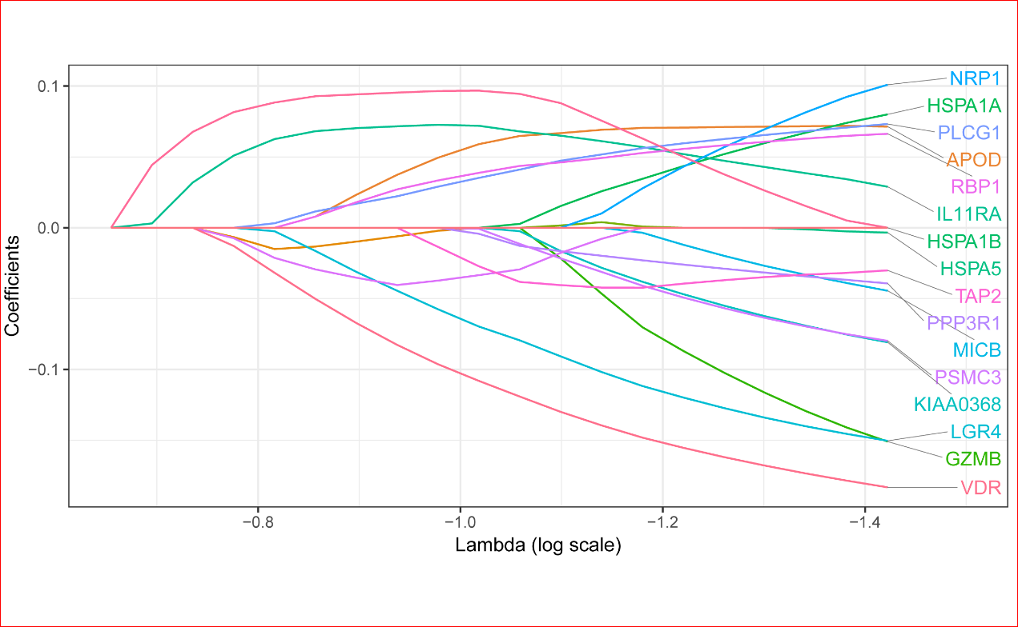
Supplemental Fig. S2. Heatmap of IRGS in two risk groups.
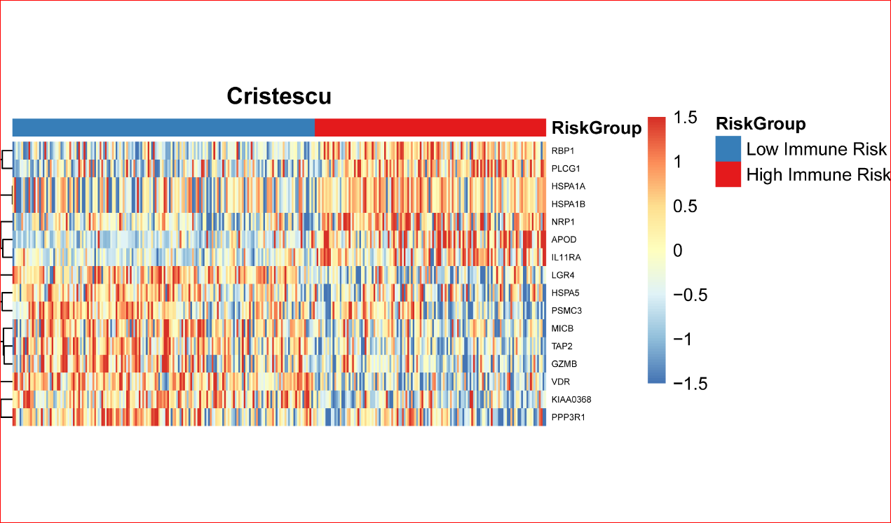
Supplemental Fig. S3. Obtain the optimal cutoff at 10 years in time-dependent ROC curve analysis.
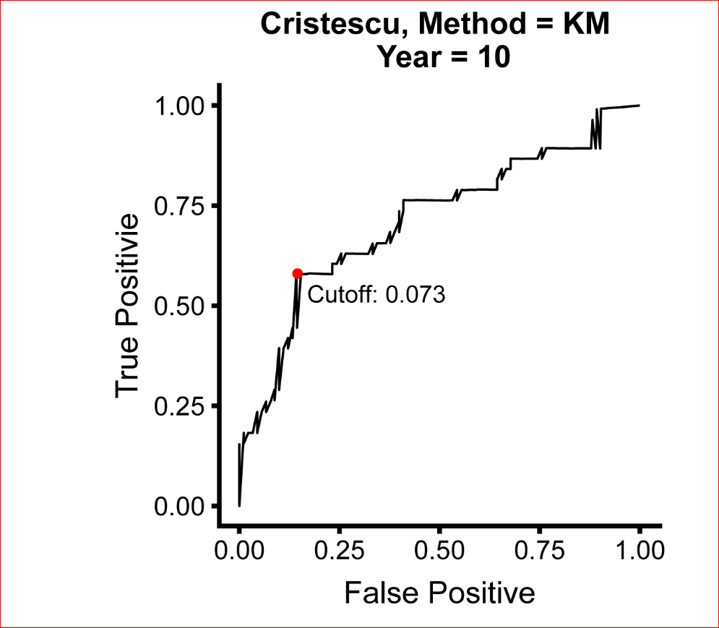
Supplemental Fig. S4. Kaplan-Meier curves in stage I&II validation cohorts of the IRGS. (A) and (C) OS among stage I&II GC patients in the validation 1 cohort. (C) and (D) OS among stage I&II GC patients in the validation 2 cohort. Hazard ratios (HRs) and 95% CIs are for high vs. low immune risk. P values comparing risk groups were calculated with the log-rank test.
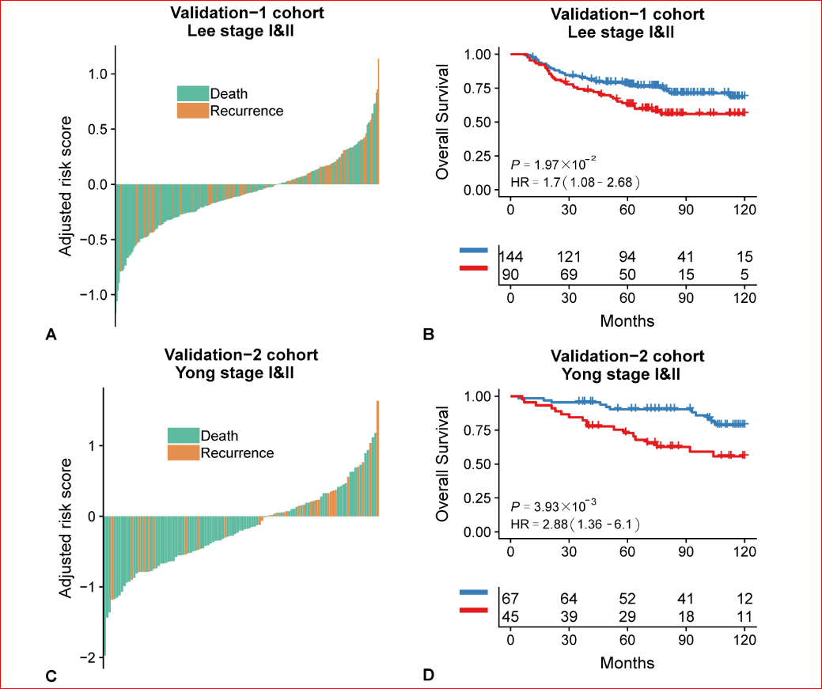
Supplemental Fig. S5. Gene ontology (GO) of the 16 immune signature genes.
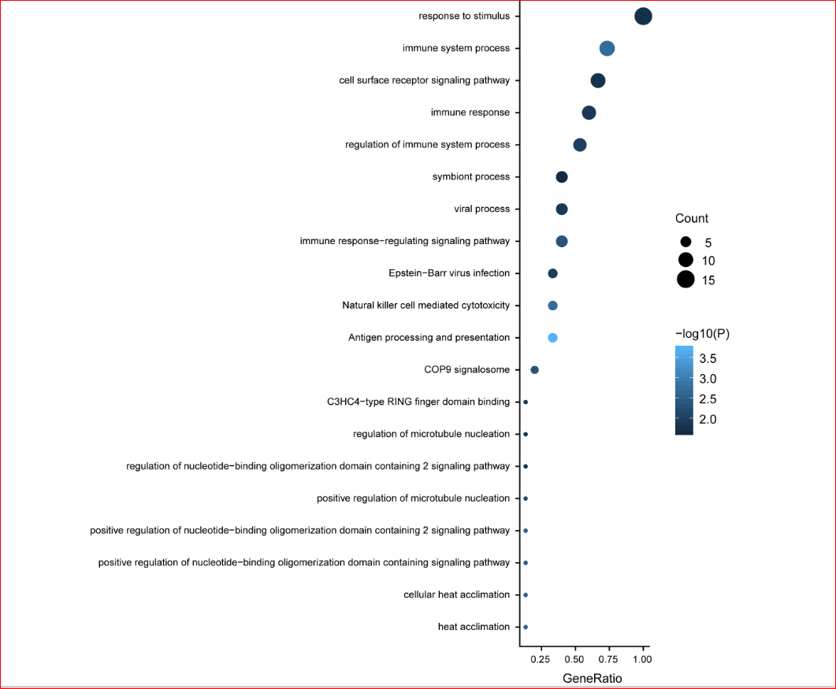
Supplemental Fig. S6. Gene Set Enrichment Analysis (GSEA) of the differentially expressed genes between risk groups. P-values were calculated by GSEA software.


