Supplementary Figure 1. Platelet scattergrams from a healthy individual with a normal immature platelet fraction (a) and a patient with immune thrombocytopenia with a high immature platelet fraction (b). A platelet-specific channel measures side fluorescent light (SFL) on the X axis and forward scattered light (FSC) on the Y axis after staining platelets using reagents containing oxazine fluorescent dyes. Red blood cells typically show weak-to-medium SFL and strong FSC (blue cluster), while normal platelets also show weak-to-medium SFL but weak FSC (sky-blue cluster). Immature platelets are distinguished by their strong SFL and medium FSC (yellow-green cluster).

(a)
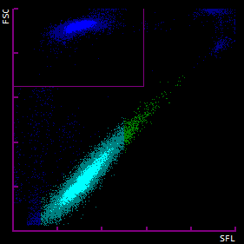
(b)
