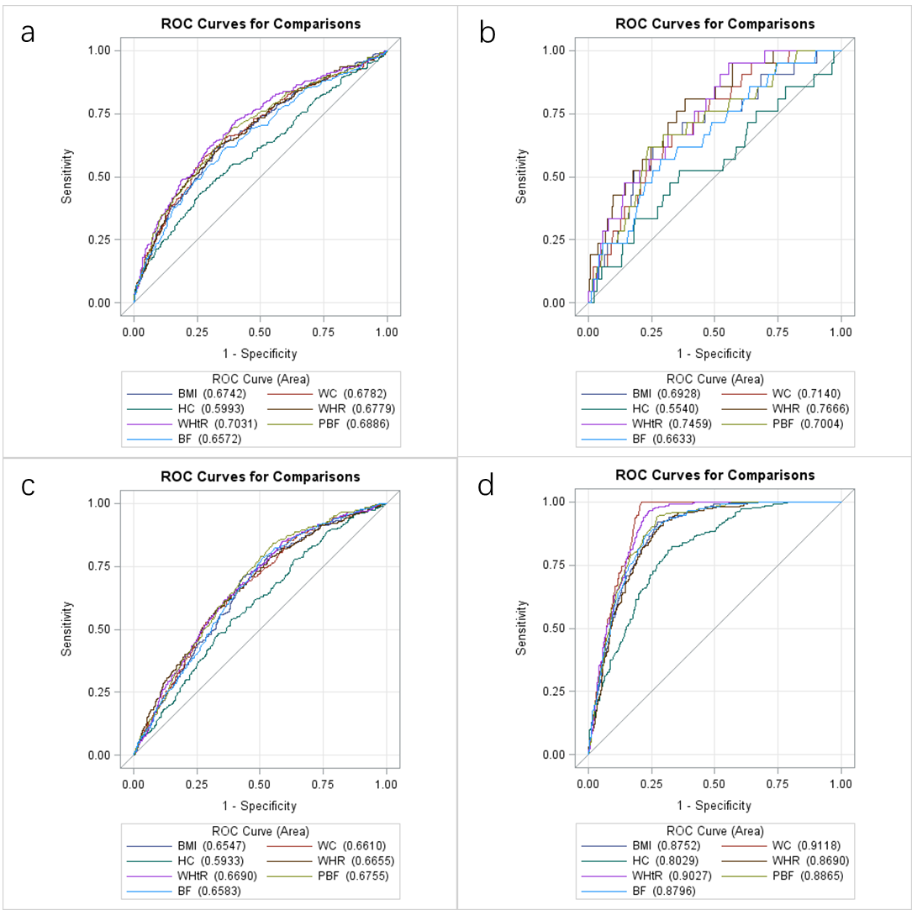
Figure S2. The area under the curve of each adiposity variable for the presence of various CVDRF in female
a. hypertension
b. diabetes
c. dyslipidemia
d. metabolic syndrome

