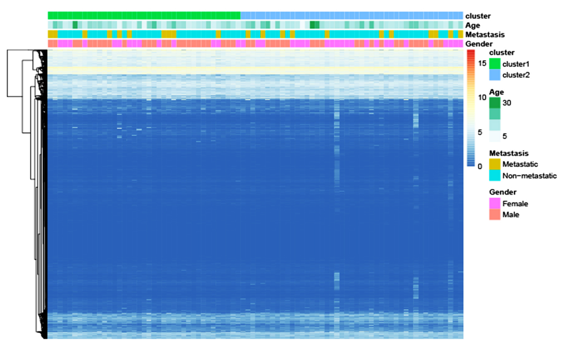
Figure S1. Heatmap of 84 samples gene expression.

