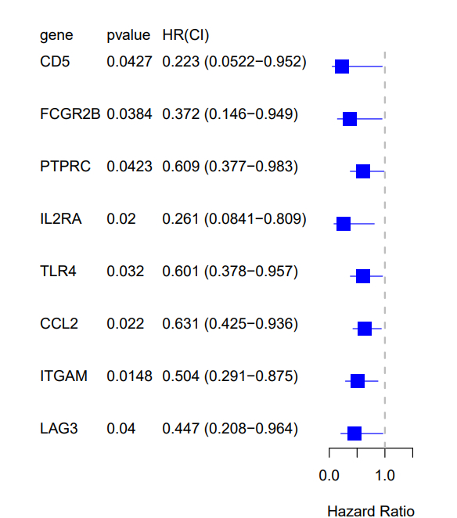
Figure S2. Univariate Cox regression analysis of overall survival for each pyroptosis-related DEG.

