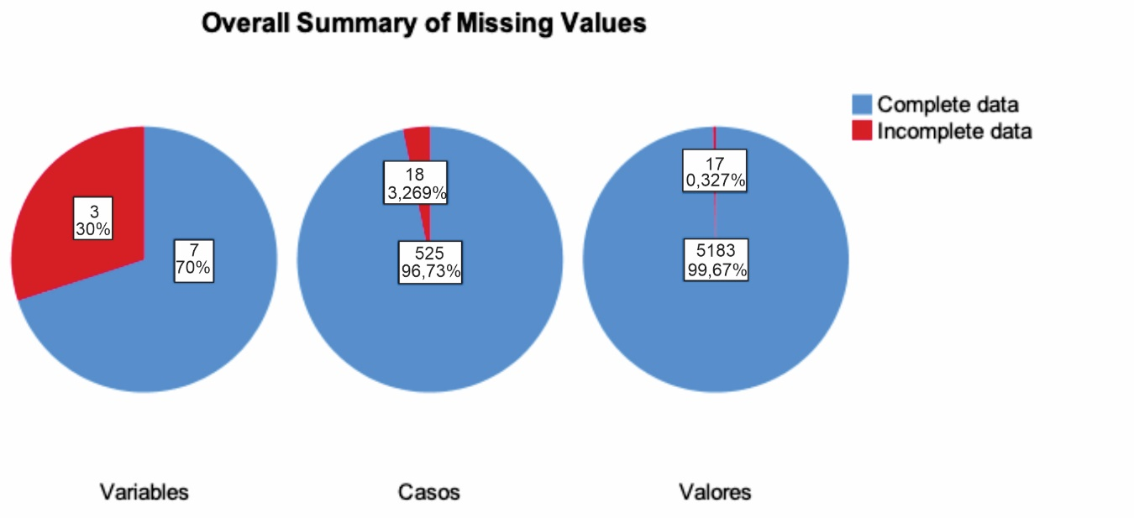

Supplemental File 1. Summary of Missing Values

