Supplemental Digital Content 1. The same actor presenting as either a low or high SES “patient”
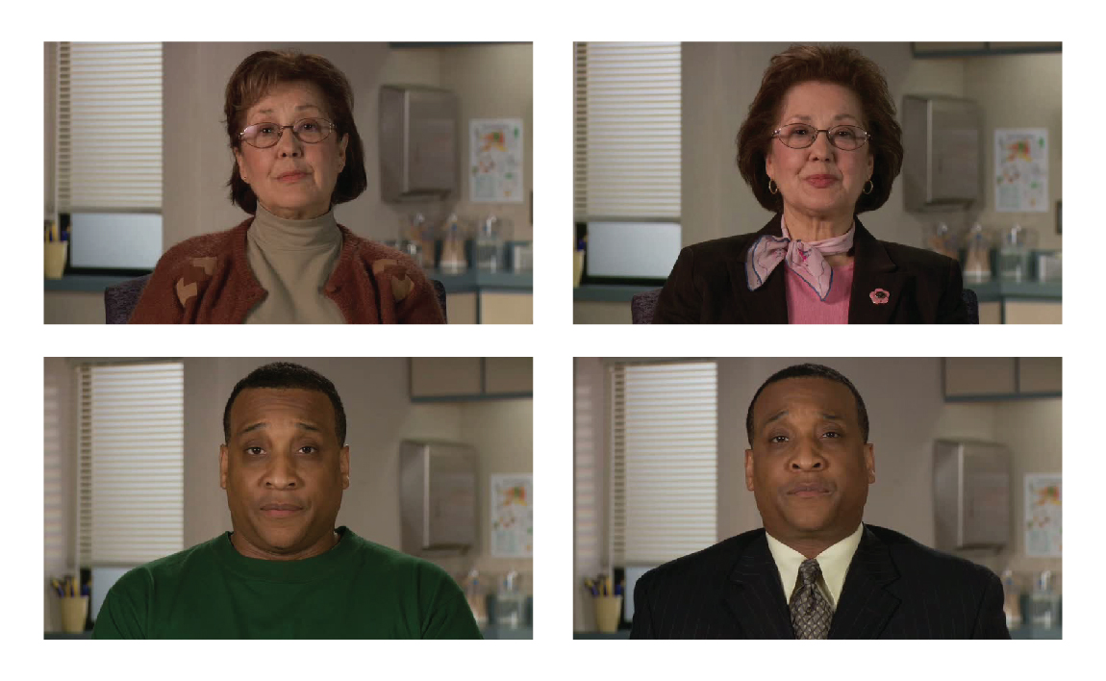
“Patients” differed only slightly in appearance. Females presented with broach, blazer, and makeup (upper SES) or turtleneck and no makeup (lower SES). Males presented with collar and tie (upper SES) or t-shirt (lower SES).

