SUPPLEMENTAL DIGITAL CONTENT
for
Racial/Ethnic Differences in 30-day Mortality for Heart Failure and Pneumonia in the Veterans Health Administration using Claims-Based, Clinical, and Social Risk-Adjustment Variables

Table of Contents
Supplemental Digital Content 1, Table. ICD-9 Codes for Primary Diagnoses…………...3
Supplemental Digital Content 2, Figure. Exclusion Flowchart for the Study Population...4
Supplemental Digital Content 3, Table. Summary of Missing Data for Clinical Variables and Area Deprivation Index, by Race/Ethnicity, for HF……………………………………..5
Supplemental Digital Content 4, Table. Summary of Missing Data for Clinical Variables and Area Deprivation Index, by Race/Ethnicity, for Pneumonia……….…………………..6
Supplemental Digital Content 5, Figure. Unadjusted Mortality Rates by Year for HF and Pneumonia………………………………………………………………………………..……..7
Supplemental Digital Content 6, Table. Average Marginal Effects (95% CI) [Cohort excluding Veterans hospitalized in VAMC outside continental US]………………..……...8
Supplemental Digital Content 7, Table. Average Marginal Effects (95% CI), stratified by ejection fraction……………………………………………………………………………….....9
Supplemental Digital Content 8, Table. Average Marginal Effects (95% CI) [One Random Admission Per Veteran]…………………………………………………………….10

Supplemental Digital Content 1, Table. ICD-9 Codes for Primary Diagnoses
Primary Diagnoses | ICD-9 Codes/Descriptions
Heart Failure | 402.01, 402.11, 402.91, 404.01, 404.03, 404.11, 404.13, 404.91, 404.93, 428.0, 428.1, 428.20, 428.21, 428.22, 428.23, 428.30, 428.31, 428.32, 428.33, 428.40, 428.41, 428.42, 428.43, and 428.9
Pneumonia | 480.0, 480.1, 480.2, 480.3, 480.8, 480.9, 481, 482.0, 482.1, 482.2, 482.30, 482.31, 482.32, 482.39, 482.40, 482.41, 482.42, 482.49, 482.81, 482.82, 482.83, 482.84, 482.89, 482.9, 483.0, 483.1, 483.8, 485, 486, 487.0, and 488.11
Sepsis or RF [with secondary diagnosis of pneumonia] | 38 STREPTOCOCCAL SEPTICEMIA  38.1 STAPHYLOCOCCAL SEPTICEMIA  38.1 STAPHYLOCOCCAL SEPTICEMIA, UNSPECIFIED  38.11 STAPHYLOCOCCUS AUREUS SEPTICEMIA  38.11 METHICILLIN SUSCEPTIBLE STAPHYLOCOCCUS AUREUS SEPTICEMIA  38.12 METHICILLIN RESISTANT STAPHYLOCOCCUS AUREUS SEPTICEMIA  38.19 OTHER STAPHYLOCOCCAL SEPTICEMIA  38.2 PNEUMOCOCCAL SEPTICEMIA  38.3 SEPTICEMIA DUE TO ANAEROBES  38.4 SEPTICEMIA DUE TO GRAM-NEGATIVE ORGANISM, UNSPECIFIED  38.41 SEPTICEMIA DUE TO HEMOPHILUS INFLUENZAE (H. INFLUENZAE)  38.42 SEPTICEMIA DUE TO ESCHERICHIA COLI (E. COLI)  38.43 SEPTICEMIA DUE TO PSEUDOMONAS  38.44 SEPTICEMIA DUE TO SERRATIA  38.49 OTHER SEPTICEMIA DUE TO GRAM-NEGATIVE ORGANISMS  38.8 OTHER SPECIFIED SEPTICEMIAS  38.9 UNSPECIFIED SEPTICEMIA  518.81 ACUTE RESPIRATORY FAILURE  518.82 OTHER PULMONARY INSUFFICIENCY, NEC  518.84 ACUTE AND CHRONIC RESPIRATORY FAILURE  785.52 SEPTIC SHOCK  799.1 RESPIRATORY ARREST  995.91 SEPSIS  995.92 SEVERE SEPSIS

Supplemental Digital Content 2, Figure. Exclusion Flowchart for the Study Population
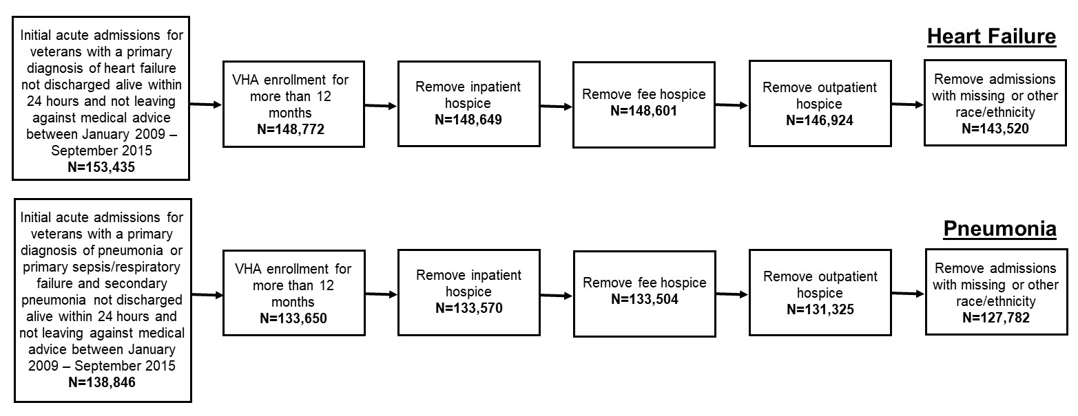

Supplemental Digital Content 3, Table. Summary of Missing Data for Clinical Variables and Area Deprivation Index, by Race/Ethnicity, for Heart Failure
Variable | Heart Failure (n=143,520)
 | White (n=101,226) |  | Black (n=38,044) |  | Hispanic (n=4,250)
 | Number Missing | % | Number Missing | % | Number Missing | %
Systolic Blood Pressure | 2,193 | 2.17 | 765 | 2.01 | 82 | 1.93
Diastolic Blood Pressure | 947 | 0.94 | 316 | 0.83 | 37 | 0.87
Heart Rate | 55 | 0.05 | 8 | 0.02 | 2 | 0.04
Respiratory Rate | 833 | 0.82 | 258 | 0.68 | 30 | 0.71
Blood Urea Nitrogen | 5,880 | 5.81 | 2,474 | 6.50 | 319 | 7.51
Oxygen Saturation | 582 | 0.57 | 184 | 0.48 | 21 | 0.49
Creatinine | 815 | 0.81 | 516 | 1.36 | 127 | 2.99
Potassium | 3,275 | 3.24 | 1,603 | 4.21 | 238 | 5.60
Hematocrit | 4,991 | 4.93 | 984 | 2.59 | 76 | 1.79
B-type Natriuretic Peptide | 12,557 | 12.40 | 5,006 | 13.16 | 629 | 14.8
Body Mass Index | 15,225 | 15.04 | 5,690 | 14.96 | 585 | 13.76
Left- Ventricular Ejection Fraction | 34,950 | 34.53 | 11,160 | 29.33 | 1,784 | 41.98
Sodium | 2,776 | 2.74 | 1,426 | 3.75 | 233 | 5.48
Area Deprivation Index | 1,048 | 1.04 | 267 | 0.70 | 388 | 9.13

Supplemental Digital Content 4, Table. Summary of Missing Data for Clinical Variables and Area Deprivation Index, by Race/Ethnicity, for Pneumonia
Variable | Pneumonia (n=127,782)
 | White (n=101,868) |  | Black (n=19,590) |  | Hispanic (n=6,324)
 | Number Missing | % | Number Missing | % | Number Missing | %
Systolic Blood Pressure | 1,910 | 1.87 | 365 | 1.86 | 89 | 1.41
Diastolic Blood Pressure | 239 | 0.23 | 44 | 0.22 | 10 | 0.16
Heart Rate | 20 | 0.02 | 3 | 0.02 | 0 | 0.00
Respiratory Rate | 33 | 0.03 | 9 | 0.05 | 0 | 0.00
Blood Urea Nitrogen | 5,789 | 5.68 | 1,315 | 6.71 | 373 | 5.90
Oxygen Saturation | 24 | 0.02 | 7 | 0.04 | 0 | 0.00
Creatinine | 725 | 0.71 | 218 | 1.11 | 79 | 1.25
Potassium | 3,121 | 3.06 | 718 | 3.67 | 215 | 3.40
Hematocrit | 4,957 | 4.87 | 598 | 3.05 | 78 | 1.23
Body Mass Index | 8,970 | 8.81 | 1,622 | 8.28 | 367 | 5.80
Sodium | 2,645 | 2.60 | 628 | 3.21 | 215 | 3.40
Serum Glucose | 3,608 | 3.54 | 888 | 4.53 | 269 | 4.25
Area Deprivation Index | 1,150 | 1.13 | 139 | 0.71 | 689 | 10.90

Supplemental Digital Content 5, Figure. Unadjusted Mortality Rates by Year for HF and Pneumonia
- Heart Failure
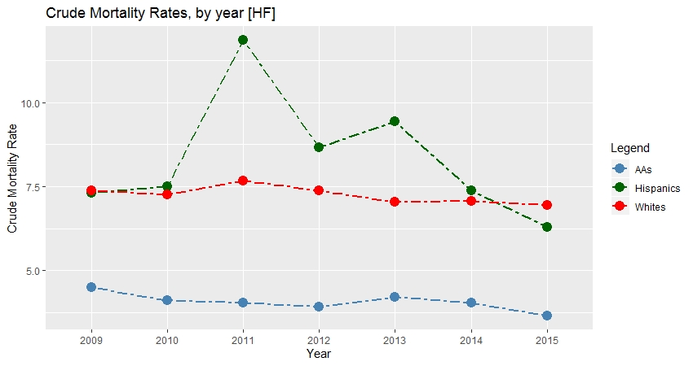
- Pneumonia
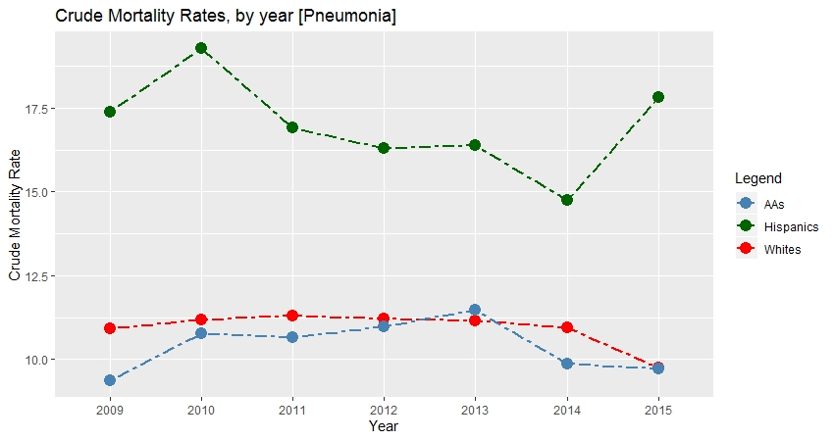
Unadjusted mortality rates for 2015 only include data for three quarters due to end of study period; all other years include data for four quarters
Supplemental Digital Content 6, Table. Average Marginal Effects (95% CI) [Cohort excluding Veterans hospitalized in VAMC outside continental US] -> Percent chance of mortality for Black and Hispanic Veterans relative to White Veterans
 | Heart Failure (n=141,109) |  | Pneumonia (n=124,400)
 | Black (n=37,878) | Hispanic (n=2,915) | Black (n=19,515) | Hispanic (n=3,680)
Base | -2.11  (-2.38, -1.83) | -0.83  (-1.70, 0.06) | 0.98  (0.47, 1.49) | 0.63  (-0.41, 1.68)
Claims-Based | -2.15  (-2.43, -1.86) | -0.45  (-1.37, 0.48) | 0.07  (-0.42, 0.57) | 0.27  (-0.75, 1.29)
Clinical | -1.55  (-1.84, -1.25) | -0.33  (-1.22, 0.56) | -0.52  (-0.99, -0.05) | 0.65  (-0.38, 1.68)
Claims-Based + Clinical | -1.54  (-1.84, -1.24) | -0.20  (-1.10, 0.71) | -0.83  (-1.30, -0.36) | 0.23  (-0.77, 1.22)
Claims-Based + Clinical  + Sociodemographic | -1.62  (-1.92, -1.32) | -0.22  (-1.12, 0.68) | -0.99  (-1.46, -0.52) | 0.33  (-0.67, 1.33)
Claims-Based + Clinical + VA Hospital | -1.31  (-1.64, -0.97) | -0.02  (-0.96, 0.92) | -0.96  (-1.46, -0.46) | 0.23  (-0.81, 1.27)
All models adjusted for Quarter, Age, Sex

Supplemental Digital Content 7, Table. Average Marginal Effects (95% CI), stratified by ejection fraction -> Percent chance of mortality for Black and Hispanic Veterans relative to White Veterans
 | Ejection Fraction <40  (n=51,579) |  | Ejection Fraction ≥40  (n=44,047) |  | Unknown Ejection Fraction (n=47,894)
 | Black (n=17,246) | Hispanic (n=1,292) | Black  (n=9,638) | Hispanic (n=1,174) | Black (n=11,160) | Hispanic (n=1,784)
Base | -2.60  (-3.05, -2.16) | -0.86  (-2.19, 0.47) | -1.18  (-1.63, -0.74) | 0.66  (-0.63, 1.95) | -2.74  (-3.30, -2.18) | 1.87  (0.49, 3.25)
Claims-Based | -2.59  (-3.05, -2.13) | -0.12  (-1.57, 1.33) | -1.12  (-1.58, -0.66) | 1.09  (-0.29, 2.47) | -2.87  (-3.43, -2.30) | 1.88  (0.48, 3.27)
Clinical | -1.72  (-2.18, -1.25) | 0.29  (-1.11, 1.70) | -0.32  (-0.83, 0.19) | 0.80  (-0.44, 2.05) | -1.85  (-2.44, -1.25) | 2.06  (0.75, 3.38)
Claims-Based + Clinical | -1.62  (-2.10, -1.14) | 0.65  (-0.81, 2.11) | -0.29  (-0.81, 0.23) | 1.08  (-0.23, 2.39) | -1.89  (-2.49, -1.29) | 1.89  (0.58, 3.20)
Claims-Based + Clinical  + Sociodemographic | -1.71  (-2.19, -1.22) | 0.63  (-0.83, 2.09) | -0.37  (-0.89, 0.15) | 1.30  (-0.05, 2.65) | -1.94  (-2.54, -1.35) | 2.27  (0.92, 3.62)
Claims-Based + Clinical + VA Hospital | -1.18  (-1.72, -0.64) | 0.24  (-1.25, 1.74) | -0.39  (-0.95, 0.17) | 0.05  (-1.19, 1.30) | -1.80  (-2.45, -1.15) | 1.23  (-0.32, 2.77)
All models adjusted for Quarter, Age, Sex
Clinical variables do not include ejection fraction for this analysis

Supplemental Digital Content 8, Table. Average Marginal Effects (95% CI) [One Random Admission Per Veteran] -> Percent chance of mortality for Black and Hispanic Veterans relative to White Veterans
 | Full Cohort |  |  |  | Cohort excluding Veterans hospitalized in VAMC outside continental US
 | Heart Failure (n=82,763) |  | Pneumonia (n=102,646) |  | Heart Failure (n=81,378) |  | Pneumonia (n=99,883)
 | Black (n=18,743) | Hispanic (n=3,343) | Black (n=16,397) | Hispanic (n=5,768) | Black (n=18,694) | Hispanic (n=2,277) | Black (n=16,357) | Hispanic (n=3,368)
Base | -1.85  (-2.28, -1.43) | 0.86  (-0.08, 1.81) | 0.73  (0.16, 1.31) | 4.89  (3.94, 5.84) | -1.86  (-2.28, -1.44) | -1.11  (-2.16, -0.05) | 0.72  (0.15, 1.29) | 0.10  (-1.01, 1.22)
Claims-Based | -1.87  (-2.30, -1.44) | 1.04  (0.08, 2.00) | -0.12  (-0.68, 0.44) | 4.39  (3.46, 5.32) | -1.88  (-2.31, -1.45) | -0.90  (-1.97, 0.18) | -0.12  (-0.67, 0.44) | -0.18  (-1.27, 0.91)
Clinical | -1.06  (-1.51, -0.60) | 1.05  (0.15, 1.96) | -0.85  (-1.39, -0.32) | 3.33  (2.46, 4.20) | -1.07  (-1.53, -0.62) | -0.95  (-1.96, 0.06) | -0.84  (-1.37, -0.31) | 0.04  (-1.04, 1.12)
Claims-Based + Clinical | -1.06  (-1.52, -0.59) | 1.14  (0.23, 2.06) | -1.07  (-1.61, -0.53) | 3.09  (2.22, 3.95) | -1.07  (-1.53, -0.60) | -0.78  (-1.81, 0.25) | -1.05  (-1.58, -0.51) | -0.24  (-1.30, 0.83)
Claims-Based + Clinical + Sociodemographic | -1.21  (-1.68, -0.75) | 1.31  (0.37, 2.24) | -1.24  (-1.77, -0.70) | 3.63  (2.75, 4.52) | -1.21  (-1.67, -0.75) | -0.78  (-1.82, 0.25) | -1.19  (-1.72, -0.66) | -0.10  (-1.17, 0.96)
Claims-Based + Clinical + VA Hospital | -0.88  (-1.38, -0.37) | 0.07  (-0.97, 1.10) | -1.13  (-1.71, -0.55) | 0.26  (-0.79, 1.32) | -0.89  (-1.39, -0.39) | -0.68  (-1.75, 0.40) | -1.12  (-1.69, -0.55) | -0.34  (-1.44, 0.77)
All models adjusted for Quarter, Age and Sex

