**Supplemental Digital Content**

**Supplemental Table 1:** States included in the analysis

**Supplemental Table 2:** Changes in participant characteristics at age 65, the age of eligibility for Medicare coverage: A regression discontinuity analysis

**Supplemental Table 3:** Sensitivity analyses

**Supplemental Table 4:** Comparison of survey respondents between who did and did not answer the lung cancer screening question

**Supplemental Table 5:** Changes in health insurance coverage and lung cancer screening at age 65 by education and geographic location

**Supplemental Table 6:** Changes in access to care at age 65: A regression discontinuity analysis

**Supplemental Figure 1:** Lung cancer screening among men and women at lower risk for lung cancer, above and below age 65

**Supplemental Figure 2:** Participant characteristics just above and below age 65

**Supplemental Figure 3:** Findings from Chi-square tests for discontinuity in lung cancer screening use among high-risk respondents, at age 65 and other ages

**Supplemental Figure 4:** Discontinuity in lung cancer screening relative to discontinuity in health insurance coverage

**Supplemental Method 1:** Method of ascertaining which participants did and did not meet USPSTF lung cancer screening criteria

**Supplemental Method 2:** Statistical model

**References**

**Supplemental Table 1: States included in the analysis**

|  |  |
| --- | --- |
| **Year** | **States** |
| 2017 | Florida, Georgia, Maryland, Missouri, Nevada, Oklahoma, Vermont, Wyoming, Kansas, Maine |
| 2018 | Delaware, Maryland, New Jersey, South Dakota, Texas, West Virginia, Oklahoma, Maine |
| 2019 | Arizona, Idaho, Kentucky, Maine, Minnesota, Missouri, Montana, North Carolina, North Dakota, Pennsylvania, Rhode Island, South Carolina, Utah, Vermont, West Virginia, Wisconsin, Kansas, Nebraska, Oklahoma, Maryland |

Notes: This table shows which states adopted the optional module for lung cancer screening in the BRFSS in 2017, 2018, and 2019.

**Supplemental Table 2: Changes in participant characteristics at age 65, the age of eligibility for Medicare coverage: A regression discontinuity analysis**

|  |  |  |  |  |
| --- | --- | --- | --- | --- |
|  | Men | | Women | |
| **Age 63-64** | **RD at age 65** | **Age 63-64** | **RD at age 65** |
| Fraction at high risk for lung cancer | 17.8 | 0.2 | 11.9 | -3.1 |
| (-4.2 to 4.6) | (-6.7 to 0.6) |
| P = 0.93 | P = 0.10 |
| Fraction retired | 39.7 | 1.3 | 46.9 | -2.6 |
| (-4.2 to 6.9) | (-8.1 to 2.9) |
| P = 0.64 | P = 0.36 |
| Fraction unemployed | 6.6 | 1.4 | 8.0 | 2.6 |
| (-2.9 to 5.7) | (-1.9 to 7.0) |
| P = 0.53 | P = 0.26 |
| Fraction who are veterans | 19.3 | 1.2 | 2.1 | 0.6 |
| (-3.0 to 5.3) | (-0.9 to 2.1) |
| P = 0.59 | P = 0.43 |
| Fraction with college education | 56.1 | -2.0 | 60.7 | -1.5 |
| (-7.1 to 3.1) | (-6.4 to 3.3) |
| P = 0.45 | P = 0.54 |

Notes: This table shows the results of regression discontinuity analyses of respondent characteristics at age 65 using the BRFSS 2017-2019. All regressions adjusted for respondents’ age, race, income level, state of residence, state’s Medicaid expansion status, and year of the interview. In addition, estimates for the fraction at high risk for lung cancer adjusted for respondents’ employment status, education level, and veteran status; estimates for the fraction retired and the fraction unemployed adjusted for respondents’ education level and veteran status; estimates for the fraction who are veterans adjusted for respondents’ employment status and education level; and estimates for the fraction with college education adjusted for respondents’ employment status and veteran status. 95 percent confidence intervals calculated using robust standard errors are in parentheses.

**Supplemental Table 3: Sensitivity analyses**

|  |  |  |  |  |
| --- | --- | --- | --- | --- |
|  | High-risk adults | | Lower-risk adults | |
| **Men** | **Women** | **Men** | **Women** |
| Main specification | 16.2 | 1.6 | 3.7 | 3.9 |
| (2.4 to 30.0) | (-19.8 to 23.0) | (-0.5 to 8.0) | (0.3 to 7.6) |
| P = 0.02 | P = 0.88 | P = 0.09 | P = 0.04 |
| *Change Bandwidth* | | | | |
| Bandwidth 8 | 16.0 | 2.6 | 2.5 | 3.1 |
| (-0.4 to 32.3) | (-21.2 to 26.5) | (-3.1 to 8.1) | (-1.3 to 7.5) |
| P = 0.06 | P = 0.83 | P = 0.39 | P = 0.17 |
| Bandwidth 10 | 14.7 | 2.6 | 2.4 | 3.6 |
| (2.3 to 27.1) | (-16.4 to 21.6) | (-1.8 to 6.5) | (0.1 to 7.2) |
| P = 0.02 | P = 0.79 | P = 0.26 | P = 0.04 |
| *Change Order of Polynomial* | | | | |
| Linear (1) | 7.7 | -0.6 | 0.7 | 1.4 |
| (0 to 15.3) | (-11.1 to 9.80) | (-1.7 to 3.1) | (-0.7 to 3.5) |
| P = 0.05 | P = 0.91 | P = 0.57 | P = 0.20 |
| *Change Covariates* | | | | |
| Exclude state indicators | 15.3 | 0.4 | 3.7 | 4.1 |
| (1.5 to 29.1) | (-21.2 to 22.0) | (-0.6 to 8.0) | (0.4 to 7.7) |
| P = 0.03 | P = 0.97 | P = 0.09 | P = 0.03 |
| Exclude year indicators | 16.2 | 2.0 | 3.7 | 3.9 |
| (2.4 to 30.1) | (-19.5 to 23.5) | (-0.6 to 8.0) | (0.2 to 7.6) |
| P = 0.02 | P = 0.86 | P = 0.09 | P = 0.04 |
| No covariates | 14.8 | 2.7 | 4.3 | 3.8 |
| (0.7 to 28.9) | (-20.0 to 25.4) | (-0.1 to 8.6) | (0.1 to 7.5) |
| P = 0.04 | P = 0.82 | P = 0.05 | P = 0.05 |
| *Other Regression Methods* | | | | |
| Interacted model | 15.4 | 2.1 | 3.8 | 3.9 |
| (1.4 to 29.4) | (-19.9 to 24.1) | (-0.5 to 8.1) | (0.2 to 7.6) |
| P = 0.03 | P = 0.85 | P = 0.09 | P = 0.04 |
| Logistic regression | 18.1 | 0.8 | 4.3 | 4.9 |
| (19.8 to 265.3) | (-139.3 to 150.5) | (-16.9 to 186.1) | (6.3 to 181.9) |
| P = 0.03 | P = 0.94 | P = 0.10 | P = 0.04 |
| Non-parametric method | 9.4 | 1.0 | 2.2 | 1.8 |
| (0.8 to 18.0) | (-12.3 to 14.2) | (-0.4 to 4.8) | (-0.4 to 4.1) |
| P = 0.03 | P = 0.89 | P = 0.09 | P = 0.11 |
| *Change Inclusion of People who Turn 65 During Look-Back Period* | | | | |
| Include with an indicator variable for this group | 16.3 | 1.7 | 3.7 | 4.0 |
| (2.5 to 30.2) | (-19.7 to 23,1) | (-0.6 to 8.0) | (0.3 to 7.7) |
| P = 0.02 | P = 0.87 | P = 0.09 | P = 0.03 |

Notes: This table shows changes in lung cancer screening utilization at age 65 by gender under various model specifications. The first row includes findings from the main specification, which used a bandwidth of 9 and adjusted for trends in age using a quadratic polynomial. In the subsequent rows, we changed the bandwidth to 8 and 10, adjusted for trends in age using a linear specification, used interacted models, usedlogistic regression, or adjusted for aging effects using a non-parametric modeling method that placed a higher weight on observations closer to age 65 with a triangular kernel. We used the Stata command rd for this non-parametric method.1 The final rows present results of models using an alternative approach to deal with data from respondents who were only partially treated during the 12-month look-back period (i.e., participants with reported age 65): creating a dummy variable for those respondents. 95% confidence intervals are in parentheses.

**Supplemental Table 4: Comparison of survey respondents between who did and did not answer the lung cancer screening question**

|  |  |  |  |  |  |  |  |  |
| --- | --- | --- | --- | --- | --- | --- | --- | --- |
| Age groups: 57-64 and 66-74 | | | | | | | | |
|  | **Raw No. (Weighted %) of Patientsa (n = 91 664)** | | | | | | | |
|  | **High-riskb (n = 11 163)** | | | | **Lower-riskb (n = 80 501)** | | | |
| Characteristic | **Non-missingc (n = 10 951)** | **Missingc (n = 212)** | ***P* Valued** | **SMD** | **Non-missingc (n = 68 140)** | **Missingc (n = 12 361)** | ***P* Valued** | **SMD** |
| Age, median (IQR), y | 64 (9) | 66 (9) | .036 | -.145 | 66 (9) | 66 (9) | <0.001 | .058 |
| Sex |  |  |  |  |  |  |  |  |
| Male | 5 948 (57.4) | 100 (47.8) | .22 | .144 | 28 885 (45.6) | 4 848 (41.1) | <0.001 | .065 |
| Female | 4 999 (42.6) | 112 (52.2) | 39 230 (54.4) | 7 510 (58.9) |
| Race/ethnicity |  |  |  |  |  |  |  |  |
| Non-Hispanic white | 9 706 (87.3) | 178 (87.9) | .31 | .152 | 57 238 (77.3) | 10 435 (77.7) | .008 | .025 |
| Non-Hispanic Black | 376 (5.9) | 8 (3.0) | 5 024 (11.3) | 841 (11.0) |
| Hispanic | 151 (2.4) | 7 (5.1) | 1 947 (7.3) | 336 (5.8) |
| Others | 554 (4.4) | 14 (4.0) | 2 733 (4.1) | 514 (5.5) |
| Income |  |  |  |  |  |  |  |  |
| Less than $25,000 | 3 651 (35.7) | 90 (47.4) | .44 | .388 | 12 170 (22.6) | 1 932 (21.3) | .08 | .054 |
| $25,000 to less than $50,000 | 2 753 (30.3) | 40 (24.4) | 14 377 (24.3) | 2 431 (23.2) |
| $50,000 or more | 2 982 (34.0) | 29 (28.2) | 30 473 (53.1) | 5 530 (55.5) |
| Employment status |  |  |  |  |  |  |  |  |
| Unemployed | 449 (5.9) | 5 (12.3) | .15 | .162 | 1 859 (3.9) | 333 (5.2) | .02 | .043 |
| Employed | 3 232 (40.8) | 46 (47.5) | 26 541 (46.5) | 5 086 (47.9) |
| Retired | 4 837 (53.3) | 92 (51.3) | 31 824 (49.6) | 5 592 (47.0) |
| Education |  |  |  |  |  |  |  |  |
| College-educated | 5 536 (44.3) | 100 (45.7) | .87 | .065 | 47 752 (62.1) | 8 949 (66.7) | <0.001 | .053 |
| Non-college educated | 5 396 (55.7) | 111 (54.3) | 20 246 (37.9) | 3 374 (33.3) |
| Veteran status |  |  |  |  |  |  |  |  |
| Veteran | 2 555 (22.5) | 46 (16.9) | .29 | .035 | 10 155 (14.6) | 1 393 (11.3) | <0.001 | .108 |
| Non-veteran | 8 385 (77.5) | 164 (83.1) | 57 901 (85.4) | 10 948 (88.7) |

**Supplemental Table 4: Comparison of survey respondents between who provided answers to the lung cancer screening question and who did not (continued)**

|  |  |  |  |  |  |  |  |  |
| --- | --- | --- | --- | --- | --- | --- | --- | --- |
| Age group 57-64 and 66-74 | | | | | | | | |
|  | **Raw No. (Weighted %) of Patientsa (n = 91 664)** | | | | | | | |
|  | **High-riskb (n = 11 163)** | | | | **Lower-riskb (n = 80 501)** | | | |
| Characteristic | **Non-missingc (n = 10 951)** | **Missingc (n = 212)** | ***P* Valued** | **SMD** | **Non-missingc (n = 68 140)** | **Missingc (n = 12 361)** | ***P* Valued** | **SMD** |
| Health insurance status | | |  |  |  |  |  |  |
| Insured | 10 155 (92.8) | 206 (97.6) | .05 | .194 | 65 296 (94.6) | 11 780 (94.1) | .25 | .019 |
| Uninsured | 766 (7.2) | 6 (2.4) | 2 718 (5.4) | 538 (5.9) |
| Medicaid expansion status | | |  |  |  |  |  |  |
| Expanded | 5 486 (41.1) | 110 (36.2) | .48 | .036 | 36 784 (43.3) | 5 234 (39.5) | <0.001 | .235 |
| Not expanded | 5 465 (58.9) | 102 (63.8) | 31 356 (56.7) | 7 127 (60.5) |
| Ever diagnosed with COPD | | |  |  |  |  |  |  |
| Yes | 4 017 (35.6) | 105 (57.7) | .003 | .280 | 5 981 (8.8) | 647 (5.0) | <0.001 | .140 |
| No | 6 852 (64.4) | 102 (42.3) | 61 849 (91.2) | 11 663 (95.0) |
| Ever diagnosed with asthma | | |  |  |  |  |  |  |
| Yes | 1 701 (14.9) | 50 (21.7) | .16 | .213 | 8 987 (12.7) | 1 492 (11.7) | .08 | .034 |
| No | 9 202 (85.1) | 158 (78.3) | 58 958 (87.3) | 10 830 (88.3) |
| Have personal doctor(s) or health care provider(s) | | |  |  |  |  |  |  |
| Yes | 9 650 (88.0) | 198 (88.5) | .94 | .177 | 62 699 (91.8) | 11 233 (89.9) | 0.001 | .041 |
| No | 1 275 (12.0) | 14 (11.5) | 5 248 (8.2) | 1 091 (10.1) |
| Routine checkup within the past year | | |  |  |  |  |  |  |
| Yes | 9 063 (84.5) | 188 (91.5) | .17 | .221 | 58 735 (87.9) | 10 321 (83.6) | <0.001 | .067 |
| No | 1 795 (15.5) | 19 (8.5) | 8 980 (12.1) | 1 907 (16.4) |
| Skipped care because of costs in the past 12 months | | |  |  |  |  |  |  |
| Yes | 1 334 (13.0) | 32 (18.8) | .32 | .088 | 4 626 (8.2) | 774 (7.4) | .13 | .021 |
| No | 9 585 (87.0) | 178 (81.2) | 63 377 (91.8) | 11 546 (92.6) |

Abbreviations: COPD, chronic obstructive pulmonary disease; SMD, standardized mean difference

a Weighted percentages were estimated using data from BRFSS 2017-2019. Percentages have been rounded and may not total 100.

v Respondents at high-risk for lung cancer are adults age 55 to 80 who have a 30 pack-year smoking history and who either currently smoke or quit within the past 15 years. All others are at lower-risk.

c Respondents who had non-missing lung cancer screening data were those who provided a “yes” or “no” answer to the lung cancer screening question.

d *P* value for age is from the Wilcoxon rank sum test, and *P* values for other characteristics are from the χ2 test.

**Supplemental Table 5:** **Changes in health insurance coverage and lung cancer screening at age 65 by education and geographic location**

**Panel A: People with high lung cancer risk (meet USPSTF criteria for screening)**

|  |  |  |  |  |  |  |
| --- | --- | --- | --- | --- | --- | --- |
|  | Change in Coverage | | | Change in Lung Cancer Screening | | |
|  | **Age 63-64** | **RD at Age 65** | | **Age 63-64** | **RD at Age 65** | |
|  |  | **Unadjusted** | **Adjusted** |  | **Unadjusted** | **Adjusted** |
| By education |  |  |  |  |  |  |
| College educated | 88.9 | 13.5 | 13.1 | 12.8 | 13.5 | 11.3 |
| (4.4 to 22.5) | (5.1 to 21.2) | (-4.4 to 31.4) | (-4.7 to 27.2) |
| P = 0.004 | P = 0.001 | P = 0.14 | P = 0.17 |
| Not college educated | 91.5 | 5.3 | 6.3 | 15.2 | 6.9 | 6.4 |
| (-1.3 to 11.9) | (0.1 to 12.4) | (-11.4 to 25.3) | (-11.0 to 23.8) |
| P = 0.12 | P = 0.05 | P = 0.46 | P = 0.47 |
| By geographic location | | |  |  |  |  |
| State expanded Medicaid eligibility among low-income adults | 94.7 | 5.4 | 6.1 | 14.2 | 11.0 | 9.6 |
| (-2.0 to 12.8) | (-1.2 to 13.4) | (-8.7 to 30.8) | (-9.7 to 28.8) |
| P = 0.15 | P = 0.10 | P = 0.27 | P = 0.33 |
| State did not expand Medicaid eligibility among low-income adults | 87.3 | 11.2 | 11.7 | 14.0 | 7.8 | 8.5 |
| (3.6 to 18.9) | (4.1 to 19.3) | (-9.0 to 24.5) | (-7.6 to 24.6) |
| P = 0.004 | P = 0.003 | P = 0.36 | P = 0.30 |

**Panel B: People with lower risk (do not meet USPSTF criteria)**

|  |  |  |  |  |  |  |
| --- | --- | --- | --- | --- | --- | --- |
|  | Change in Coverage | | | Change in Lung Cancer Screening | | |
|  | **Age 63-64** | **RD at Age 65** | | **Age 63-64** | **RD at Age 65** | |
|  |  | **Unadjusted** | **Adjusted** |  | **Unadjusted** | **Adjusted** |
| By education |  |  |  |  |  |  |
| College educated | 94.1 | 4.4 | 4.8 | 4.3 | 2.2 | 2.2 |
| (2.4 to 6.4) | (2.7 to 6.8) | (-1.2 to 5.7) | (-1.2 to 5.7) |
| P < 0.001 | P < 0.001 | P = 0.21 | P = 0.20 |
| Not college educated | 87.3 | 9.3 | 8.2 | 4.3 | 7.0 | 6.3 |
| (4.8 to 13.8) | (3.7 to 12.7) | (2.0 to 12.0) | (1.4 to 11.2) |
| P < 0.001 | P < 0.001 | P = 0.006 | P = 0.01 |
| By geographic location | | |  |  |  |  |
| State expanded Medicaid eligibility among low-income adults | 93.6 | 6.0 | 6.0 | 3.4 | 4.2 | 3.7 |
| (3.0 to 9.0) | (3.2 to 8.9) | (0.6 to 7.8) | (0.2 to 7.3) |
| P < 0.001 | P < 0.001 | P = 0.02 | P = 0.04 |
| State did not expand Medicaid eligibility among low-income adults | 90.0 | 6.0 | 6.2 | 4.9 | 3.9 | 3.7 |
| (3.0 to 9.0) | (3.2 to 9.1) | (-0.4 to 8.1) | (-0.5 to 7.9) |
| P < 0.001 | P < 0.001 | P = 0.07 | P = 0.09 |

Notes: The columns include findings from stratified analyses of health insurance coverage and lung cancer screening by education and by geographic location. Models were centered at 65, so estimates apply to age 65. “Unadjusted” estimates control only for age. Models allowed age trend terms to vary above versus below the cutoff. Adjusted estimates by education adjusted for respondents’ age, race, employment status, income level, veteran status, state of residence, state’s Medicaid expansion status, and year of the interview. Adjusted estimates by geographic location adjusted for respondents’ age, race, employment status, income level, education level, veteran status, state of residence, and year of the interview. 95% confidence intervals calculated using robust standard errors are in parentheses.

**Supplemental Table 6: Changes in access to care at age 65: A regression discontinuity analysis**

|  |  |  |  |  |  |  |
| --- | --- | --- | --- | --- | --- | --- |
|  | Men | | | Women | | |
|  | **Age 63-64** | **RD at age 65** | | **Age 63-64** | **RD at age 65** | |
|  |  | **Unadjusted** | **Adjusted** |  | **Unadjusted** | **Adjusted** |
| Forego care due to cost in the past year | 9.9 | -5.7 | -5.3 | 12.8 | -3.6 | -3.9 |
| (-11.1 to -0.2) | (-10.4 to -0.3) | (-9.0 to 1.9) | (-9.2 to 1.4) |
| P = 0.04 | P = 0.04 | P = 0.21 | P = 0.15 |
| Routine checkup in the past year | 81.8 | 5.8 | 5.3 | 87.8 | 2.9 | 3.2 |
| (-0.9 to 12.4) | (-1.1 to 11.7) | (-2.1 to 7.9) | (-1.7 to 8.2) |
| P = 0.09 | P = 0.11 | P = 0.26 | P = 0.20 |

Abbreviation: RD, regression discontinuity

Notes: The columns include findings from stratified analyses, including only men or women as noted in the headlines. Models were centered at 65, so estimates apply to age 65. “Unadjusted” estimates control only for age. Models allowed age trend terms to vary above versus below the cutoff. Adjusted estimated regression discontinuities at age 65 adjusted for respondents’ age, race, employment status, income level, education level, veteran status, state of residence, state’s Medicaid expansion status, and year of the interview. 95% confidence intervals calculated using robust standard errors are in parentheses.

**Supplemental Figure 1: Lung cancer screening among men and women at lower risk for lung cancer, above and below age 65**

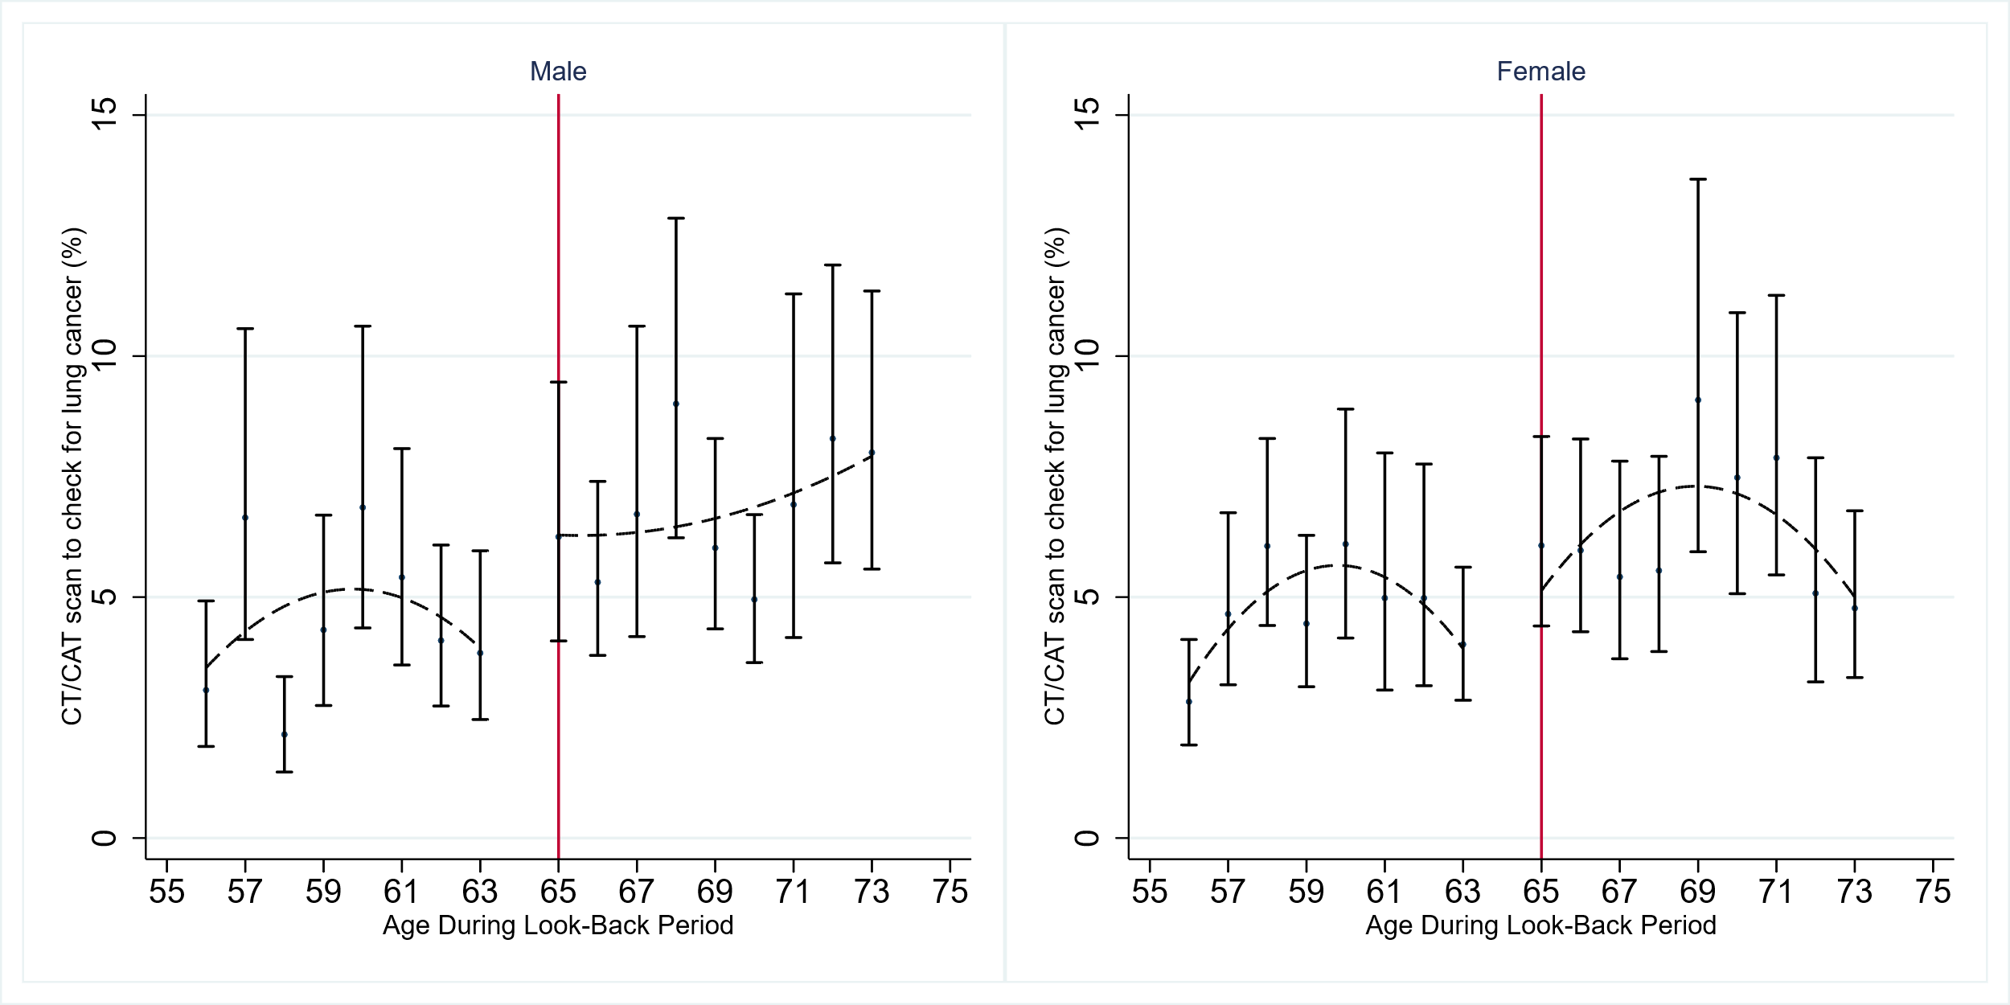

Notes: These graphs show the proportion of people at lower risk for lung cancer who reported having a CT/CAT scan check for lung cancer during the past 12 months. Age 65 is the age of nearly-universal access to Medicare coverage. The scatterplots were fit separately by sex, above and below this age cutoff. Data from people who turned 65 during the 12-month look-back period (e.g., who had partial exposure to nearly universal Medicare coverage) were excluded from the analysis. Data are from BRFSS 2017-2019.

**Supplemental Figure 2: Participant characteristics just above and below age 65**

1. High risk for lung cancer

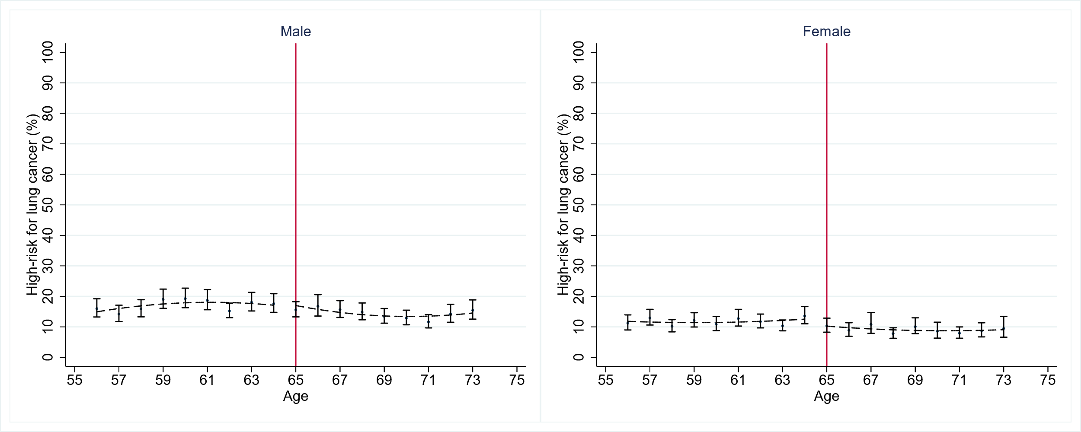

1. Retired

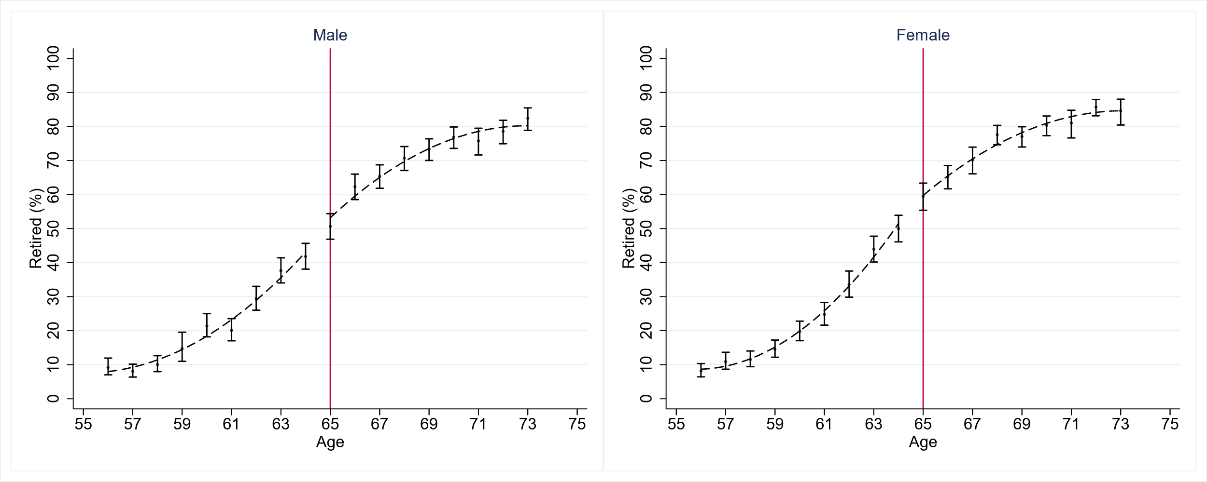

1. Unemployed

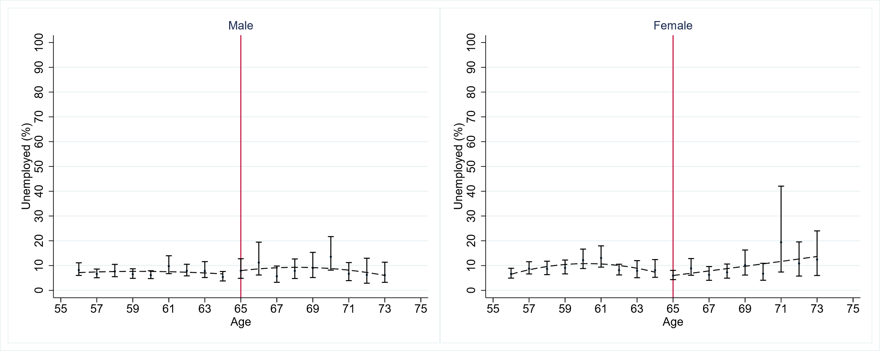

1. Veteran

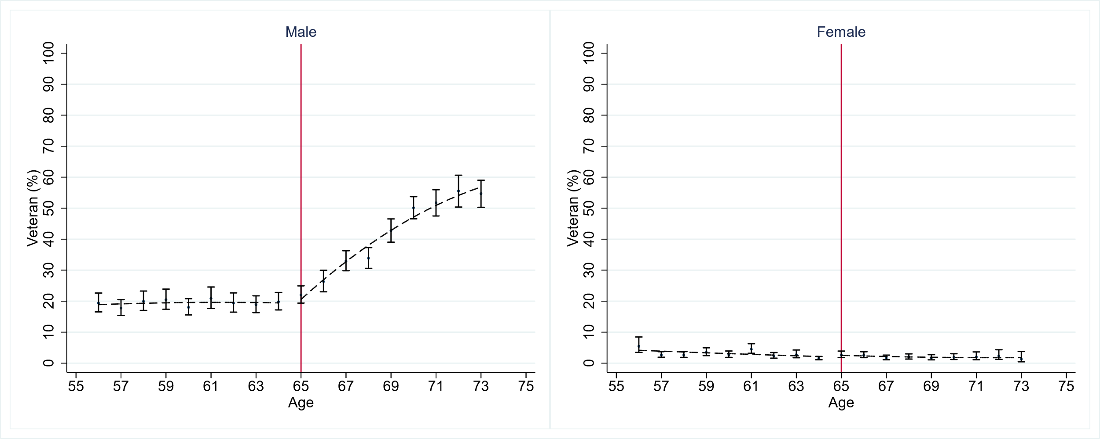

1. College education

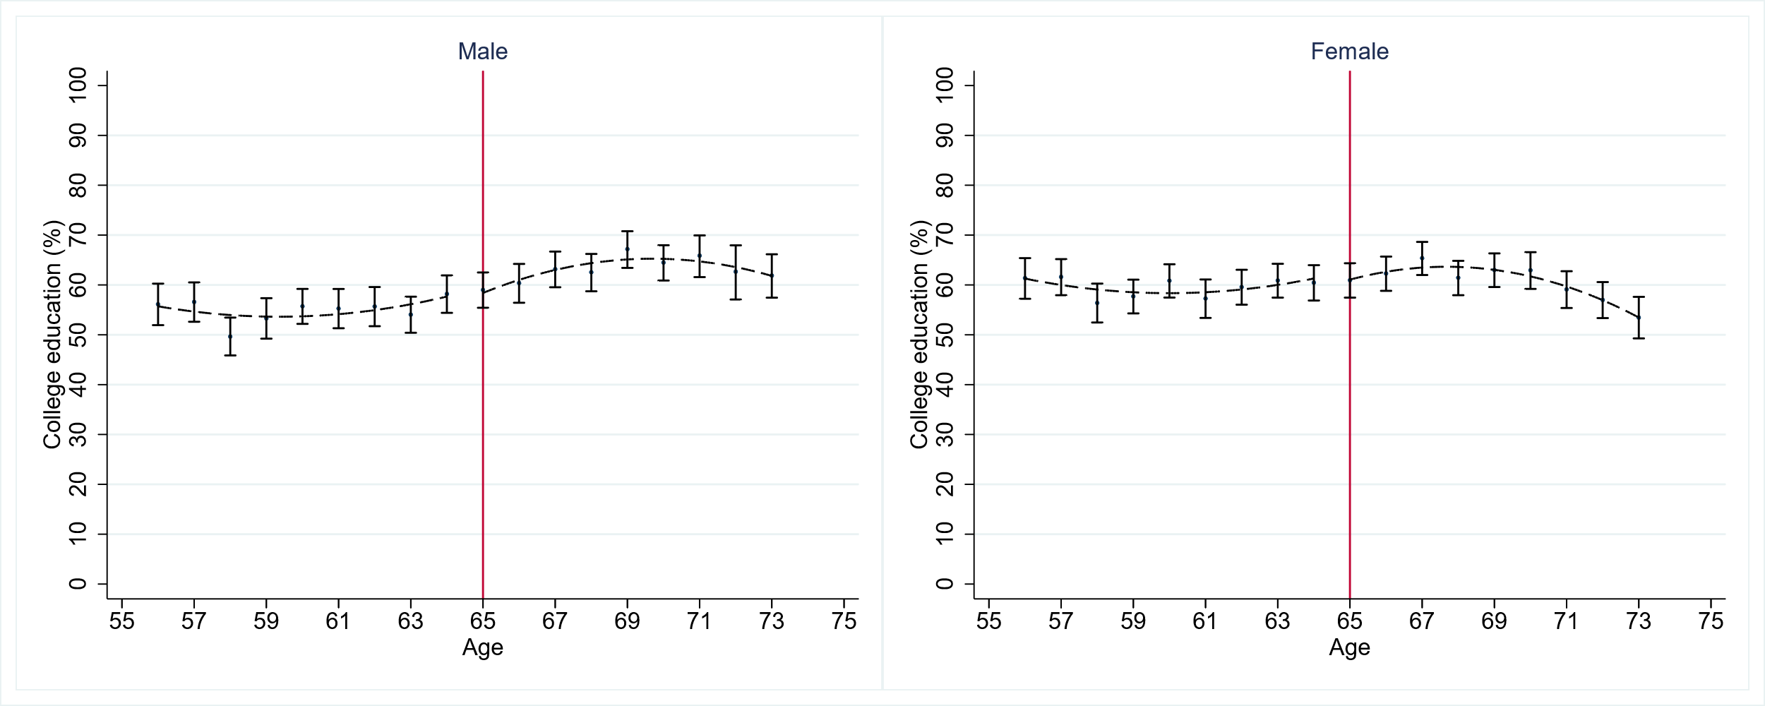

Notes: These graphs show trends in key economic and demographic variables just above and below age 65, the age of nearly-universal access to Medicare coverage. The x-axis is age, and the y-axis is the percentage of people with each characteristic of interest. These graphs include quadratic regression lines estimated separately below vs. above age 65 for each gender. Data are from BRFSS 2017-2019.

**Supplemental Figure 3: Findings from Chi-square tests for discontinuity in lung cancer screening use among high-risk respondents, at age 65 and other ages**

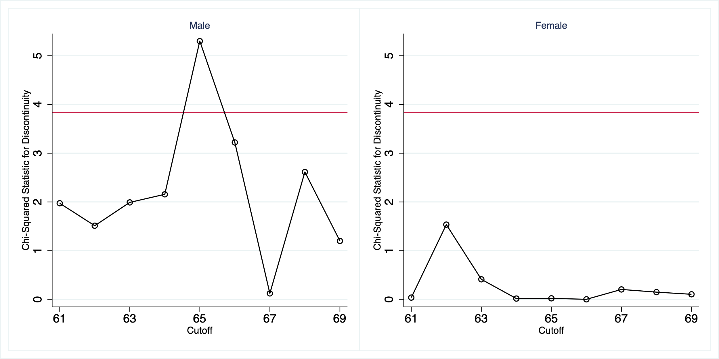

Notes: The Chi-squared statistics plotted tested the significance of the discontinuity in lung cancer screening use found when different ages were used as the cutoff in the regression discontinuity analysis. The horizontal line depicts the cutoff for statistical significance at the 0.05 level.

**Supplemental Figure 4: Discontinuity in lung cancer screening relative to discontinuity in health insurance coverage**



Notes: This graph shows the relationship between change in health insurance coverage and change in lung cancer screening across groups (correlation=0.75, *p*=0.03). The X-axis represents the discontinuity in health insurance coverage, and the Y-axis depicts the discontinuity in lung cancer screening at age 65. Each point on the scatter indicates the findings for the listed subgroup and risk level of survey participants.

**Supplemental Method 1: Method of ascertaining which participants did and did not meet USPSTF lung cancer screening criteria**

To ascertain which participants did and did not meet USPSTF criteria for being at high risk for lung cancer, we used data from the BRFSS lung cancer screening module and core survey questions. The survey participant’s current age and smoking status (never smoker, former smoker, or current smoker) were drawn from the core questions. Never smokers were classified as not meeting the risk criteria for lung cancer screening. For current and former smokers, we classified the ages when the participant started and stopped smoking, as well as the number of cigarettes smoked, using data from the lung cancer screening module. If these data were missing, we used another question from the Respiratory Health section of the core questionnaire, “Over your lifetime, how many years have you smoked tobacco products?” to determine the length of tobacco product smoking. The pack-year history of current or former smokers was calculated by multiplying the number of years the respondent smoked by the packs smoked per day, which was calculated by dividing the number of cigarettes smoked daily by 20.

**Supplemental Method 2: Statistical model**

We estimated the following multivariable model:

$$Y_{ist}\sim f(δ_{0}+δ_{1}a_{i}+δ_{2}a_{i}×D_{i}+δ_{3}D_{i}+δ_{4}a_{i}^{2}+{δ_{5}a_{i}^{2}×D_{i}+Z}_{ist})$$

$Y_{ist}$ indicates lung cancer screening receipt in the last 12 months for a person of age $a_{i}$, living in state *s* in year *t*. The age variable, $a_{i}$, is centered at 66, the youngest age of those who were 65 or older throughout the 12-month look-back period. The exposure variable of interest, $D_{i}$, is an indicator that takes the value 1 for people who were 65 or older throughout the 12-month look-back period and takes the value 0 for people who were younger than 65 throughout the 12-month look-back period. The model adjusted for respondents’ age, race, employment status, income level, education level, veteran status, state of residence, state’s Medicaid expansion status, and year of the interview as covariates ($Z_{ist}$), and allowed age trend terms to vary above and below the cutoff. $δ_{3}$, which is the coefficient of interest, capturing sharp changes in the outcome of interest associated with nearly universal Medicare coverage.

**References**

1. Nichols A. *RD: Stata Module for Regression Discontinuity Estimation*. Boston College Department of Economics; 2016. Accessed January 19, 2021. https://ideas.repec.org/c/boc/bocode/s456888.html