Supplemental Digital Content
Supplement Methods:
HSCRN VDW
The virtual data warehouse (VDW) is a common data model implemented by healthcare organizations belonging to the Health Care Systems Research Network (HCSRN)¹. Through this network, healthcare systems have adopted a common set of data tables, common variable definitions, and core relational data structures to facilitate multisite collaboration. Data are extracted from each organization’s electronic health record to create data tables that are stored and maintained locally by each site. Each site is responsible for writing and testing code to populate the data tables using specifications outlined by the HCSRN. These common data formats create efficiencies for data extraction, collection and aggregation across participating organizations. For additional information on the VDW please visit: https://www.hcsrn.org/en/Resources/VDW/.
Statistical Methods
To evaluate trends in visit rates we applied analytic approaches appropriate for time series data. Given that our goal was to understand the impact of specific interruptions to healthcare delivery (i.e., COVID-19 pandemic) we utilized an interrupted time series design to evaluate trends in visit rates over a 30-month period. We chose to use segmented, or piecewise, regression models^{2,3} to estimate the effects of COVID-19 events on visit rates. Regression models were constructed using the AUTOREG procedure⁴ in SAS. Piecewise linear autoregressive error models were used to account for correlated time observations. Up to 12 lags were included in the model to improve model fit and reduce autocorrelation. Lags were removed via a stepwise method in which the procedure starts with a high-order model with all 12 autoregressive parameters and then sequentially removes them until all autoregressive parameters are statistically significant (p < 0.05). For some models, autoregressive parameters that did not meet statistical significance were retained in models to improve overall fit and model diagnostics. Model diagnostics were examined and included partial autocorrelation plots, white noise probability plots, and tests for autocorrelation (Durbin-Watson test⁵) and heteroscedasticity (ARCH test⁶). To evaluate changes in trends across the three eras, the regression models were included 6 terms of interest described below. Models were constructed separately for each site, department, and type of encounter. For a given time t in weeks, the estimated value of the time series model at time t can be expressed as: $y_{t}={\hat{b}}_{01}+{\hat{b}}_{11}t+ {\hat{b}}_{02}*{era}_{2}+{\hat{b}}_{12}*{era}_{2}*\left(t-31\right)+{\hat{b}}_{03}*{era}_{3}+{\hat{b}}_{13}*{era}_{3}*\left(t-52\right)+{\hat{v}}_{t}+e_{t}$, where
$${\hat{b}}_{01}$$ | Intercept pre-covid
$${\hat{b}}_{11}$$ | Pre-covid slope
$${\hat{b}}_{02}$$ | Level change at start of era 2
$${\hat{b}}_{12}$$ | Change in slope from pre-covid to era 2
$${\hat{b}}_{03}$$ | Level change at start of era 3
$${\hat{b}}_{13}$$ | Change in slope from era2 to era 3
$${era}_{2}$$ | $is an indicator variable to denote if time t occured after$03/13/2020 otherwise the value is 0
$${era}_{3}$$ | $is an indicator variable to denote if time t occured after 12$/31/2020  otherwise the value 0.
$${\hat{v}}_{t}$$ | estimates of autocorrelation at time t
$$e_{t}$$ | residual error at time t and is assumed to be normally and independently distributed with mean 0 and variance $σ^{2}$

Results are presented as model-based estimates with associated standard errors.

References
1. Ross TR, Ng D, Brown JS, et al. The HMO Research Network Virtual Data Warehouse: A Public Data Model to Support Collaboration. EGEMS (Wash DC). 2014;2(1):1049. doi:10.13063/2327-9214.1049
2. Cook, TD, Campbell, DT (1979) Quasi-experimentation. Design & analysis issues for field settings. Boston, MA: Houghton Mifflin Company.
3. Gillings, D, Makuc, D, Siegel, E (1981) Analysis of interrupted time series mortality trends: an example to evaluate regionalized perinatal care. American Journal of Public Health. 1981; 71, 38–46. 7.
4. SAS Institute Inc. 2014. SAS/ETS® 13.2 User's Guide. Cary, NC: SAS Institute Inc.
5. Ansley, C. F., Kohn, R., and Shively, T. S. “Computing p-Values for the Generalized Durbin-Watson and Other Invariant Test Statistics.” Journal of Econometrics. 1992; 54:277–300.
6. McLeod, A. I., and Li, W. K. (1983). “Diagnostic Checking ARMA Time Series Models Using Squared-Residual Autocorrelations.” Journal of Time Series Analysis. 1983; 4:269–273.
Supplemental Table 1. Summary of Encounters by Region and Era
 | KPCO |  |  | KPGA |  |  | KPMAS
Characteristic | Pre-COVID | Recovery and Shutdown | Covid-19 Vaccination Phase | Pre-COVID | Recovery and Shutdown | Covid-19 Vaccination Phase | Pre-COVID | Recovery and Shutdown | Covid-19 Vaccination Phase
Average Number of Enrolled Persons* | 418,322 | 406,603 | 398,177 | 252,139 | 243,708 | 259,713 | 616,865 | 635,027 | 653,027
Virtual Visits Offered
- Phone | X | X | X | X | X | X | X | X | X
- Video |  | X | X | X | X | X | X | X | X
- Chat | X | X | X | X | X** | X
Adult Primary Care
Total Number of Visits | 1,159,528 | 673,475 | 434,886 | 702,320 | 416,248 | 287,820 | 1,832,337 | 1,140,325 | 727,446
In-person Visits | 951,714 | 287,018 | 276,565 | 642,240 | 162,561 | 159,449 | 1,632,892 | 447,469 | 405,158
Virtual Visits | 207,814 | 386,457 | 158,321 | 60,080 | 253,687 | 129,371 | 199,445 | 692,856 | 322,288
Behavioral Health
Total Number of Visits | 121,975 | 88,454 | 56,635 | 129,453 | 92,421 | 59,458 | 219,313 | 169,345 | 114,923
In-person Visits | 105,057 | 2,863 | 4,939 | 89,520 | 1,711 | 2,246 | 168,463 | 3,078 | 1,580
Virtual Visits | 16,918 | 85,591 | 51,696 | 39,933 | 90,710 | 57,212 | 50,850 | 166,267 | 113,343
* Average membership count during era for adults age > 19 year as of the 1st of the month.
** KPGA added chats in June 2020.

Supplemental Table 2. Explanation of parameter estimates from segmented regression models
Parameter | Interpretation
b₀₁ | Intercept pre-covid
b₁₁ | Pre-covid slope
b₀₂ | Level change at start of era 2
b₁₂ | Change in slope from pre-covid to era 2
b₀₃ | Level change at start of era 3
b₁₃ | Change in slope from era2 to era 3

Supplemental Figures 1a-c. Proportion of encounters completed in-person (dark blue) and virtually (light blue) in Adult Primary Care from 1/1/2019 – 3/12/2020, 3/13/2020- 12/31/2020; 1/1/2021 – 6/30/2021 at (a) Kaiser Permanente Colorado; (b) Kaiser Permanente Georgia; (c) Kaiser Permanente Mid-Atlantic States. The proportion of virtual encounter increased during the second and third eras.
Supplemental Figures 2a-c. Proportion of encounters completed in-person (dark blue) and virtually (light blue) in Behavioral Health from 1/1/2019 – 3/12/2020, 3/13/2020- 12/31/2020; 1/1/2021 – 6/30/2021 at (a) Kaiser Permanente Colorado; (b) Kaiser Permanente Georgia; (c) Kaiser Permanente Mid-Atlantic States. Most encounters during the second and third eras were completed virtually.

Supplemental Figures 1a-c.
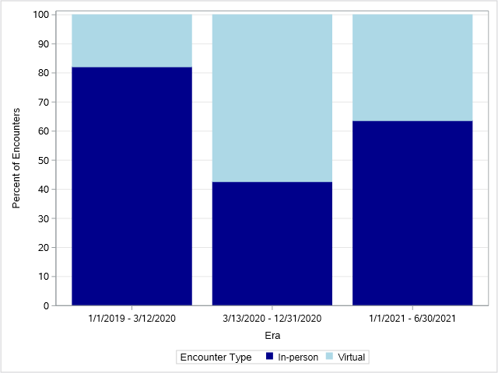
A-KPCO
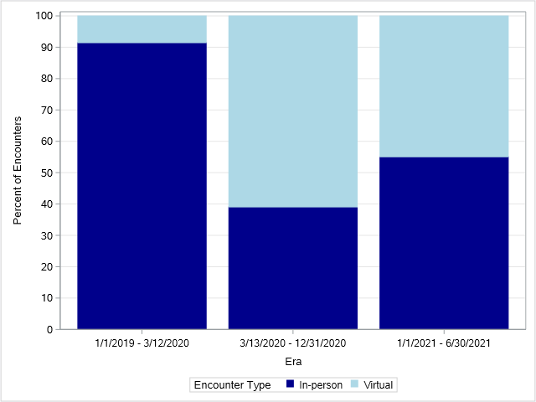
B- KPGA
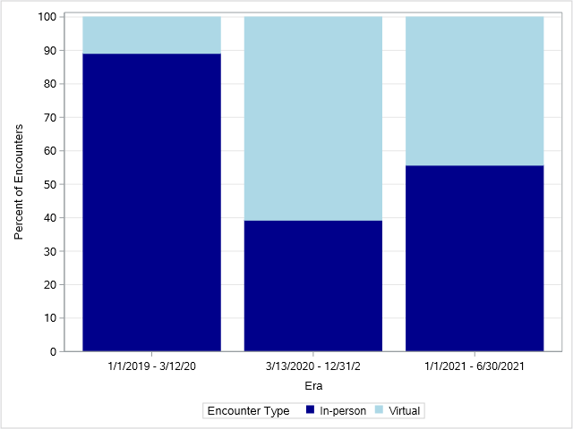
C- KPMAS
Supplemental Figures 2a-c.
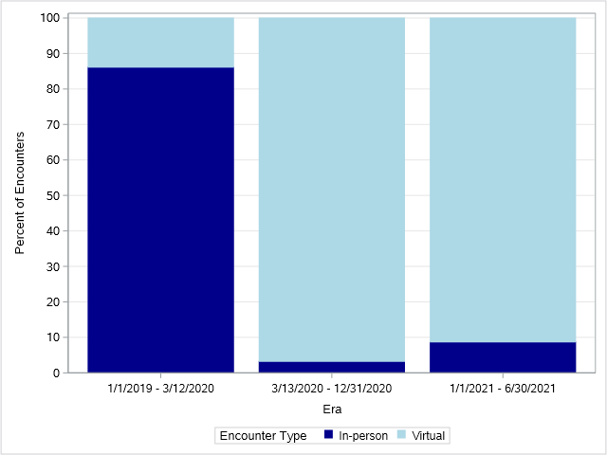
A-KPCO
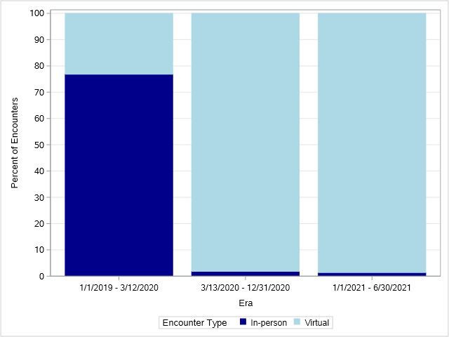
B- KPGA
C- KPMAS

