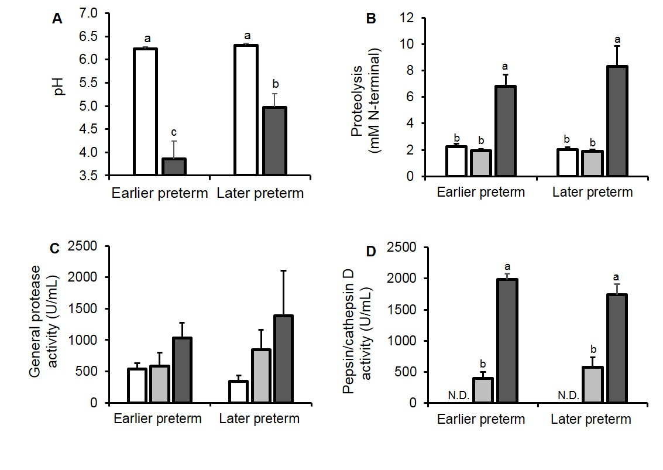
Supplemental Digital Content 5. (A) pH, (B) proteolysis, (C) general protease activity and (D) pepsin/cathepsin D activity in human milk (white bars), human milk incubated to simulate gastric conditions (milk_{inc}, gray bars) and infant gastric samples (black bars). Paired milk, milk_{inc} and gastric samples were separated by gestational age (GA) at birth, either earlier preterm (N = 10, 24–27 wk GA, 17–42 days of postnatal age) or later preterm (N = 6, 28–32 wk GA, 5–30 days of postnatal age). Values are mean ± SEM. Letters a, b and c show statistically significant differences between groups (P ≤ 0.05) using two-way ANOVA followed by Tukey’s honest significant difference post hoc test for pH, proteolysis, general protease activity and pepsin/cathepsin D activity.

