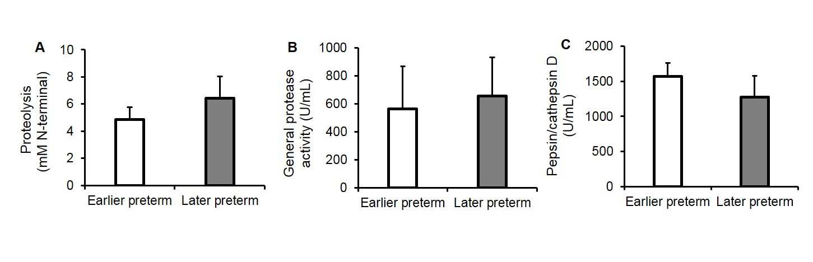
Supplemental Digital Content 6. Activity of pepsin estimated by subtracting the paired values from human milk incubated to simulate gastric conditions (milk_{inc}) from those in the stomach for (A) proteolysis, (B) general protease activity and (C) pepsin/cathepsin D activity. Paired milk_{inc} and gastric samples were separated by gestational age (GA), earlier preterm (N = 10, 24–28 wk GA, 17–42 days of postnatal age) and later preterm (N = 6, 28–32 wk GA, 5–30 days of postnatal age). Values are mean ± SEM. Asterisks show statistically significant differences between variables (**, P ≤ 0.01; * P ≤ 0.05) using t-tests between earlier preterm (white bars) and later preterm (gray bars) infants.

