Supplementary Digital Content (SDC)

SDC-1- Details of the Methodology

Diagnostic criteria for AIH included abnormal hepatic function tests and classical histological criteria (variable degree/combination of interface hepatitis, lymphoplasmacytic portal infiltrate, and hepatic pseudorosette formation) with or without presence of autoantibodies and/or elevated serum total Immunoglobulin G levels, after exclusion of other common hepatic disorders. Other important histological finding that was evaluated, amongst others, was Emperipolesis, which was defined by the presence of a lymphocyte or a plasma cell within the cytoplasm of hepatocytes [1, 2; see also SDC-2]. ASC was diagnosed based on features of AIH along with either abnormal cholangiographic study (multiple strictures and/or dilatations of intra or extrahepatic biliary tree) or evidence of significant bile ductal injury (including fibro-obliterative cholangitis, bile duct loss, and/or periductal fibrosis) on hepatic histopathology. Also, for diagnostic score comparisons, we also included consecutive pediatric non-AILD subjects (diagnosis based on standard criteria) as a control group (in 1:1 ratio): Wilson’s disease (n=22), Non-cirrhotic portal fibrosis (n=18) [22], Drug induced liver injury (n=12), Celiac hepatitis (n=9), Primary sclerosing cholangitis (n=7), Chronic Hepatitis B infection (n=7), Progressive familial intrahepatic cholestasis type 3 (n=4), Budd Chiari syndrome (n=3), Congenital hepatic fibrosis (n=2) and idiopathic paucity of interlobular bile ducts (n=1).
Data, including demographic features, laboratory tests (including IgG levels, autoimmune serology etc), markers of hepatic disease severity (Child Turcott Pugh/CTP score and Model for end-stage liver disease/MELD score if > 12 years age or Pediatric end-stage liver disease/PELD score if < 12 years age), liver stiffness measurement/LSM by transient elastography, hepatic histopathology and imaging (including abdominal ultrasonography and magnetic resonance imaging or MRI, if available) reports, were retrieved from hospital electronic case records, after ethical committee approval and entered in a standard proforma. Indication of biliary MRI imaging was high serum gamma glutamyl transpeptidase levels, inadequate response to immunosuppression, biliary abnormalities on abdominal ultrasonography and/or presence of significant biliary disease on hepatic histopathology. Auto-antibodies tested in all subjects included: antinuclear antibody (ANA), anti smooth muscle antibody (ASMA) and p-antinuclear cytoplasmic antibody (p-ANCA) by indirect immunosfluorescence (IF); anti liver and kidney type 1 (anti LKM1) and anti-soluble liver antigen (anti SLA) by Western blot method. Also, subjects were tested for IgA-anti tissue transglutaminase antibodies (IgA-TTG, by enzyme-linked immunosorbent assay/ELISA) and anti-liver cytosol antibody-1 (anti-LC-1, by Western blot method), as per clinical picture and logistic(s) availability. Mutation testing of TPMT (Thiopurine S- Methyltransferase) enzyme was done, as per logistics, in those patients with pre-treatment cytopenia or in those who developed cytopenias after treatment onset. This included testing for three commoner mutations, i.e. mutations 2, 3B and 3C). Liver biopsy was performed in all cases, either by percutaneous or transjugular method. Hepatic histopathology was verified independently by two trained and blinded hepatopathologists [AR and CB]. Standard diagnostic work up also included that for other major causes of liver diseases: infectious (Hepatitis A/Hepatitis E/Hepatitis B/Epstein Barr virus/Cytomegalovirus), Wilson’s disease, hepatic vascular disorders, structural biliary disorders etc, as per clinical picture.
Clinical presentation of all cases was classified into: acute liver failure (as per standard definition, [3]), acute hepatitis (acute and index presentation without acute liver failure or advanced hepatic fibrosis (defined as > F4 fibrosis as per Ishak staging system [4]), chronic hepatitis (prolonged or recurrent symptoms without advanced hepatic fibrosis), chronic liver disease (based on advanced hepatic fibrosis, with or without decompensation defined based on presence or absence of variceal bleed, ascites and/or hepatic encephalopathy) and acute on chronic liver failure (as per standard criteria [5]). Patients were subjected to upper esophageal endoscopy for variceal screening, and varices and portal hypertensive gastropathy (PHG) were graded as per standard definitions [6, 7]. Portal hypertension (PHTN) was defined when > 1 of following were present- gastro-esophageal varices on upper gastrointestinal endoscopy, > grade 3 splenomegaly [8], age appropriate dilatation of portal vein [9] and/or porto-venous collaterals on abdominal imaging).
AIH cases were classified into various types: type 1 AIH (positive ANA and/or ASMA); type 2 AIH (positive anti LKM-1 and/or anti LC-1 antibody); seronegative (negative ANA, ASMA, anti LKM-1 antibody and anti-SLA, on at least two occasions); and unclassified (varying combinations of antibodies, e.g ANA + anti LKM-1 etc).
All patients with AIH received conventional treatment with prednisolone (dose 1-2 mg/kg/day), initiated alone or in combination with azathioprine (dose 1-2.5 mg/kg/day), based on serum total bilirubin levels, with maintenance therapy with azathioprine with or without low dose prednisolone (dose 0.05-0.1 mg/kg/day). Indications for use of second (mycophenolate mofetil) and third (tacrolimus and sirolimus) line therapies, in sequential manner, included the following: uncontrollable side effects of previous medications, failure of previous medications to induce remission despite at least 6 months of therapy and/or worsening of hepatic functions on previous medications). ASC cases were treated with AIH regimen along with ursodeoxycholic acid (dose 15-20 mg/kg/day) and biliary radiological interventions (dilatation with or without stenting) if needed. Remission (for routine immunosuppression optimisation) was strictly defined as improvement in both serum alanine aminotransferase (ALT) and serum aspartate aminotransferase (AST) to < 1.5 upper limit of normal after starting of therapy.
Extra-hepatic autoimmune disorders (EHADs) that were evaluated included: hypothyroidism (abnormal age-appropriate thyroid profile including free T4/free T3 and/or thyroid stimulating hormone/TSH levels on two occasions at least 3 weeks apart, with/without gland enlargement); celiac disease (defined as ‘classical celiac disease’ if high serum IgA TTG levels along with abnormal duodenal histology, and as ‘potential celiac disease’ if high serum tissue transglutaminase levels but no mucosal abnormalities or symptomatology, as per standard guidelines [10,11]); skin disease (clinical evidence of vitiligo/alopecia/psoriasis/ichthyosis); hemolytic anemia (positive direct coomb’s test, evidence of hemolysis on peripheral blood smear and corrected blood reticulocyte count > 2 %); insulin-dependent diabetes mellitus/DM (as per standard criteria including absolute need of insulin for sugar control, young age of onset and/or history of ketoacidosis [12, 13]); inflammatory bowel disease (based on clinical symptoms and bowel histopathology); and joint disease (arthritis/artralgia).

SDC-2- Hepatic biopsy picture depicting classical Emperipolesis (arrows) i.e presence of a lymphocyte or a plasma cell within the cytoplasm of hepatocytes in a case of Autoimmune Liver Disease

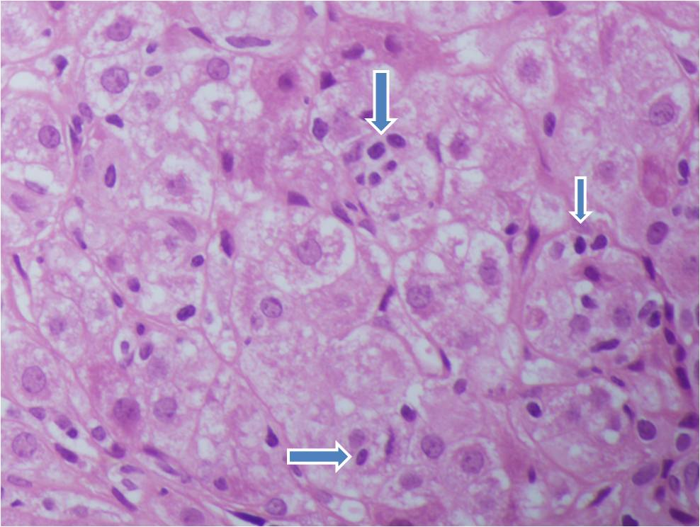

SDC-3- Spectrum of Extrahepatic Autoimmune Disorders (EHAD) in study population

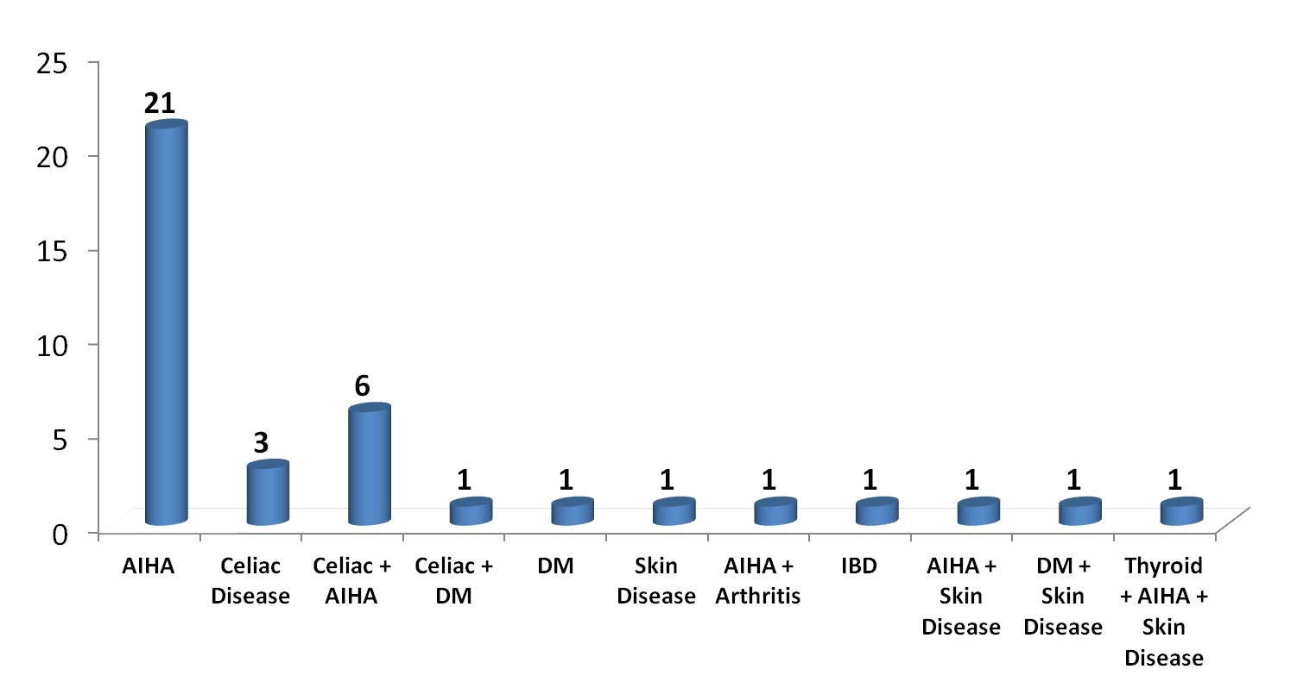
Abbreviations- AIHA- Autoimmune Hemolytic anemia, DM- Diabetes Mellitus, IBD- Inflammatory Bowel disease

SDC-4- Details of Extrahepatic Autoimmune Disorders (EHADs) in study population

Overall 38 (44.7 %), out of total 85 subjects, subjects had evidence of EHADs. Out of these 38 subjects, 27 (31.8 %) had only single EHAD while 11 (12.9 %) had combination of two (10 subjects) or three (1 subject) EHADs. The distribution of EHADs included (alone or in combination) is depicted in SDC-2. Family history of autoimmune disorders was positive in seen in 9 (10.5 %) subjects.
The most common EHAD was AIHA, seen in total 30 (35.3 %) subjects. Work up for CD (serum TTG levels and serum total IgA levels) was available in 69 (81.2 %) subjects. Out of these, 10 subjects had evidence of gluten induced enteropathy with 5 patients in classical disease group and 5 patients in potential disease group. Median titres of serum TTG were 102 RU/ml (range 84-551). Four of these had seronegative AILD, and all, except two, achieved remission at median duration of 9 months. Three patients (aged 4 year 4 months, 12 year 4 months, and 15 year 2 months at presentation) were diagnosed as having DM, with all three having presented as diabetic ketoacidosis (DKA) after 15 weeks, 13 weeks and 43 months after institution of immunosuppression, respectively. The immunosuppression, at the time of diagnosis of DKA, was prednisolone (dose 0.1 mg/kg/day) + azathioprine (dose 2.2 mg/kg/day) (first patient), azathioprine monotherapy (2 mg/kg/day) (second patient) and prednisolone (0.5 mg/kg/day) + azathioprine (2.0 mg/kg/day) (third patient). Insulin antibodies were not available in any of the three cases due to logistic issues, while c-peptide level, available only in the third patient, was within normal range. The first child also had associated potential celiac disease, while second child also had associated vitiligo. Overall, three patients had associated skin disease- 1 each with vitiligo, psoriasis and icthyosis, as per dermatology opinion. One patient had confirmed hypothyroidism with persistent high TSH levels, and positive results for both anti-thyroid peroxidase antibody and anti-thyroglobulin antibody.
When statistical analysis was done to compare clinical and laboratory features of AILD cases with (n=38) and without (n=47) associated EHADs, those with EHADs had higher proportion of patients having decompensated liver disease at presentation (Odd’s ratio 2.6, 95 % Confidence Interval/C.I 1.1 to 6.4, p-value 0.046), more severe anemia (mean difference -1.78, 95 % C.I -2.66 to -0.89, p-value < 0.001,) and hypoalbuminemia (mean difference -0.38, 95 % C.I -0.72 to -0.04, p-value 0.027), while there was no difference in clinical features, treatment outcomes and other indices of hepatic function [SDC-4]. Subgroup analysis of similar parameters, when done in AILD cases with (n=10) or without (n=59) celiac disease (in those with available data), did not reveal any significant differences [data not shown]. Multivariate analysis was not attempted in view of limited study sample size.

SDC-5: Variables of significance on comparison of features of AILD cases with (n=38) and without (n=47) associated extra-hepatic autoimmune disorders (EHADs)

Parameter | AILD with EHADs (n=38) | AILD without EHADs (n=47) | Effect Size, 95 % CI*** | p-Value****
Presence of Decompensation at presentation* | 21 (55.3) | 15 (31.9) | 2.63, 1.1 to 6.4 | 0.046
Hemoglobin (g/dl)** | 9.1 (7.4-10.3) | 10.7 (9.4-12.1) | -1.77, -2.66 to -0.89 | < 0.001
Albumin (g/dl)** | 2.6 (2-2.9) | 3.0 (2.3-3.5) | -0.38, -0.72 to -0.04 | 0.027

*Data as number (percentage), ** Data as Median (25th-75th percentile), ***Mean difference/95 % CI for comparison of means and OR/95 % CI for comparison of proportions, **** p-value < 0.05 as significant

Abbreviations: AILD- Autoimmune liver disease, OR- Odd’s Ratio, CI- Confidence interval

SDC-6- Details of Treatment given and Outcomes in study population
In AIH cases, 9 (14.3 %) subjects required institution of second line therapy. Indications of these included presence of cytopenia (leucopenia < 4000 per cumm and/or thrombocytopenia < 50,000 per cumm) in 5 subjects, poor medical response to first line therapy in 3 subjects and both in 1 subject. Four (6.3 %) subjects required institution of third line therapy (tacrolimus in all 4 and then tacrolimus to sirolimus conversion in 1). Two patients (both with < F4 fibrosis) in AIH group were shifted from prednisolone to budesonide therapy (3 mg twice a day) due to severe side effects (bilateral cataract and cushingoid facies). In the ASC group, 4 subjects required second line therapy due to severe cytopenias (3 subjects) and poor medical response (1 subject). Seventy percent of total cohort (i.e 60 out of 85) suffered from drug related side effects though mild only in majority. Most common side effect was cushingoid facies (in 54 subjects), while severe side effects included cataract (n=8), cytopenia (n=8), impaired glucose tolerance (n=2) and hypertension (n=1) amongst others.
Out of the total 70 patients with AIH, 5 patients were lost to follow up after initial evaluation and diagnosis. Two patients (aged 5 and 12 years), both presenting as ALF, underwent living related liver transplantation (LDLT). Out of these 2 patients, first child is doing well 58 weeks after transplantation with normal graft status and uneventful post transplant period except one episode of asymptomatic cytomegalovirus re-activation which was medically controlled. The second child expired on Day 39 after LT secondary to refractory sepsis (culture proven Klebsiella and Mucormycosis infection). Out of the remaining 63 subjects, at a median follow up of 16 months (Interquartile Range or IQR i.e 25th-75th percentiles of 7-38.5 months), 55 children (78.6 %) achieved remission, while 7 (10 %) did not achieve remission but improved medically (remaining 1 child died without achieving remission, as described later). Six children died over the study period, including 4 children who achieved initial remission and 1 child who died after LT (described earlier). Of these 6 children, 2 children (both females), aged 8 years and 10.5 years at diagnosis, having achieved remission at 12 weeks and 9 weeks respectively died 24 months after initial presentation. Both had history of repeated poor drug compliance and developed progressive hepatic deterioration after stoppage of immunosuppression and expired later due to superimposed septic illness. The third child, aged 15 years at presentation, expired 11 months after initial presentation, due to myocarditis and subsequent refractory shock (suspected viral illness), after having achieved remission within 16 weeks. He was in continued remission when he suffered fatal acute illness. The fourth child, aged 14 years at presentation, presented as decompensated CLD, and failed to show any improvement after institution of immunosuppression. She was listed for LT, but developed bone marrow proven hemophagocytosis syndrome along with progressive hepatic dysfunction (refractory ascites, variceal bleed and encephalopathy), and expired 3 months after presentation. The fifth child, aged 11 years, presented as ACLF (with superimposed hepatitis A infection), and similarly showed initial response to immunosuppression (had remission), but later expired due to septic shock (candidal sepsis) 2 months after presentation. Also, 2 more patients were later listed for LT, in view of worsening hepatic dysfunction (with decompensation, despite initial remission) due to repeated disease flares secondary to poor drug compliance. In seronegative cases, as in the seropositive group, there were similar high remission rates with good treatment outcomes [as highlighted in SDC-8]. Thus, out of the overall cohort (n = 70), good outcome (survival with native liver with medically controllable disease), at last follow up, was seen in 56 subjects (80 %) while poor outcome (death and/or, underwent or listed for LT) was seen in 9 (12.9 %) subjects, with rest 5 (7.1 %) being lost to follow up.
In subjects with ASC, at a median follow up of 9 months (IQR 3.5 – 24 months), 9 children (60 %) achieved remission, while 3 (20 %) did not achieve remission but improved medically. One subject died, 3 months after presentation, due to superimposed sepsis while on immunosuppression, while 2 subjects were listed for LT in view of worsening hepatic functions despite medical management. Thus, out of the overall cohort (n = 15), good outcome (survival with native liver with medically controllable disease), at last follow up, was seen in 12 subjects (80 %) while poor outcome (death and/or, listed for LT) was seen in 3 (20 %) subjects.

SDC-7: Variables with significance on comparison of AIH versus ASC group
Parameter | AIH (n= 70) | ASC (n= 15) | Effect Size, 95 % CI** | p-value***
Age at diagnosis (Years)* | 9.6 [7.0 – 12.5] | 14 [9.5 – 16.3] | -2.5, -4.9 to -0.2 | 0.033
Platelet count* | 115,000 [81750 – 250500] | 74000[50,000 – 162000] | 69364, 22779 to 115950 | 0.005
AST (IU/L)* | 267.5 [149.8 – 573.3] | 124 [89 – 294] | 290.9, 133.9 to 448.1 | < 0.001
ALT (IU/L)* | 187.5 [95.8 – 452.8] | 107 [60 – 123] | 272.3, 159.4 to 385.2 | < 0.001
Simplified diagnostic criteria* | 7 | 6 | 0.7, 0.1 to 1.2 | 0.018
Pre-Treatment Original criteria* | 17 | 14 | 3.0, 1.3 to 4.8 | 0.001
Post-Treatment Original criteria* | 20 | 17 | 2.9, 0.8 to 5.1 | 0.010
New AILD Score* | 8 | 7 | 0.9, -0.6 to 2.6 | 0.219
Liver Biopsy findings****:  - Bile Ductular Reaction  - Bile Duct Injury  - Bile Duct Loss  - Bridging Necrosis  - Cholestasis  - Pseudorosette  - Parenchymal collapse | 45 (64.3 %)  9 (12.9 %)  0  17 (24.3 %)  29 (41.4 %)  55 (78.6 %)  25 (35.7 %) | 15 (100 %)  15 (100 %)  6 (40 %)  0  15 (100 %)  3 (20 %)  1 (6.7 %) | 0.8, 0.6 to 0.9  12.2, 3.8 to 39.1  8.8, 4.7 to 16.2  1.3, 1.1 to 1.5  13.7, 1.9 to 99.4  14.7, 3.7 to 58.8  7.8, 0.9 to 62.7 | 0.004  < 0.001  < 0.001  0.034  < 0.001  < 0.001  0.031
* Data as Median (25th-75th percentile), ** Mean Difference/95 % CI for comparison of means and OR/95 % CI for comparison of proportions, *** p-value < 0.05 as significant, **** Data as n (%)

Abbreviations: AIH- Autoimmune hepatitis, ASC- Autoimmune sclerosing cholangitis, AILD- Autoimmune Liver Disease, ALT- Alanine Aminotransferase, AST- Aspartate Aminotransferase, OR- Odd’s Ratio, CI- Confidence interval

SDC-8: Comparison of features between seronegative and seropositive AIH subjects
Parameter | Seronegative AIH [n = 16] | Seropositive AIH [n = 54]
Age at onset (years)* | 7.6 [4.1 – 11.5] | 8.60 [5.7 – 10.9]
Age at diagnosis (years)* | 8.5 [6.3 – 12.7] | 9.7 [7.2 – 12.6]
Sex (M:F) | 1.7:1 | 0.8:1
Syndromic Diagnosis, n (%):  - Acute Hepatitis (AH)  - Chronic Hepatitis (CH)  - Acute Liver Failure (ALF)  - Compensated Chronic Liver Disease (CLD)  - Decompensated CLD  - Acute on Chronic Liver Failure (ACLF) | 1 (6.3 %)  3 (18.8 %)  2 (12.5 %)  4 (25.0 %)  6 (37.5 %)  0 | 10 (18.5 %)  0  3 (5.6 %)  19 (35.2 %)  13 (24 %)  9 (16.7 %)
Acute Presentation (AH + ALF + ACLF), n (%) | 3 (18.8 %) | 25 (46.3 %)
Advanced Fibrosis [> F4] at Presentation, n (%) | 10 (62.5 %) | 41 (75.9 %)
Jaundice as Presentation, n (%) | 16 (100 %) | 47 (87 %)
Presence of Portal Hypertension, n (%) | 11 (68.8 %) | 38 (70.4 %)
Decompensation at Presentation, n (%) | 6 (37.5 %) | 24 (44.4 %)
Extrahepatic Autoimmune Disorders, n (%) | 8 (50 %) | 23 (42.6 %)
Hemoglobin (g/dl)* | 10.35 [8.97 – 11.83] | 10.20 [8.4 – 11.7]
Total Leucocyte Count (/cumm)* | 7300 [4750 – 10250] | 7400 [5275 – 9750]
Platelet Count (/cumm)* | 100,000 [75250 - 206750] | 133000 [89000 – 265250]
Total Bilirubin (mg/dl)* | 4.1 [2.13 – 10.10] | 5.1 [1.9 – 13.2]
Direct Bilirubin (mg/dl)* | 1.90 [0.8 – 6.35] | 2.5 [0.8 – 6.9]
AST (IU/L)* | 288 [178 – 909] | 266 [133.5 – 573.3]
ALT (IU/L)* | 162 [89 – 1025] | 190.5 [97.2 – 376.5]
SAP (IU/L)* | 271.5 [186.5 – 457.25] | 292 [204.3 – 417]
GGTP (IU/L)* | 50 [25.75 – 87] | 41 [29.5 – 66.5]
Albumin (g/dl)* | 2.6 [2.22 – 3.6] | 2.7 [2.2 – 3.3]
INR* | 1.55 [1.3 – 2.0] | 1.7 [1.3 – 2.2]
Total IgG (g/L)* | 26 [17.6 – 35.3] | 24.4 [19.8 – 31.7]
ESR (mm/1st hour)*,** | 19 [11 – 48] | 27 [15 – 46]
Liver Stiffness (K Pa)*,*** | 18.2 [10.7 – 54.5] | 27.9 [19.9 – 38.9]
CTP Score* | 8 [6 - 9] | 9 [7 – 11]
PELD/MELD Score* | 12 [8 – 15.5] | 15.5 [9 – 21]
Remission, n (%)  - Yes  - No  - Not Applicable (LT or No Follow up) | 13 (81.3 %)  1 (6.3 %)  2 (12.5 %) | 45 (83.3 %)  4 (7.4 %)  5 (9.3 %)

*Data as Median (Interquartile Range/IQR 25th to 75th percentile), **Available in 15 and 50 subjects respectively, ***Available in 13 and 42 subjects respectively

Abbreviations: AIH- Autoimmune hepatitis, ASC- Autoimmune sclerosing cholangitis, ALT- Alanine Aminotransferase, AST- Aspartate Aminotransferase, INR- International normalised ratio, LT- Liver transplantation, SAP- Serum alkaline phosphatase, GGTP- Gamma glutamyl transpeptidase, ESR- Erythrocyte sedimentation rate, CTP- Child Turcott Pugh, MELD- Model for end-stage liver disease, PELD- Pediatric end-stage liver disease

SDC-9: Baseline characteristics of AILD and Non AILD subjects
Parameter | AILD (n = 85) | Non AILD (n = 85) | Effect Size, 95 % CI** | p-value***
Age* | 9.9 [7.5 – 14] | 11.7 [8 – 15] | -0.9, -2.2 to 0.3 | 0.132
Sex (M:F) | 1.07:1 | 2.15:1 | 0.5,0.3 to 0.9 | 0.041
Laboratory Parameters*  - Total Bilirubin (mg/dl)  - AST (IU/L)  - ALT (IU/L)  - GGTP (IU/L)  - Albumin (g/dl)  - INR  - PELD/MELD | 5.4 [2.2 – 11.30]  260 [125 – 452]  138 [87 – 353]  44 [30 – 69]  2.6 [2.15 – 3.30]  1.7 [1.3 – 2.1]  15 [8 – 21] | 2.4 [1.1 – 7.9]  105 [55 – 184]  66 [35 – 133]  51 [25 – 76]  2.8 [2.0 – 3.5]  1.4 [1.2 – 2.0]  13 [6 - 22] | 1.4, -1.5 to 4.3  233.9, 101.6 to 366.2  190.3, 81.3 to 299.2  -7.1, -33.2 to 19.1  -0.1, -0.3 to 0.2  -0.01, -0.3 to 0.3  1.1, -2.2 to 4.4 | 0.344  0.001  0.001  0.595  0.459  0.934  0.503

*Data as Median (Interquartile Range/IQR 25th to 75th percentile), ** Mean Difference/95 % CI for comparison of means and OR/95 % CI for comparison of proportions, *** p-value < 0.05 as significant

Abbreviations: AILD- Autoimmune Liver Disease, ALT- Alanine Aminotransferase, AST- Aspartate Aminotransferase, INR- International normalised ratio, GGTP- Gamma glutamyl transpeptidase, MELD- Model for end-stage liver disease score, PELD- Pediatric end-stage liver disease score, OR- Odd’s Ratio, CI- Confidence interval

SDC-10: Comparison of receiver operating characteristic (ROC) curves of simplified (year 2008) score, original (year 1999, pre-treatment) score and new proposed (year 2017) score [For overall cohort, i.e, 85 AILD subjects, and 85 Non-AILD Control subjects]
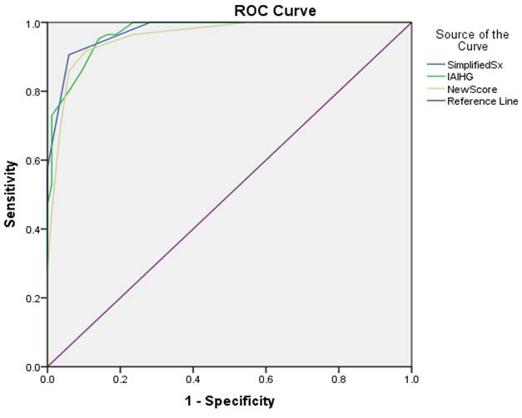
Abbreviations: AILD- Autoimmune Liver Disease

SDC-11: Comparison of the three diagnostic scores: Original (year 1999, pre-treatment) score, Simplified (year 2008) score, and New proposed (year 2017) score [For only total AIH subjects, after excluding ASC cases]

Score | Sensitivity | Specificity | Positive Predictive Value | Negative Predictive Value | Correctly Classified | AUROC  (95 % C.I)
Original score  (Cut off > 10) | 81 % | 97.2 % | 97.1 % | 81.2 % | 88.4 % | 0.979 (0.962 – 0.996)
Original score  (Cut off > 15) | 98.1 % | 81.6 % | 72.9 % | 98.8 % | 87.1 %
Simplified score  (Cut off > 6 ) | 93 % | 95.2 % | 94.3 % | 94.1 % | 94.2 % | 0.981 (0.964 – 0.997)
Simplified score  (Cut off > 7) | 100 % | 75.9 % | 61.4 % | 100 % | 82.6 %
New proposed score  (Cut off > 7) | 92.9 % | 94.1 % | 92.9 % | 94.1 % | 93.5 % | 0.976 (0.954 – 0.998)
New proposed score  (Cut off > 8) | 94.4 % | 81.2 % | 72.9 % | 96.5 % | 85.8 %

Abbreviations: AUROC- Area under receiver operating characteristic curve, CI- Confidence interval

SDC-12: Comparison of receiver operating characteristic (ROC) curves of simplified (year 2008) score, original (year 1999, pre-treatment) score and new proposed (year 2017) score [For only total AIH subjects, after excluding ASC cases]

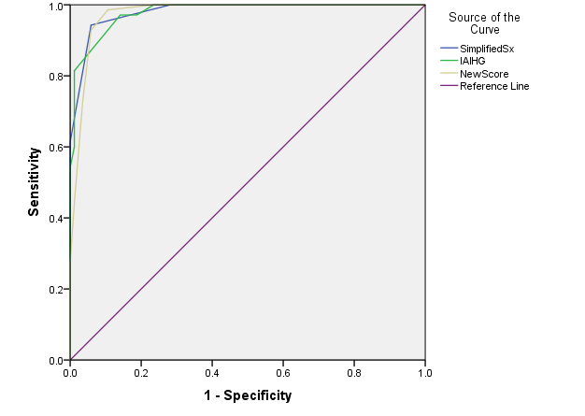
Abbreviations: AIH- Autoimmune hepatitis, ASC- Autoimmune sclerosing cholangitis

References
- Balitzer D, Shafizadeh N, Peters MG, et al. Autoimmune hepatitis: review of histologic features included in the simplified criteria proposed by the international autoimmune hepatitis group and proposal for new histologic criteria. Mod Pathol. 2017;30(5):773-783.
- Tiniakos DG, Brain JG, Bury YA. Role of Histopathology in Autoimmune Hepatitis. Dig Dis. 2015;33 Suppl 2:53-64.
- Squires RH Jr, Shneider BL, Bucuvalas J, et al. Acute liver failure in children: the first 348 patients in the pediatric acute liver failure study group. J Pediatr. 2006;148:652-658.
- Ishak K, Baptista A, Bianchi L, et al. Histological grading and staging of chronic hepatitis.J Hepatol 1995;22:696-699.
- Sarin SK, Kedarisetty CK, Abbas Z, et al; APASL ACLF Working Party. Acute-on-chronic liver failure: consensus recommendations of the Asian Pacific Association for the Study of the Liver (APASL) 2014. Hepatol Int. 2014;8:453-71.
- Garcia-Tsao G, Sanyal AJ, Grace ND, et al; Practice Guidelines Committee of the American Association for the Study of Liver Diseases; Practice Parameters Committee of the American College of Gastroenterology. Prevention and management of gastroesophageal varices and variceal hemorrhage in cirrhosis.Hepatology. 2007 ;46(3):922-38.
- Sarin SK, Lahoti D, Saxena SP, et al. Prevalence, classification and natural history of gastric varices: a long-term follow-up study in 568 portal hypertension patients.Hepatology. 1992 ;16(6):1343-9.
- Ogilvie C, Evans CC. Splenomegaly. In: Ogilvie C, Evans CC, editors. Chamberlaine’s Symptoms and Signs in Clinical Medicine. 11th ed. London: Brucks, Butterworth/ELBS, 1987: 480-7.
- Soyupak S, Gunesli A, Seydaoğlu G, et al. Portal venous diameter in children: normal limits according to age, weight and height. Eur J Radiol. 2010;75(2):245-7.
- Husby S, Koletzko S, Korponay-Szabó IR, et al; ESPGHAN Working Group on Coeliac Disease Diagnosis; ESPGHAN Gastroenterology Committee; European Society for Pediatric Gastroenterology, Hepatology, and Nutrition. European Society for Pediatric Gastroenterology, Hepatology, and Nutrition guidelines for the diagnosis of celiac disease. J Pediatr Gastroenterol Nutr. 2012;54(1):136-60.
- ICMR Guideline on Diagnosis and Management of Celiac Disease. http://www.icmr.nic.in/guidelines/ICMR%20Guideline%20on%20Celiac%20Disease-Dec%202016.pdf. Accessed 2nd August 2017.
- American Diabetes Association. Diagnosis and classification of diabetes mellitus. Diabetes Care. 2014;37 Suppl 1:S81-90.
- Kalra S, Kalra B, Sharma A. Prevalence of type 1 diabetes mellitus in Karnal district, Haryana state, India. Diabetol Metab Syndr. 2010;2:14.

