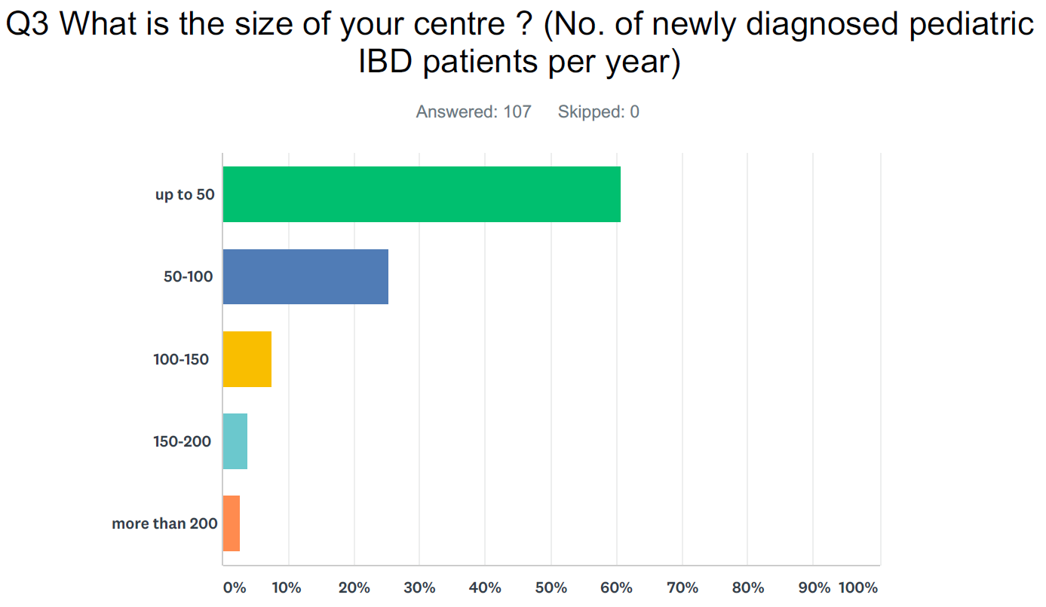

Part 1 - Diagnostic approach (Q27 - Q39)
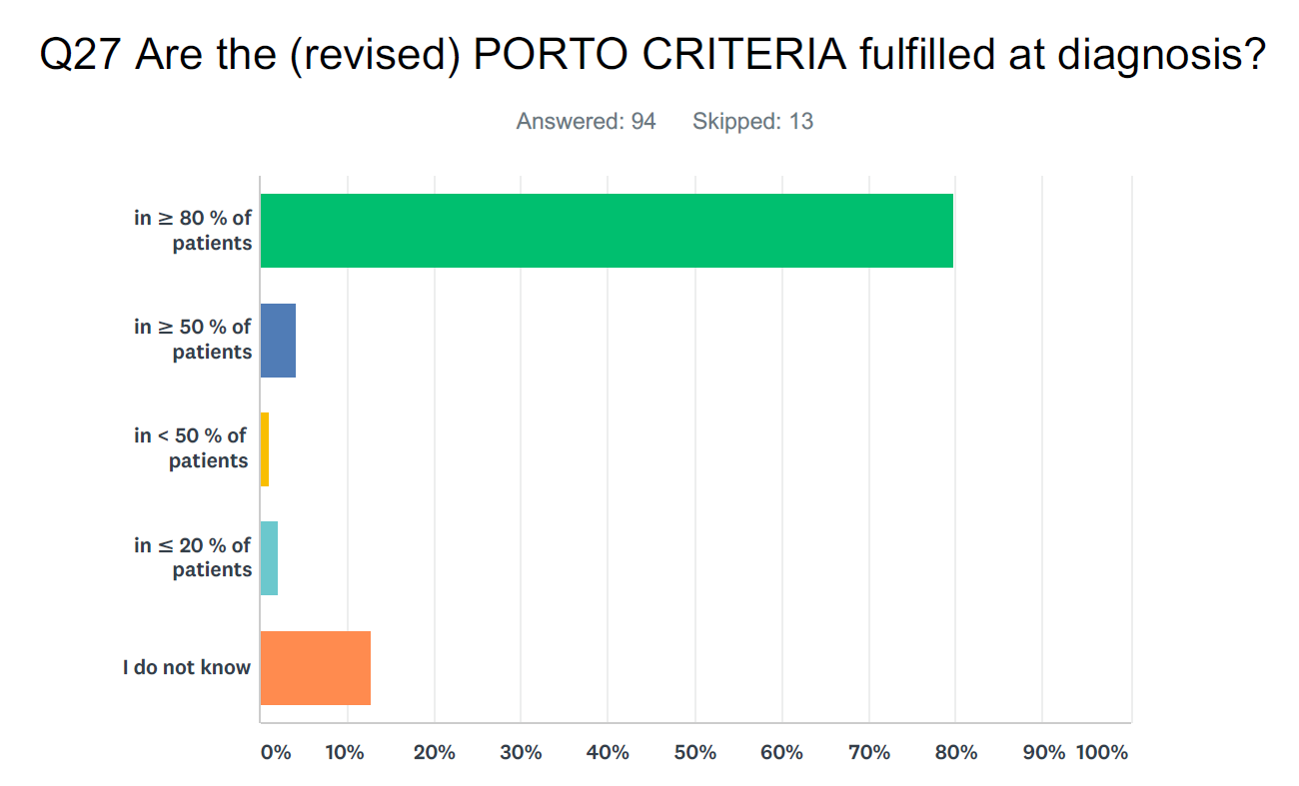
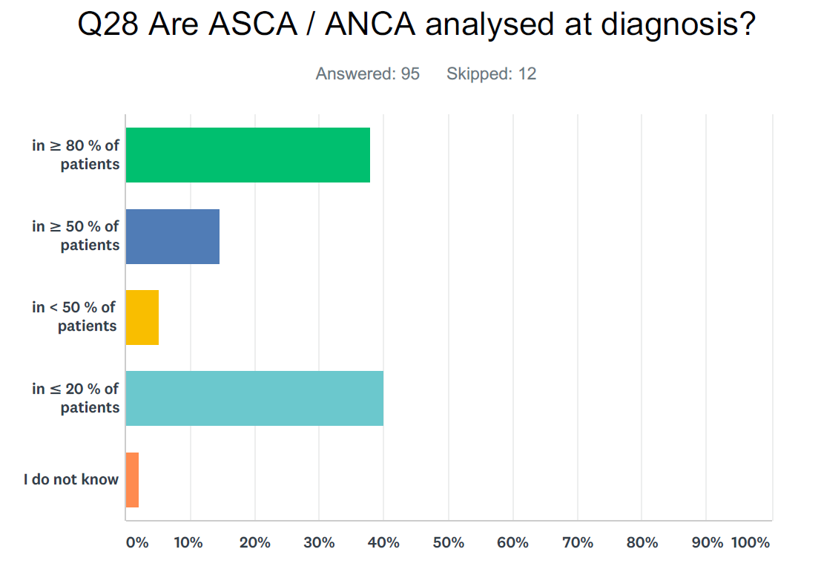

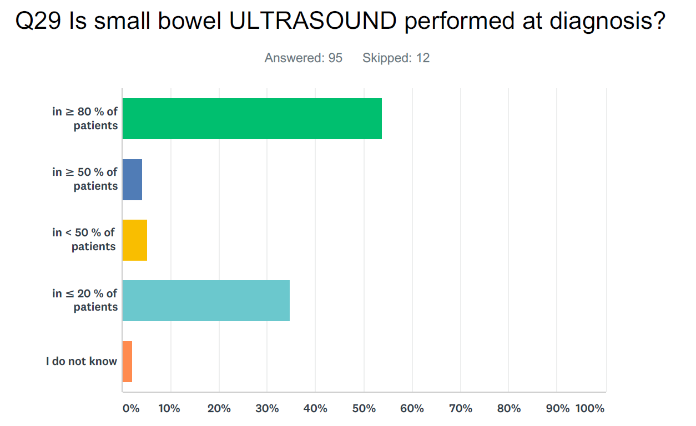

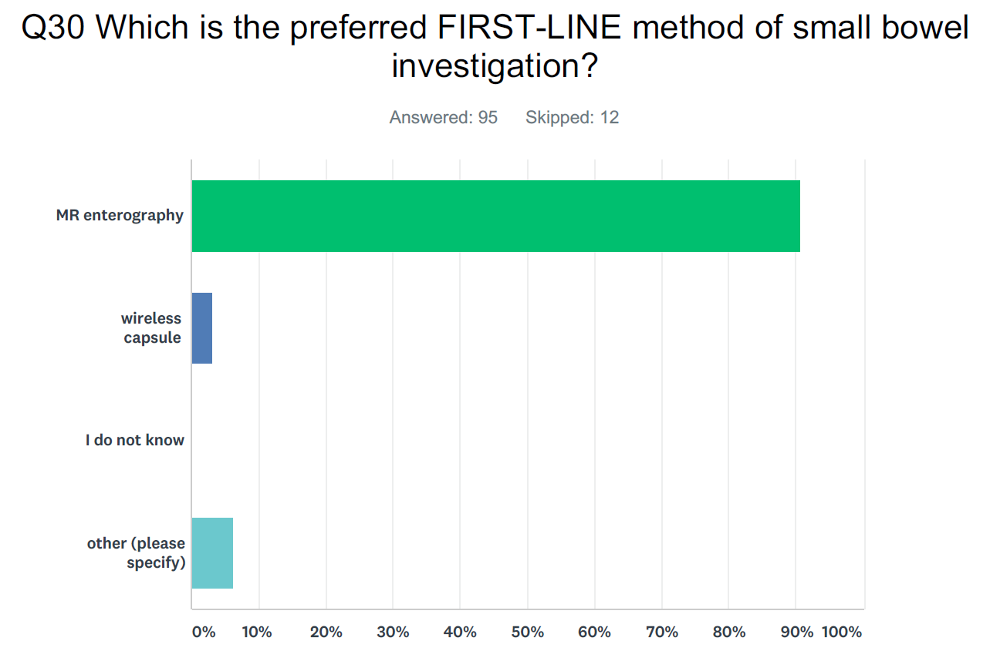
Other: small bowel series; ultrasound; either MRe or capsule

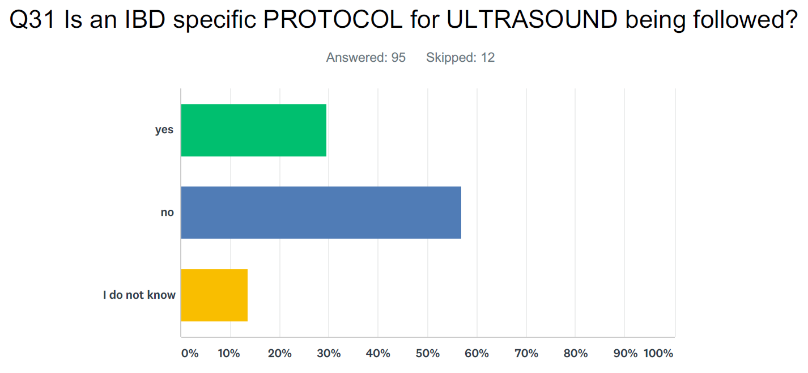
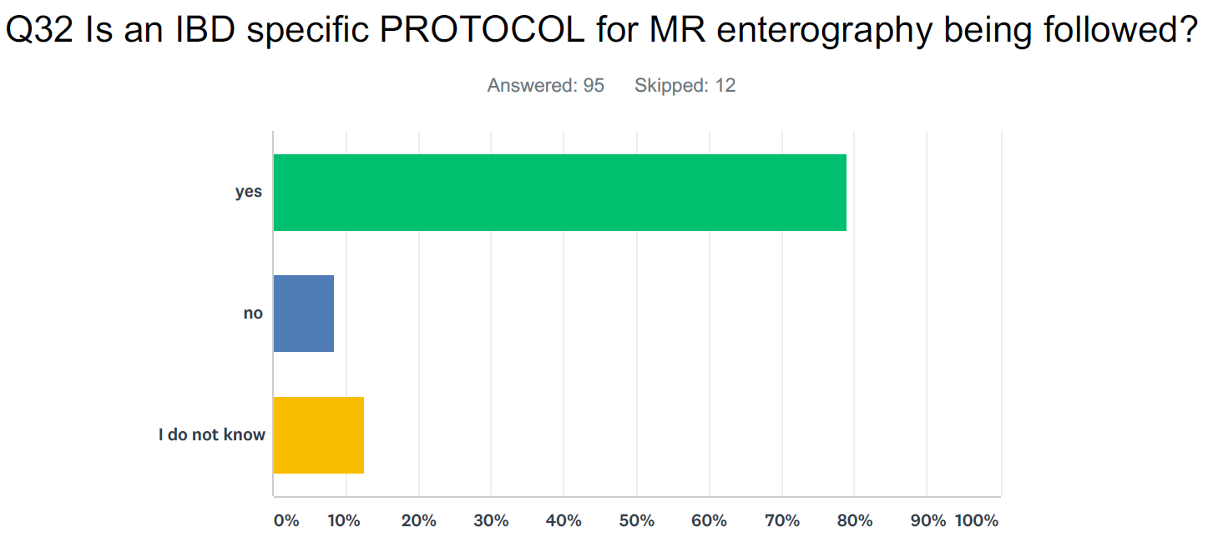

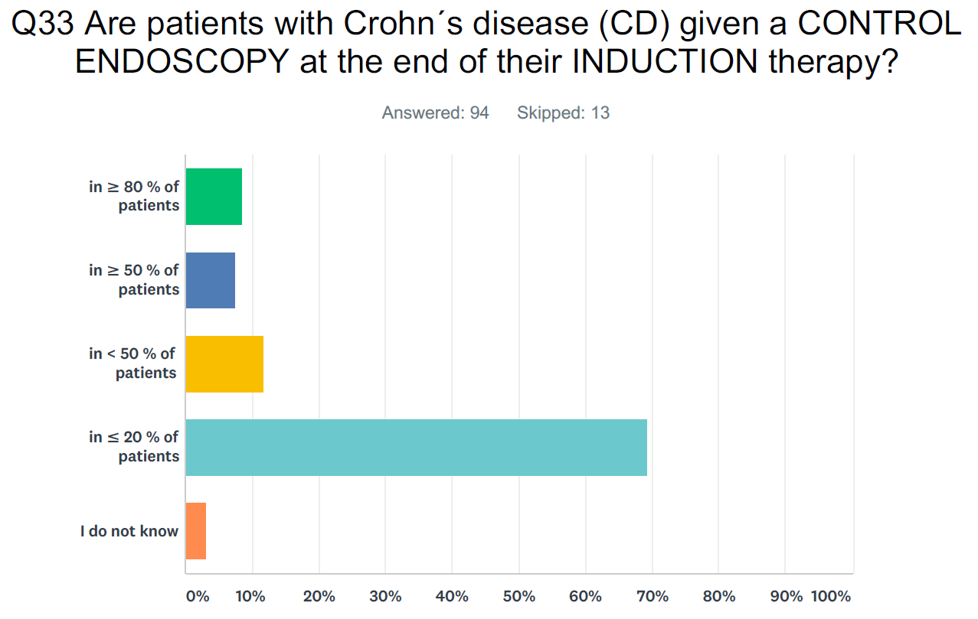
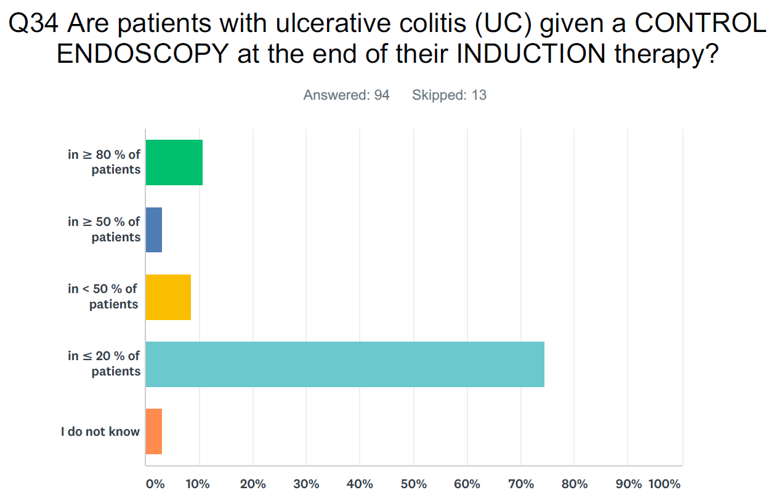

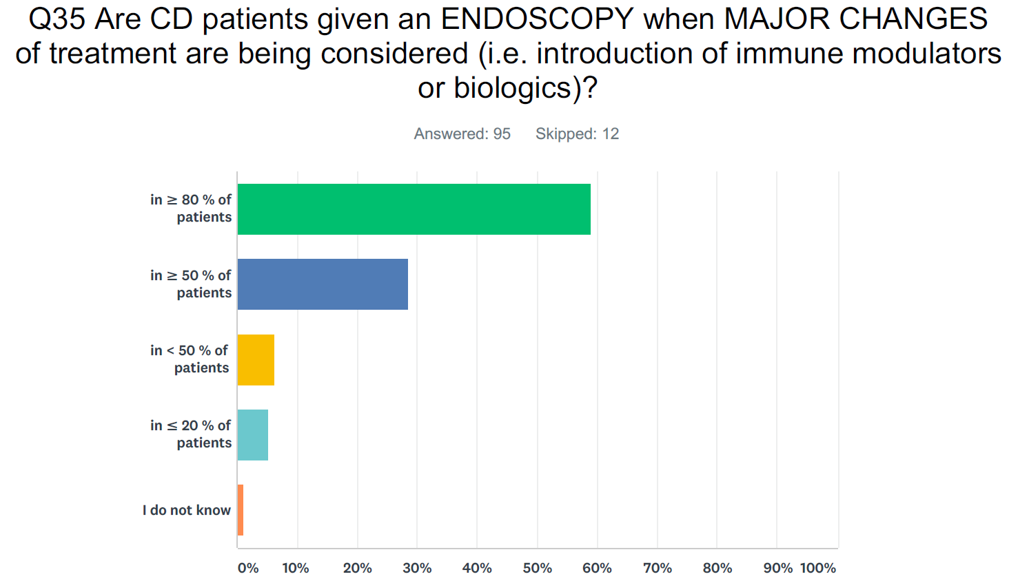
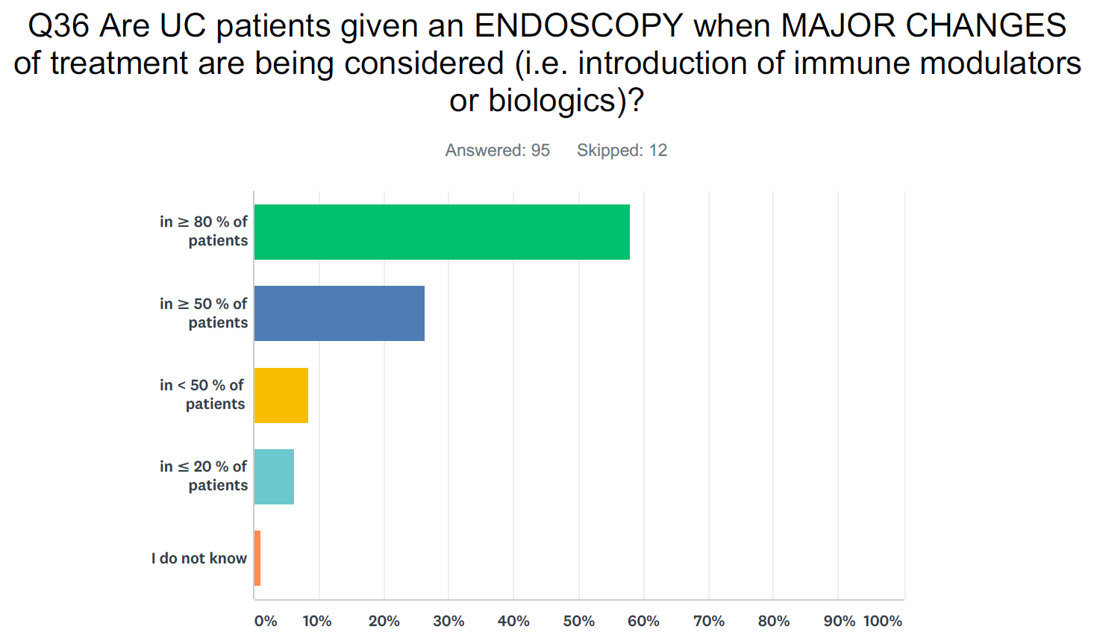

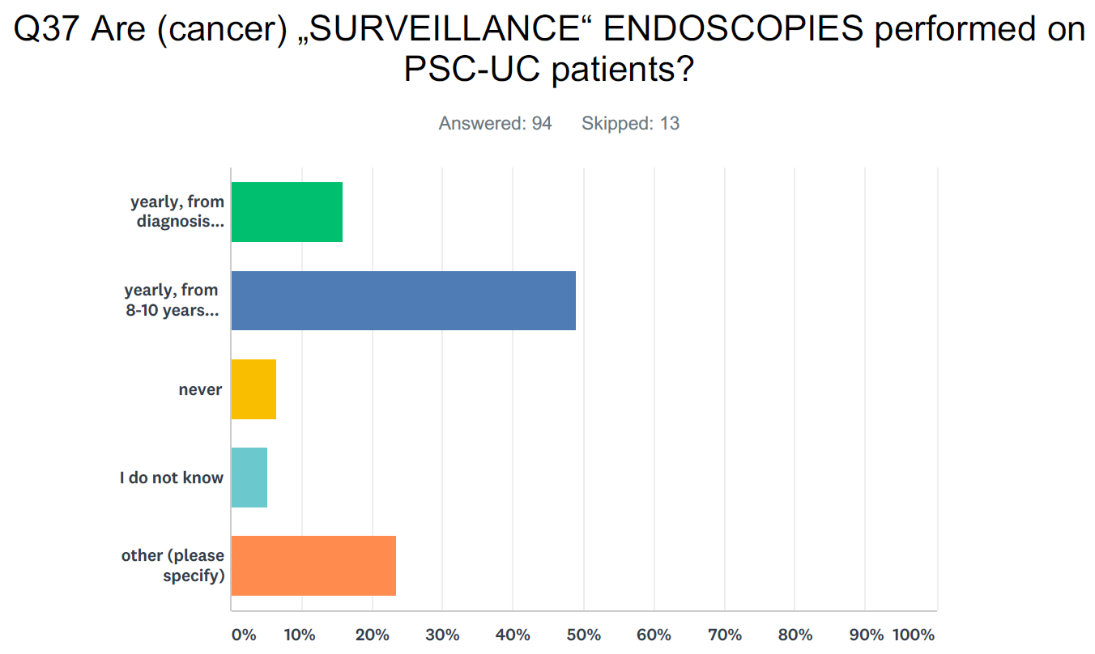
Other: not yearly; every 2-3 years; case by case; depending on age and the endoscopic activity; at transition
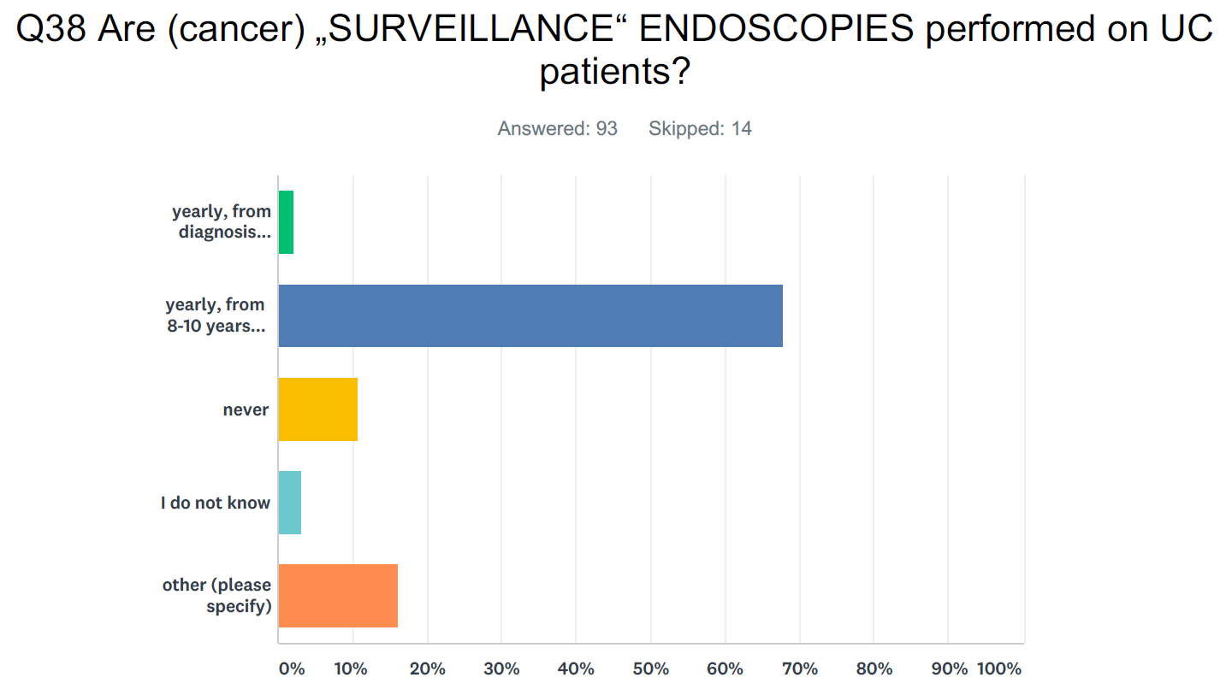
Other: not yearly; every 2-5 years; depending on disease activity and histological findings; at transition

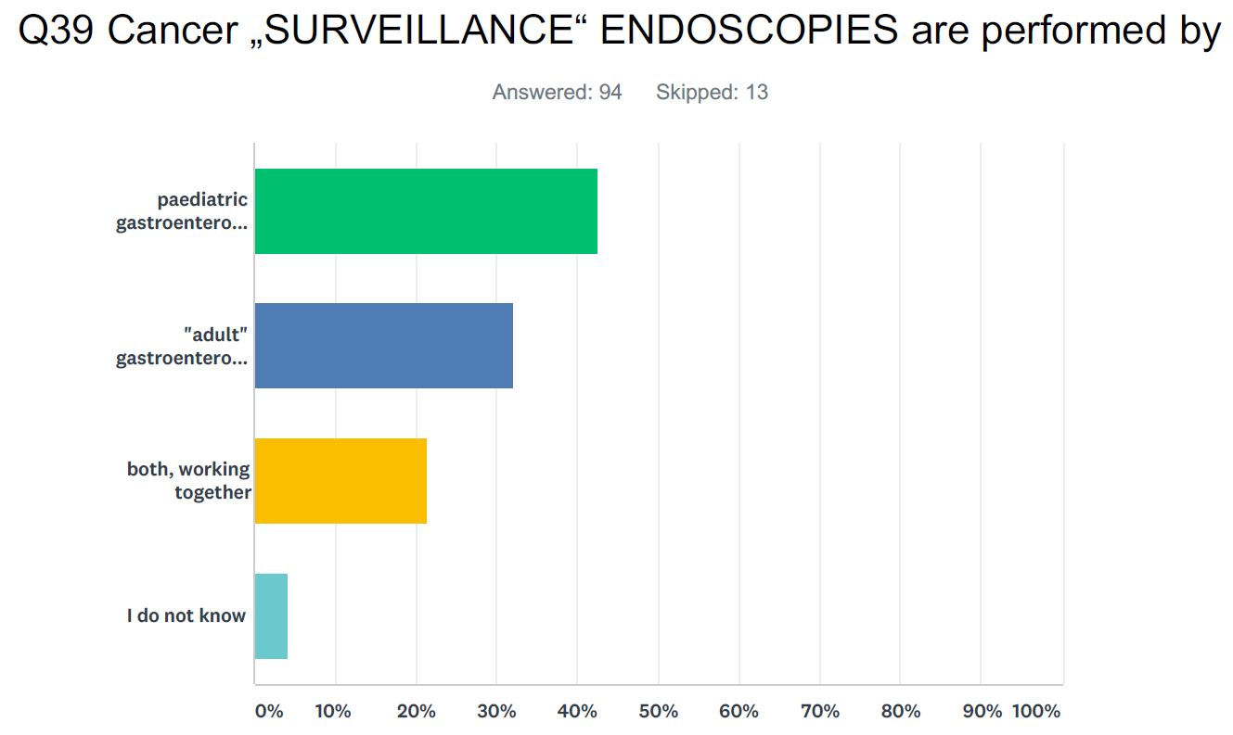

Part 2 - Therapeutic approach (Q40 - Q89)
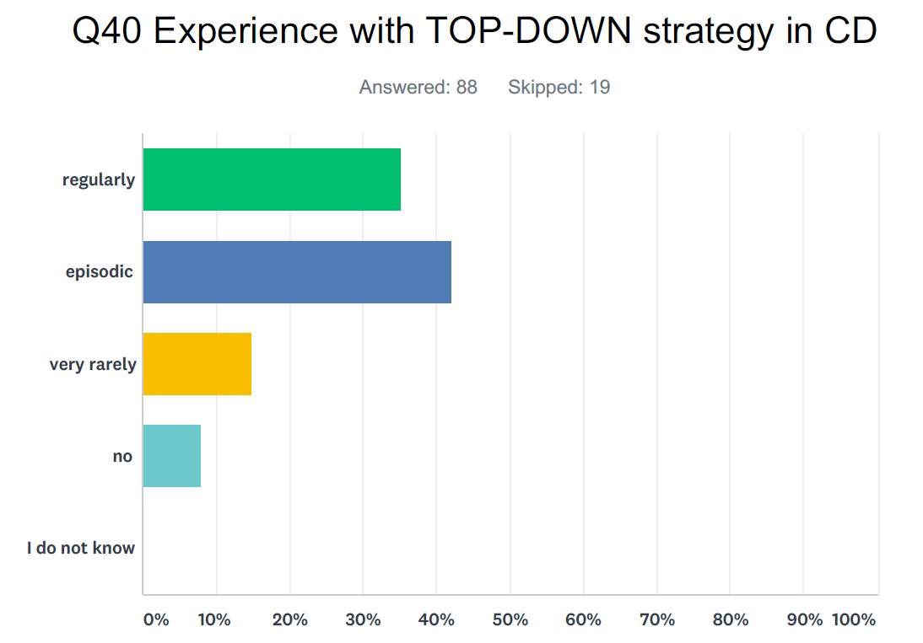

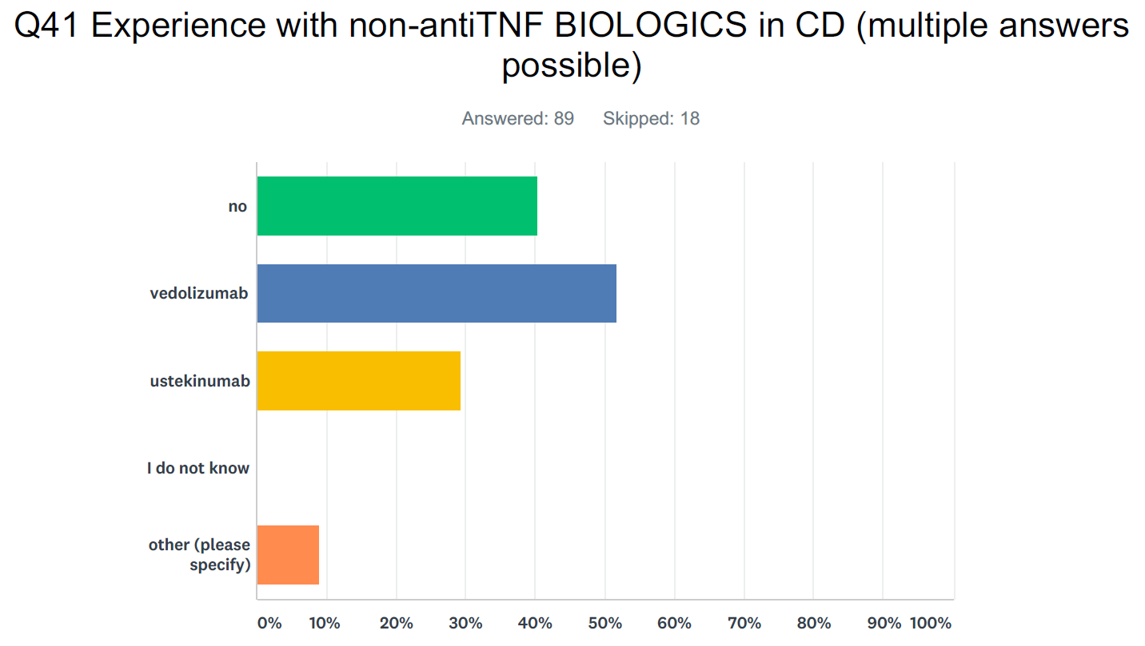
Other: not available in our country; tofacitinib; natalizumab; abatacept

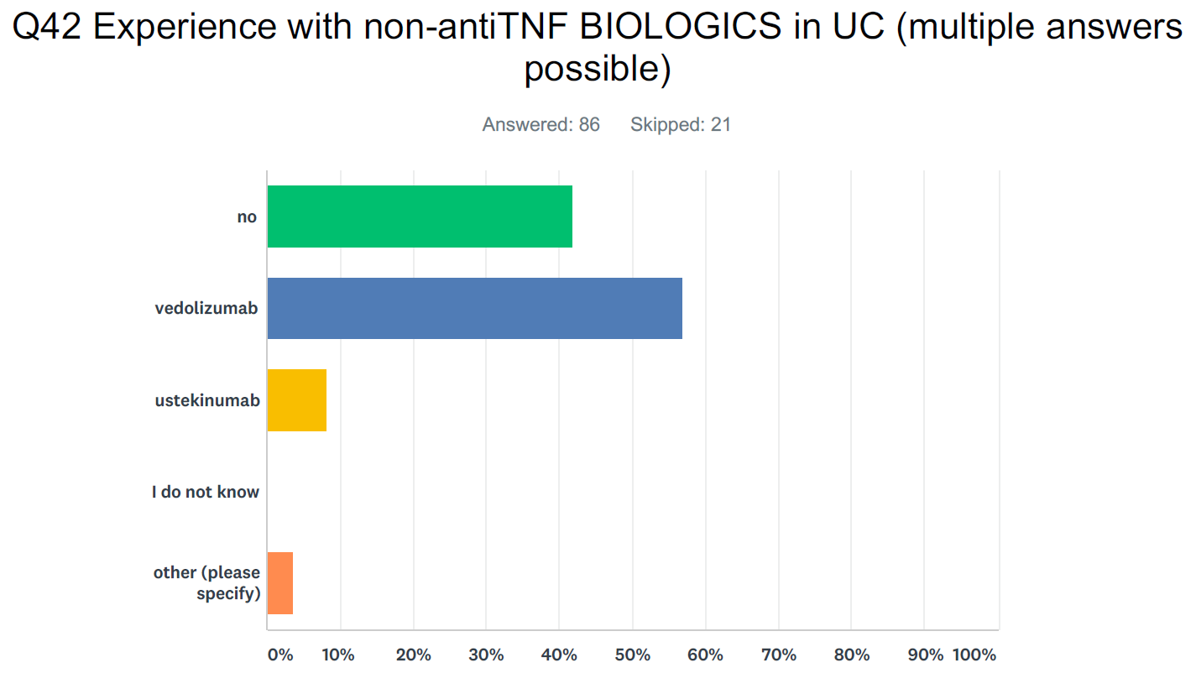
Other: as for CD

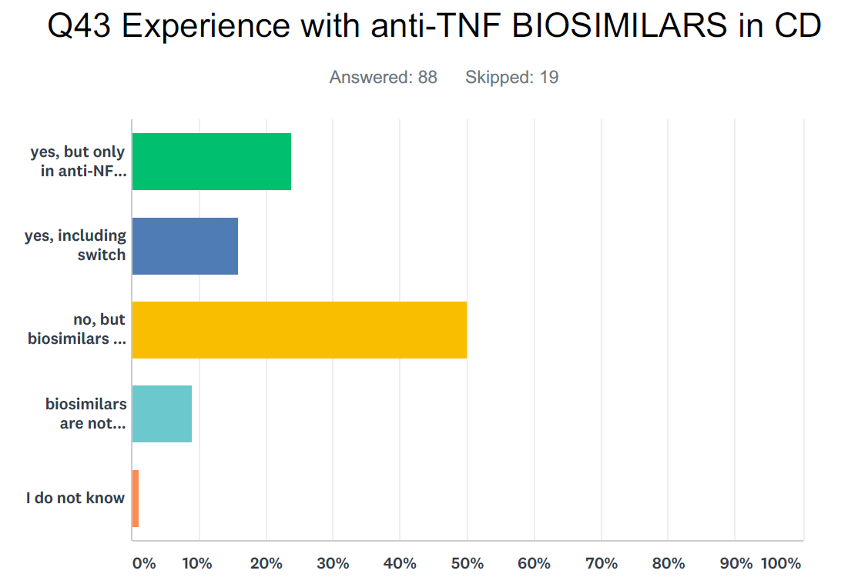
Legend (y axis from top): yes, but only in anti-TNF naiive; yes, including switch; not, but biosimilars are approved in my country; biosimilars are not approved in my country

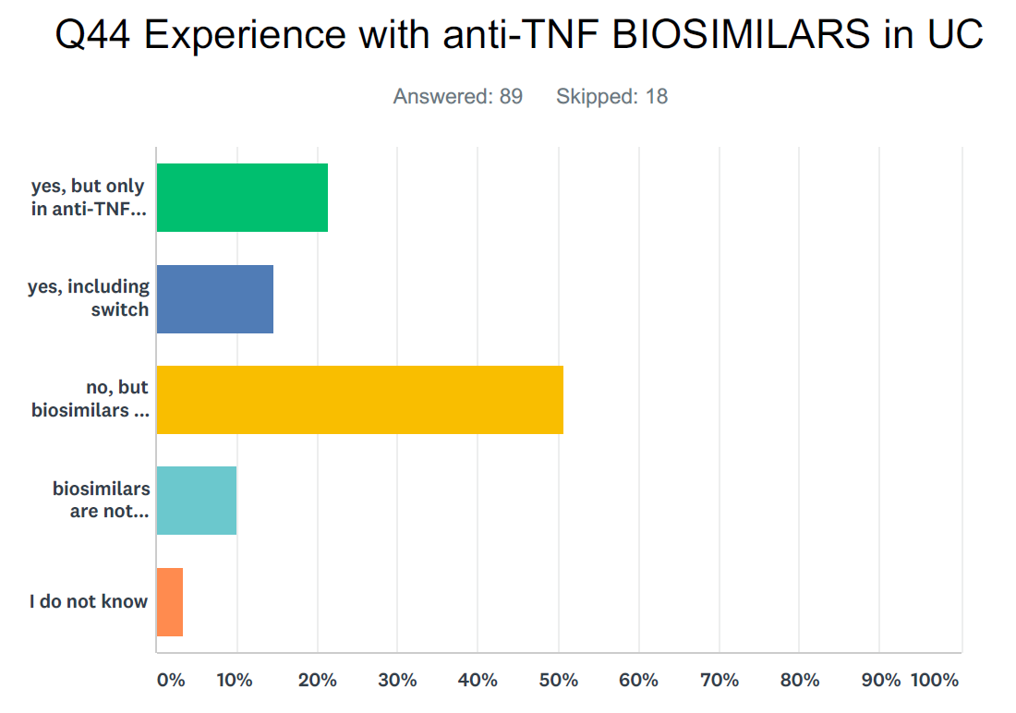
Legend (y axis from top): yes, but only in anti-TNF naiive; yes, including switch; not, but biosimilars are approved in my country; biosimilars are not approved in my country

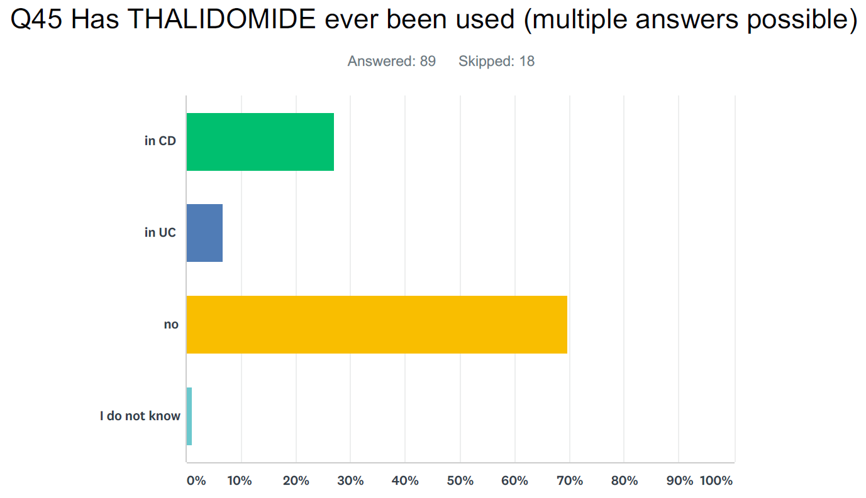

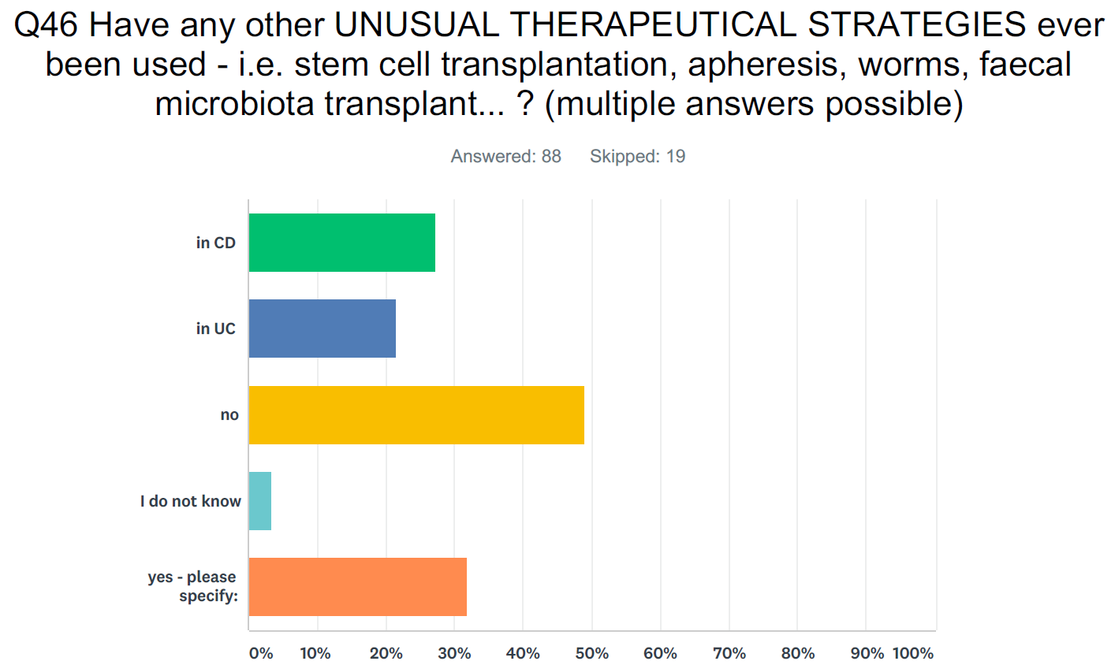
Comments: stem cell transplant; faecal transplant; immunotherapy; leukocyte apheresis; boswellia; worms; antibiotics; tacrolimus

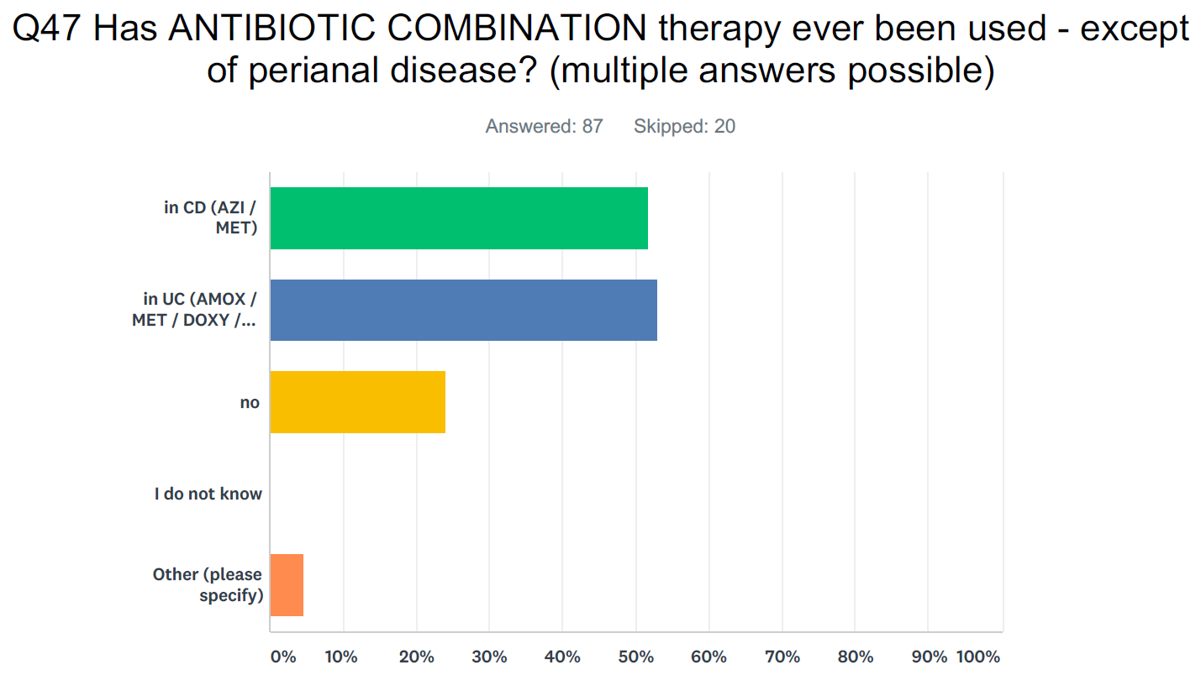
No relevant comments under "other"

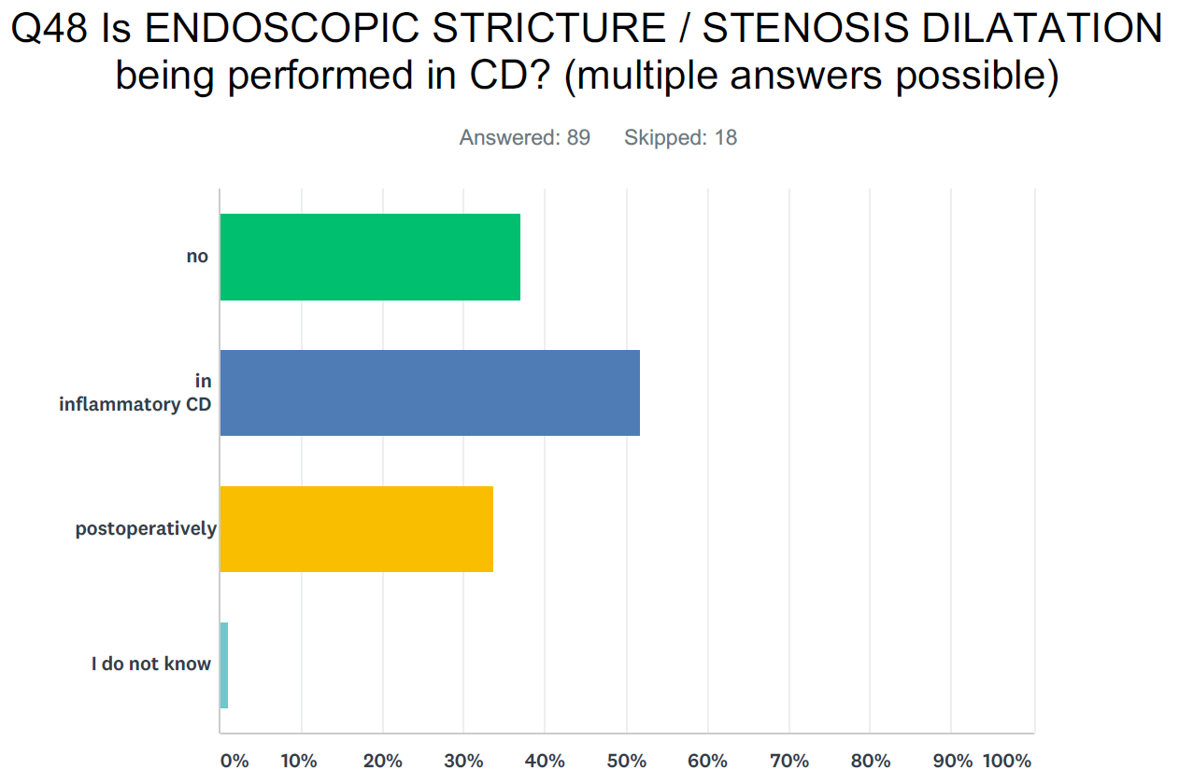

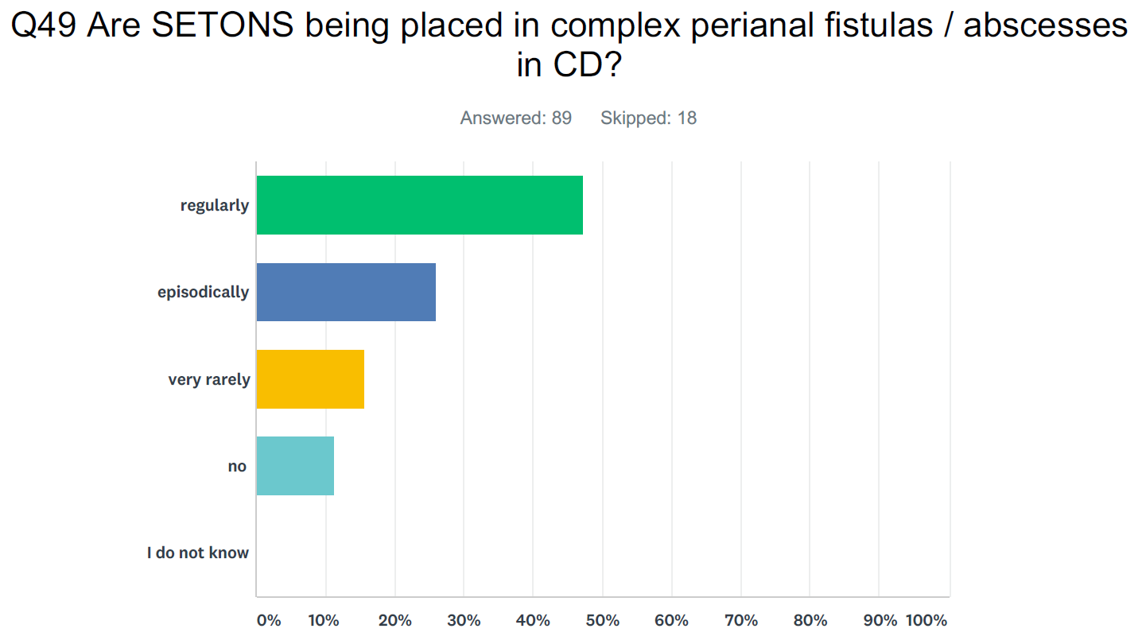

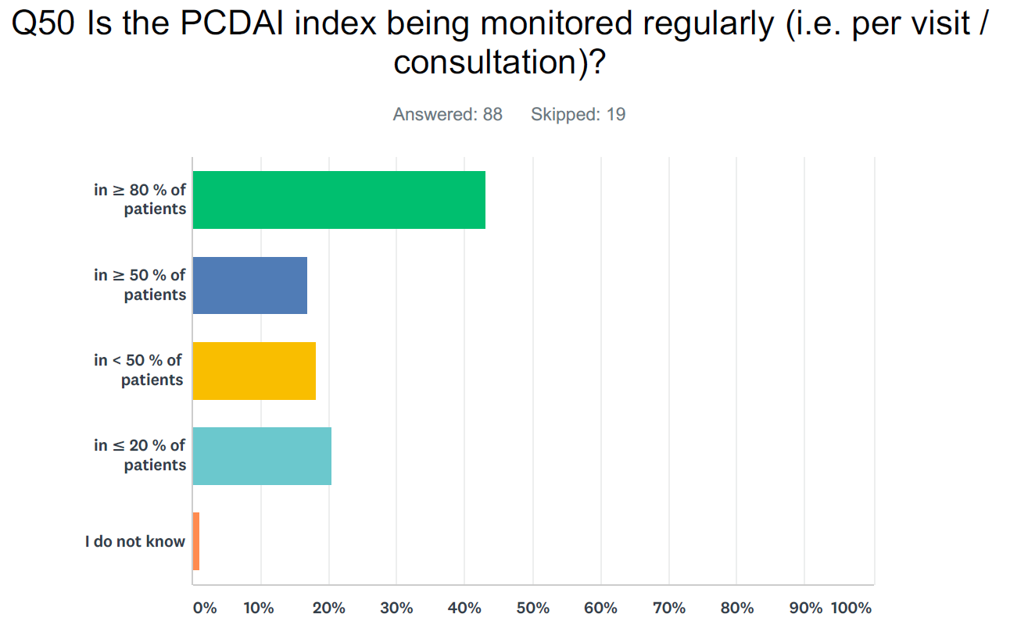

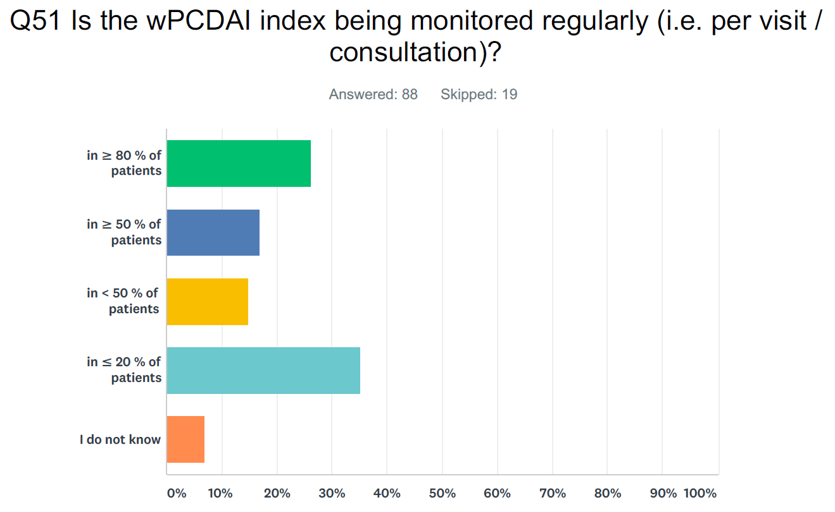

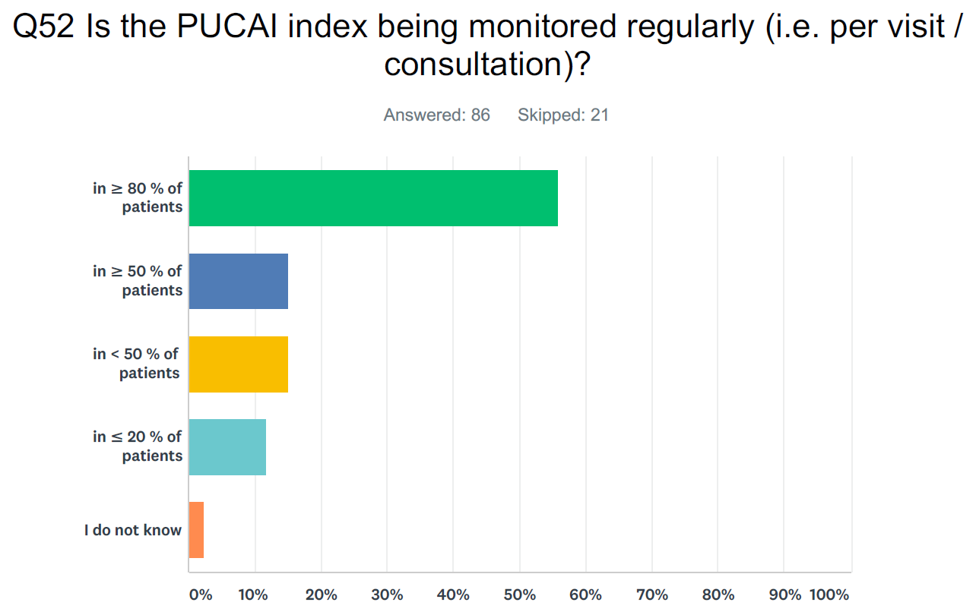

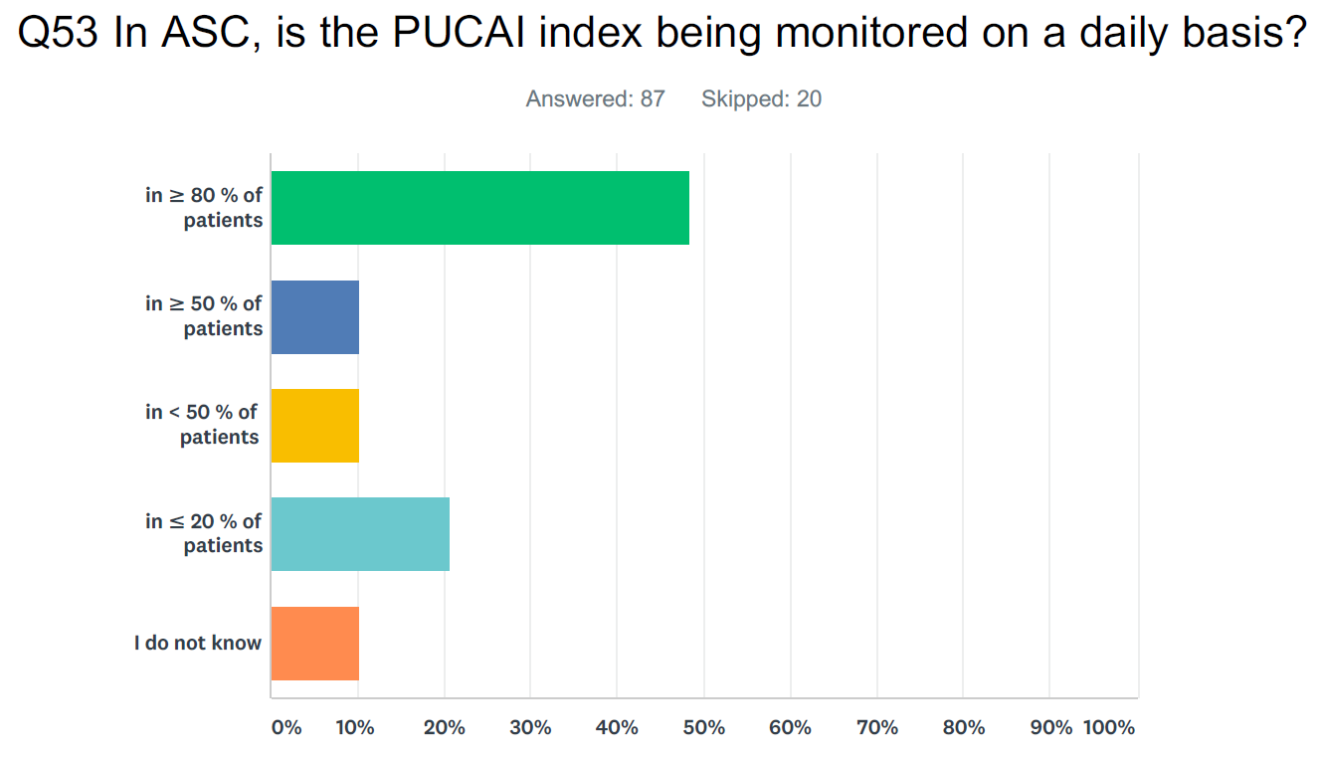

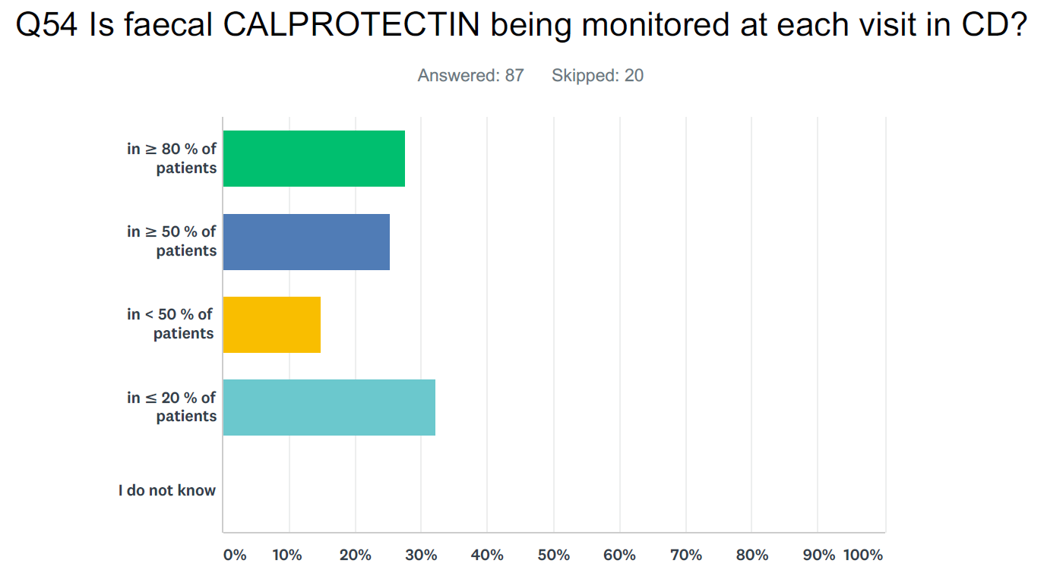

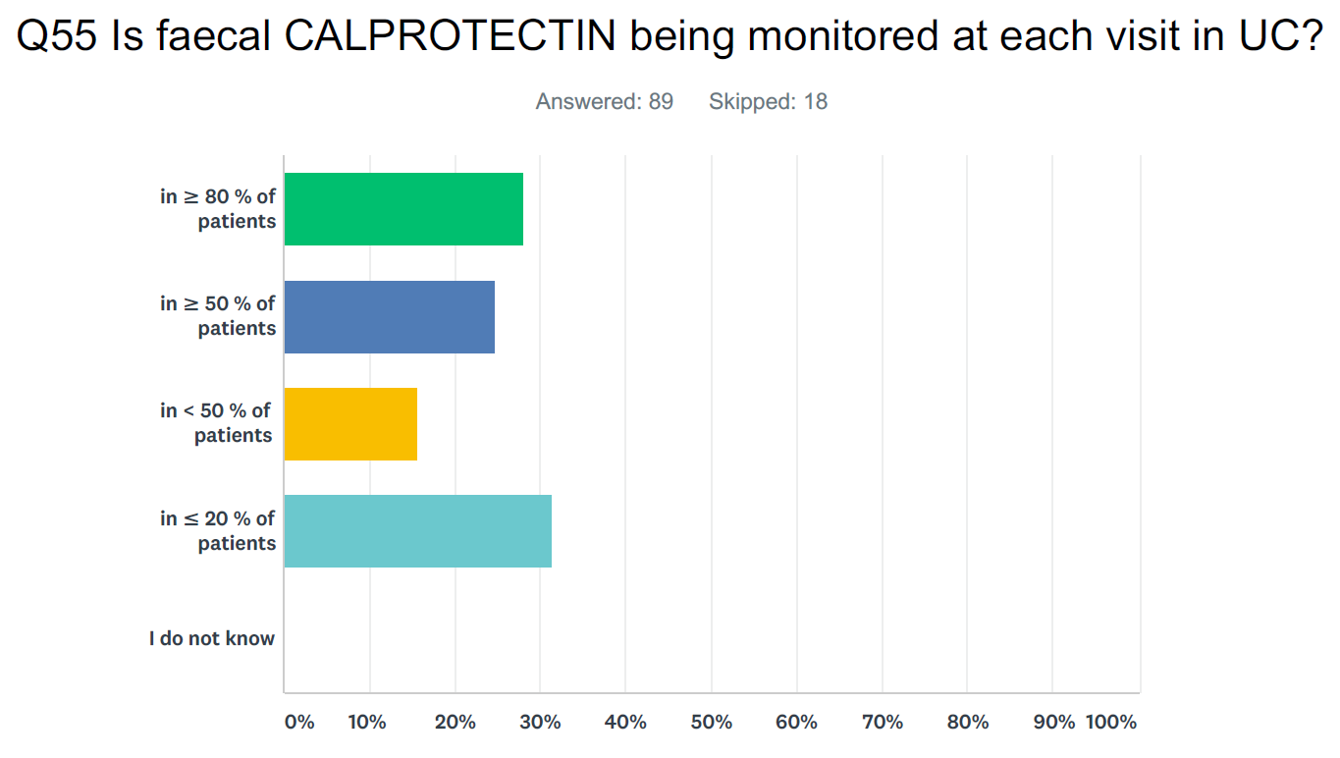

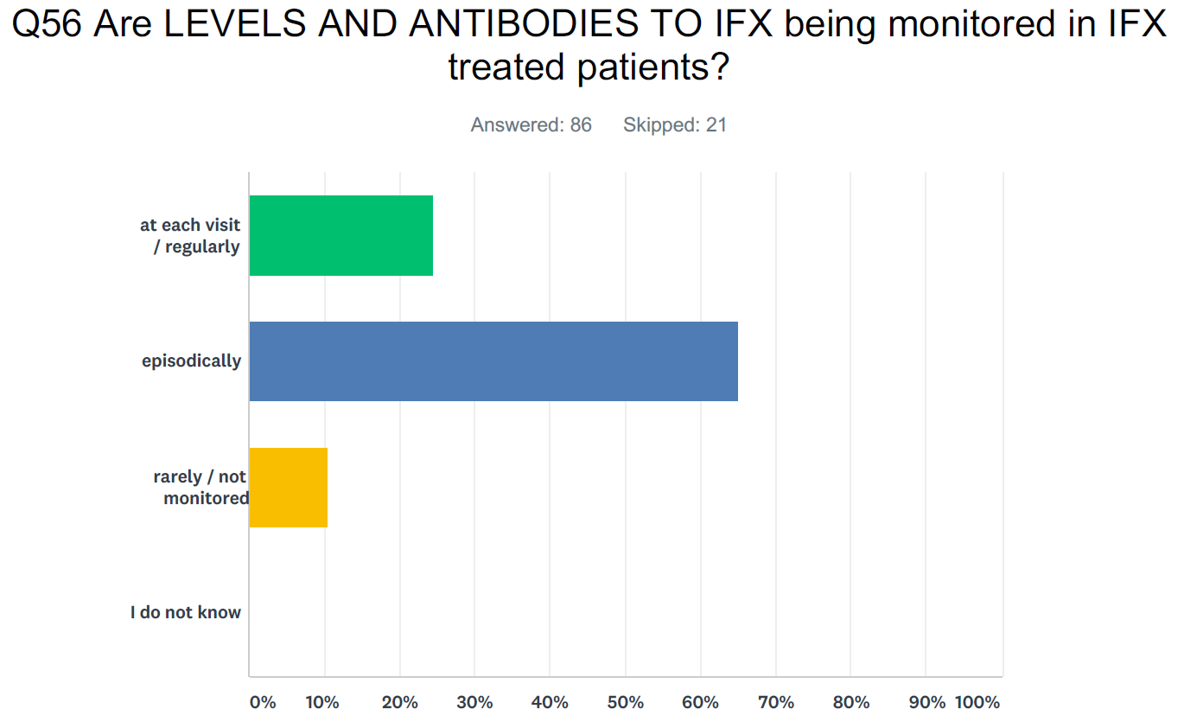

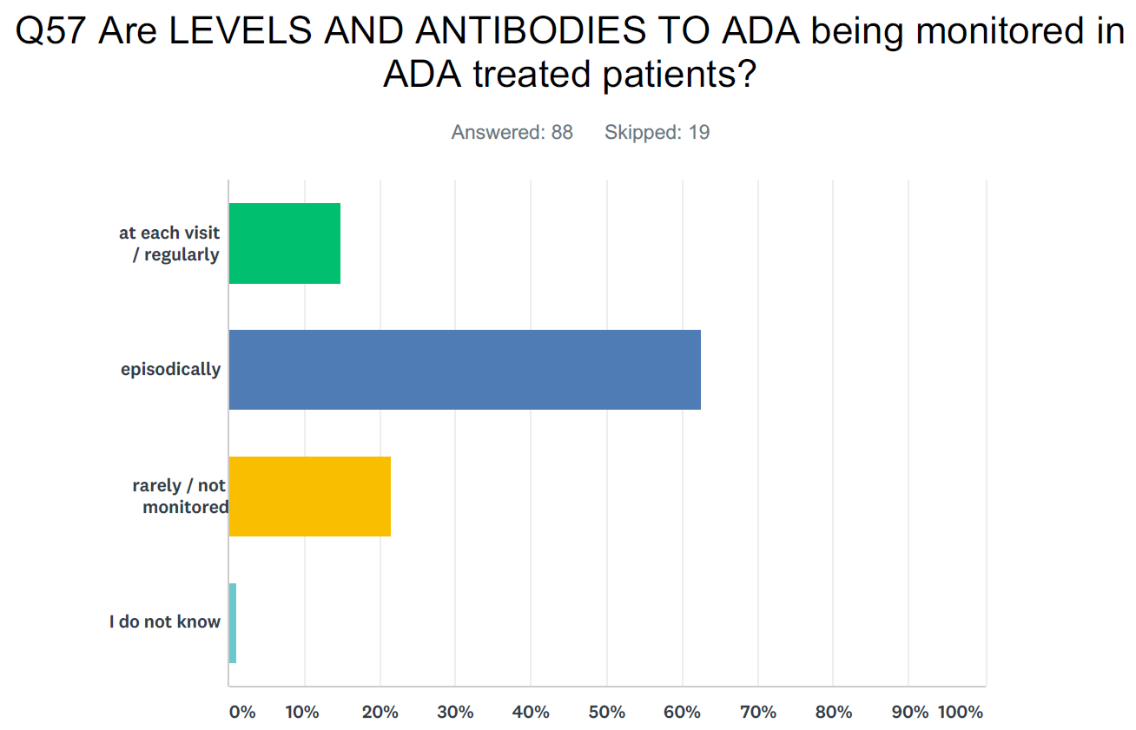

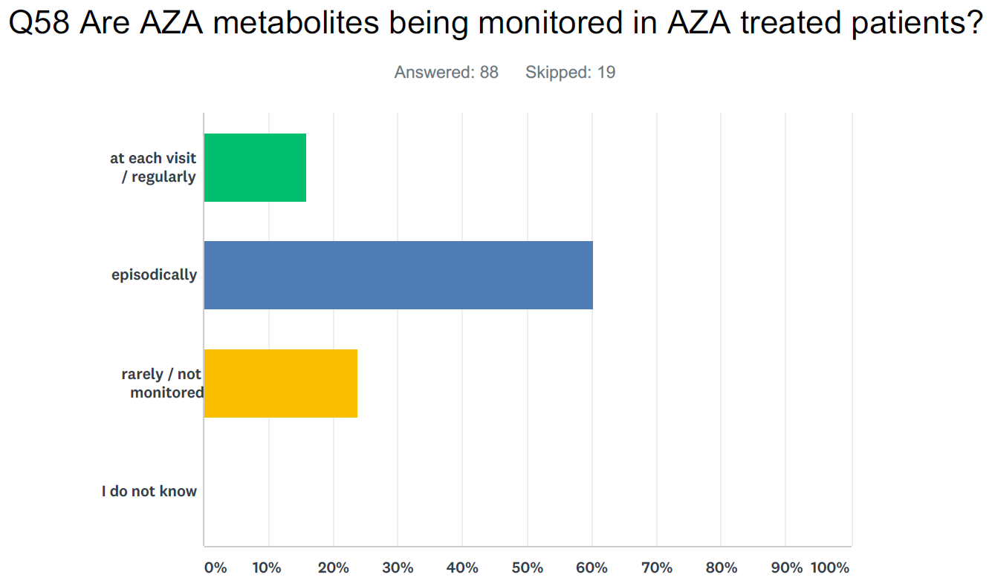

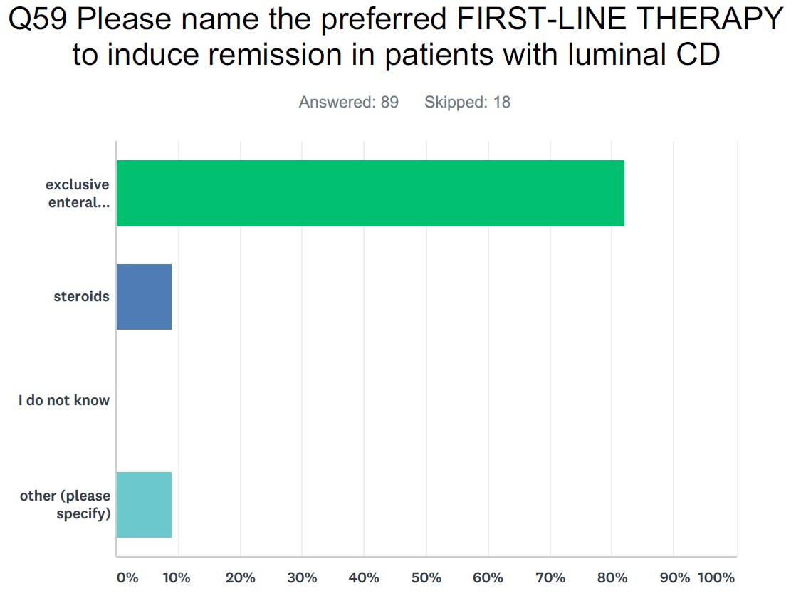
Other: anti-TNF for high-risk CD; no preference; AZA+steroids+EEN
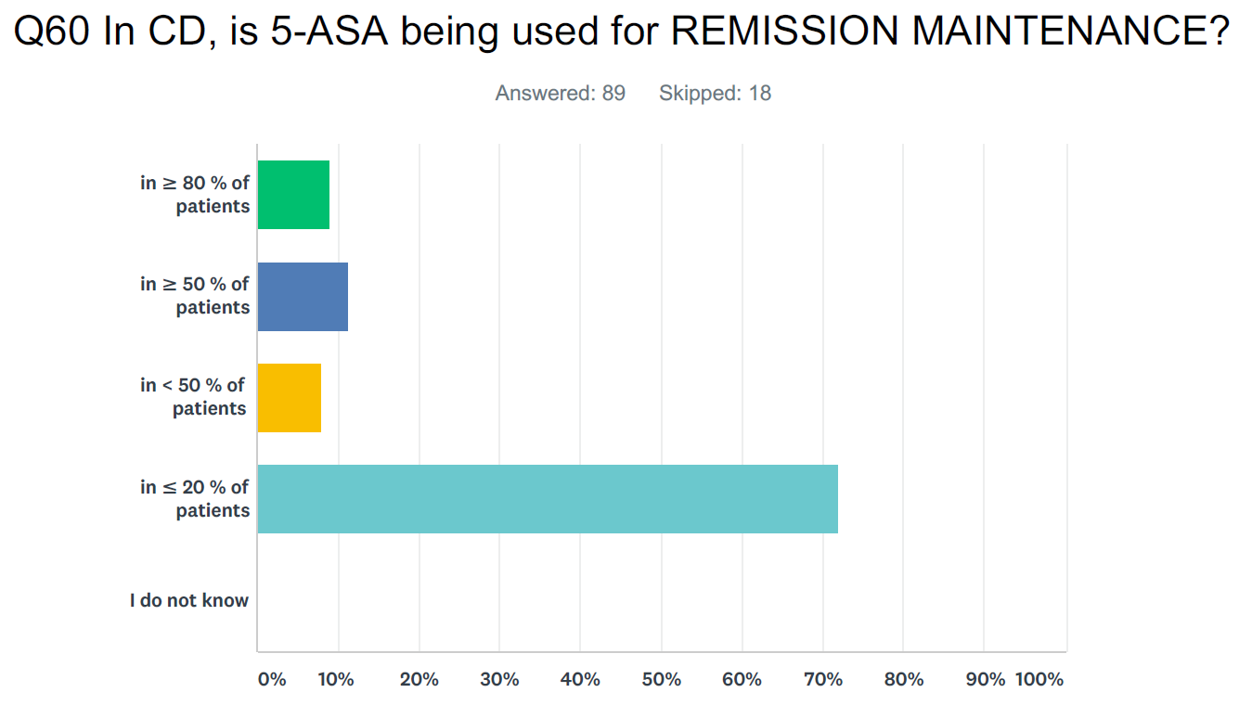

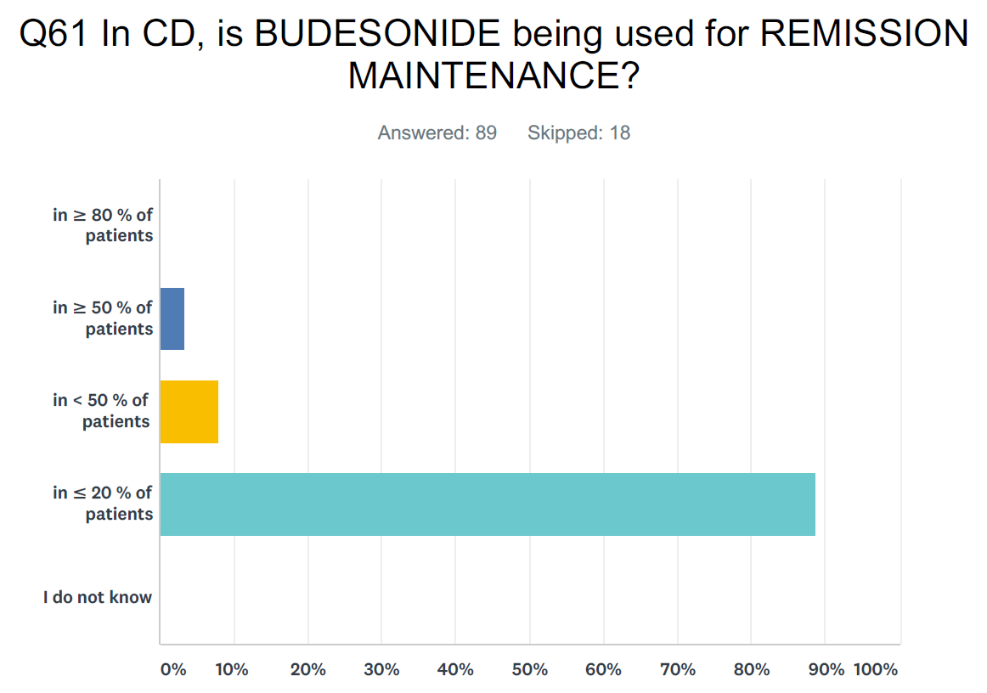

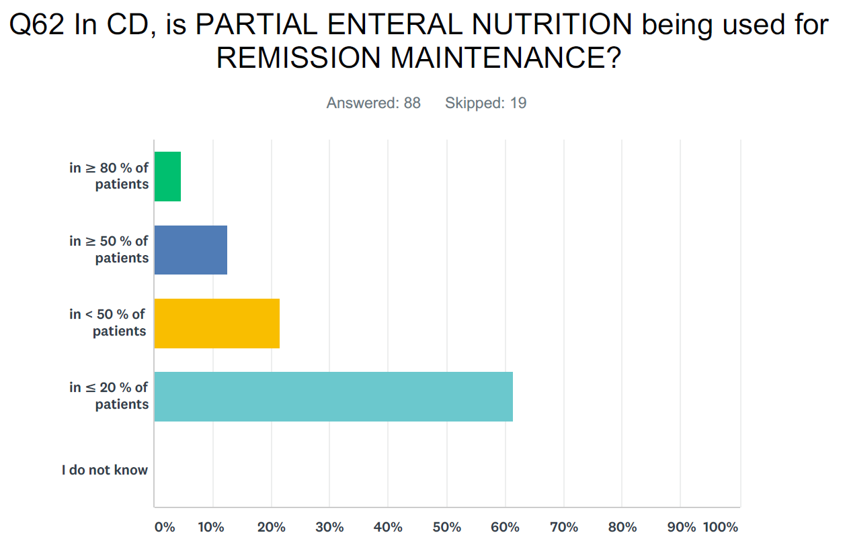

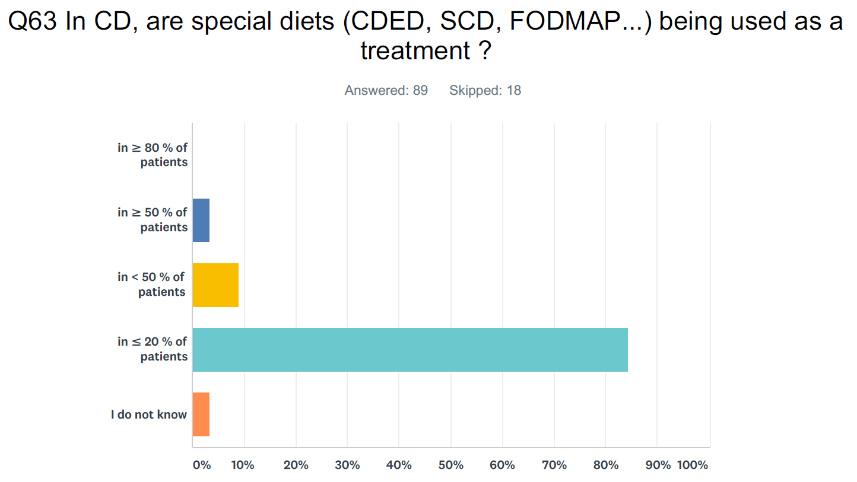

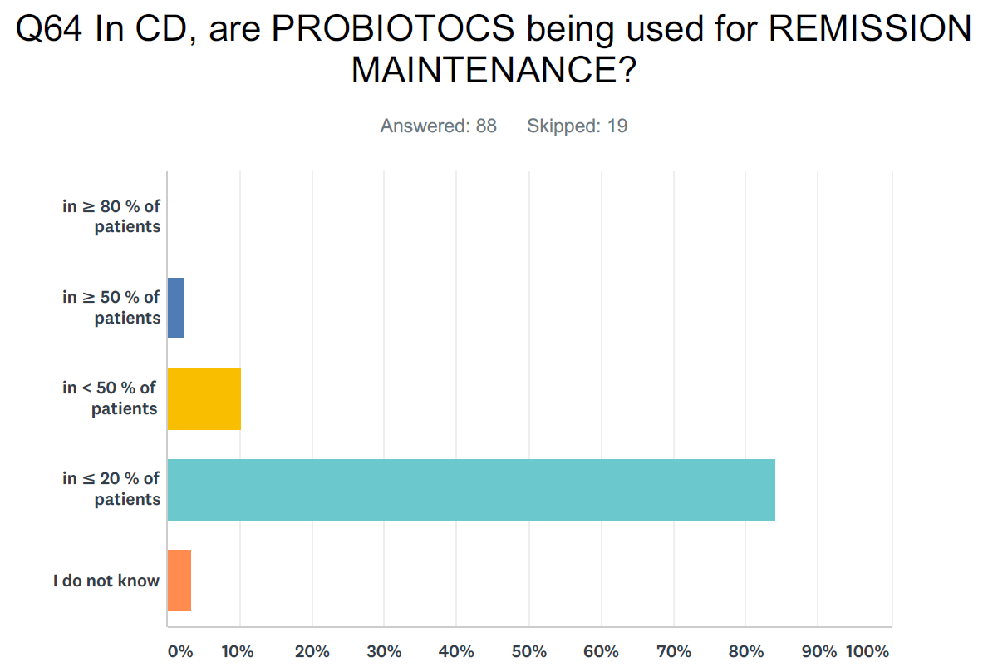

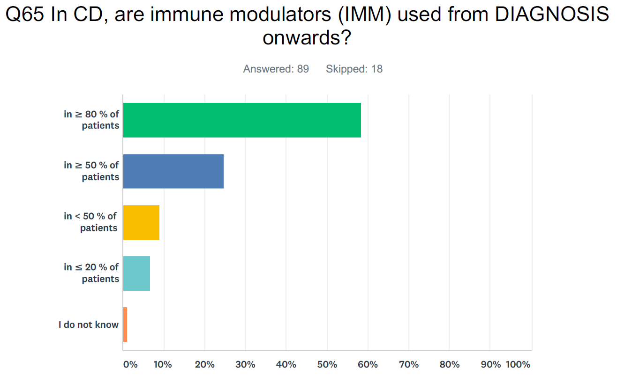

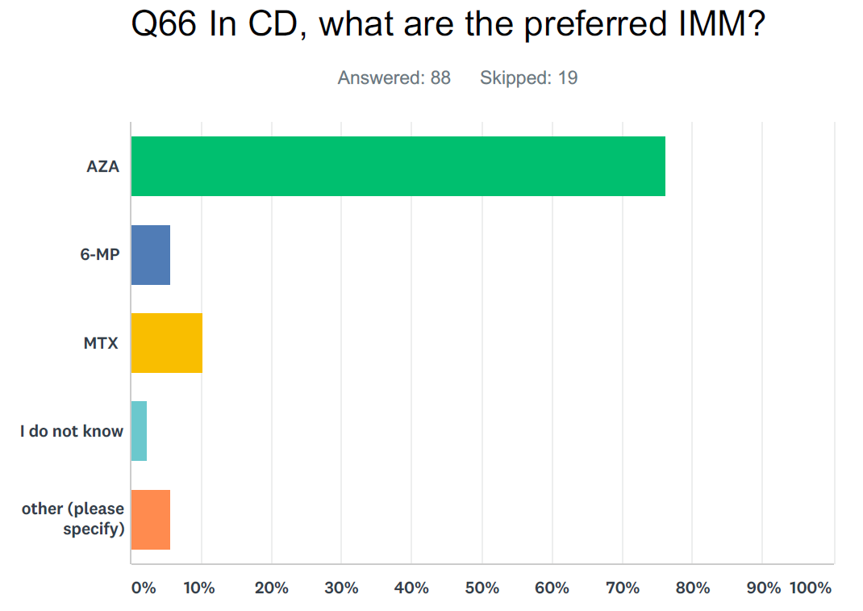
Other: AZA/6-MP in girls; MTX in boys
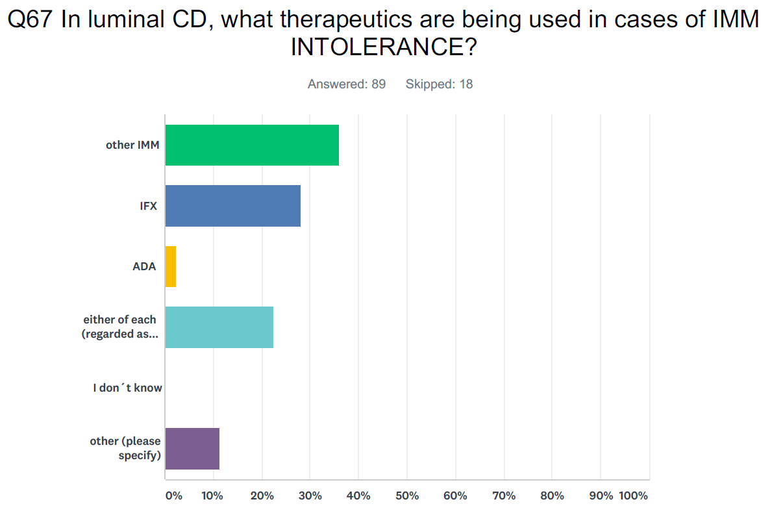
Other: N/A as top down; MTX,IFX,ADA; allopurinol and monoclonals; enteral nutrition; depending on side effects and/or severity; Legend (y axis from top): other IMM; IFX; ADA; either of each (regarded as equally efficacious); I don´t know; other (please specify)
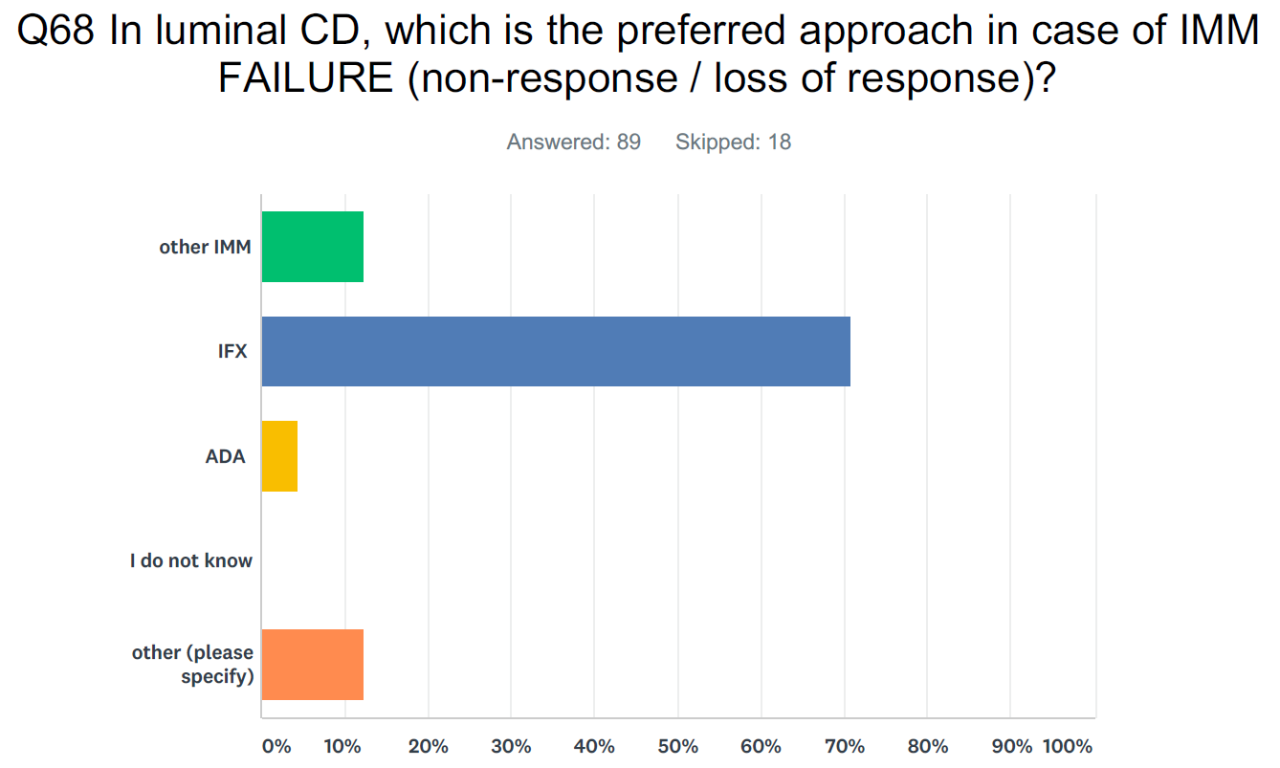
Other: N/A as top down; ADA or IFX; allopurinol and monoclonals; enteral nutrition; case dependent

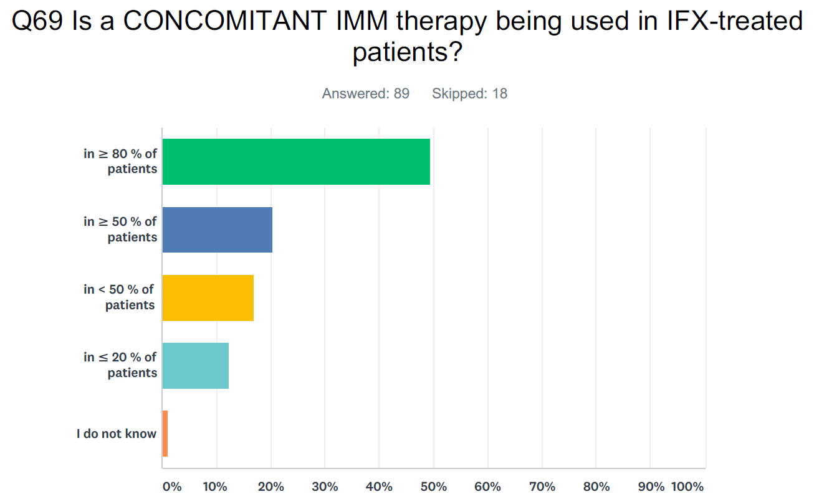

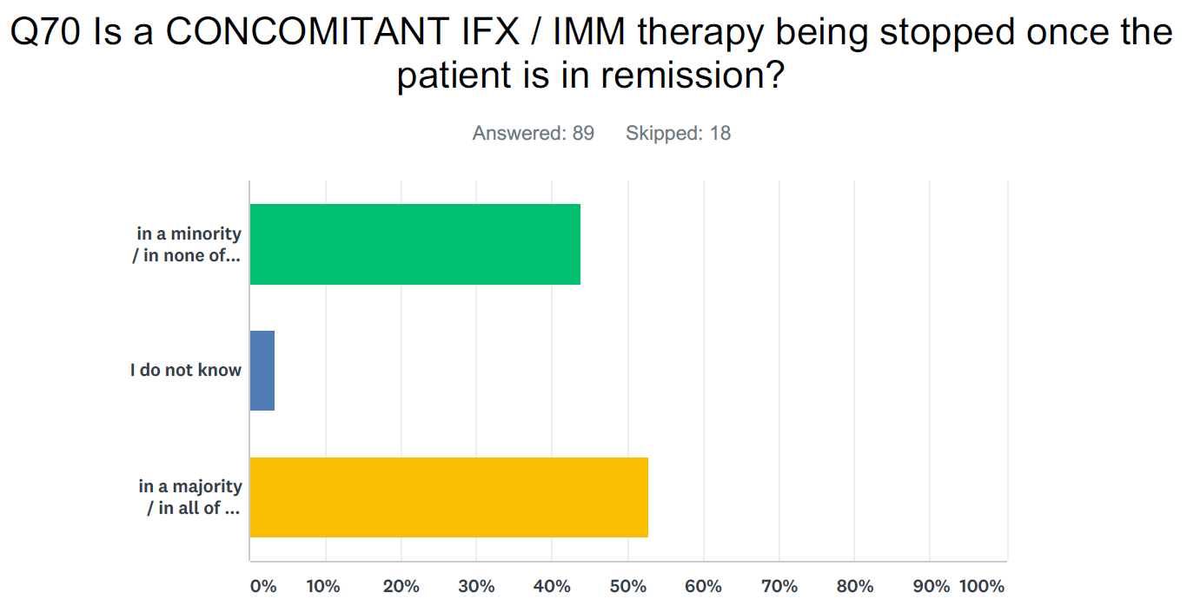
Legend (y axis from top): in a minority / in none of the patients; I do not know; in a majority / in all of the patients (please give the interval)
Interval: 3-6 months; 4 months; 4-6 months; 6-9 months; 3-9 months; 6-12 months; 1 year; 2 years
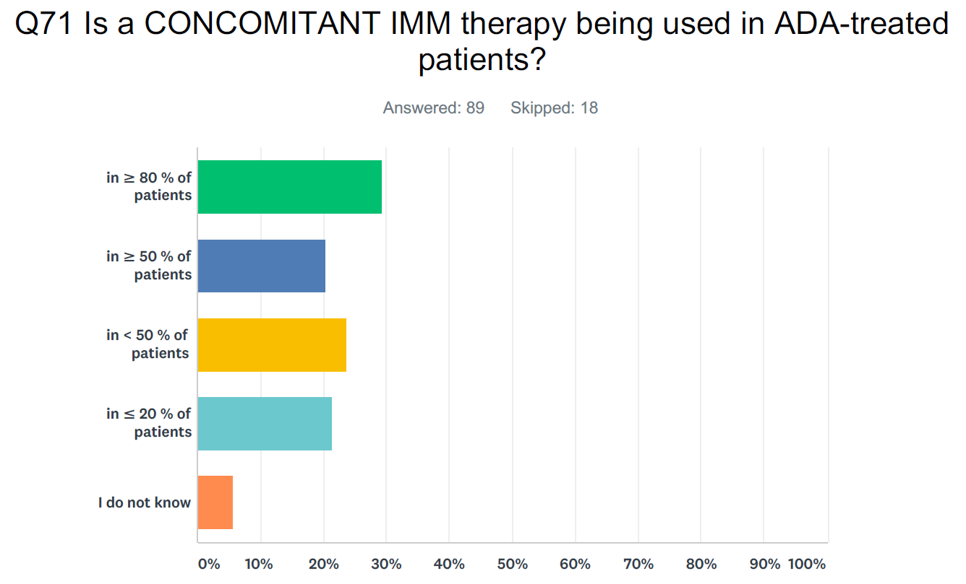

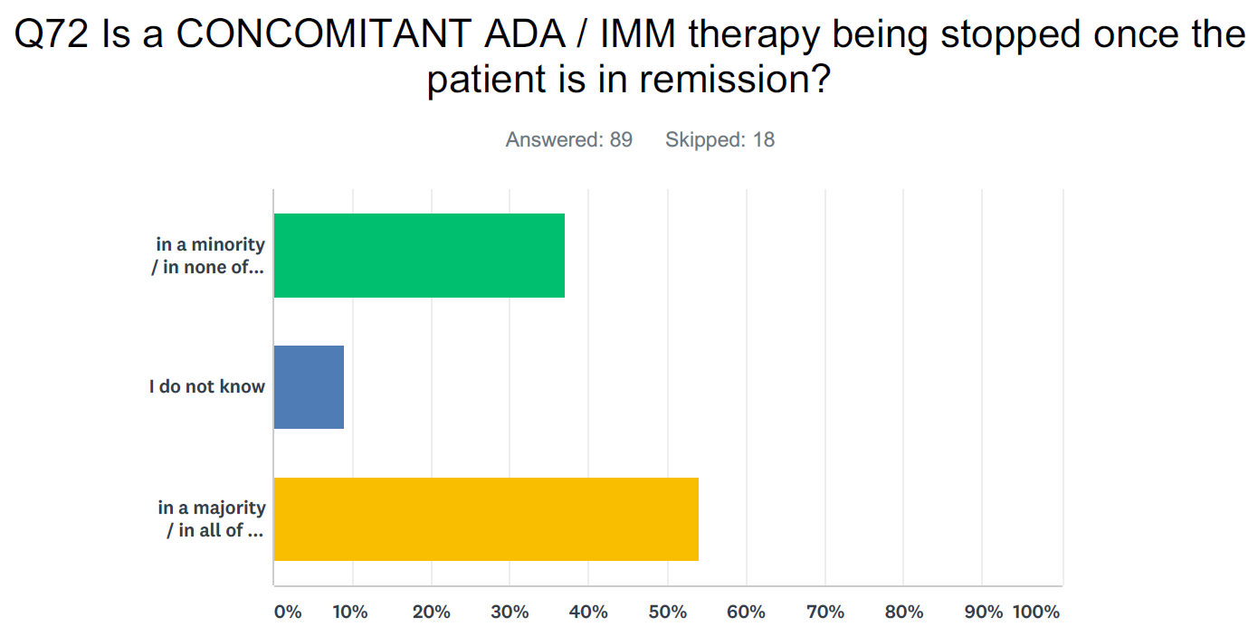
Legend (y axis from top): in a minority / in none of the patients; I do not know; in a majority / in all of the patients (please give the interval)
Interval: 3-6 months; 4 months; 4-6 months; 6-9 months; 3-9 months; 6-12 months; 1 year; 2 years

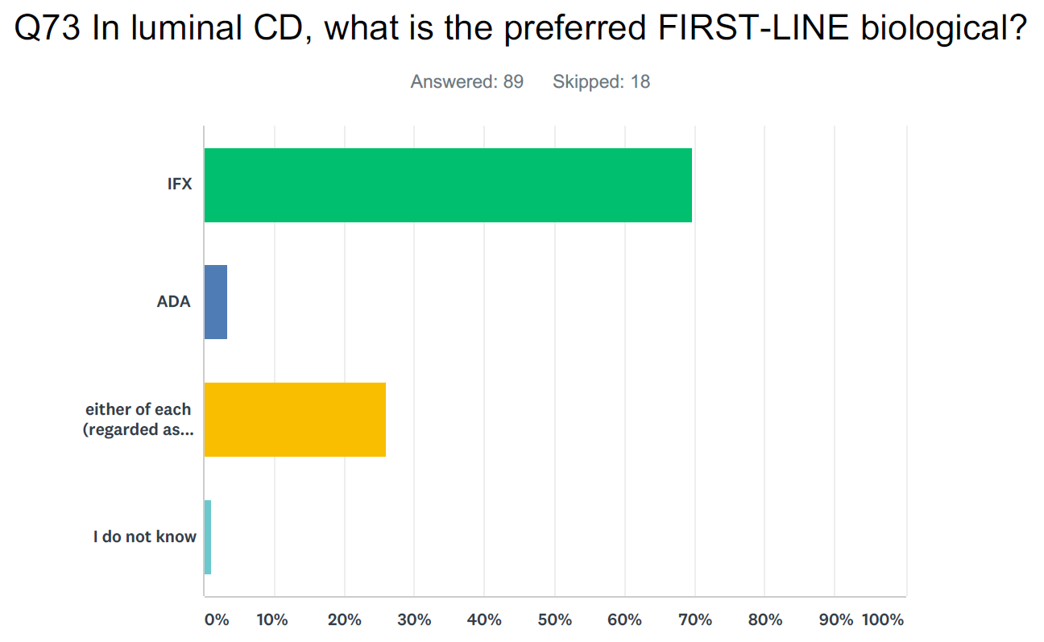
Legend (y axis from top): IFX; ADA; either of each (regarded as equally efficacious); I do not know

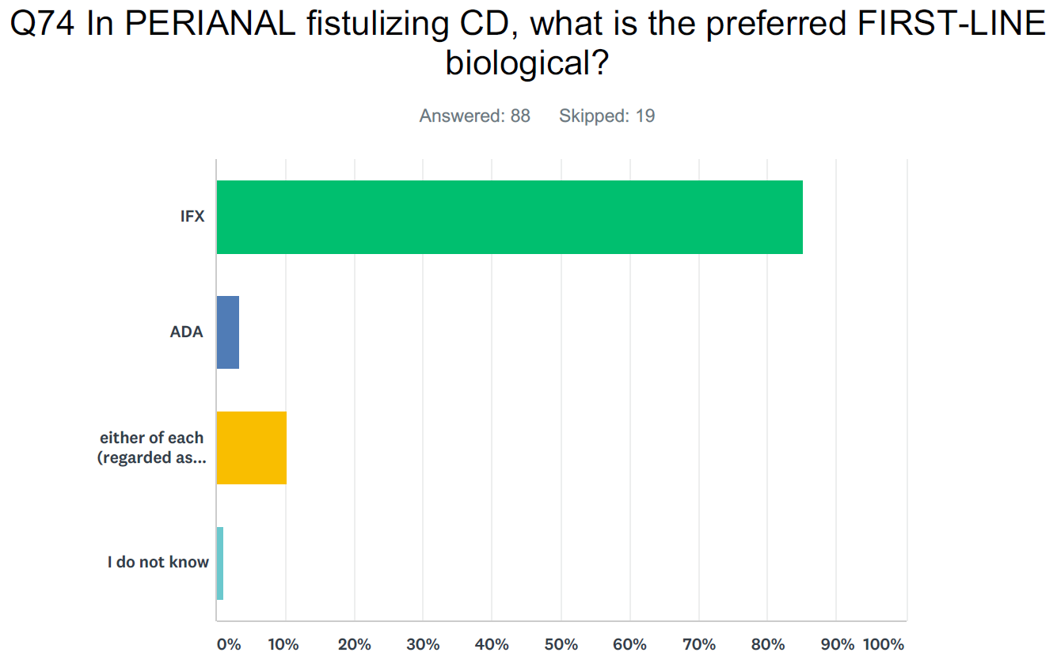
Legend (y axis from top): IFX; ADA; either of each (regarded as equally efficacious); I do not know

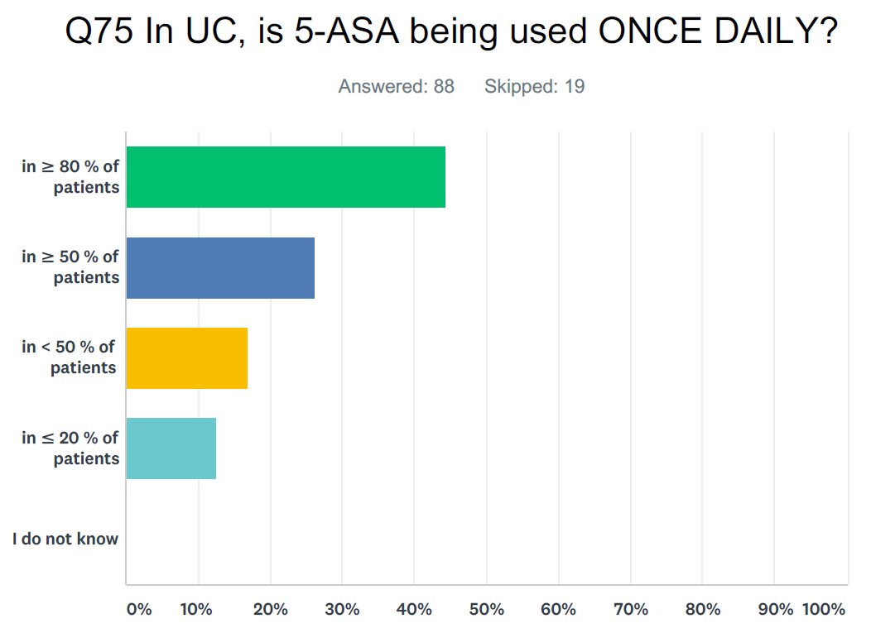
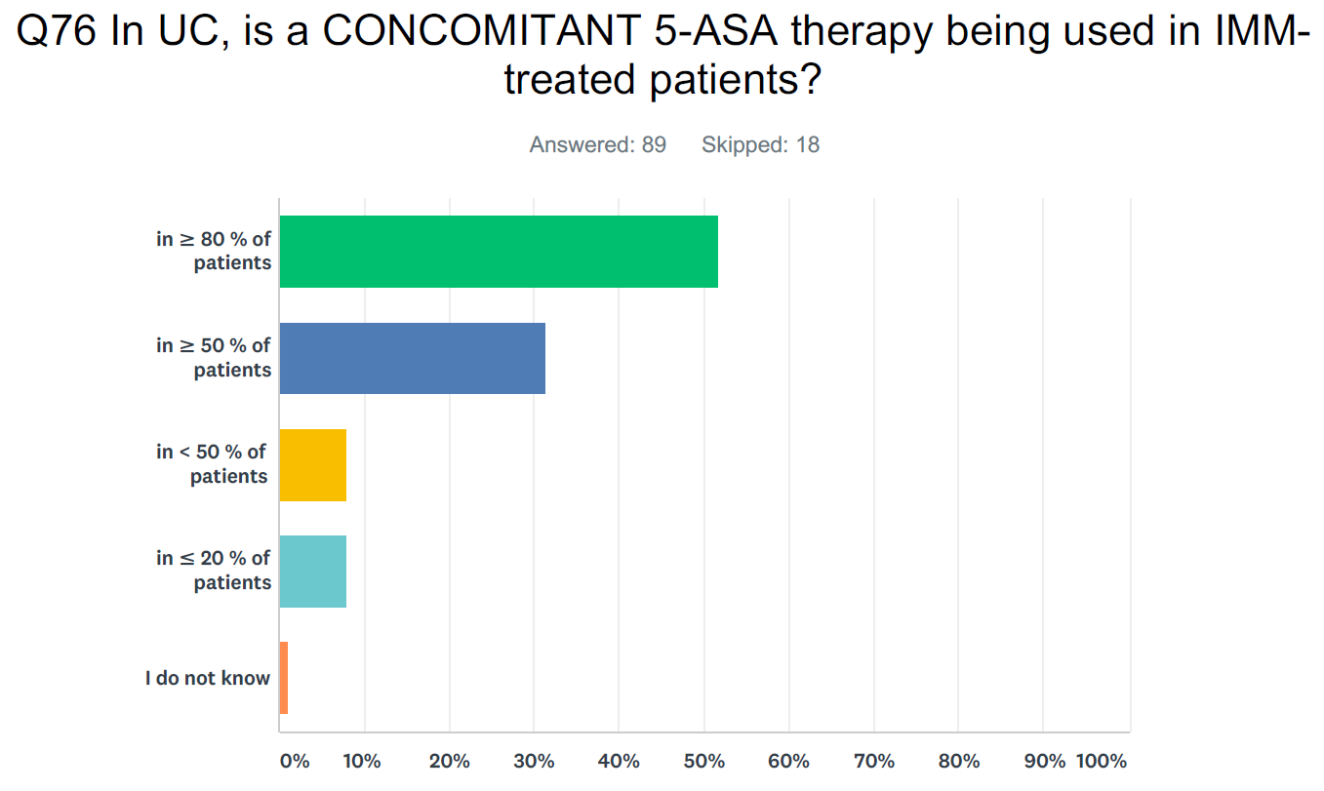

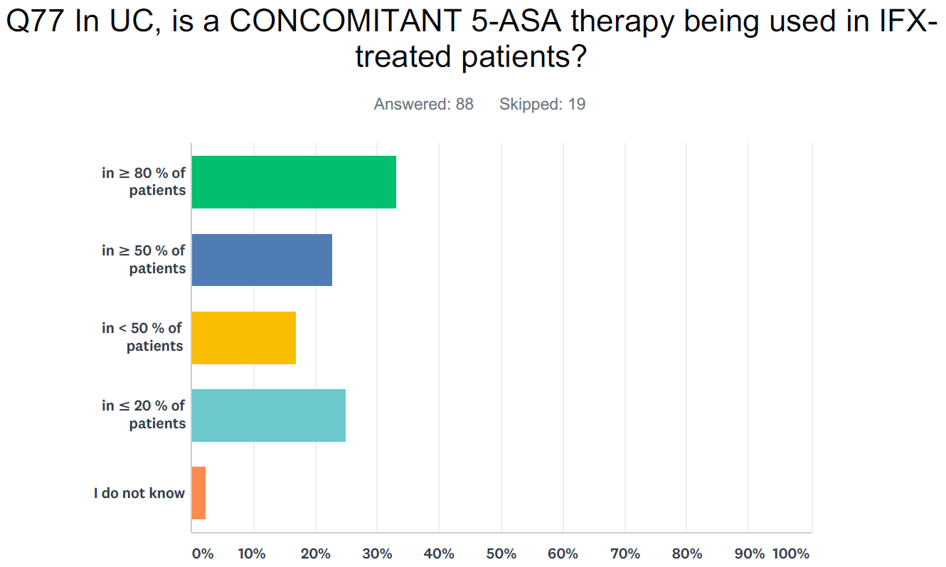

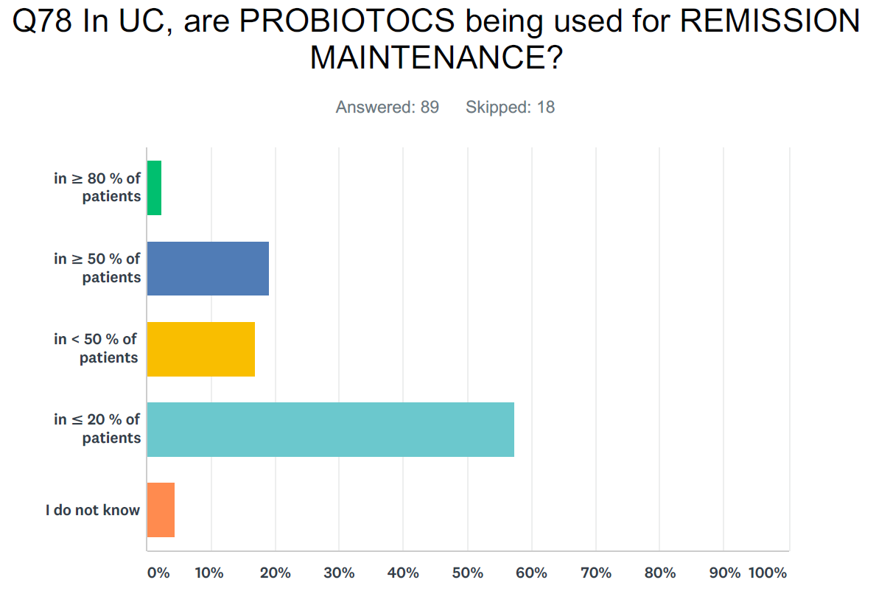

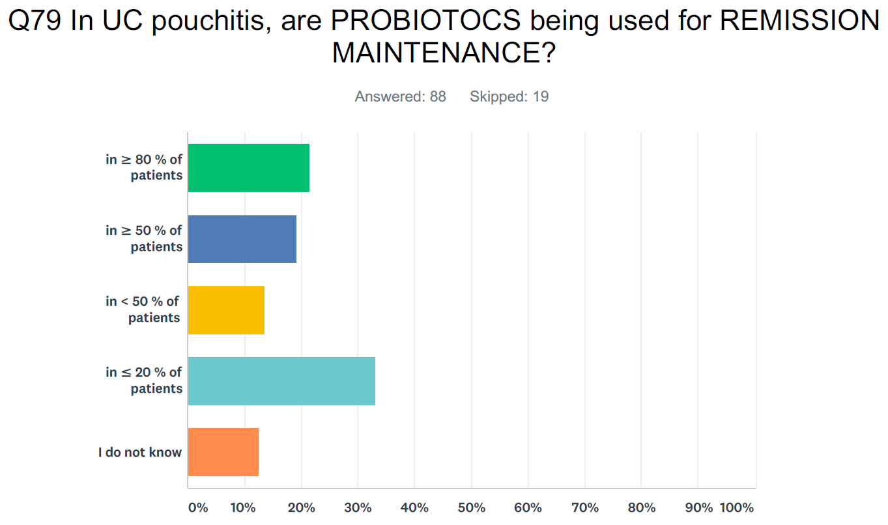

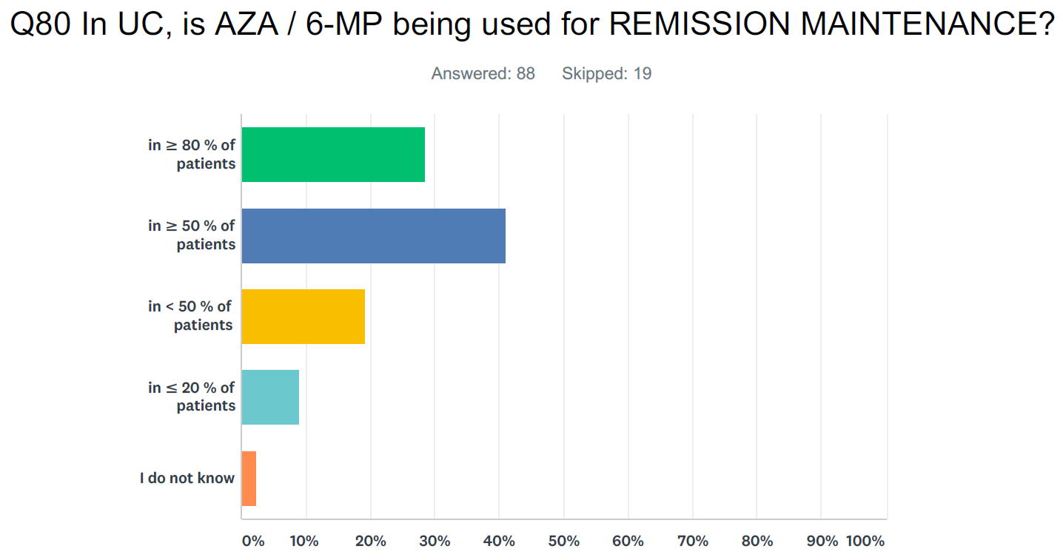

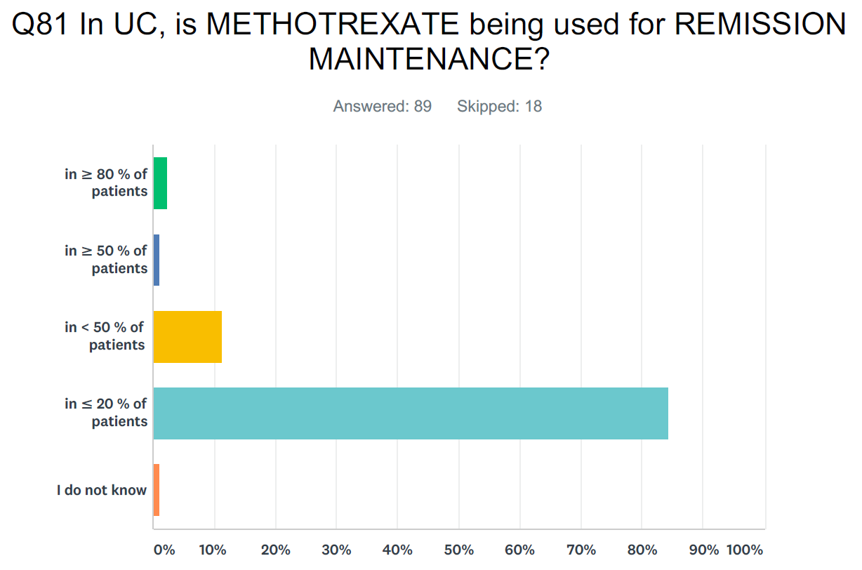

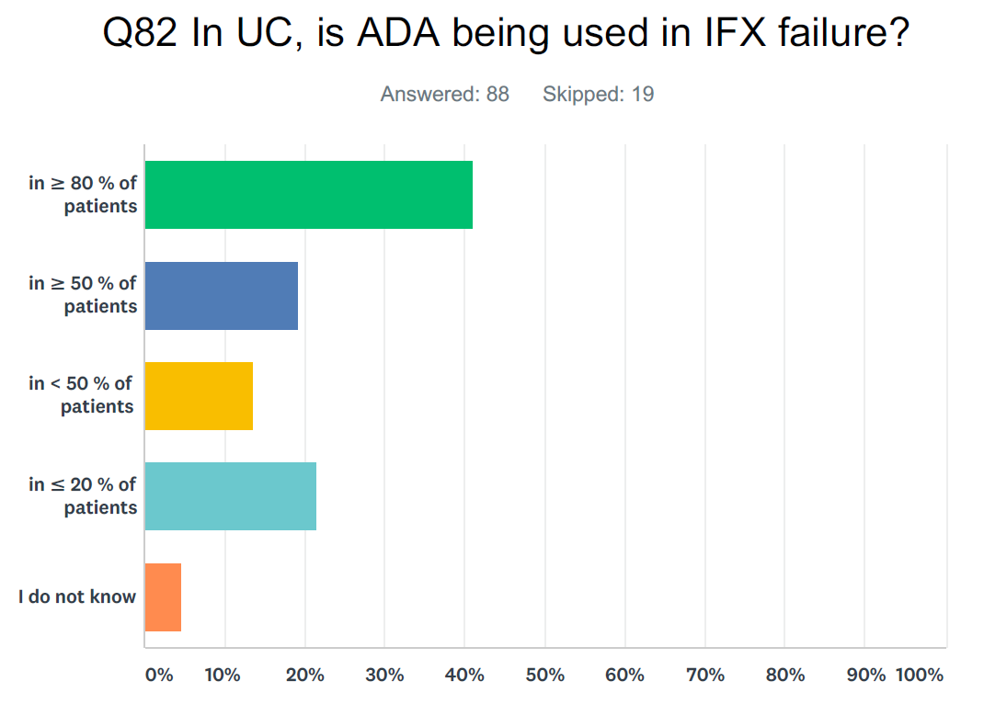

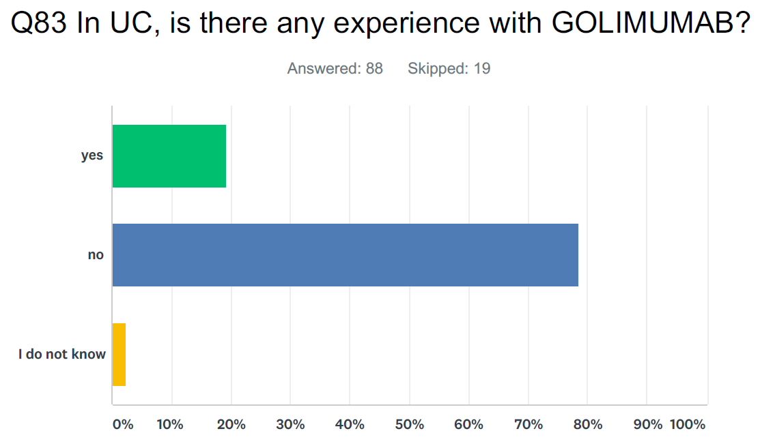

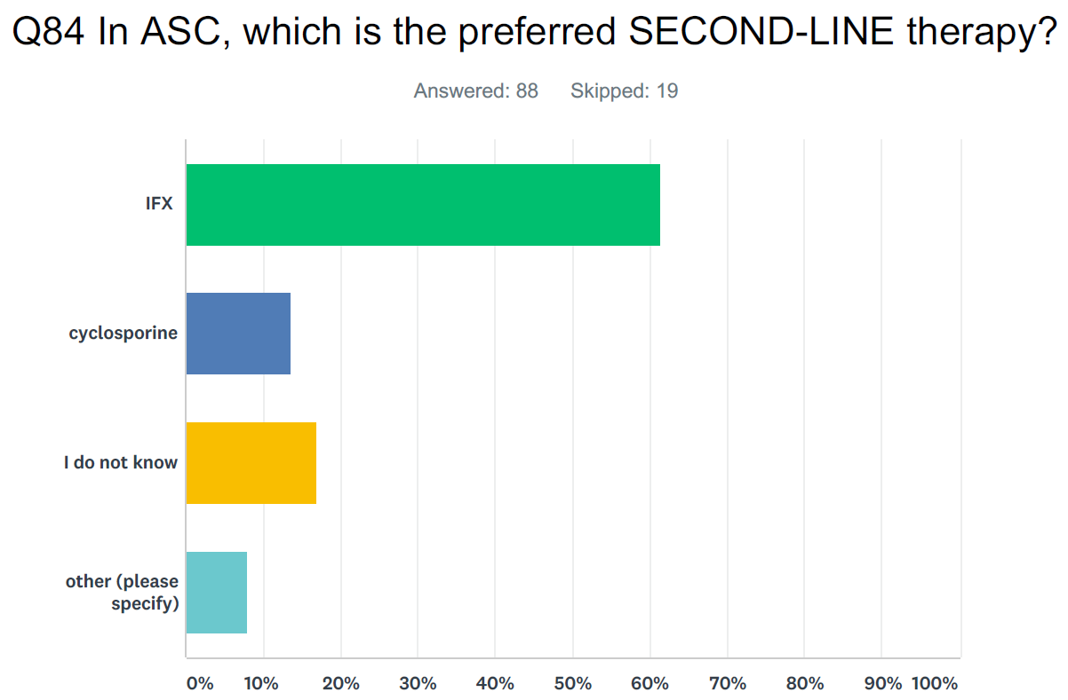
Other: tacrolimus; cyclosporine A (CSA); mycophenolate mofetil; either IFX or CSA (individual decision)

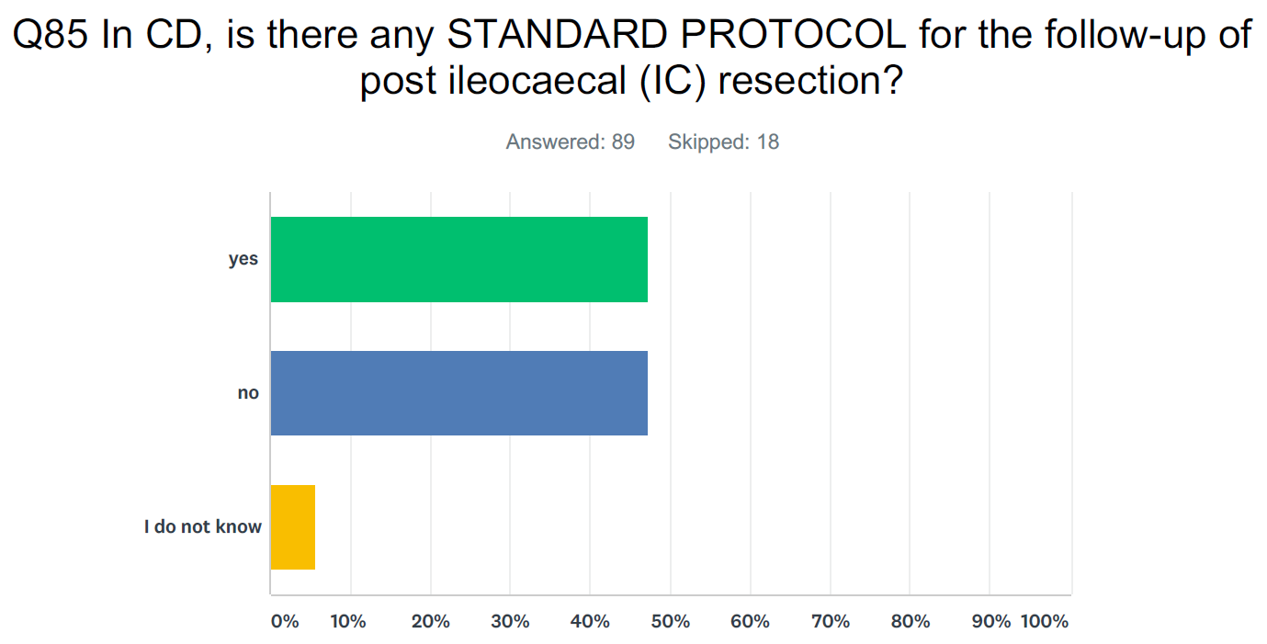

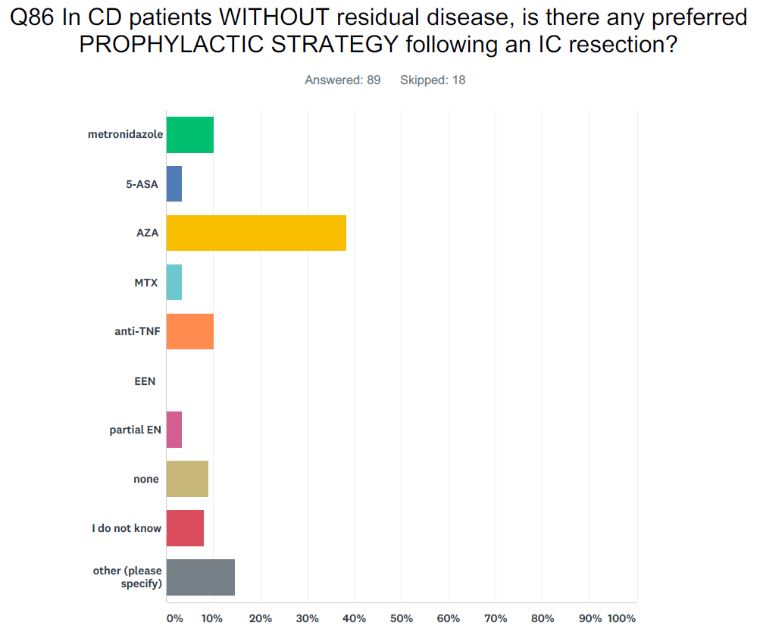
Other: monitor with post-operative colonoscopy and faecal calprotectin; 3 months metronidazole, AZA, PEN; IFX or AZA; 6-MP
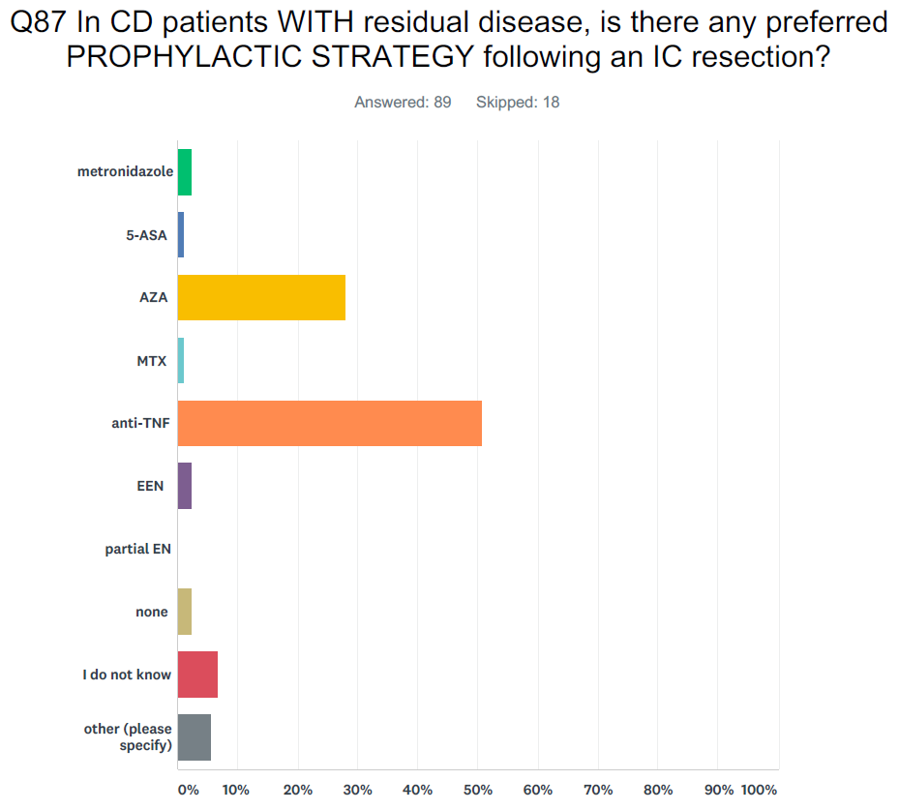

Other: same as above (Q 86); depending on localisation of the disease
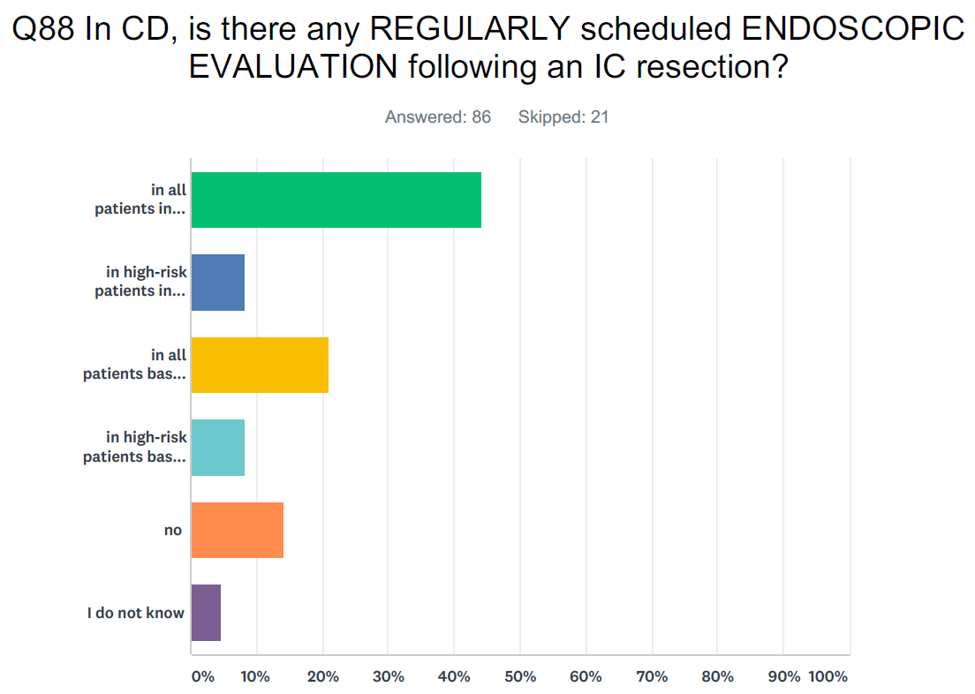
Legend (y axis from top): in all patients in regular intervals; in high-risk patients in regular intervals; in all patients based on clinical/laboratory markers (e.g. calprotectin); in high-risk patients based on clinical/laboratory markers (e.g. calprotectin); no; I do not know
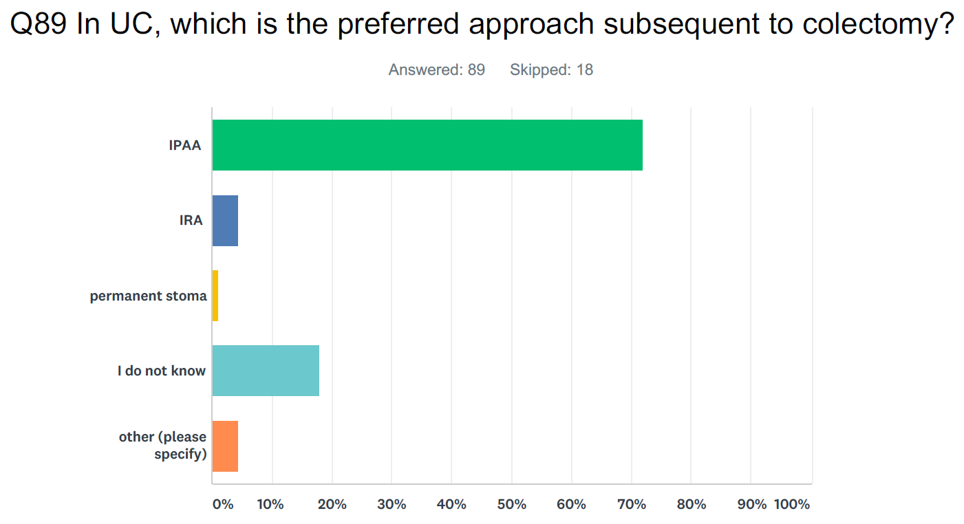
Other: colectomy and ileostomy and ileonal J pouch at a second stage; temporary stoma + defunction as first step; based on interdisciplinary approach individually tailored to the patient

