Your child recently had an MRI scan to measure the amount of fat present in the liver.

The picture on the left side shows a normal liver. The amount of fat in a normal liver is less than 5%. This amount of fat causes the liver to look pink.

The picture on the right side is your child’s liver. The amount of fat in your child’s liver is X %. Fat build up in the liver causes the liver to look more yellow. This condition is known as fatty liver. The picture does not show inflammation or scarring of the liver that are other injuries associated with fatty liver. Permanent scarring (cirrhosis) is a serious condition of the liver that may result from untreated disease.
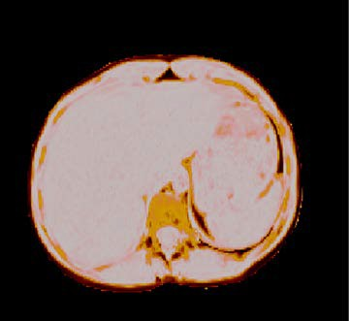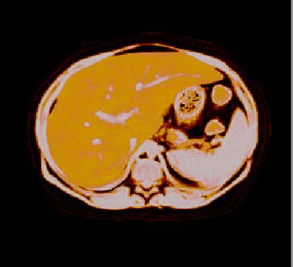

Normal liver: The pink color means that the liver has a normal amount of fat. Fat amount is less than 5%.

Your child’s liver: The yellow color means that there is an increased amount of fat present.
These images indicate that your child has fatty liver. Weight loss is the recommended treatment for this condition. A successful weight loss program should change the liver color from dark yellow to light yellow to pink.

