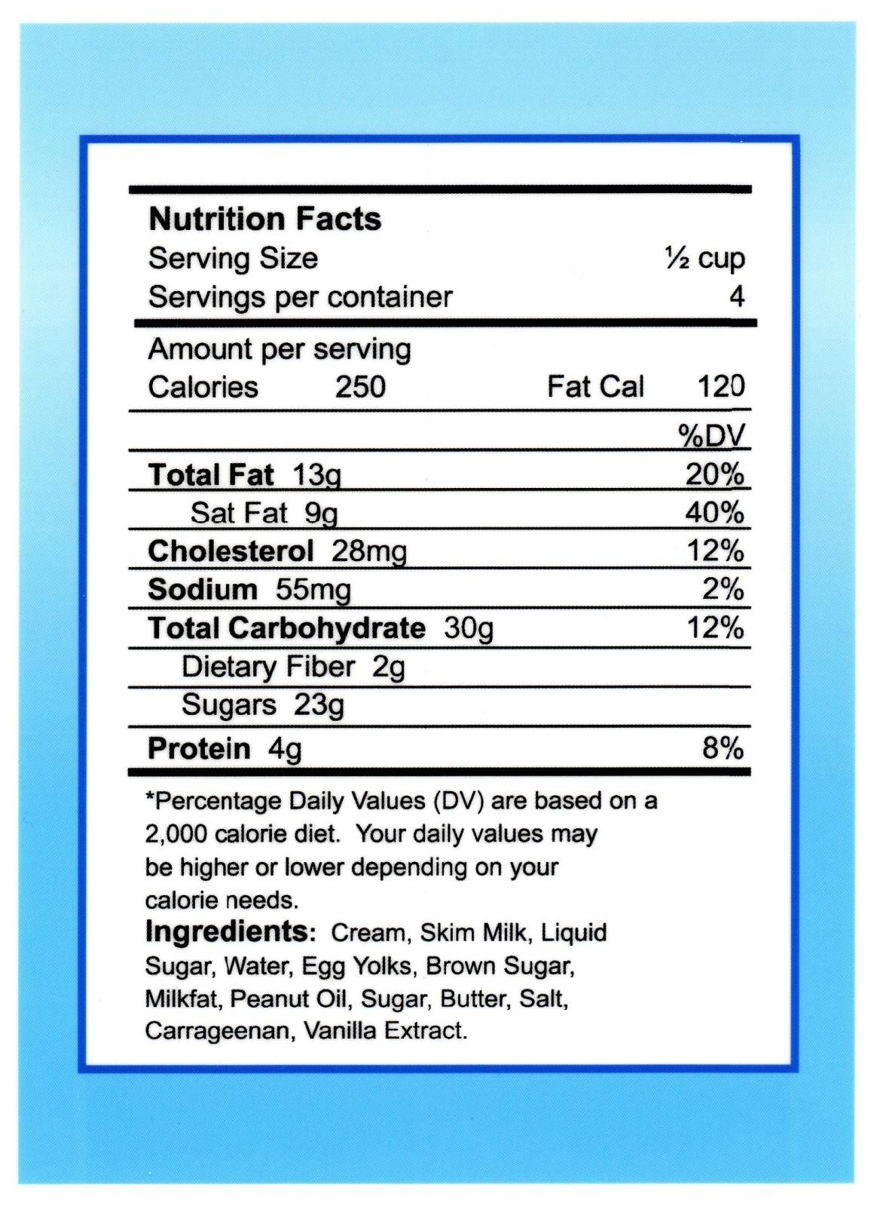

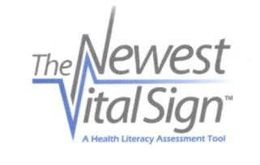

Score Sheet for the Newest Vital Sign Questions and Answers

READ TO SUBJECT:
This information is on the back of a container of a point of ice cream.

- If you eat the entire container, how many calories will you eat?
Answer: 1,000 is the only correct answer

- If you are allowed to eat 60 grams of carbohydrates as a snack, how much ice cream could you have?
Answer: Any of the following is correct: 1 cup (or any amount up to 1 cup), half the container. Note: If patient answers “two servings,” ask “How much ice cream would that be if you were to measure it into a bowl?”

- Your doctor advises you to reduce the amount of saturated fat in your diet.
You usually have 42 g of saturated fat each day, which includes one serving of ice cream. If you stop eating ice cream, how many grams of saturated fat would you be consuming each day?
Answer: 33 is the only correct answer

- If you usually eat 2,500 calories in a day, what percentage of your daily value of calories will you be eating if you eat one serving?
Answer: 10% is the only correct answer

READ TO SUBJECT:
Pretend that you are allergic to the following substances: penicillin, peanuts, latex gloves, and bee stings.

- Is it safe for you to eat this ice cream?
Answer: No

- (Ask only if the patient responds “no” to question 5): Why not?
Answer: Because it has peanut oil.

Number of correct answers:

Interpretation

Score of 0-1 suggests high likelihood (50% or more) of limited literacy. Score of 2-3 indicates the possibility of limited literacy.
Score of 4-6 almost always indicates adequate literacy.
ANSWER CORRECT?
yes | no

February 2011

