Legend Figure, Supplemental Digital Content 1:
Flow diagram of study patients

Figure, Supplemental Digital Content 1: Consort Flow Chart of Study
Patients excluded
(n = 14)
- FiO2 requirement >60% = 4
- Active air leak = 5
- Died before enrolment = 3
- High frequency ventilation = 2
Consecutive patients screened for eligibility
(n = 54)

Number of patients enrolled with informed consent (n = 40)

Number of patients followed up and analyzed
(n = 40)

Table, Supplemental Digital Content 2:
Prerequisites and Procedure of Indirect Calorimetry
Prerequisites to measurement
- Feeds to be given at a same quantity and frequency for at least 12 hours
- Last feed should have been given at least 4 hours before the measurement
- Ventilator settings must remain constant for 90 minutes’ prior
- Inspired FiO₂ should remain constant during the measurement
- Patient’s body temperature should be 35.5ºC - 38.5ºC in the previous 3 hours.
- If the child is on hemodialysis, indirect calorimetry was done at least 4 hours after the end of dialysis session
- Patient should not be agitated or in pain during the measurements. Analgesics or sedatives if necessary were given at least 30 minutes before the study
Procedure of IC
- Calorimeter was warmed up for 1 hour and then calibrated before each test using a known gas mixture containing 16% oxygen, 5% carbon dioxide, and rest balanced with nitrogen.
- Steady state (defined as a period of at least 5 minutes with <10% fluctuation in oxygen consumption (VO₂) and carbon dioxide production (VCO₂) and < 5% fluctuation in respiratory quotient) was achieved before the start of measurement.
- If the steady state was not achieved, the study period was prolonged and/or additional measurements were taken at a separate time.
- Flow sensor and gas calibrations were performed before each measurement.
- In mechanically ventilated children, flow sensor was connected to the expiratory outlet of ventilator with an adaptor and a sampling port was connected to a T-piece connector attached to an inspiratory limb of the ventilator circuit.

Legend Figure, Supplemental Digital Content 3:
Bland Altman plots depicting agreement of predictive equations with mREE. 1a. Schofield; P=0.002, 2b. FAO/WHO/UNU; P=0.006, 3c. Harris Benedict equations; P=0.012

Figure, Supplemental Digital Content 3:
Bland Altman plots depicting agreement of predictive equations with mREE

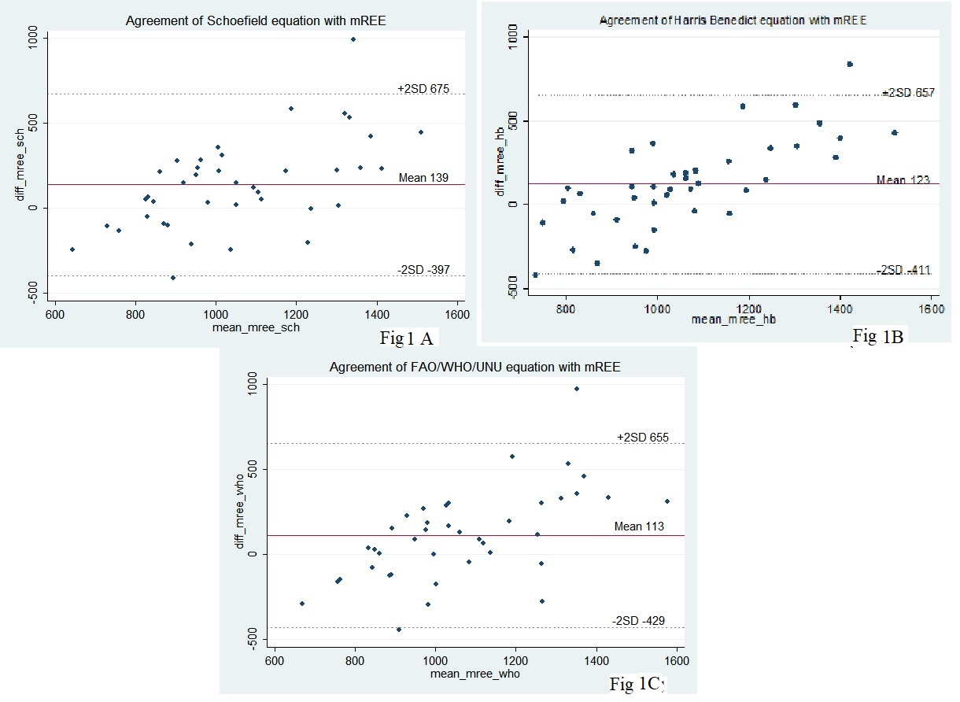

Table, Supplemental Digital Content 4:
Correlation of baseline nutrition status and clinical variables
Variable | Underweight  N = 7 (17.5%) | Not Underweight  N = 33 (82.5%) | P value
Age* (yr) | 5.6 ± 1.1 | 8 ± 2.6 | 0.017
BMI* (Kg/m²) | 11.8 ± 0.75 | 16.4 ± 2.2 | <0.0001
PRISM III* | 18.3 ± 5.7 | 19.7 ± 7.9 | 0.78
mREE* (Kcal) | 1007 ± 130 | 1148 ± 333 | 0.47
mREE/kg* (Kcal/kg) | 68 ± 24 | 48 ± 12 | 0.025
Cumulative calorie balance* (Kcal) | -1834 ± 1665 | -1745 ± 2349 | 0.32
Cumulative nitrogen balance* (g) | -8.5 ± 8 | -6.2 ± 12.6 | 0.28
Ventilation free days* | 11 ± 11 | 16.8 ± 7.9 | 0.31
Health care associated infection | 1 | 3 | 0.46
*Mean ± SD

