Supplemental Digital Content 1 (Table). Model Parameters for Short-term and Long-term Analyses
Costs per Health Care State | $ (range) | Reference
Short-term Costs, per hospital day
No IFALD, no complications | 2,900 (2,465 – 3,335) | 13
IFALD, no complications | 3,100 (2,635 – 3,565) | 13
IFALD +1 complication | 3,791 (3,222 – 4,359 | 16,34
IFALD + 2 complications | 4,895 (4,161 – 5,630) | 16,34
Complications, no IFALD | 3,790 (3,222 – 4,359) | 16,34
Parenteral nutrition | 200 (170 – 230) | 16
Guideline physician consult | 35 (29.75 – 40.25) | 14
NICU physician, day 1 | 953 (810 – 1,096) | 14
NICU physician, day 2-27 | 402 (342 – 463) | 14
NICU physician, day 28 | 886 (753 – 1,019) | 14
NICU physician, >day 28 | 414 (352 – 476) | 14
Long-term Costs, per year
Mild disability | $1,240 | 20
Moderate disability | $1,240 | 20
Severe disability | $49,312 | 20
Chronic liver disease | $24,640 | 23
No long term complications | $0
Transition Probabilities Between States | Probability (range)
No Guideline Use, per hospital day
No IFALD to IFALD | 0.00657 (0.00558 – 0.00755) | 7
No IFALD to IFALD + 1 complication | 0.00820 (0.00697 – 0.00943) | 7
No IFALD to IFALD + 2 complications | 0.00125 (0.00106 – 0.00144) | 7
No IFALD to other complication | 0.00223 (0.00189 – 0.00256) | 7
Guideline Use, per hospital day
No IFALD to IFALD | 0.00328 (0.00279 – 0.00378) | 7
No IFALD to IFALD + 1 complication | 0.00368 (0.00312 – 0.00423) | 7
No IFALD to IFALD + 2 complications | 0.00069 (0.00059 – 0.00080) | 7
No IFALD to other complication | 0.00177 (0.00151 – 0.00204) | 7
All Neonates, per hospital day
Any state to death | 0.00117 (0.00099 – 0.00134) | 7
Any complication to discharge | 0.00315 (0.02679 – 0.03624) | 7
Long-term Complications During Childhood
Mild disability | 0.625 | 20
Moderate disability | 0.247 | 20
Severe disability | 0.128 | 20
Liver disease (cirrhosis) | 0.130 | 22
Long-term Effectiveness | Utility (QALY)
Mild disability | 0.85 | 20
Moderate disability | 0.645 | 20
Severe disability | 0.47 | 20
Liver disease (cirrhosis) | 0.67 | 24
IFALD, intestinal failure-associated liver disease; QALY, quality adjusted life year. Complication=sepsis or necrotizing enterocolitis. Costs are in US dollars.

Supplemental Digital Content 2 (Figure). Long-term Heath State Transitions. Following initial hospitalization in the neonatal intensive care unit, infants could transition to cirrhosis and/or disability from necrotizing enterocolitis or sepsis.
NICU=neonatal intensive care unit
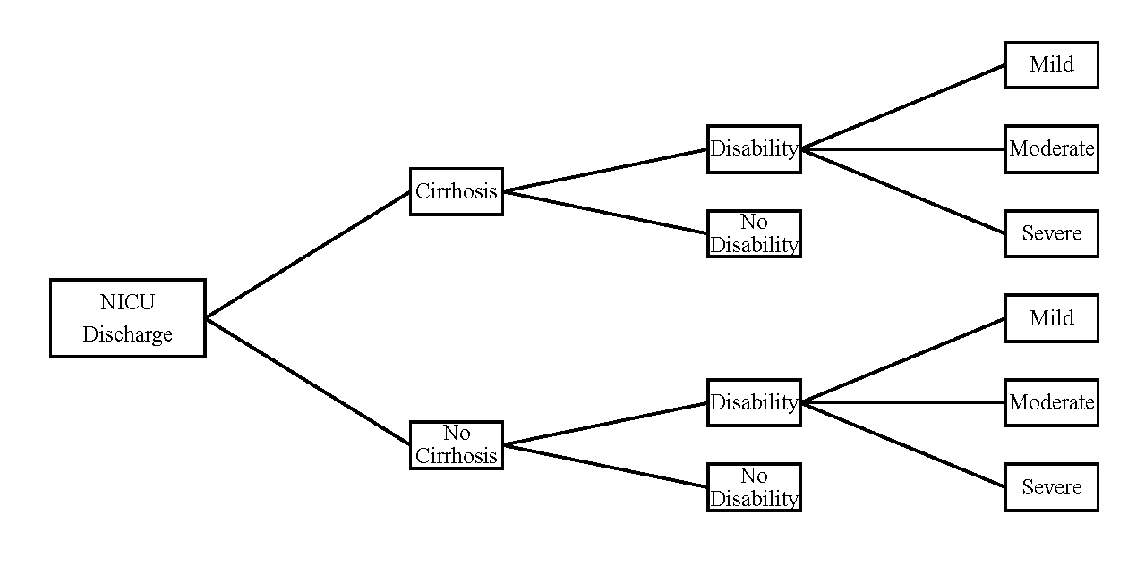

Supplemental Digital Content 3 (Table). Deterministic Incremental Cost-effectiveness Ratios Comparing Feeding Guideline Use with Standard of Care
Short-term Outcomes | Cost ($) | Hospital Stay  (Total Days) | ICER  ($/Stay)
Health Care Sector Perspective
No Guideline Use | 31,258,902 | 8,296 | reference
Guideline Use | 29,295,553 | 8,096 | -9,832
Societal Perspective
No Guideline Use | 32,316,869 | 8,296 | reference
Guideline Use | 30,328,053 | 8,096 | -9,959
Long-term Outcomes | Cost ($/Year) | Utility (QALY) | ICER  ($/QALY)
No Guideline Use | 4,030 | 0.9 | reference
Guideline Use | 2,830 | 0.91 | -91,756
Short-term model based on 100 surgical infants per group at risk of intestinal failure-associated liver disease, necrotizing enterocolitis and sepsis. Long-term model based on probability of progressing to cirrhosis and/or disability from sepsis and necrotizing enterocolitis. Costs are in US dollars.
ICER=incremental cost-effectiveness ratio; QALY=quality adjusted life year

