**Supplemental Figure 1**: Presence of interface hepatitis and lobular inflammation in the liver biopsies

251658240

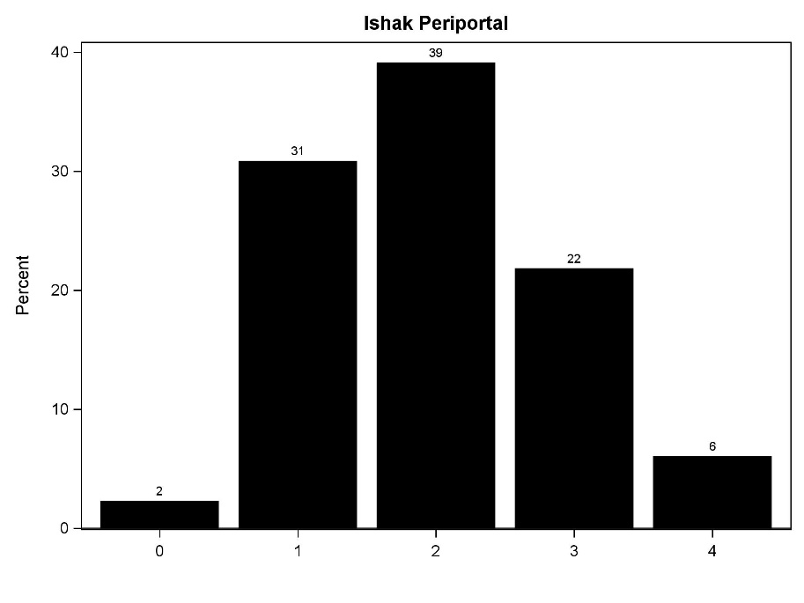

Interface hepatitis was mild in 31%, moderate in 61%, severe in 6% and not present in 2%.

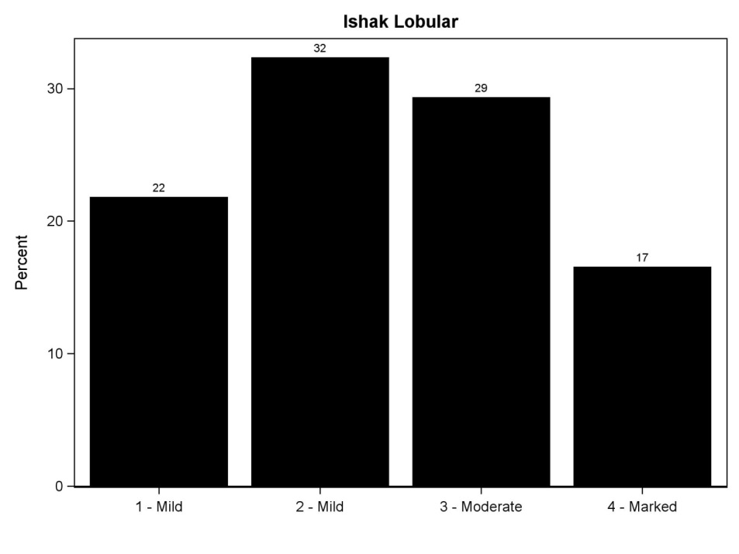

Lobular inflammation was mild in 54%, moderate in 29% and marked in 17%.

**Supplemental Figure 2**: Correlation between fibrosis, duration of infection, age at biopsy and Hepatitis B (HBV) viral load.



No associations were found between fibrosis stage and duration of infection, age at biopsy, or HBV DNA level.

**Supplemental Figure 3**: Correlation between fibrosis-4 (FIB-4) index, inflammation and fibrosis

251658240



FIB-4 correlated with inflammation, but not with fibrosis.