Supplemental Figure 1: The United States of America Divided into Regions based on the Census Bureau*
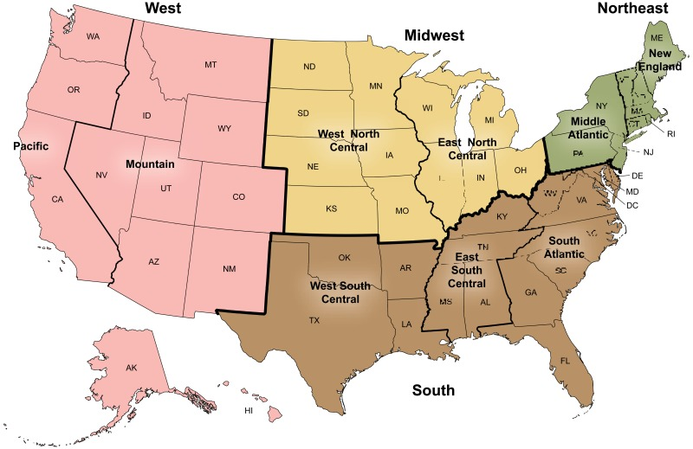

*Source: U.S Census Bureau ²⁴

