A serious case of a button battery ingestion
A 3 year old boy was admitted to the hospital due to fever. The cause of the fever was unknown, but because a sepsis was suspected he was treated with antibiotics intravenously for 7 days. One day after discharge he was admitted again but now with a severe gastro-intestinal bleeding and collapse. Due to an ongoing bleeding the patient was intubated to minimalize the chance of aspiration. An x-ray made to check the position of the tube showed a foreign body suggestive of a button battery on the level of the clavicles.
An endoscopy by the ENT doctor in combination with the pediatric gastroenterologist was performed, but due to the active bleeding the battery was not visualized. A CT scan showed an active bleeding in the left common carotid artery. Surgery performed directly by a general pediatric surgeon, vascular surgeon and ENT doctor showed fistula between a perforated esophagus and the carotid artery (supplementary figure 1). In addition a tracheoesophageal fistula was seen. All defects were closed and the battery was removed. Antibiotics were started due to the high risk of mediastinitis. The total amount of blood loss during surgery was impressing and estimated to be around 4 times the total circulating blood volume which required continuous transfusions. After surgery the patient developed a hemiparesis of the right side of the body and the CT scan of the head showed ischemia of the left hemisphere and water shed strokes in the frontal and occipital areas. Fortunately, since then a bit of the neurological function regained and no other complications occurred. He was discharged with oral feeding after staying in the hospital for several months. The parents never noticed a battery ingestion. The episode of fever before the gastro-intestinal bleeding was most probably due to mediastinitis. In retrospect an x-ray made at that time also showed the battery. This case illustrates how hard it can be to discover a button battery ingestion in unwitnessed cases, and the dramatic presentation it may have.

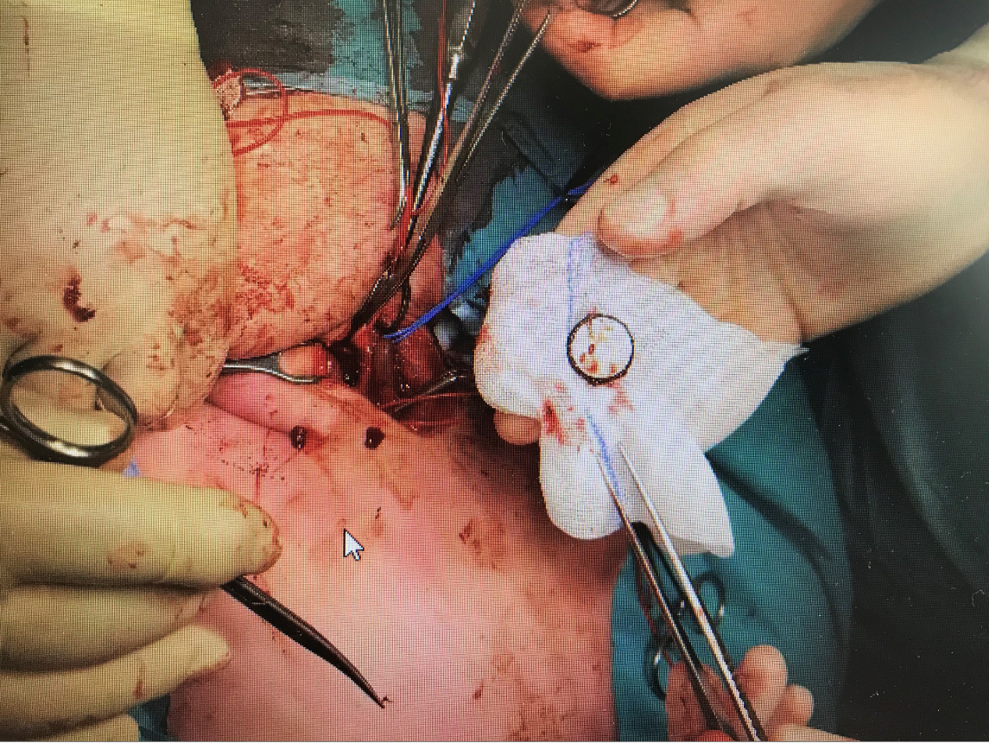
Supplementary figure 1: removal of the battery during surgery

