Supplementary Figure 2

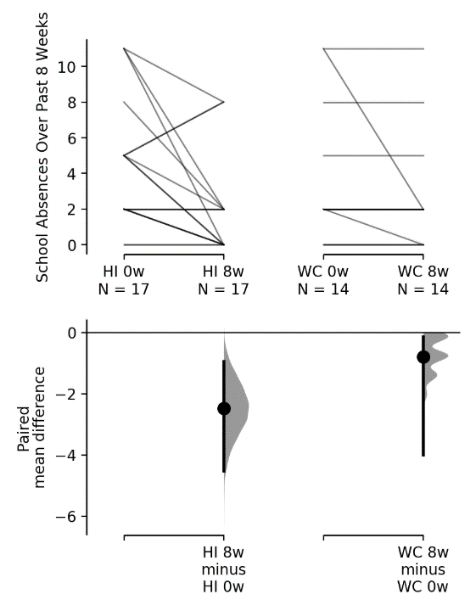
Supplementary Figure 2: Paired mean differences for parent-reported school absences in the past 8 weeks at baseline (0w) and week 8 (8w) in HI and WC. Number of school absences decreased in 59% of HI patients compared to 14% of WC patients, with p < 0.01 by chi-square test. HI = Hypnosis Intervention. WC = Waitlist Control.

