Supplementary Figure 3: Self-Hypnosis Practice Frequency and QoL

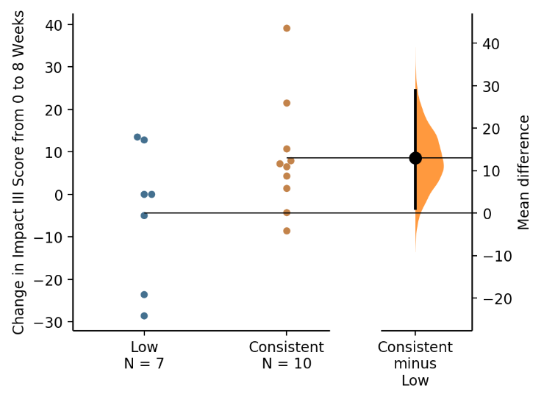
Supplementary Figure 3: Two-group comparison of HI patients who practiced self-hypnosis at least 3-4 times per week on average (Consistent) and those who did not (Low) by change in Impact III score from 0 to 8 weeks. Unpaired mean difference between Low and Consistent: 13 [95% CI 1.16, 28.8], p=0.1. QoL: quality of life.

