Long-term Sebelipase Alfa Treatment in Children and Adults With Lysosomal Acid Lipase Deficiency

Barbara K. Burton, Alejandra Consuelo Sanchez, Maria Kostyleva, Ana Maria Martins, Sachin Marulkar, Florian Abel, Ivo Barić

Supplemental Digital Content

Supplemental Digital Content

Supplemental Digital Content 1:
Text:
Inclusion Criteria
Exclusion Criteria

Supplemental Digital Content 2:
Text:
Assignment of Ishak Stage, Steatosis Scores, and Lobular and Portal Inflammation Scores

Supplemental Digital Content 3:
Table S1. Percentage of Patients Meeting Key Inclusion Criteria

Supplemental Digital Content 4:
Table S2. Baseline Demographic and Clinical Characteristics

Supplemental Digital Content 5:
Figure S1. Changes in Median ALT (A) and AST (B) Over Time

Supplemental Digital Content 6:
Figure S2. Changes in Median LDL-C (A) and HDL-C (B) Over Time

Supplemental Digital Content 7:
Table S3. Change From Baseline to Week 144 in Liver and Lipid Parameters in Patients With Cirrhosis at Baseline

Supplemental Digital Content 8:
Text:
Changes in Liver and Lipid Parameters in Patients Who Had Received Prior Liver Transplant or Hematopoietic Stem Cell Transplant

Supplemental Digital Content 9:
Table S4. Summary of Treatment-Emergent Adverse Events (TEAEs) by Preferred Term

Supplemental Digital Content 1

Inclusion Criteria
For inclusion into the trial, patients were required to fulfill all of the following criteria:
- Patient was >8 months of age at the time of dosing
- Patient or patient’s parent or legal guardian (if applicable) consented to participation in the study. If the patient was of minor age, he/she was willing to provide assent where required per local regulations, and if deemed able to do so
- Confirmation of lysosomal acid lipase deficiency (LAL-D) diagnosis as determined by the central laboratory; a patient who received a liver transplant (LT) or underwent hematopoietic stem cell transplantation (HSCT) and did not show evidence of LAL enzyme deficiency by dried blood spot (DBS) analysis due to the effects of transplantation was required to have either:
  - Molecular genetic testing that confirmed mutations in both alleles of the LIPA gene (note: in a highly suggestive case of LAL-D where only 1 mutation was identified, patients could be included based on a fibroblast enzyme activity assay); OR
  - Appropriately documented (based on consultation with the sponsor) historical result of an enzyme test prior to HSCT or LT (performed in DBS, leukocytes, or fibroblasts)
- Patients >8 months but <4 years of age at screening were to have at least 1 of the following documented clinical manifestations of LAL-D:
  - Dyslipidemia (defined as screening low-density lipoprotein cholesterol [LDL-C] level >130 mg/dL; triglycerides >200 mg/dL)
  - Elevated aminotransferases (alanine aminotransferase level ≥1.5 times the upper limit of normal based on the age- and gender-specific normal ranges of the central laboratory performing the assay)
  - Impaired growth as defined as:
    - Weight-for-age (WFA) or height-for-age (HFA) less than the age- and gender- appropriate 5th percentile on a standard World Health Organization (WHO) (patients ≤24 months of age) or Centers for Disease Control and Prevention (CDC) (patients >24 months and <4 years of age) WFA or HFA chart for at least 3 months prior to study entry; OR
    - Poor weight gain as evidenced by calculated weight percentile decreasing across 2 major percentile (99th, 97th, 95th, 90th, 75th, 50th, 25th, 10th, 5th, 3rd, and 1st) lines on a standard WHO (patients ≤24 months of age) or CDC (patients >24 months and <4 years of age) WFA chart over a period of 6 months prior to study entry
  - Suspected malabsorption with:
    - Persistent unexplained gastrointestinal symptoms such as nausea, diarrhea, abdominal pain, and bloating; OR
    - Unexplained anemia, or other abnormalities suggestive of malabsorption (eg, osteomalacia, hypoalbuminemia, prolonged bleeding time due to vitamin K deficiency); AND
    - Documented small intestinal disease involvement on a small bowel biopsy performed within 1 year of screening
  - Other clinical manifestation of LAL-D in the opinion of the investigator and in consultation with the sponsor (eg, abnormal cardiac or pulmonary functions, or presence of lymphadenopathy by imaging or palpation)
- Patients ≥4 years of age at screening were to have at least 1 of the following documented clinical manifestations of LAL-D:
  - Evidence of advanced liver disease (eg, cirrhosis confirmed by imaging or biopsy) at screening accompanied by:
    - Clinically significant portal hypertension as defined by a hepatic venous pressure gradient ≥10 mm Hg; OR
    - Documented esophageal varices (historical or by esophagogastroduodenoscopy at screening, unless medically contraindicated due to a high risk of endoscopy-related bleeding based on the presence of esophageal varices on endoscopy carried out within 3 months of assessment)
  - Disease recurrence in patients with past LT or HSCT (eg, re-accumulation of lipid-containing Kupffer cells, recurrence of fibrosis)
  - Persistent dyslipidemia (defined as LDL-C >130 mg/dL, triglycerides >200 mg/dL, or HDL-C <40 mg/dL in males and <50 mg/dL in females) that had persisted despite 3 or more months of treatment with 1 or more lipid-modifying therapies such as statins, cholesterol absorption inhibitors (eg, ezetimibe), combination therapies (single pill; ezetimibe/simvastatin, niacin/simvastatin), fibrates (fenofibrate, gemfibrozil, fenofibric acid), niacin, or bile acid sequestrants (cholestyramine, colestipol, colesevelam)
  - Suspected malabsorption based on the following manifestations:
    - Documented small intestinal involvement by small bowel biopsy performed within 1 year of screening; AND
    - Unexplained iron deficiency, osteopenia, weight loss, or chronic diarrhea; OR
    - Impaired growth in pediatric patients defined as:
- WFA or HFA less than the age- and gender- appropriate 5th percentile on a standard CDC WFA chart for at least 6 months prior to study entry; OR
- Poor weight gain as evidenced by calculated weight percentile decreasing across 2 major percentile (99th, 97th, 95th, 90th, 75th, 50th, 25th, 10th, 5th, 3rd, and 1st) lines on a standard CDC WFA chart over a period of 6 months prior to study entry
  - Other clinical manifestation of LAL-D in the opinion of the investigator and in consultation with the sponsor (eg, abnormal cardiac or pulmonary functions, or presence of lymphadenopathy by imaging or palpation)
- Male and female patients of childbearing potential were to agree to use a highly reliable method of birth control (expected failure rate <5% per year) from the screening visit through 4 weeks after the last dose of sebelipase alfa
- Women of child-bearing potential were to have a negative serum pregnancy test result prior to entering the study
- Patients receiving lipid-modifying therapies were to be on a stable dose of the medication or stable apheresis regimen for at least 4 weeks prior to treatment and be willing to remain on a stable dose for at least the first 12 weeks of treatment in the study
- Patients receiving medications for the treatment of nonalcoholic fatty liver disease (eg, glitazones, high-dose vitamin E, metformin, ursodeoxycholic acid) were to be on a stable dose for at least 4 weeks prior to treatment and be willing to remain on a stable dose for at least the first 12 weeks of treatment in the study
Exclusion Criteria
Any of the following was regarded as a criterion for exclusion from the trial:
- Patient met eligibility criteria for another interventional study of sebelipase alfa in LAL-D that was open for enrollment in the region where the patient was to receive treatment
- Patient had known causes of active liver disease other than LAL-D which had not been adequately treated (eg, chronic viral hepatitis, autoimmune hepatitis, alcoholic liver disease)
- Patient was unable or unwilling to comply with study procedures
- Patient received an HSCT or LT <2 years from the time of dosing
- Female patient was nursing or pregnant
- Patient with comorbidities other than complications due to LAL-D which, in the opinion of the investigator and in consultation with the sponsor, were irreversible or associated with a high mortality risk within 6 months or would interfere with study compliance or data interpretation (eg, excessive alcohol consumption)
- Exposure to any investigational product within 30 days of screening for a small molecule and within 60 days of screening for a biologic
- Known hypersensitivity to eggs

Supplemental Digital Content 2

Assignment of Ishak Stage, Steatosis Scores, and Lobular and Portal Inflammation Scores
Ishak stages were assigned as stage 0 = no fibrosis (normal); stage 1 = portal fibrosis (mild); stage 2 = portal fibrosis (moderate to severe); stage 3 = bridging fibrosis (few bridges); stage 4 = bridging fibrosis (many bridges); stage 5 = early cirrhosis; stage 6 = established or advanced cirrhosis. Computer-assisted morphometry was used to quantify steatosis. Steatosis scores were 0 = no macrovesicular or microvesicular steatosis; 1 = fat vacuoles replacing <5% of hepatocyte area; 2 = fat vacuoles replacing 5%–33% of hepatocyte area; 3 = fat vacuoles replacing 33%–66% of hepatocyte area; 4 = fat vacuoles replacing >66% of hepatocyte area. Lobular inflammation scores were 0 = none; 1 = 1 focus or less per 10X objective; 2 = 2–4 foci per 10X objective; 3 = 5–10 foci per 10X objective; 4 = >10 foci per 10X objective. Portal inflammation scores were 0 = none; 1 = mild, some or all portal areas; 2 = moderate, some or all portal areas; 3 = moderate/marked, all portal areas; 4 = marked, all portal areas.
Supplemental Digital Content 3

Table S1. Percentage of Patients Meeting Key Inclusion Criteria
Inclusion Criterion | n (%)
Patients >8 months to <4 years of age (n=6)
Impaired growth | 1 (17)
Suspected malabsorption | 1 (17)
Dyslipidemia | 6 (100)
Elevated aminotransferases | 6 (100)
Other clinical manifestations of LAL-Dª | 0 (0)
Patients ≥4 years of age (n=25)
Suspected malabsorption | 7 (28)
Dyslipidemia | 13 (52)
Advanced liver disease | 5 (20)
Previous liver or hematopoietic stem cell transplant | 4 (16)^{b}
Other clinical manifestations of LAL-Dª | 4 (16)
LAL-D, lysosomal acid lipase deficiency.
ªIncludes abnormal cardiac or pulmonary functions, or presence of lymphadenopathy by imaging or palpation; atypical clinical manifestations include mesenteric lymphadenopathy, pulmonary hypertension, and later-onset growth impairment.
^{b}Two patients had previous liver transplant, approximately 9 years and 19 years prior to the first dose of sebelipase alfa, respectively, and 2 patients had previous hematopoietic stem cell transplant, approximately 7 years and 19 years prior to the first dose of sebelipase alfa; all 4 patients had a confirmed diagnosis of LAL-D; 2 had persistent dyslipidemia, 1 of whom also had suspected malabsorption; and 1 had other clinical manifestations of LAL-D.

Supplemental Digital Content 4

Table S2. Baseline Demographic and Clinical Characteristics
Parameter | Total  (N=31)
Age at start of sebelipase alfa treatment, years
Mean (SD) | 16.9 (14.7)
Median (range) | 11.7 (3–55)
Age distribution at informed consent, n (%)
2 to <4 years | 6 (19)
4 to 18 years | 16 (52)
>18 years | 9 (29)
Sex, n (%)
Male | 19 (61)
Female | 12 (39)
Race, n (%)
White | 27 (87)
Other | 4 (13)
Time since diagnosis, years
Mean (SD) | 6.6 (10.4)
Median (range) | 1.31 (0.1–44.3)
LIPA mutations, n (%)ª
Homozygous for c894 G→A | 7 (23)
Heterozygous for c894 G→A | 13 (43)
Other mutations | 9 (30)
No variants found | 1 (3)
Concomitant use of lipid-modifying medication, n (%)^{b}
Any agent | 16 (52)
Statin | 12 (39)
Other^{c} | 6 (19)
Ishak stage,^{d} n (%)
Stage 0: No fibrosis (normal) | 2 (7)
Stage 1: Portal fibrosis (mild) | 4 (13)
Stage 2: Portal fibrosis (moderate to severe) | 3 (10)
Stage 3: Bridging fibrosis (few bridges) | 12 (40)
Stage 4: Bridging fibrosis (many bridges) | 1 (3)
Stage 5: Early cirrhosis | 0
Stage 6: Established or advanced cirrhosis | 8 (27)
SD, standard deviation.
ªPatients may have received more than 1 lipid-modifying medication.
^{b}Colestipol (n=2), colestyramine (n=2), ezetimibe (n=1), or nicotinic acid (n=1).
^{c}n=30.
ªPercentages are based on the number of subjects with LIPA genetic sequencing results. Testing was not performed for 1 subject in the 4- to 18-year age group.
^{b}Patients may have received more than 1 lipid-modifying medication.
^{c}Colestipol (n=2), colestyramine (n=2), ezetimibe (n=1), or nicotinic acid (n=1).
^{d}n=30.

Supplemental Digital Content 5

Figure S1. Changes in Median ALT (A) and AST (B) Levels Over Time
Data are medians plus interquartile ranges (Q1, Q3). ULNs used by the central laboratory for ALT were: females (any age) and males <10 years of age: 34 U/L; males ≥10 years: 43 U/L. ULNs for AST were: ≥18 years of age: females, 34 U/L; males, 36 U/L; 7 to <18 years: females and males, 40 U/L; 4 to <7 years: females, 48 U/L; males, 59 U/L; <4 years: females, 56 U/L; males, 69 U/L. ALT, alanine aminotransferase; AST, aspartate aminotransferase; BL, baseline; ULN, upper limit of normal.

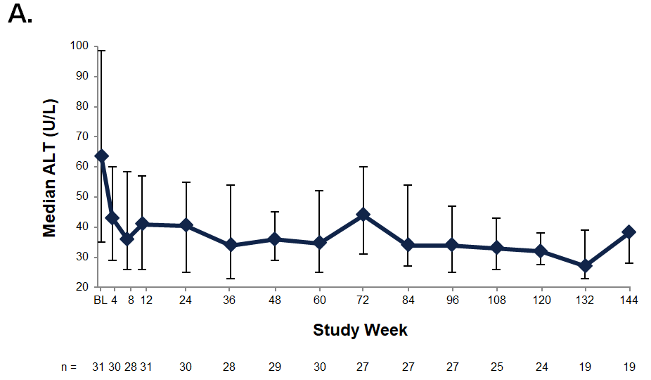

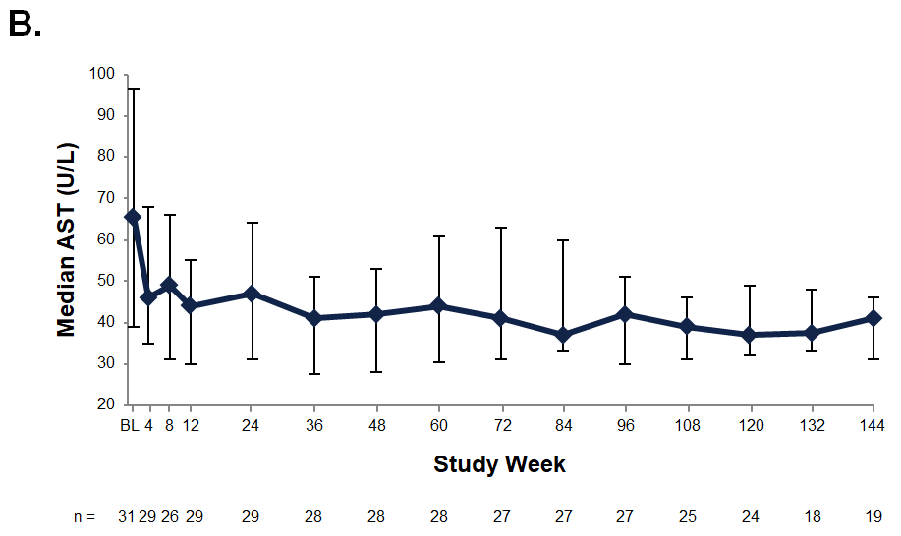

Supplemental Digital Content 6

Figure S2. Changes in Median LDL-C (A) and HDL-C (B) Levels Over Time
Data are medians plus interquartile ranges (Q1, Q3). The generally accepted upper limit of normal for LDL-C is 129 mg/dL in children and adults; the generally accepted lower limit of normal for HDL-C is 40 mg/dL in children and adult males and 50 mg/dL in adult females (1). BL, baseline; HDL-C, high-density lipoprotein cholesterol; LDL-C, low-density lipoprotein cholesterol.
      - Grundy SM, Stone NJ, Bailey AL, et al. 2018 AHA/ACC/AACVPR/AAPA/ABC/
ACPM/ADA/AGS/APhA/ASPC/NLA/PCNA Guideline on the Management of Blood Cholesterol. Circulation 2019;139:e1082-e143.

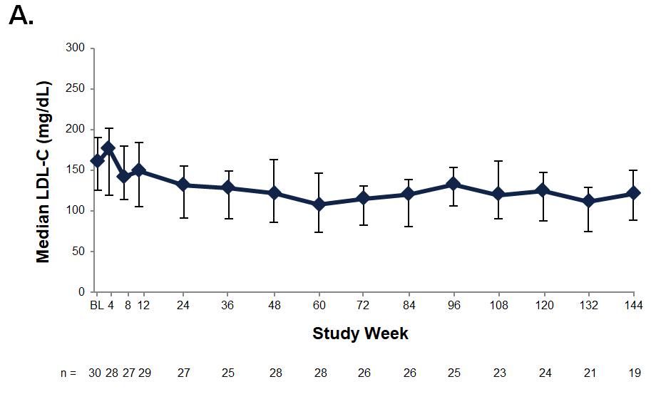

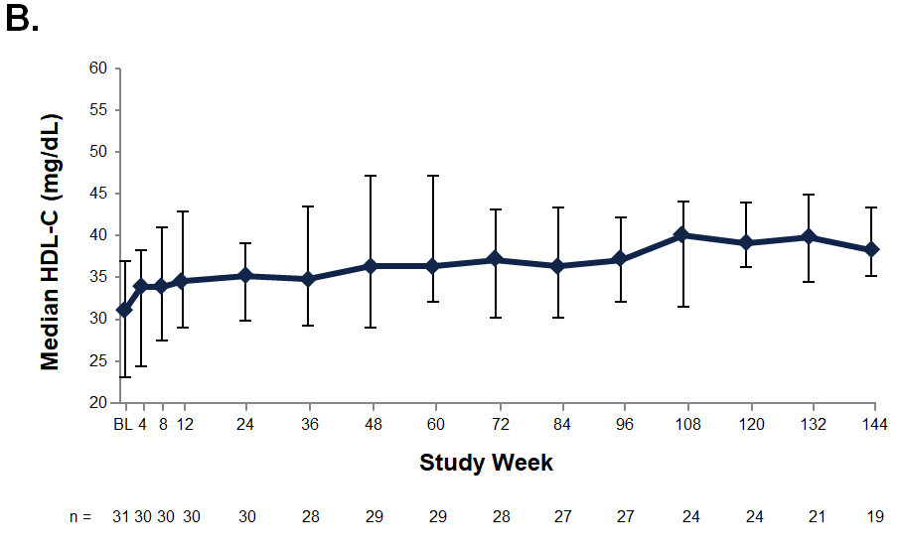

Supplemental Digital Content 7

Table S3. Change From Baseline to Week 144 in Liver and Lipid Parameters in Patients With Cirrhosis at Baseline
 | Median (Range)
 | Absolute Value | Absolute Value  [Change From Baseline]
 | Baseline  (N=8) | Week 144  (N=5)
ALT, U/L | 90.8 (47–183) | 38.0 (20–44)  [–73.0 (–163 to –7)]
AST, U/L | 112.0 (42–275) | 41.0 (30–45)  [–45.0 (–245 to –30)]
GGT, U/L | 75.8 (40–184) | 18.0 (16–90)  [–25.5 (–166 to 25)
Albumin, g/L | 40.0 (33–47) | 41.0 (38–43)  [–1.0 (–6 to 6)]
Total bilirubin, μmol/L | 16.3 (9–91) | 14.0 (7–70)  [–2.0 (–21 to 6)]
Alkaline phosphatase, U/L | 355.5 (86–502) | 262.0 (98–327)  [–157.5 (–175 to –15)]
LDL-C, mg/dL | 105.3 (85–183) | 88.9 (42–159)  [–39.4 (–95 to –12)]
HDL-C, mg/dL | 33.9 (16–47) | 37.9 (15–41)  [4.1 (–2 to 19)]
Non-HDL-C, mg/dL | 127.7 (99–231) | 107.9 (58–189)  [–44.1 (–124 to –17)]
Triglycerides, mg/dL | 113.4 (55–240) | 101.0 (82–161)  [–23.9 (–147 to 27)]
Total cholesterol, mg/dL | 159.0 (133–254) | 148.9 (93–227)  [–45.6 (–105 to –13)]
Liver volume, MN | 1.3 (1–2)ª | 1.4 (1–2)^{b}  [–0.2 (–1 to 0)]^{c}
Liver fat content, % | 6.535 (2.64–10.62) | 6.390 (3.29–8.25)^{b}  [–2.500 (–5.59 to –1.75)]^{b}
ALT, alanine aminotransferase; AST, aspartate aminotransferase; GGT, gamma glutamyltransferase; HDL-C, high-density lipoprotein cholesterol; LDL-C, low-density lipoprotein cholesterol; MN, multiples of normal.
ªn=7; ^{b}n=4; ^{c}n=3.

Supplemental Digital Content 8

Changes in liver and lipid parameters in patients who had received prior liver transplant or hematopoietic stem cell transplant
For the 2 patients who had undergone liver transplantation (LT) (>2 years prior to enrollment), treatment with sebelipase alfa resulted in relatively stable liver function: alanine aminotransferase levels increased slightly in 1 patient and remained normal in the other. Lipid levels either remained stable or improved during treatment.

Two other patients who had received a prior hematopoietic stem cell transplant (HSCT) for lysosomal acid lipase deficiency (LAL-D) very early in life (ie, at 3 months and at 8 months of age) enrolled in this study at 7 and 19 years of age, respectively. At baseline, they presented with severe disease burden, with evidence of multiple disease manifestations including growth retardation, dyslipidemia, hepatic steatosis, liver fibrosis, and hepatosplenomegaly. The severe presentation and young age at initial disease presentation were similar to what is observed in infantile-onset disease. In both cases, HSCT provided impressive survival compared with the median historical survival of 3.7 months for subjects presenting with LAL-D in infancy (1). During treatment with sebelipase alfa, serum transaminase levels increased modestly in both patients; the patient with magnetic resonance imaging data had a liver volume that was essentially normal at baseline and throughout the study, and an increase in liver fat content was observed in that patient; effects on serum lipids were variable in both patients. Considering the early and severe disease presentation, these 2 patients may have benefitted from a 3–5 mg/kg weekly dose of sebelipase alfa, which offered clinical benefit in patients with infantile-onset LAL-D (2). However, they received relatively lower doses (1 mg/kg every other week to 3 mg/kg weekly), which may explain their variable response to treatment. In cases of early and severe disease presentation, early dietary care, frequent disease monitoring, and early escalation to an effective dose of sebelipase alfa may help to improve clinical outcomes.

1. Jones SA, Banikazemi M, Bialer M, et al. Rapid progression and mortality of lysosomal acid lipase deficiency presenting in infants. Genet Med 2016;18:452-58.
2. Vijay S, Brassier A, Ghosh A, et al. Long-term survival with sebelipase alfa enzyme replacement therapy in infants with rapidly progressive lysosomal acid lipase deficiency: final results from 2 open-label studies. Orphanet J Rare Dis 2021;16:13.

Supplemental Digital Content 9

Table S4. Summary of Treatment-Emergent Adverse Events (TEAEs) by Preferred Term
Event | n (%)
Any TEAE | 31 (100)
Most common TEAEs (≥3 patients)
Pyrexia | 17 (55)
Nasopharyngitis | 14 (45)
Diarrhea | 13 (42)
Abdominal pain | 12 (39)
Headache | 10 (32)
Upper respiratory tract infection | 10 (32)
Vomiting | 10 (32)
Cough | 8 (26)
Epistaxis | 7 (23)
Gastroenteritis | 7 (23)
Pharyngitis | 7 (23)
Respiratory tract infection | 7 (23)
Contusion | 6 (19)
Vitamin D deficiency | 6 (19)
Upper abdominal pain | 6 (19)
Oropharyngeal pain | 5 (16)
Conjunctivitis | 4 (13)
Ecchymosis | 4 (13)
Bronchitis | 3 (10)
Body temperature increased | 3 (10)
Catarrh | 3 (10)
Constipation | 3 (10)
Dizziness | 3 (10)
Ear infection | 3 (10)
Eye infection | 3 (10)
Fatigue | 3 (10)
Hematoma | 3 (10)
Influenza | 3 (10)
Limb injury | 3 (10)
Nausea | 3 (10)
Constipation | 3 (10)
Oral herpes | 3 (10)
Acute otitis media | 3 (10)
Rhinitis | 3 (10)
Rhinorrhea | 3 (10)
Sinusitis | 3 (10)
Urinary tract infection | 3 (10)
TEAE related to study drug | 10 (32)
Severe TEAEª | 4 (13)
Infusion-associated reaction | 3 (10)
TEAE leading to discontinuation from the study^{b} | 1 (3)
Any serious TEAE | 10 (32)
Abdominal pain | 3 (10)
Pneumonia | 2 (6)
Anaphylactic reaction | 1 (3)
Clavicle fracture | 1 (3)
Device breakage (central catheter) | 1 (3)
Fluid overload | 1 (3)
Gastrointestinal hemorrhage | 1 (3)
Hepatic function abnormal | 1 (3)
Liver transplant | 1 (3)
Lower abdominal pain | 1 (3)
Pneumothorax | 1 (3)
Radius fracture | 1 (3)
Shock | 1 (3)
Serious TEAE related to study drug^{c} | 1 (3)
TEAE leading to death | 0
ªAbdominal pain (n=2); increased body temperature (n=1); gastrointestinal hemorrhage, fluid overload, shock, and liver transplant (n=1); all severe TEAEs were assessed by the investigator as unrelated or unlikely to be related to study treatment.
^{b}Liver transplant; assessed as unrelated to study treatment.
^{c}Anaphylactic reaction.

