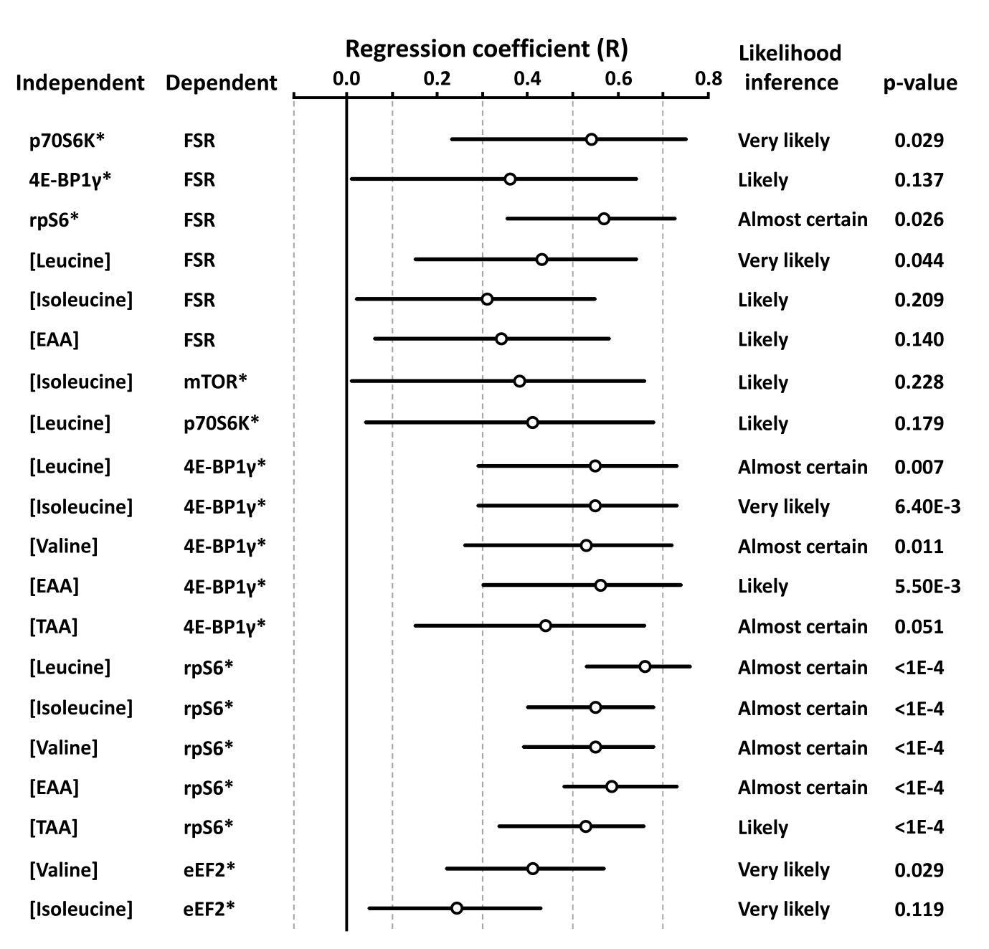

Supplementary Data 1. Outcome for the regressions of mean plasma amino-acid concentration or mTOR-pathway phosphoprotein phosphorylation state on the myofibrillar protein fractional synthetic rate (FSR), and plasma amino acids on phosphoprotein phosphorylation state with skeletal muscle FSR. Data are effect size (regression coefficient, R) with 90% confidence interval. Only statistically clear outcomes based on the magnitude-based inference method are presented. Abbreviations: EAA, essential amino acids; TAA, total amino acids. Thresholds for assigning qualitative terms to chances of substantial (r>0.1) correlations: <0.5%, almost certainly not; <5.0%, very unlikely; <25%, unlikely; <75%, possible; >75%, likely; >95%, very likely; >99.5%, almost certain. Lower correlations required greater certainty to be included as a clear outcome (i.e. likely-to-almost certain), where r =0.1<0.3, 99% confidence; r=0.3<0.5, 95% confidence; r >0.5, 90% confidence. Therefore, a correlation was unclear if the likelihood for an opposing correlation overlapped into the lower level of confidence. Effect size thresholds were: <0.1 trivial, <0.3 small, <0.5 moderate, <0.7 large, <0.9 very large, <1.0 almost perfect. For brevity, data for correlations involving isoleucine and valine are only shown if at least one of the time-points met inclusion threshold criteria.*denotes log-transformed variable.

