ONLINE SUPPLEMENTAL APPENDIX:
Methods to estimate VO2max upon acute hypoxia exposure.

Martin MacInnis^{1,2}, Sean Nugent¹, Kristin MacLeod¹, Keith Lohse³
¹ School of Kinesiology, University of British Columbia, Canada
² Department of Kinesiology, McMaster University, Canada
³ School of Kinesiology, Auburn University, USA

Corresponding author for the appendix:
Keith Lohse, PhD
School of Kinesiology,
Auburn University,
301 Wire Road
Auburn, AL, 36849
United States of America
p: 334.844.1982
e: motorlearnlab@gmail.com

Supplemental Table I. Predicted decreases in VO2max for a variety of baseline values (in mL• kg⁻¹•min⁻¹) and altitudes (in km), shown as point estimates and 95% prediction intervals.
 | Baseline VO_{2max} (mL• kg⁻¹•min⁻¹)
Test Altitude (km) | 35 | 45 | 55 | 65 | 75
1 | 31.47 ±6.66 | 44.24 ±6.66 | 54.01 ±6.66 | 60.75 ±6.66 | 64.47 ±6.66
2 | 31.27 ±6.66 | 42.46 ±6.66 | 50.64 ±6.66 | 55.79 ±6.66 | 57.94 ±6.66
3 | 30.19 ±6.66 | 39.81 ±6.66 | 46.40 ±6.66 | 49.97 ±6.66 | 50.53 ±6.66
4 | 28.25 ±6.66 | 36.29 ±6.66 | 41.29 ±6.66 | 43.29 ±6.66 | †42.27
5 | 25.44 ±6.66 | 36.29 ±6.66 | 35.32 ±6.66 | 35.73 ±6.66 | †33.13
6 | 21.76 ±6.66 | 31.89 ±6.66 | 28.48 ±6.66 | 27.31 ±6.66 | †23.12
Note. The prediction intervals shown are based on the sqrt(τ²)∙z_{crit}∙$\overline{s_{p}}$.
As τ² reflects the variance between studies with the same predicted value (ie, the same values on all covariates), the sqrt(τ²) is thus conceptually similar to the standard deviation for a single point of the regression line. Multiplying this value, τ = 0.61, by the z-critical value 1.96, returns the margin of error in standardized units. In order to transform the margin of error back into mL• kg⁻¹•min⁻¹, we multiply the margin of error by the average pooled standard deviation, $\overline{s_{p}}=5.59$, to approximate the 95% margin of error in the original units, MOE = ±6.66.
† denotes an estimate that should be treated with caution because these high-fitness, high-altitude estimates extrapolate beyond the available data.

The Effects of Altitude and Baseline Fitness on VO2max
Keith Lohse
Monday, December 15th, 2014

Constructing the basic random-effects model.
First, you need to make sure that the "metafor" package is installed and make sure to have the "AltFit.txt" file saved in your working directory.
library(metafor);library(plyr);library(dplyr);library(tidyr);library(ggplot2);library(RCurl)
if(!file.exists("./data")){dir.create("./data")}
fileURL<-"https://raw.github.com/keithlohse/AltFit/master/AltFit Dec 15.txt"
download.file(fileURL, destfile="./data/AltFit.txt", method="curl")
## Warning: running command 'curl
## "https://raw.github.com/keithlohse/AltFit/master/AltFit.txt" -o
## "./data/AltFit.txt"' had status 127
## Warning in download.file(fileURL, destfile = "./data/AltFit.txt", method =
## "curl"): download had nonzero exit status
FULLDATA<-read.table("./data/AltFit.txt", header = TRUE, sep="\t")
tail(FULLDATA)
## Number Reference SampleSize NumFemale Hypobaric Mode LowAlt
## 100 84 Esposito, 2010 9 0 0 cycle 40
## 101 85 Roels, 2007 8 0 0 cycle 0
## 102 85 Roels, 2007 10 0 0 cycle 0
## 103 86 Puype, 2013 9 0 0 cycle 0
## 104 86 Puype, 2013 10 0 0 cycle 0
## 105 86 Puype, 2013 10 0 0 cycle 0
## HighAlt DiffAlt BVO2 BVO2SD AVO2 AVO2SD Altitude Swithin ES
## 100 5000 4960 51.5 8.7 38.8 5.4 5 7.240511 -12.7
## 101 3000 3000 58.1 2.3 47.6 2.3 3 2.300000 -10.5
## 102 3000 3000 58.5 2.2 48.3 3.0 3 2.630589 -10.2
## 103 3000 3000 54.8 6.9 48.7 5.7 3 6.328507 -6.1
## 104 3000 3000 56.8 9.5 50.9 8.9 3 9.204890 -5.9
## 105 3000 3000 55.1 5.4 48.5 5.1 3 5.252142 -6.6
## d Vd_Independent Vd_Corr J G
## 100 -1.7540198 0.3076829 0.14101627 0.9032258 -1.5842760
## 101 -4.5652174 0.9012878 0.71378781 0.8888889 -4.0579710
## 102 -3.8774582 0.5758671 0.42586705 0.9142857 -3.5451046
## 103 -0.9638924 0.2480302 0.08136357 0.9032258 -0.8706125
## 104 -0.6409637 0.2102709 0.06027086 0.9142857 -0.5860239
## 105 -1.2566301 0.2394780 0.08947798 0.9142857 -1.1489189
## Vg_Independent Vg_Corr
## 100 0.2510129 0.11504345
## 101 0.7121286 0.56398049
## 102 0.4813778 0.35599009
## 103 0.2023473 0.06637777
## 104 0.1757693 0.05038152
## 105 0.2001840 0.07479629
Once the data are imported, we want to create our basic random-effects (RE) model. The standard RE model provides you with a summary effect size and measures of heterogeneity. Because we are ultimately interested in building on this model using meta-regression, the first RE model can be thought of as an "intercept only model". That is, we are estimating the average drop in VO2 Max regardless of baseline fitness or altitude.
Model1<-rma(G,Vg_Corr,data=FULLDATA)
Model1
##
## Random-Effects Model (k = 105; tau^2 estimator: REML)
##
## tau^2 (estimated amount of total heterogeneity): 1.8505 (SE = 0.2842)
## tau (square root of estimated tau^2 value): 1.3603
## I^2 (total heterogeneity / total variability): 95.11%
## H^2 (total variability / sampling variability): 20.46
##
## Test for Heterogeneity:
## Q(df = 104) = 963.2363, p-val < .0001
##
## Model Results:
##
## estimate se zval pval ci.lb ci.ub
## -1.7740 0.1403 -12.6427 <.0001 -2.0490 -1.4990 ***
##
## ---
## Signif. codes: 0 '***' 0.001 '**' 0.01 '*' 0.05 '.' 0.1 ' ' 1
confint(Model1)
##
## estimate ci.lb ci.ub
## tau^2 1.8505 1.6980 3.4424
## tau 1.3603 1.3031 1.8554
## I^2(%) 95.1115 94.6958 97.3114
## H^2 20.4560 18.8529 37.1936
We can see the result is statistically significant, but not necessarily meaningful, it just tells us that the average drop is not 0. The most important thing this does give us is the tau-squared value for the intercept only model.
Tau tells us the variance between effect sizes without controlling for altitude or baseline VO2. (This tau-squared value will be used as the "baseline" variance in our subsequent analyses)
To visualize the data at this stage, we can create some of the basic forest plots and funnel plots you might normally see in a meta-analysis. Be warned, however, that the forest plot will be very, very busy as there are 105 independent groups of subjects in this analysis. Also that the funnel plot will be very skewed. In this case, funnel plot skew is not the result of publication bias, but the result of a physiological ceiling (i.e., taking someone to altitude will never make their VO2max higher).
#Creating a forest plot to show the RE model of all of the data
forest(Model1, cex=1.5)
#Creating a funnel plot to show potential bias in the full dataset
funnel(Model1)
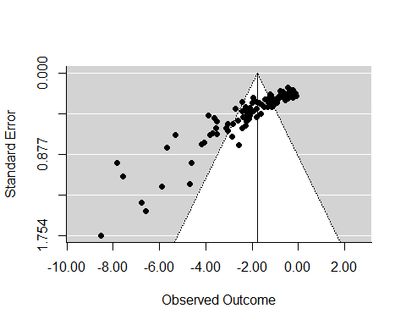
#Statistical test of symmetry
regtest(Model1, model = "lm")
##
## Regression Test for Funnel Plot Asymmetry
##
## model: weighted regression with multiplicative dispersion
## predictor: standard error
##
## test for funnel plot asymmetry: t = -19.0397, df = 103, p < .0001
#This test just tells us that the effect sizes are negatively skewed, but that is okay.
#Given the physiological limits, we only expect to see negative changes.

Explaining heterogeneity with meta-analytic regressions.
Prior to calculating our meta-regression, we want to visual the relationships between our predictors and our outcomes. Code for generating figures and coducting correlation analyses is provided below:
#Plotting the data prior to analysis
plot(G~HighAlt, data = FULLDATA, cex.lab=1.2)
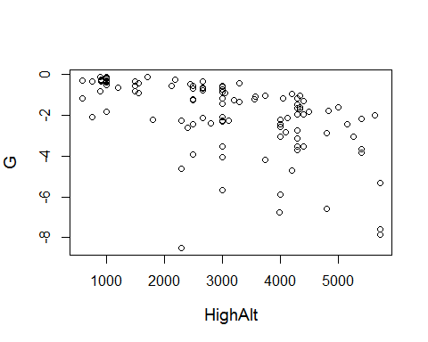
cor.test(FULLDATA$G,FULLDATA$HighAlt)
##
## Pearson's product-moment correlation
##
## data: FULLDATA$G and FULLDATA$HighAlt
## t = -6.3407, df = 103, p-value = 6.16e-09
## alternative hypothesis: true correlation is not equal to 0
## 95 percent confidence interval:
## -0.6550055 -0.3764224
## sample estimates:
## cor
## -0.5298598
#same plot in Km
plot(G~Altitude, data = FULLDATA, cex.lab=1.2)
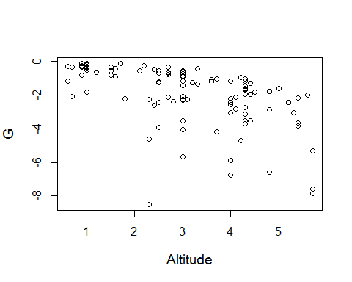
cor.test(FULLDATA$G,FULLDATA$Altitude)
##
## Pearson's product-moment correlation
##
## data: FULLDATA$G and FULLDATA$Altitude
## t = -6.3346, df = 103, p-value = 6.339e-09
## alternative hypothesis: true correlation is not equal to 0
## 95 percent confidence interval:
## -0.6547123 -0.3759817
## sample estimates:
## cor
## -0.5294905
#effect size as a function of baseline vo2
plot(G~BVO2, data = FULLDATA, cex.lab=1.2)
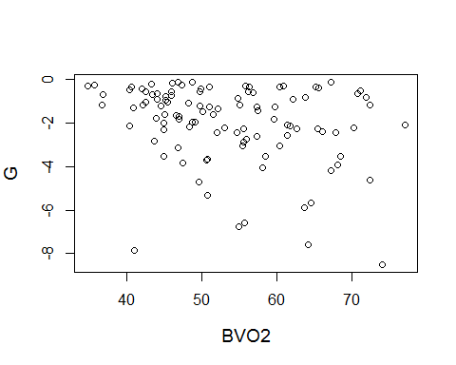
cor.test(FULLDATA$G,FULLDATA$BVO2)
##
## Pearson's product-moment correlation
##
## data: FULLDATA$G and FULLDATA$BVO2
## t = -2.8915, df = 103, p-value = 0.004678
## alternative hypothesis: true correlation is not equal to 0
## 95 percent confidence interval:
## -0.44243410 -0.08690283
## sample estimates:
## cor
## -0.2740042
#Relationship (none) between altitude and baseline vo2
plot(Altitude~BVO2, data = FULLDATA, cex.lab=1.2)
line<-lm(FULLDATA$Altitude~FULLDATA$BVO2)
abline(line)
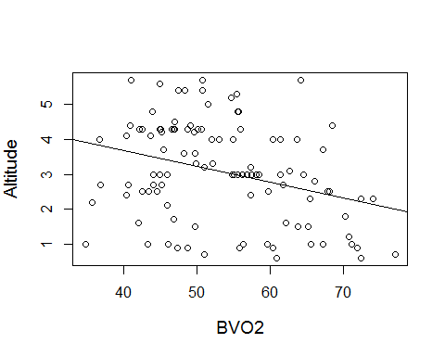
cor.test(FULLDATA$Altitude,FULLDATA$BVO2)
##
## Pearson's product-moment correlation
##
## data: FULLDATA$Altitude and FULLDATA$BVO2
## t = -3.3581, df = 103, p-value = 0.001101
## alternative hypothesis: true correlation is not equal to 0
## 95 percent confidence interval:
## -0.4770752 -0.1303147
## sample estimates:
## cor
## -0.3141339
One of the issues with these data was that the fittest subjects (those with VO2max > 75) were never taken to high altitude. This made the altitude~base line fitness relationship appear negative. We can re-run that correlation after removing the fittest individuals. We can see then that the negative correlation is probably the result of no trials taking elite athletes to very high altitudes.
#Recreating the same test removing the fittest subjects
lessfit<-subset(FULLDATA, BVO2< 70)
plot(Altitude~BVO2, data = lessfit, cex.lab=1.2)
line<-lm(lessfit$Altitude~lessfit$BVO2)
abline(line)
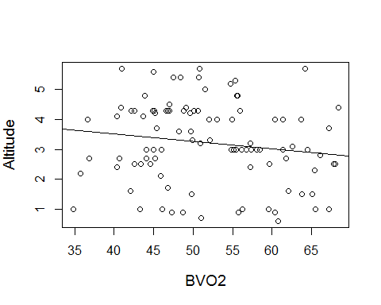
cor.test(lessfit$Altitude,lessfit$BVO2)
##
## Pearson's product-moment correlation
##
## data: lessfit$Altitude and lessfit$BVO2
## t = -1.5137, df = 95, p-value = 0.1334
## alternative hypothesis: true correlation is not equal to 0
## 95 percent confidence interval:
## -0.34242619 0.04743566
## sample estimates:
## cor
## -0.1534616
We can also create a table or a bar plot to show the different modalities that were used across the various experiments:
#Creating a barplot of the different testing modalities.
table(FULLDATA$Mode)
##
## cycle rowing skiing treadmill
## 85 1 1 18
barplot(table(FULLDATA$Mode), ylim=c(0,80))
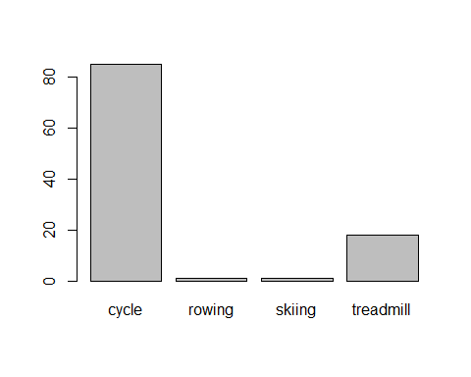
Prior to running our meta-regressions, we still want to get some descriptive statistics (means and standard deviations) for all of our predictors. Knowing these values is an important first step in understanding our data. We want to be careful in interpreting regression output that we do not generalize beyond our data. Thus, we do not want to predict the drop in VO2max for a person with a baseline VO2 of 85 mL/kg/ min if the highest VO2max in our database is 65 mL/kg/min!
##Obtaining descriptive statistics:
#The average baseline VO2
mean(FULLDATA$BVO2)
## [1] 53.52467
#The standard deviation of baseline VO2
sd(FULLDATA$BVO2)
## [1] 9.826217
#The average TEST altitude
mean(FULLDATA$Altitude)
## [1] 3.075238
#The standard deviation of TEST
sd(FULLDATA$Altitude)
## [1] 1.417526
#The average BASELINE altitude
mean(as.numeric(FULLDATA$LowAlt), na.rm=TRUE)
## [1] 5.67619
#The standard deviation of BASELINE altitude
sd(as.numeric(FULLDATA$LowAlt), na.rm=TRUE)
## [1] 6.484442
#The average pooled standard deviation
##THIS IS IMPORTANT FOR TRANSFORMING EFFECT SIZES BACK INTO VO2 UNITS LATER ON!
mean(FULLDATA$Swithin)
## [1] 5.591304

META REGRESSION MODELS

Using Centered Predictors.
For analyses, we want to use predictors in which values of zero are meaningful (this greatly simplifies the interpretation of the outputs). For altitude, a value of zero is meaningful because that would represent a test that took place at sea-level. For baseline fitness, however, a value of zero is not meaningful because that is not a possible VO2max for a research participant to have. Thus, we center baseline fitness around the average baseline VO2max. As a result, in the centered variable a value of zero represents the average level of fitness, positive values are fitter participants, and negative values are less fit participants.
##Creating a centered predictor of BVO2
##The centered predictor is useful for the statistical models.
mean(FULLDATA$BVO2)
## [1] 53.52467
FULLDATA$BVO2C<-FULLDATA$BVO2-mean(FULLDATA$BVO2)
##The mean of the "centered" variable is zero. Thus, positive scores are people above
#the mean and negative scores are people below the mean.
mean(FULLDATA$BVO2C)
## [1] -1.691901e-15
We are also interested in nonlinear effects of both altitude and baseline fitness. Thus, we created the quadratic predictors of baseline fitness^2 and altitude^2 to be inlcluded in our analyses:
##We also want nonlinear versions of
#CENTERED baseline VO2
FULLDATA$BVO2C_SQ<-FULLDATA$BVO2C*FULLDATA$BVO2C
#Non-centered baseline VO2
FULLDATA$BVO2_SQ<-FULLDATA$BVO2*FULLDATA$BVO2
#and Altitude
FULLDATA$AltSq<-FULLDATA$Altitude^2
##We do not need to create a centered version of the altitude variable because an altitude of 0 is already a meaningful value (i.e., sea-level), whereas a raw Baseline VO2 Max of 0 is not a meaningful value (i.e., that person would be dead).
After creating the centered and the nonlinear predictor variables, we are finally ready to enter them into our statistical models. Code for creating each of these models is provided below. Starting with the simplest and moving up to the most complex.
##Model2
#Simple effect of Altitude (in km)
Model2<-rma(G, Vg_Corr, mods=~Altitude,data=FULLDATA, method="REML")
Model2
##
## Mixed-Effects Model (k = 105; tau^2 estimator: REML)
##
## tau^2 (estimated amount of residual heterogeneity): 0.9668 (SE = 0.1591)
## tau (square root of estimated tau^2 value): 0.9832
## I^2 (residual heterogeneity / unaccounted variability): 91.02%
## H^2 (unaccounted variability / sampling variability): 11.13
## R^2 (amount of heterogeneity accounted for): 47.76%
##
## Test for Residual Heterogeneity:
## QE(df = 103) = 592.9905, p-val < .0001
##
## Test of Moderators (coefficient(s) 2):
## QM(df = 1) = 62.2249, p-val < .0001
##
## Model Results:
##
## estimate se zval pval ci.lb ci.ub
## intrcpt 0.0708 0.2449 0.2892 0.7724 -0.4092 0.5509
## Altitude -0.5887 0.0746 -7.8883 <.0001 -0.7350 -0.4425 ***
##
## ---
## Signif. codes: 0 '***' 0.001 '**' 0.01 '*' 0.05 '.' 0.1 ' ' 1
qqnorm(Model2, main="Mixed-Effects Model")
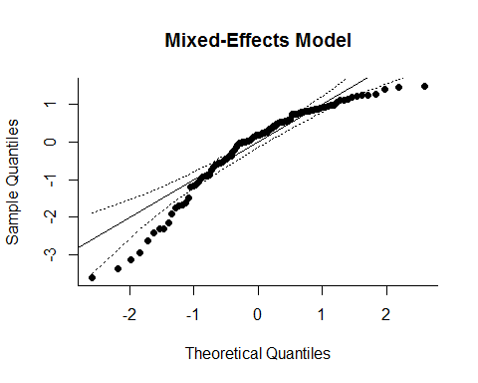
##Model5: Using the centered baseline VO2 Max values
#Main effects of both BVO2C and Altitude
Model5<-rma(G, Vg_Corr, mods=~Altitude+BVO2C,data=FULLDATA, method="REML")
Model5
##
## Mixed-Effects Model (k = 105; tau^2 estimator: REML)
##
## tau^2 (estimated amount of residual heterogeneity): 0.5179 (SE = 0.0939)
## tau (square root of estimated tau^2 value): 0.7196
## I^2 (residual heterogeneity / unaccounted variability): 84.37%
## H^2 (unaccounted variability / sampling variability): 6.40
## R^2 (amount of heterogeneity accounted for): 72.01%
##
## Test for Residual Heterogeneity:
## QE(df = 102) = 440.2968, p-val < .0001
##
## Test of Moderators (coefficient(s) 2,3):
## QM(df = 2) = 148.6939, p-val < .0001
##
## Model Results:
##
## estimate se zval pval ci.lb ci.ub
## intrcpt 0.4585 0.1940 2.3632 0.0181 0.0782 0.8387 *
## Altitude -0.7107 0.0612 -11.6037 <.0001 -0.8307 -0.5906 ***
## BVO2C -0.0658 0.0088 -7.4386 <.0001 -0.0831 -0.0485 ***
##
## ---
## Signif. codes: 0 '***' 0.001 '**' 0.01 '*' 0.05 '.' 0.1 ' ' 1
qqnorm(Model5, main="Mixed-Effects Model")
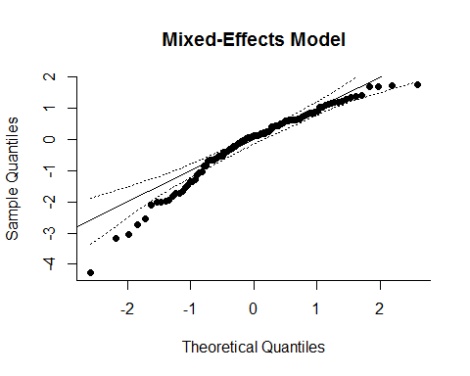
###Using the Centered predictor of BVO2 (BVO2C)
##Model7
#Adding the interaction of BVO2C and Altitude
Model7<-rma(G, Vg_Corr, mods=~Altitude*BVO2C,data=FULLDATA, method="REML")
Model7
##
## Mixed-Effects Model (k = 105; tau^2 estimator: REML)
##
## tau^2 (estimated amount of residual heterogeneity): 0.4651 (SE = 0.0865)
## tau (square root of estimated tau^2 value): 0.6820
## I^2 (residual heterogeneity / unaccounted variability): 82.88%
## H^2 (unaccounted variability / sampling variability): 5.84
## R^2 (amount of heterogeneity accounted for): 74.87%
##
## Test for Residual Heterogeneity:
## QE(df = 101) = 418.4853, p-val < .0001
##
## Test of Moderators (coefficient(s) 2,3,4):
## QM(df = 3) = 164.7479, p-val < .0001
##
## Model Results:
##
## estimate se zval pval ci.lb ci.ub
## intrcpt 0.4192 0.1857 2.2569 0.0240 0.0551 0.7832 *
## Altitude -0.7224 0.0592 -12.2045 <.0001 -0.8385 -0.6064 ***
## BVO2C -0.0277 0.0167 -1.6540 0.0981 -0.0605 0.0051 .
## Altitude:BVO2C -0.0165 0.0064 -2.5719 0.0101 -0.0291 -0.0039 *
##
## ---
## Signif. codes: 0 '***' 0.001 '**' 0.01 '*' 0.05 '.' 0.1 ' ' 1
qqnorm(Model7, main="Mixed-Effects Model")
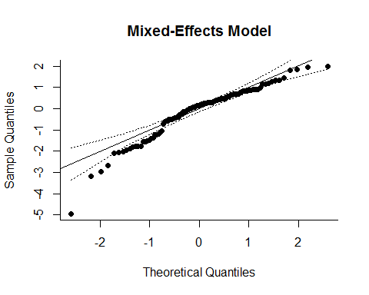
#Adding the interaction of BVO2C and AltSq
Model9<-rma(G, Vg_Corr, mods=~Altitude*BVO2C+AltSq,data=FULLDATA, method="REML")
Model9
##
## Mixed-Effects Model (k = 105; tau^2 estimator: REML)
##
## tau^2 (estimated amount of residual heterogeneity): 0.4507 (SE = 0.0847)
## tau (square root of estimated tau^2 value): 0.6714
## I^2 (residual heterogeneity / unaccounted variability): 82.38%
## H^2 (unaccounted variability / sampling variability): 5.68
## R^2 (amount of heterogeneity accounted for): 75.64%
##
## Test for Residual Heterogeneity:
## QE(df = 100) = 400.6114, p-val < .0001
##
## Test of Moderators (coefficient(s) 2,3,4,5):
## QM(df = 4) = 170.8793, p-val < .0001
##
## Model Results:
##
## estimate se zval pval ci.lb ci.ub
## intrcpt -0.0801 0.3338 -0.2400 0.8103 -0.7343 0.5740
## Altitude -0.2932 0.2469 -1.1871 0.2352 -0.7771 0.1908
## BVO2C -0.0178 0.0174 -1.0227 0.3065 -0.0519 0.0163
## AltSq -0.0730 0.0410 -1.7817 0.0748 -0.1533 0.0073 .
## Altitude:BVO2C -0.0199 0.0066 -3.0018 0.0027 -0.0328 -0.0069 **
##
## ---
## Signif. codes: 0 '***' 0.001 '**' 0.01 '*' 0.05 '.' 0.1 ' ' 1
qqnorm(Model9, main="Mixed-Effects Model")
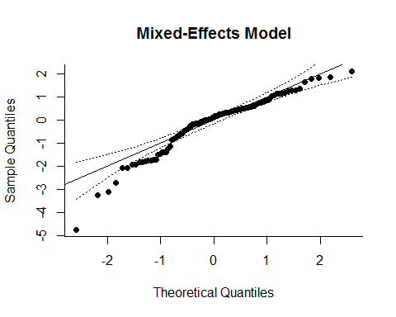
#Adding the interaction of BVO2C and AltSq
Model10<-rma(G, Vg_Corr, mods=~Altitude*BVO2C+AltSq+BVO2C_SQ,data=FULLDATA, method="REML")
Model10
##
## Mixed-Effects Model (k = 105; tau^2 estimator: REML)
##
## tau^2 (estimated amount of residual heterogeneity): 0.3770 (SE = 0.0739)
## tau (square root of estimated tau^2 value): 0.6140
## I^2 (residual heterogeneity / unaccounted variability): 79.55%
## H^2 (unaccounted variability / sampling variability): 4.89
## R^2 (amount of heterogeneity accounted for): 79.63%
##
## Test for Residual Heterogeneity:
## QE(df = 99) = 361.1893, p-val < .0001
##
## Test of Moderators (coefficient(s) 2,3,4,5,6):
## QM(df = 5) = 200.1313, p-val < .0001
##
## Model Results:
##
## estimate se zval pval ci.lb ci.ub
## intrcpt 0.3052 0.3303 0.9240 0.3555 -0.3422 0.9527
## Altitude -0.3294 0.2309 -1.4265 0.1537 -0.7820 0.1232
## BVO2C 0.0063 0.0176 0.3588 0.7197 -0.0282 0.0408
## AltSq -0.0777 0.0384 -2.0204 0.0433 -0.1530 -0.0023 *
## BVO2C_SQ -0.0027 0.0008 -3.3938 0.0007 -0.0042 -0.0011 ***
## Altitude:BVO2C -0.0283 0.0067 -4.2245 <.0001 -0.0415 -0.0152 ***
##
## ---
## Signif. codes: 0 '***' 0.001 '**' 0.01 '*' 0.05 '.' 0.1 ' ' 1
qqnorm(Model10, main="Mixed-Effects Model")
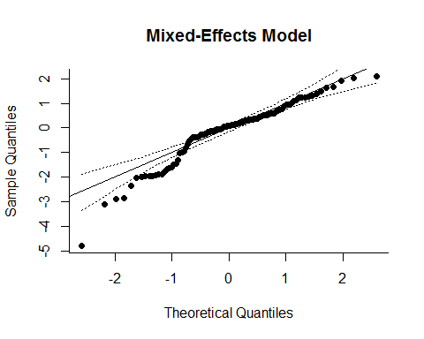
Finally, we are often interested in generating figures that reflect the weight of different studies in our meta-analysis (more precise studies 'count' more in the analysis). Sample code for plotting datapoints with a size corresponding to the weight is provided below. This code can then be applied to a variety of different plots:
##Creating weighted figures
wi<-1/sqrt(FULLDATA$Vg_Corr)
size<-0.5+3*(wi-min(wi))/(max(wi)-min(wi))
plot(FULLDATA$Altitude,FULLDATA$ES, pch=1, cex=size, lwd=2, ylim=c(-40,10))
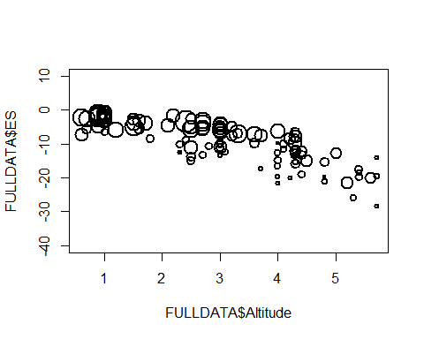

Using Non-Centered Predictors.
While the centered predictor is useful for analysis, the non-centered predictor can be very useful for creating graphs and figures. The models are reproduced below, only we call on the non-centered predictor. This will change the regression coefficients.
#Adding the interaction of BVO2 and AltSq
Model11<-rma(G, Vg_Corr, mods=~Altitude*BVO2+AltSq+BVO2_SQ,data=FULLDATA, method="REML")
Model11
##
## Mixed-Effects Model (k = 105; tau^2 estimator: REML)
##
## tau^2 (estimated amount of residual heterogeneity): 0.3770 (SE = 0.0739)
## tau (square root of estimated tau^2 value): 0.6140
## I^2 (residual heterogeneity / unaccounted variability): 79.55%
## H^2 (unaccounted variability / sampling variability): 4.89
## R^2 (amount of heterogeneity accounted for): 79.63%
##
## Test for Residual Heterogeneity:
## QE(df = 99) = 361.1893, p-val < .0001
##
## Test of Moderators (coefficient(s) 2,3,4,5,6):
## QM(df = 5) = 200.1313, p-val < .0001
##
## Model Results:
##
## estimate se zval pval ci.lb ci.ub
## intrcpt -7.7328 2.7199 -2.8431 0.0045 -13.0636 -2.4019 **
## Altitude 1.1872 0.4659 2.5483 0.0108 0.2741 2.1004 *
## BVO2 0.2940 0.0930 3.1604 0.0016 0.1117 0.4764 **
## AltSq -0.0777 0.0384 -2.0204 0.0433 -0.1530 -0.0023 *
## BVO2_SQ -0.0027 0.0008 -3.3938 0.0007 -0.0042 -0.0011 ***
## Altitude:BVO2 -0.0283 0.0067 -4.2245 <.0001 -0.0415 -0.0152 ***
##
## ---
## Signif. codes: 0 '***' 0.001 '**' 0.01 '*' 0.05 '.' 0.1 ' ' 1
qqnorm(Model11, main="Mixed-Effects Model")
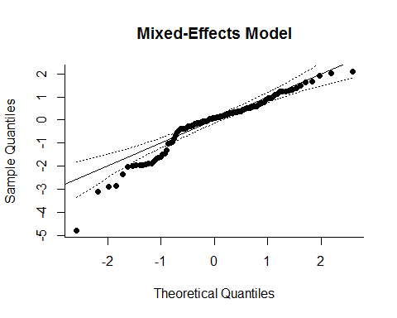

Exploring Hypobaric versus Normobaric Tests
There is an important question in altitude research about whether or not normobaric testing will yield results similar to normobaric testing for the VO2max assessment. In order to address this question, we have create a variable called "Hypobaric" in which hypobaric tests are coded as "1" and normobaric tests are coded as "0". For our regressions, we will recode these values as hypobaric = 0.5 and normobaric = -0.5. (Again, this centering is done to facilitate the interpretation of the analysis.)
FULLDATA$Hypobaric<-FULLDATA$Hypobaric-0.5
summary(as.factor(FULLDATA$Hypobaric))
## -0.5 0.5
## 66 39
#Next we can plot some descriptive information about testing conditions and effect size.
boxplot(G~Hypobaric, data = FULLDATA, cex.lab=1.2, ylab="Effect Size (g)",
xlab="-0.5 = normobaric, 0.5 = hypobaric")
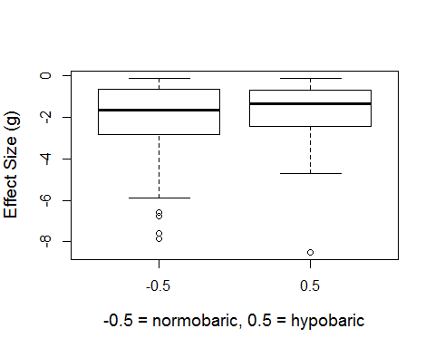
#We can get more detailed descriptive data using the code below.
ddply(FULLDATA,~Hypobaric,summarise, gM = mean(G),gSD=sd(G),n=length(G),baseM = mean(BVO2),
baseSD = sd(BVO2), altM=mean(Altitude), altSD=sd(Altitude))
## Hypobaric gM gSD n baseM baseSD altM altSD
## 1 -0.5 -2.089910 1.900727 66 52.50212 9.442751 3.260606 1.419304
## 2 0.5 -1.828746 1.639749 39 55.25513 10.336595 2.761538 1.375847
These data suggest there is no difference in VO2max between normobaric and hypobaric tests. The average effect-size for normobaric was slightly more negative than hypobaric, but the difference was not significant. Furthermore, this effect might be partially driven by the higher test altitudes used in normobaric studies. Indeed, as we will see below, the coefficient for Hypobaric, beta = 0.25, gets a lot smaller when we control for altitude in the model, beta = -0.05. Thus, the current data suggest that normobaric and hypobaric yield very similar results.
##Effects of Testing under Normobaric or Hypobaric Conditions
#Simple effect of Altitude (in km)
Hyp1<-rma(G, Vg_Corr, mods=~Hypobaric,data=FULLDATA, method="REML")
Hyp1
##
## Mixed-Effects Model (k = 105; tau^2 estimator: REML)
##
## tau^2 (estimated amount of residual heterogeneity): 1.8633 (SE = 0.2875)
## tau (square root of estimated tau^2 value): 1.3650
## I^2 (residual heterogeneity / unaccounted variability): 95.11%
## H^2 (unaccounted variability / sampling variability): 20.47
## R^2 (amount of heterogeneity accounted for): 0.00%
##
## Test for Residual Heterogeneity:
## QE(df = 103) = 959.4572, p-val < .0001
##
## Test of Moderators (coefficient(s) 2):
## QM(df = 1) = 0.7180, p-val = 0.3968
##
## Model Results:
##
## estimate se zval pval ci.lb ci.ub
## intrcpt -1.7436 0.1456 -11.9789 <.0001 -2.0289 -1.4583 ***
## Hypobaric 0.2467 0.2911 0.8474 0.3968 -0.3239 0.8172
##
## ---
## Signif. codes: 0 '***' 0.001 '**' 0.01 '*' 0.05 '.' 0.1 ' ' 1
qqnorm(Model1, main="Mixed-Effects Model")

Hyp2<-rma(G, Vg_Corr, mods=~Hypobaric+Altitude,data=FULLDATA, method="REML")
Hyp2
##
## Mixed-Effects Model (k = 105; tau^2 estimator: REML)
##
## tau^2 (estimated amount of residual heterogeneity): 0.9826 (SE = 0.1623)
## tau (square root of estimated tau^2 value): 0.9913
## I^2 (residual heterogeneity / unaccounted variability): 91.10%
## H^2 (unaccounted variability / sampling variability): 11.24
## R^2 (amount of heterogeneity accounted for): 46.90%
##
## Test for Residual Heterogeneity:
## QE(df = 102) = 586.0141, p-val < .0001
##
## Test of Moderators (coefficient(s) 2,3):
## QM(df = 2) = 61.5961, p-val < .0001
##
## Model Results:
##
## estimate se zval pval ci.lb ci.ub
## intrcpt 0.0736 0.2469 0.2979 0.7657 -0.4104 0.5575
## Hypobaric -0.0582 0.2219 -0.2623 0.7931 -0.4931 0.3767
## Altitude -0.5928 0.0762 -7.7809 <.0001 -0.7421 -0.4435 ***
##
## ---
## Signif. codes: 0 '***' 0.001 '**' 0.01 '*' 0.05 '.' 0.1 ' ' 1
qqnorm(Model1, main="Mixed-Effects Model")

Hyp3<-rma(G, Vg_Corr, mods=~Hypobaric+BVO2C,data=FULLDATA, method="REML")
Hyp3
##
## Mixed-Effects Model (k = 105; tau^2 estimator: REML)
##
## tau^2 (estimated amount of residual heterogeneity): 1.7386 (SE = 0.2711)
## tau (square root of estimated tau^2 value): 1.3185
## I^2 (residual heterogeneity / unaccounted variability): 94.76%
## H^2 (unaccounted variability / sampling variability): 19.07
## R^2 (amount of heterogeneity accounted for): 6.05%
##
## Test for Residual Heterogeneity:
## QE(df = 102) = 931.8316, p-val < .0001
##
## Test of Moderators (coefficient(s) 2,3):
## QM(df = 2) = 9.1978, p-val = 0.0101
##
## Model Results:
##
## estimate se zval pval ci.lb ci.ub
## intrcpt -1.7350 0.1410 -12.3022 <.0001 -2.0114 -1.4586 ***
## Hypobaric 0.3574 0.2847 1.2552 0.2094 -0.2007 0.9154
## BVO2C -0.0411 0.0141 -2.9061 0.0037 -0.0688 -0.0134 **
##
## ---
## Signif. codes: 0 '***' 0.001 '**' 0.01 '*' 0.05 '.' 0.1 ' ' 1
qqnorm(Model1, main="Mixed-Effects Model")

#Adding the interaction of BVO2C and AltSq
Hyp4<-rma(G, Vg_Corr, mods=~Altitude*BVO2+AltSq+BVO2_SQ+Hypobaric,data=FULLDATA, method="REML")
Hyp4
##
## Mixed-Effects Model (k = 105; tau^2 estimator: REML)
##
## tau^2 (estimated amount of residual heterogeneity): 0.3852 (SE = 0.0756)
## tau (square root of estimated tau^2 value): 0.6207
## I^2 (residual heterogeneity / unaccounted variability): 79.83%
## H^2 (unaccounted variability / sampling variability): 4.96
## R^2 (amount of heterogeneity accounted for): 79.18%
##
## Test for Residual Heterogeneity:
## QE(df = 98) = 357.3454, p-val < .0001
##
## Test of Moderators (coefficient(s) 2,3,4,5,6,7):
## QM(df = 6) = 197.8556, p-val < .0001
##
## Model Results:
##
## estimate se zval pval ci.lb ci.ub
## intrcpt -7.8224 2.7619 -2.8323 0.0046 -13.2355 -2.4092 **
## Altitude 1.1939 0.4704 2.5383 0.0111 0.2720 2.1158 *
## BVO2 0.2970 0.0944 3.1477 0.0016 0.1121 0.4819 **
## AltSq -0.0779 0.0387 -2.0112 0.0443 -0.1539 -0.0020 *
## BVO2_SQ -0.0027 0.0008 -3.3809 0.0007 -0.0043 -0.0011 ***
## Hypobaric -0.0362 0.1530 -0.2366 0.8130 -0.3361 0.2637
## Altitude:BVO2 -0.0285 0.0068 -4.1990 <.0001 -0.0418 -0.0152 ***
##
## ---
## Signif. codes: 0 '***' 0.001 '**' 0.01 '*' 0.05 '.' 0.1 ' ' 1
qqnorm(Model11, main="Mixed-Effects Model")

