Supplementary File 1 - Footwear modification procedure
In order to be able track in-shoe foot kinematics, 25 mm circular holes need to be cut in the shoe upper. A die grinder rotating at 30,000 rpm with a 25 mm hole saw can be used to cut the holes in the upper through rigid heel counter. In the presence of material of external polyethylene heel counters, a 25 mm sized hole-punches can be used to cut the holes. The edges of each hole need to be manually trimmed if the upper material had frayed (i.e. the foam inside the heel), and the circular nature of the hole is then protected from distortion by use of rigid tape.

The locations of the holes cut are defined as per the instructions in Table 1. The position of holes cut in the hindfoot were informed from previous data in our lab where x-rays were taken of 27 participants feet who wore athletic shoes with the marker set applied (Figure 1). The position of markers in the forefoot segments are identified based on manual palpation of the anatomical landmark through the shoe upper following previously established guidelines (Bishop, Paul & Thewlis 2013).

Table 1 – Instructions for the modification of shoes to apply in-shoe marker set.
Marker location | Instructions for modification
Calc 1 | Starting from the medial malleolus, the medial shoe-hole (to place Calc 1 marker) is located 60% of the x-axis distance to the posterior shoe, and 54 % of the y-axis distance to the top of the midsole.
Calc 2 | The posterior shoe hole (to place Calc 2 marker) is cut at 48% of the height of the posterior shoe form the top of the midsole in the centre of the posterior aspect of the shoe
Calc 3 | Starting from the lateral malleolus, the lateral shoe-hole (to place Calc 3 marker) is located 15% of the x-axis distance to the posterior shoe, and 50 % of the y-axis distance to the top of the midsole
Navicular Tuberosity | Shoe-hole to be located with the centre overlying the navicular tuberosity.
1MTS | Shoe-hole to be located at the midpoint between the line connecting the navicular tuberosity and the first metatarsal head.
1MTH | Shoe-hole to be located with the centre overlying the most prominent medial aspect of the first metatarsal head.
4MTS | The shoe-hole is to be located on a line that is perpendicular to the midpoint of the line connecting the navicular tuberosity and the first metatarsal head. The centre of the shoe-hole is to be 20mm from the midpoint.
Hallux | Shoe-hole to be located with the centre overlying the nail plate of the hallux.
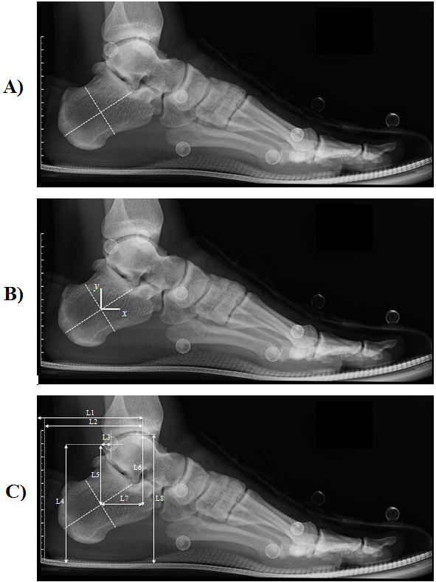
Figure 1 – Technique used to calculate position of medial and lateral hindfoot holes based on xray data.
Three part method – A) define the geometric centre of the calcaneus, B) define the origin of the calcaneus co-ordinate system and C) define the variables to calculate desired hole position from the lateral and medial malleolus. L1 - Horizontal distance (m) of Medial Malleolus marker from posterior aspect of shoe, L2 – Horizontal distance (m) of Medial Malleolus marker from posterior aspect of heel, L3 – Horizontal distance (m) of Lateral Malleolus marker from HCS_{origin}, L4 – Vertical distance (m) of Lateral Malleolus marker from the dorsal midsole, L5 – Vertical distance (m) of Lateral Malleolus marker from HCS_{origin}, L6 – Vertical distance (m) of Medial Malleolus marker from HCS_{origin}, L7 – Horizontal distance (m) of Medial Malleolus marker from HCS_{origin} and L8 – Vertical distance (m) of Medial Malleolus marker from the dorsal midsole.

