Supplement 2. Adjusted model

The calculation of CS and D′ requires a series of maximal efforts (1). However, using raw training data, it is not possible to determine whether an effort was maximal. Furthermore, in the current dataset it was not possible to access to physiological (e.g. heart rate) or psychobiological (e.g. rating of perceived exertion) data, which can be used as surrogate measures to evaluate whether a maximal effort has been performed. This is a potential limitation associated with the determination of CS and D′ from raw training data.
The conventional protocol to determine CS and D′ requires a series of maximal efforts at a constant intensity (1). Predictive trials to calculate CS and D′ should be, by definition, at intensities above CS, and continued to task failure or performed at maximal effort. Importantly, once task failure has occurred, participants can only sustain intensities below CS (2, 3).
An adjustment was therefore applied to the model used to calculate CS and D′. The adjusted model relies on the assumption that the fastest times registered for a given distance during training are likely to be part of a longer activity, and therefore may not represent the runner’s true maximal effort for that distance. For example, if a runner registers a fastest time for the 1000 m distance of 180 seconds (a pace of 3 mins∙km⁻¹) during a 39 min and 10 km activity, then this 1 km fastest time may not represent a maximal effort, since they were able to run 9 km at a still fast pace of 4 min∙km⁻¹. If, on the other hand, the remaining 9 km for such 10 km activity were run at 6 min∙km⁻¹, then we might reasonably conclude that it is effort is a better approximation of a true maximal effort. An adjustment to the model presented in the article was therefore conducted based on distance and pacing information from the remainder of the activity.
More generally, the fastest paces recorded in the 16-week period before the marathon and used to calculate CS and D′ were adjusted based on the relative difference between the distance (d_{T}) and pace (p_{T}) of the observed performance and the remaining distance (d_{R}) and pace (p_{R}) over which this performance has been achieved. If the remaining distance is long, and the remaining pace fast, then a larger discount is appropriate, compared with when the remaining distance is short or its pace is slow. In other words, if there is evidence to suggest that the runner needed to slow significantly after running their fastest pace over the target distance, then we can have more confidence in the target pace for such distance approximate a maximal effort. On the other hand, if, after registering their fastest pace, athletes continued to run far and fast then their fastest pace should be discounted.

Equation 1:
Equation 2:
Equation 3:
Equation 4:

We implemented a procedure for adjusting the fastest pace over a target distance based on Equations 1 – 4. They comprise an adjustment due to the remaining distance (Equation 5) and an adjustment due to the remaining pace (Equation 6). In addition, Equation 4 limits the total adjustment that can be applied based on the target distance; using w = 20 the max adjustment for a 400m distance (d_{T} = 0.4) is 0.13, or 0.25 for a 10k distance. The target and remaining paces (p_{T} and p_{R}) are measured in mins∙km⁻¹, target and remaining distances (d_{T} and d_{R}) are measured in kms, and p_{rest} refers to a slow (recovery) pace of 10 mins/km.
Using the example above (a 10km activity with a fastest 1km pace of 3 mins/km and the remaining 9km at 6mins/km) leads to an adjustment in this fastest 1km pace from 3 mins/km to 2.77 mins/km.
The adjusted model increased the average CS values generated by approximately 5%. Specifically, CS determined from the best performing model, which used distances of400 m, 800 m, and 5,000 m), increased from 3.69 ± 0.57 m∙s⁻¹ to 3.84 ± 0.63 m∙s⁻¹. Using the adjusted model also generated minor improvements in the prediction of MT using CS and D′ (R² value increased from 0.67 to 0.73).
The figures below (Figure 1.1 to Figure 4.1) correspond to the key results in the main paper, but using the adjusted model for the target distances. Generally, the results were similar to those obtained using the original model. The one exception concerns the relationship between the fraction of runners slowing significantly during the second half of the race relative to their early race pacing (i.e. relative BS). Using the original model there were moderate and weak positive correlations between relative BS and percentage of runners with a slowdown ≥ 1.25 for males and females (R² = 0.62 and p = 0.005, and R² = 0.36 and p = 0.13, respectively). Similarly, there was a moderate correlations between relative BS and percentage young athletes who exhibited such slowdowns (R² = 0.67, p = 0.002) but a weaker correlation for older runners (R² = 0.04, p = 0.7). Using the adjusted model these relationships were found to be stronger with R² values of 0.71 and 0.64 for male and female runners, respectively (p < 0.01); and for younger and older runners (R² = 0.71 and R² = 0.74, respectively; both p < 0.01).
References
- Muniz-Pumares D, Karsten B, Triska C, Glaister M. Methodological approaches and related challenges associated with the determination of critical power and W’. J Strength Cond Res. 2019;33(02):584–596.
- Coats EM, Rossiter HB, Day JR, Miura A, Fukuba Y, Whipp BJ. Intensity-dependent tolerance to exercise after attaining V(O2) max in humans. J Appl Physiol. 2003;95(2):483–90.
- Chidnok W, Fulford J, Bailey, et al. Muscle metabolic determinants of exercise tolerance following exhaustion: relationship to the “critical power”. J Appl Physiol. 2013;115(2):243–50.

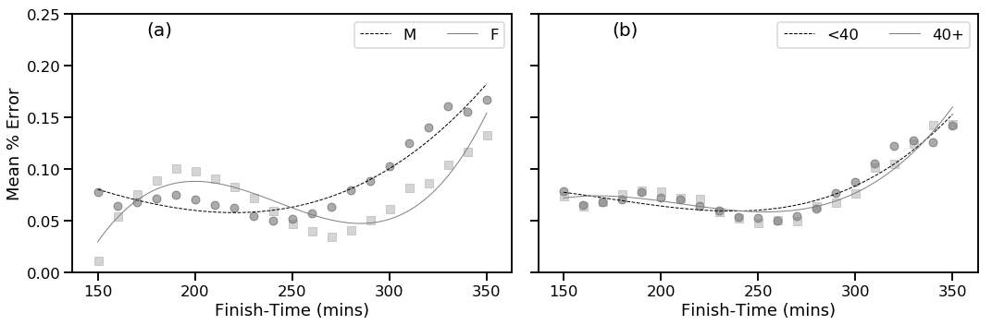

Figure 1.1 (Supplement). Mean percentage prediction error by finish-time and based on gender (a) and age category (b) using a leave-one-out test to evaluate the best performing model at predicting MT.

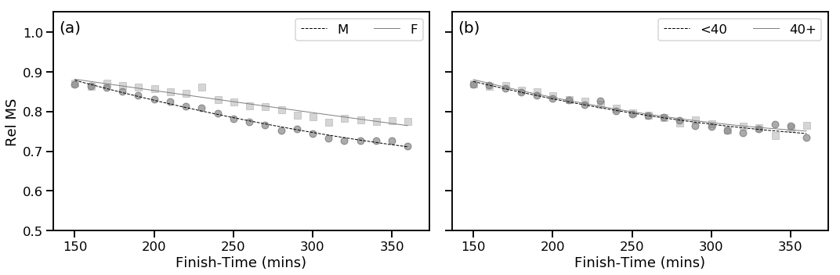

Figure 2.1 (Supplement). Relative marathon speed (Rel MS), defined as critical speed relative to marathon speed, of runners versus finish-time. Results are presented based on (a) gender and (b) age category.
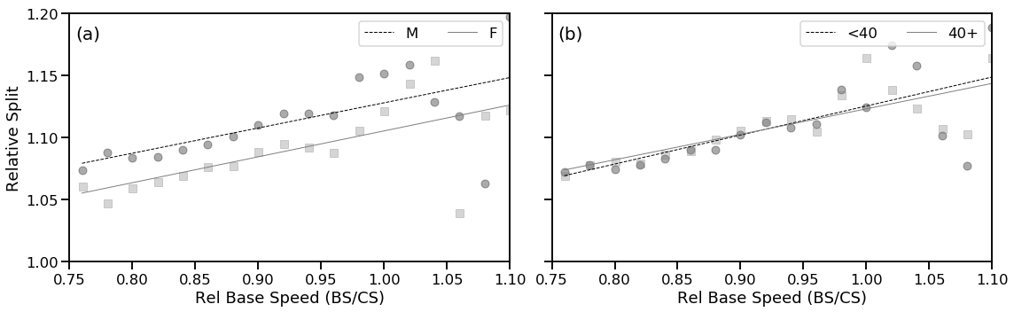

Figure 3.1 (Supplement). Relative split of runners (second-half time divided by first-half time) as a function of relative base-speed (relative BS, defined as average running speed 2-16 km as a fraction of critical speed). Results are presented based on (a) gender and (b) age category.

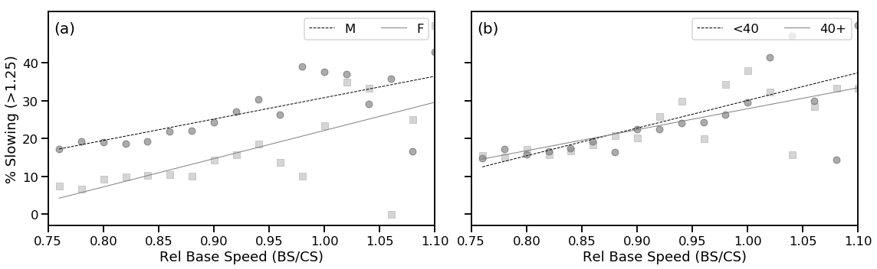

Figure 4.1 (Supplement). Percentage of runners experiencing a late-race (final 12 km of the marathon) slowdown in excess of 25% (relative to base-speed) versus relative base-speed (Rel Base Speed), defined as average running speed 2-16 km as a fraction of critical speed). Results are presented based on (a) gender and (b) age category.

