SDC 1. Description of stable isotope preparation and synthesis.
The two tetra-¹³C-labelled KME used was synthesised from a total of 47 g of ethyl acetoacetate-1,2,3,4-¹³C4 purchased form Cambridge Isotope Laboratories, USA.
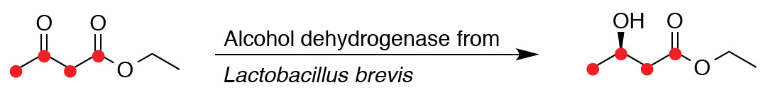
Synthesis of ethyl (R)-3-hydroxybutyrate-1,2,3,4-¹³C4: The synthesis of the first component of the 13C-labelled KME, ethyl (R)-3-hydroxybutyrate-1,2,3,4-¹³C4, was carried out using the asymmetric reduction catalysed by alcohol dehydrogenase derived from lactobacillus (ADH-LB), from the starting reagent ethyl acetoacetate-1,2,3,4-¹³C4 (reaction 1).
Reaction 1
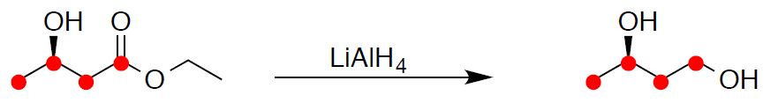
Synthesis of (R)-butane-1,3-diol-1,2,3,4-¹³C4: Half of the product prepared by the ADH-LB reduction (ethyl ester reaction 1 above) was used to synthesise the second component of the ¹³C-labelled KME, (R)-butane-1,3-diol-1,2,3,4-¹³C4. This reduction was carried out using LiAlH4 as a suspension in anhydrous THF (reaction 2).
Reaction 2
Finally, both (R)-butane-1,3-diol-1,2,3,4-¹³C4, and ethyl (R)-3-hydroxybutyrate-1,2,3,4-¹³C4 from reactions 1 and 2 were transferred to Sterling Pharmaceutical solutions Ltd (Northumberland, UK) for final KE transesterification under GMP grade conditions.
Breifly, KME was prepared from ¹³C-labelled (R)-butane-1,3-diol using an excess of unlabelled ethyl (R)-3-hydroxybutyrate (reaction 3). The reaction was carried out at 20–25 °C under reduced pressure (approx. 2 mbar) for 5 h in order to distil off the ethanol and drive the reaction forward. The product was subsequently purified by short-path distillation in two batches using Kugelrohr apparatus.
Reaction 3
KME was prepared from ¹³C-labelled ethyl (R)-3-hydroxybutyrate using an excess of unlabelled (R)-butane-1,3-diol (reaction 4). The reaction was carried out at 20–25 °C for 4 h at ~5 mbar and then for 3.5 h at ~2 mbar. Again, the product was purified by short-path distillation using Kugelrohr apparatus.
Reaction 4
Equal aliquots of the final products of both reactions 3 and 4 (>98% purity) were incorporated with the native (unlabelled) KME during drink preparation to achieve a final drink ¹³C enrichment of approximately 25%.

