Cochrane risk of bias assessment
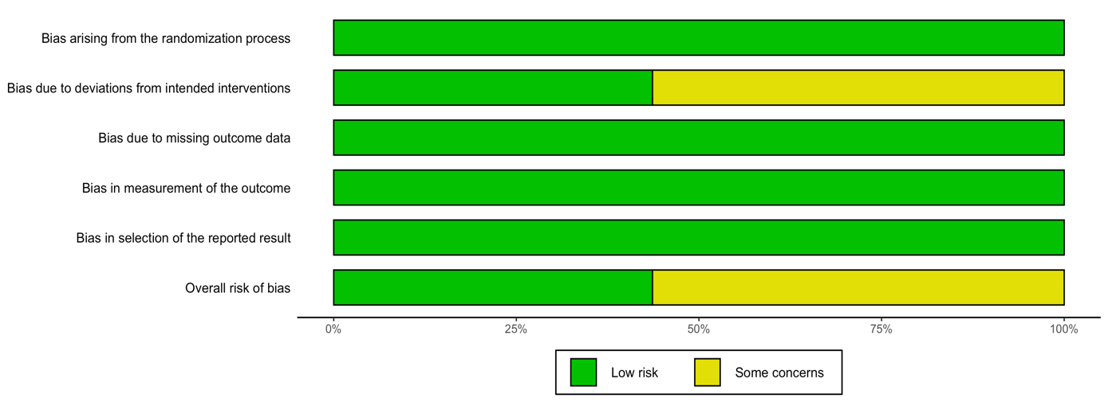
Figure 1 - Summary of the risk of bias of the included studies across the five domains.

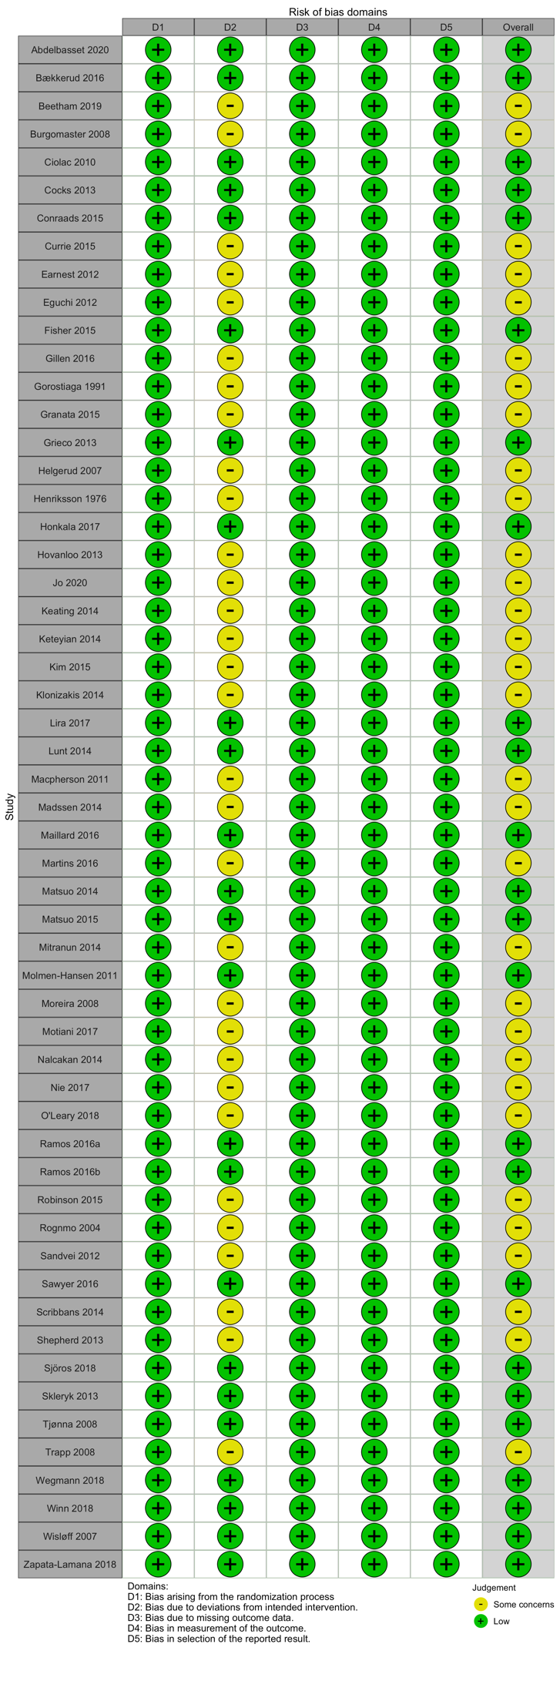
Figure 2 - Risk of bias judgement in each domain for each included study.

