Supplemental Digital Content 2
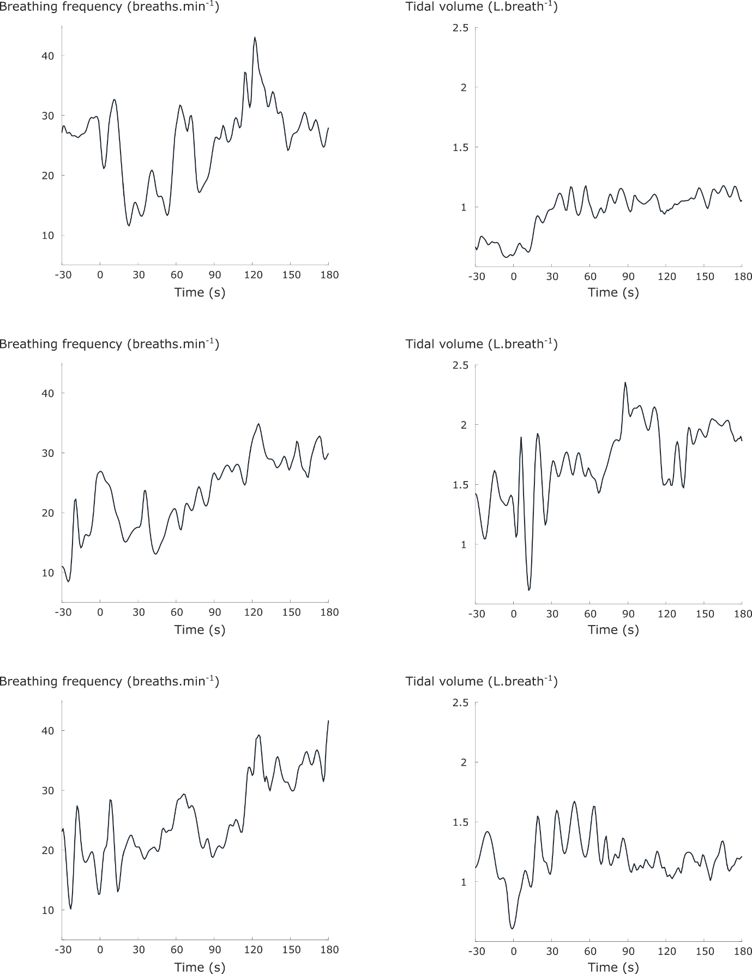
Examples of breathing frequency and tidal volume responses that show the variable nature of these responses at the onset of a constant work rate cycling test. Neighbouring plots of breathing frequency and tidal volume responses originate from the same patient.

