Supplemental Digital Content 5
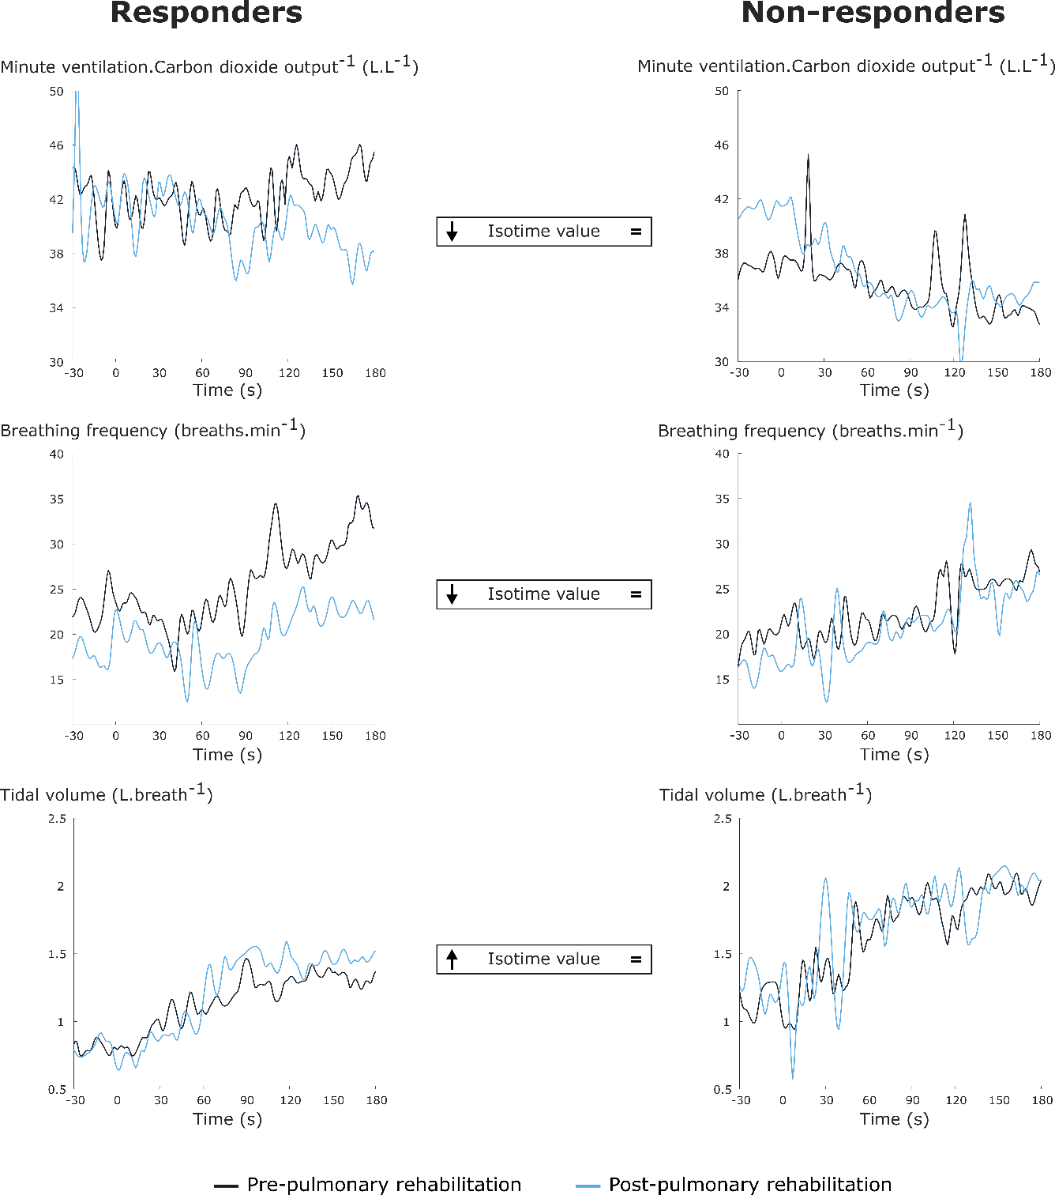
Examples of changes in physiological exercise responses following pulmonary rehabilitation for responders and non-responders. For clarity reasons, responses of different responders and non-responders are shown. Symbols in between the plotted responses indicate increased (upward arrow), decreased (downward arrow) or unchanged values (equality sign) for responders (symbols on the left side) and non-responders (symbols on the right side) following pulmonary rehabilitation. Framed symbols indicate differences between responders and non-responders for that specific variable.

