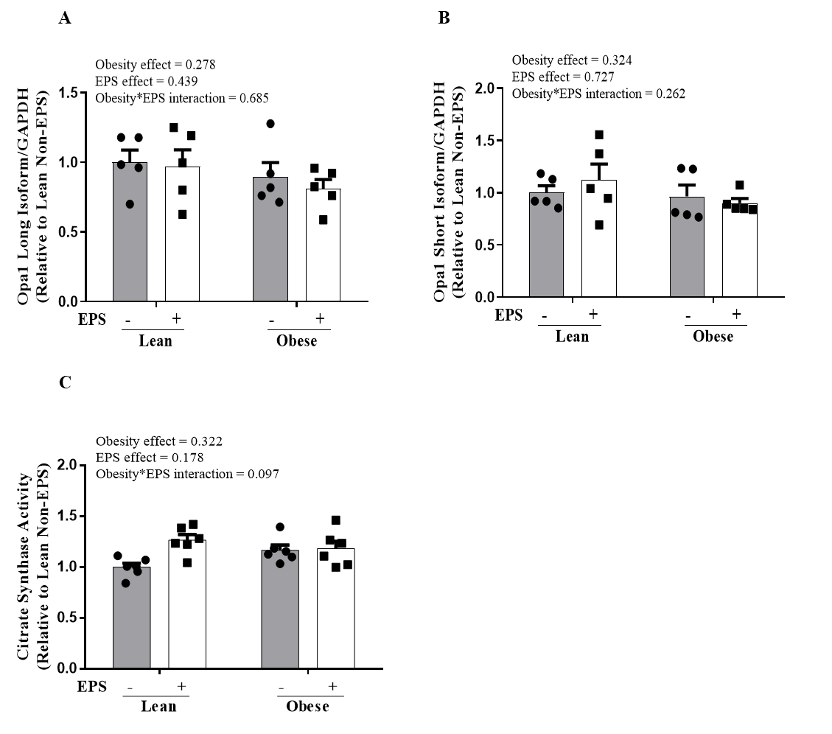
Supplemental Fig. 3 OPA1 isoforms expression and citrate synthase activity in primary myotubes derived from lean humans and humans with severe obesity with or without EPS. There were no differences in OPA1 isoform contents and citrate synthase activity between any groups. A) Opa1 long isoform; B) Opa1 short isoform; C) Citrate synthase activity. Data are presented as mean ± SEM. n=5-8/group.

