Supplemental Digital Content 4. Forest plots of sex differences for changes in cardiometabolic health indicators and publication bias funnel plots.

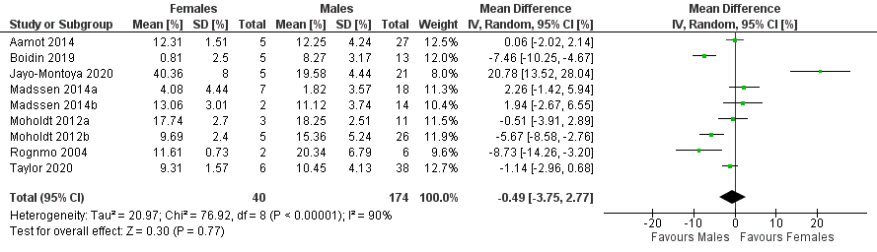
Figure 1. Forest plot of the sex-differences for relative changes in cardiorespiratory fitness with high-intensity interval training in females and males with coronary artery disease.

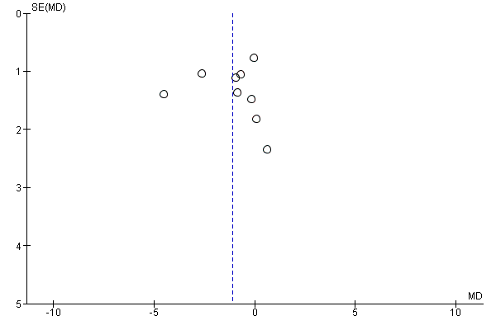
Figure 2. Funnel plot of the sex-differences for absolute changes in cardiorespiratory fitness with high-intensity interval training in females and males with coronary artery disease.
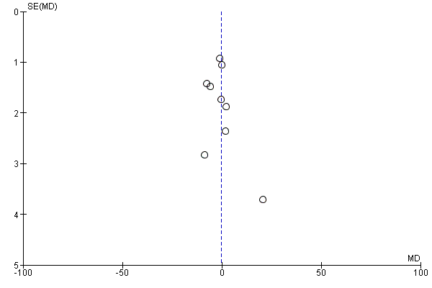
Figure 3. Funnel plot of the sex-differences for relative changes in cardiorespiratory fitness with high-intensity interval training in females and males with coronary artery disease.

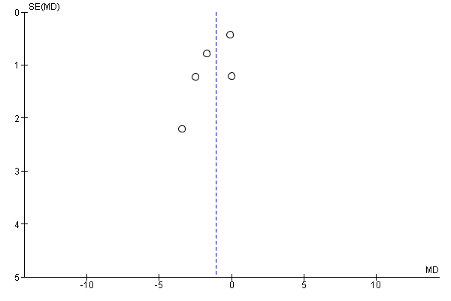
Figure 4. Funnel plot of the sex-differences for absolute changes in cardiorespiratory fitness with high-intensity interval training versus control in males with coronary artery disease.

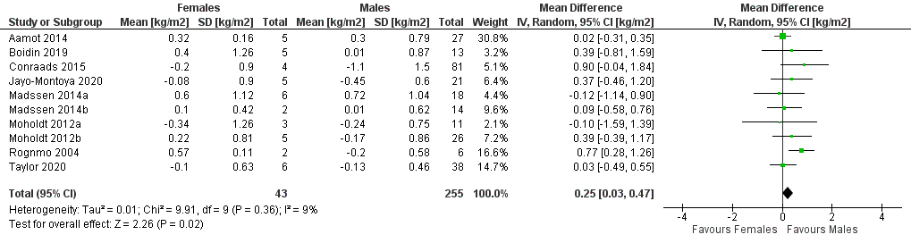

Figure 5. Forest plot of the sex-differences for changes in body mass index with high-intensity interval training in females and males with coronary artery disease.

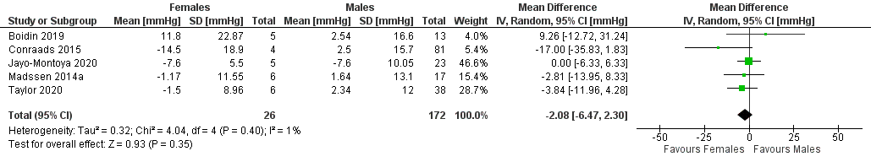

Figure 6. Forest plot of the sex-differences for changes in systolic blood pressure with high-intensity interval training in females and males with coronary artery disease.

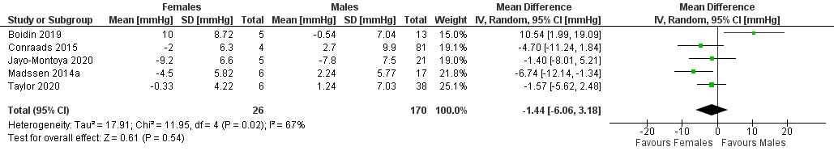

Figure 7. Forest plot of the sex-differences for changes in diastolic blood pressure with high-intensity interval training in females and males with coronary artery disease.

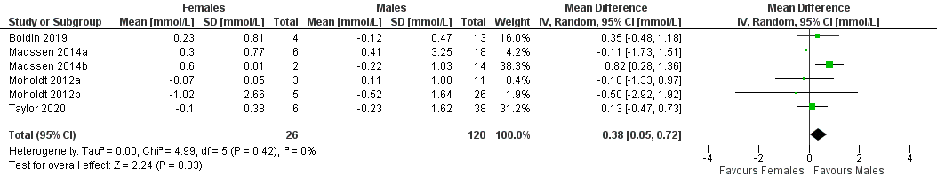

Figure 8. Forest plot of the sex-differences for changes in fasting blood glucose with high-intensity interval training in females and males with coronary artery disease.
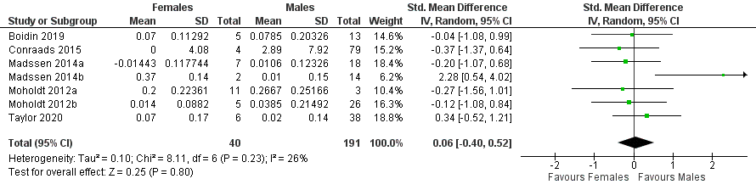

Figure 9. Forest plot of the sex-differences for changes in high-density lipoprotein cholesterol with high-intensity interval training in females and males with coronary artery disease.

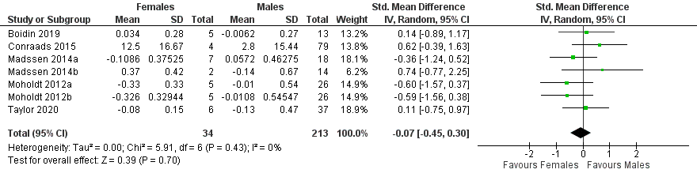

Figure 10. Forest plot of the sex-differences for changes in low-density lipoprotein cholesterol with high-intensity interval training in females and males with coronary artery disease.

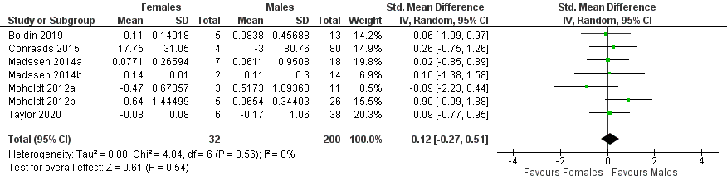

Figure 11. Forest plot of the sex-differences for changes in triglycerides with high-intensity interval training in females and males with coronary artery disease.

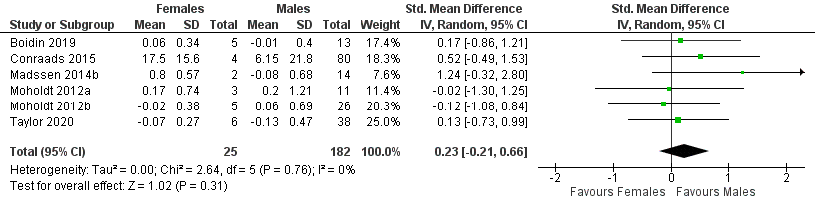

Figure 12. Forest plot of the sex-differences for changes in total cholesterol with high-intensity interval training in people with coronary artery disease.

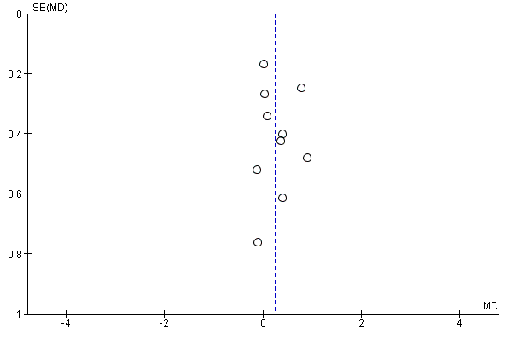
Figure 13. Funnel plot of the sex-differences for changes in body mass index with high-intensity interval training in females and males with coronary artery disease.
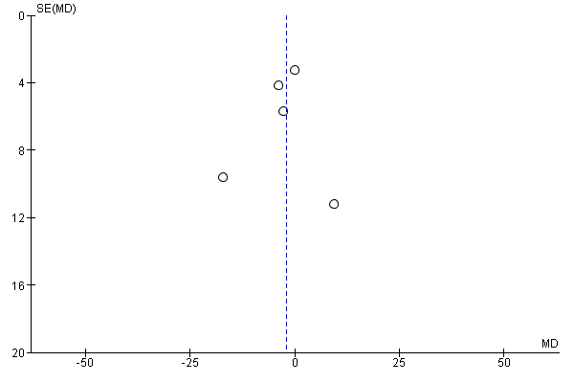
Figure 14. Funnel plot of the sex-differences for changes in systolic blood pressure with high-intensity interval training in females and males with coronary artery disease.

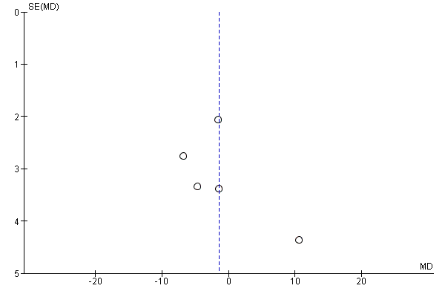
Figure 15. Funnel plot of the sex-differences for changes in diastolic blood pressure with high-intensity interval training in females and males with coronary artery disease.

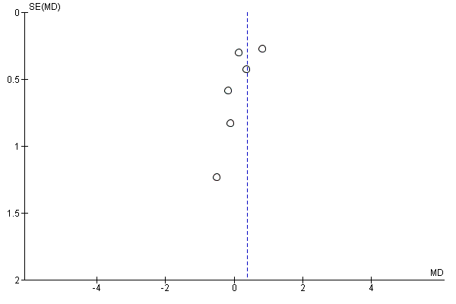
Figure 16. Funnel plot of the sex-differences for changes in fasting blood glucose with high-intensity interval training in females and males with coronary artery disease.
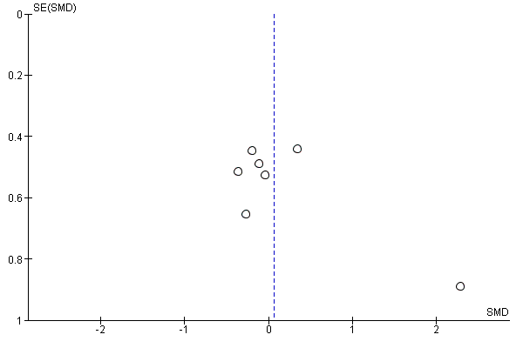
Figure 17. Funnel plot of the sex-differences for changes in high-density lipoprotein cholesterol with high-intensity interval training in females and males with coronary artery disease.

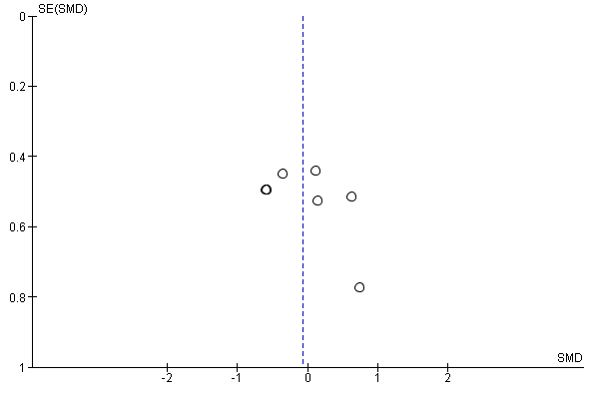
Figure 18. Funnel plot of the sex-differences for changes in low-density lipoprotein cholesterol with high-intensity interval training in females and males with coronary artery disease.

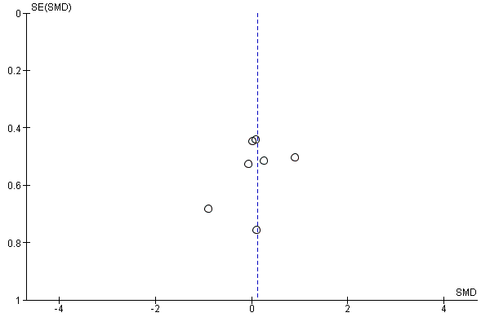
Figure 19. Funnel plot of the sex-differences for changes in triglycerides with high-intensity interval training in females and males with coronary artery disease.
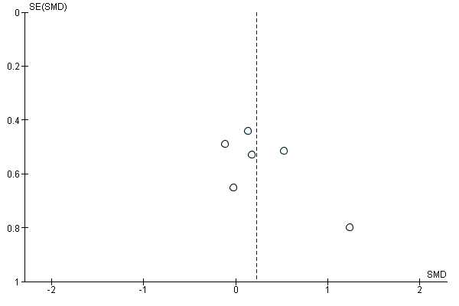
Figure 20. Funnel plot of the sex-differences for changes in total cholesterol with high-intensity interval training in females and males with coronary artery disease.

