Elite athletes and postpartum outcomes: A systematic review and meta-analysis
Online Supplement
Miranda L. KIMBER, MSc Student
Program for Pregnancy and Postpartum Health, Faculty of Kinesiology, Sport and Recreation, Women and Children’s Health Research Institute, Alberta Diabetes Institute, University of Alberta, Edmonton, Alberta, Canada.

Sarah MEYER, Undergraduate Student
Program for Pregnancy and Postpartum Health, Faculty of Kinesiology, Sport and Recreation, University of Alberta, Edmonton, Alberta, Canada.

Tara-Leigh, MCHUGH, PhD
Faculty of Kinesiology, Sport and Recreation, University of Alberta, Edmonton, Alberta, Canada.

Jane THORNTON, MD
Fowler Kennedy Sport Medicine Clinic, Department of Family Medicine, Schulich School of Medicine and Dentistry, Department of Epidemiology and Biostatistics, Schulich School of Medicine and Dentistry, Western University, London, ON, Canada

Allison SIVAK, Public Services Librarian
University of Alberta Libraries, University of Alberta, Edmonton, Alberta, Canada

Rshmi KHURANA, MD
Departments of Medicine and Obstetrics & Gynecology, Women and Children’s Health Research Institute, University of Alberta, Edmonton, Alberta, Canada.

Margie H. DAVENPORT, PhD
Program for Pregnancy and Postpartum Health, Physical Activity and Diabetes Laboratory, Faculty of Kinesiology, Sport and Recreation, Women and Children’s Health Research Institute, Alberta Diabetes Institute, University of Alberta, Edmonton, Alberta, Canada.

Corresponding Author
Margie H. Davenport, PhD
Program for Pregnancy and Postpartum Health
Faculty of Kinesiology, Sport, and Recreation
University of Alberta

1-059D Li Ka Shing Centre for Health Research Innovation
8602 - 112 St
Edmonton, Alberta, Canada
T6G 2E1
Tel: (780)492-0642
Email: margie.davenport@ualberta.ca

Table 1. Summary of postpartum outcomes
Author, year | Number of pregnant athletes | Elite to recreational (E:R) | Number of pregnant controls | Postpartum period | Prenatal physical activity level | Outcomes
Bo et al., 2007 | 31 | Elite athletes only (31:0) | 46 | 6 weeks | n/a | Breastfeeding, length of breastfeeding, low back pain, low back pain with radiation, pelvic girdle pain (SI joint, pubic symphysis, or SI joint + pubic symphysis), Stress incontinence, Urge incontinence, Mixed incontinence, Fecal incontinence, <6 week return to activity, training volume
Beilock et al., 2001 | 26 | Mixed (Elite and Recreational)* | n/a | Training performed anytime after the first pregnancy. Authors indicated most respondents kept their survey responses within 1-2 years after their first pregnancy. | 89% were still training trimester 1; 65% were training in trimester 3 | Breast pain
Bung et al., 1991 | 1 | Elite athlete only (1:0) | n/a | 6 weeks and 6 months | 6x/wk (no duration listed) | Improved performance postpartum vs pre-pregnancy
Davies et al., 1999 | 1 | Elite athlete only (1:0) | 0 | 3 months | 107 ± 19 km/wk  Intensity; 130-140 bpm | <6 week return to activity
Pentinnen & Erkkola, 1997 | 30 | Elite athletes only (30:0) | 30 | n/a | n/a | Improved and reduced performance postpartum vs pre-pregnancy
Potteiger et al., 1993 | 1 | Elite athlete only (1:0) | n/a | 4, 8, 12 and 16 weeks | Two workouts per day, 90-100 km/wk | Return to activity
Solli et al., 2018 | 1 | Elite athlete only (1:0) | 0 | 1-6 weeks | 12.9 ± 7.3 hr/wk (SD: 10.0) | Bone mineral density, injury, <6 week return to activity, training volume and intensity
Sundgot-Borgen et al., 2019 | 34 | Elite athletes only (34:0) | 34 | 9 months | n/a | Injury, improved performance postpartum, reduced performance postpartum, lack of sleep, <6 week return to activity, training volume
Tenforde et al., 2015 | 110 | Mixed (35:110) | n/a | n/a | n/a | Injury and <6 week return to activity
Zaharieva, 1965 | 13 | Elite athletes only (13:0) | n/a | 2 years | n/a | Improved performance postpartum vs pre-pregnancy and <6 week return to activity
Zaharieva, 1972 | 160 | Elite athletes only (150:0) | n/a | n/a | n/a | Length of breastfeeding, breast pain, return to activity, improved performance postpartum, reduced performance postpartum
*Author was contacted. No information ratio information was available.

JOANNA BRIGGS INSTITUTE (JBI) CRITICAL APPRAISAL OF EVIDENCE EFFECTIVENESS

Table 2. Risk of Bias for cross-sectional studies
Cross-sectional study | Were the criteria for inclusion in the sample clearly defined? | Were the study subjects and the setting described in detail? | Was the exposure measured in a valid and reliable way? | Were objective, standard criteria used for measurement of the condition? | Were confounding factors identified? | Were strategies to deal with confounding factors stated? | Were the outcomes measured in a valid and reliable way? | Was appropriate statistical analysis used?
Tenforde, 2015 | Y | Y | N | N | N | N | N | Y
Erkkola, 1997 | Y | Y | Y | N | N | N | N | Y
Bø, 2007 | Y | Y | N | N | N | N | N | Y
Beilock, 2001 | Y | Y | Y | N | N | N | N | Y
Zaharieva, 1972 | Y | N | N | N | N | N | N | N
Zaharieva, 1965 | Y | N | N | N | N | N | N | N

Table 3. Risk of Bias for case report studies
Case Report | Were the patient's demographics clearly described? | Was the patient's history clearly described and presented as a timeline? | Was the current clinical condition of the patient on presentation clearly described? | Were diagnostic tests or assessment methods and the results clearly described? | Was the intervention(s) or treatment procedure(s) clearly described? | Was the post-intervention clinical condition clearly described? | Were adverse events (harms) or unanticipated events identified and described? | Does the case report provide takeaway lessons?
Bung, 1991 | Y | Y | Y | Y | Y | Y | Y | Y
Davies, 1999 | Y | Y | Y | Y | Y | Y | Y | Y
Solli, 2018 | Y | Y | Y | Y | Y | N | Y | Y
Potteiger, 1992 | Y | Y | Y | Y | Y | Y | Y | Y

Table 4. Risk of Bias for case-control studies
Case control | Were the groups comparable other than the presence of disease in cases or the absence of disease in controls? | Were cases and controls matched appropriately? | Were the same criteria used for identification of cases and controls? | Was the exposure measured in a valid and reliable way? | Was exposure measured in the same way for cases and controls? | Were confounding factors identified? | Were strategies to deal with confounding factors stated? | Were outcomes assessed in a standard, valid and reliable way for cases and controls? | Was the exposure period of interest long enough to be meaningful? | Was appropriate statistical analysis used?
Sundogt-Borgen, 2019 | Y | Y | Y | N | Y | Y | N | Y | Y | Y

GRADE TABLES
Online Supplement Table 5: The association between pre-pregnancy elite athletic exposure and breastfeeding initiation and duration outcomes
Certainty assessment |  |  |  |  |  |  | № of patients |  | Effect |  | Certainty | Importance
№ of studies | Study design | Risk of bias | Inconsistency | Indirectness | Imprecision | Other considerations | Elite | Other | Relative  (95% CI) | Absolute  (95% CI)
Breastfeeding
1 (pooled estimate of effect, n = 1) | observational studies | serious ª | serious ^{b} | not serious | not serious | none | 28/31 (90.3%) | 44/46 (95.7%) | OR 0.42  (0.07 to 2.70) | 54 fewer per 1,000  (from 350 fewer to 27 more) | ⨁◯◯◯  VERY LOW | CRITICAL
Duration of breastfeeding
2 (pooled estimate of effect, n = 1; 1 study reported narratively) | observational studies | serious ª | serious ^{b} | not serious | not serious | none | 31 | 46 | - | MD 0.1 lower  (2.96 lower to 2.76 higher) | ⨁◯◯◯  VERY LOW | CRITICAL
Narrative summary (n = 150):
A cross-sectional study (Zaharieva, 1972) reported duration of breastfeeding among elite athletes ranged from 4-9 months.
CI: Confidence interval; OR: Odds ratio; MD: Mean difference

Explanations
a. Contributed to >50% of the weight of the pool estimate in the forest plots.
b. Heterogeneity was (high ≥ 50%) or when only one study was assessed

Online Supplement Table 6: The association between pre-pregnancy elite athletic exposure and breast pain
Certainty assessment |  |  |  |  |  |  | № of patients |  | Effect |  | Certainty | Importance
№ of studies | Study design | Risk of bias | Inconsistency | Indirectness | Imprecision | Other considerations | Elite | Other | Relative  (95% CI) | Absolute  (95% CI)
Breast pain
1 (n = 1 study reported narratively) | observational studies | not serious | serious ª | not serious | not serious | none | Narrative Summary (n = 26):  Beilock et al., (2001) (n = 26) reported 6 elite athletes reported breast sensitivity as a barrier to training in the postpartum period. |  |  |  | ⨁◯◯◯  VERY LOW | CRITICAL
CI: Confidence interval; OR: Odds ratio; MD: Mean difference

Explanations
a. b. Heterogeneity was (high ≥ 50%) or when only one study was assessed

Online Supplement Table 7: The association between pre-pregnancy elite athletic exposure and incontinence outcomes
Certainty assessment |  |  |  |  |  |  | № of patients |  | Effect |  | Certainty | Importance
№ of studies | Study design | Risk of bias | Inconsistency | Indirectness | Imprecision | Other considerations | Elite | Other | Relative  (95% CI) | Absolute  (95% CI)
Stress incontinence
2 (pooled estimate of effect, n = 2) | observational studies | serious ª | not serious | not serious | serious ^{c} | none | 16/65 (24.6%) | 23/80 (28.7%) | OR 0.83  (0.39 to 1.76) | 37 fewer per 1,000  (from 152 fewer to 128 more) | ⨁◯◯◯  VERY LOW | CRITICAL
Urge incontinence
1 (pooled estimate of effect, n = 1) | observational studies | serious ª | serious ^{b} | not serious | not serious | none | 4/31 (12.9%) | 6/46 (13.0%) | OR 0.99  (0.25 to 3.83) | 1 fewer per 1,000  (from 94 fewer to 234 more) | ⨁◯◯◯  VERY LOW | CRITICAL
Mixed incontinence
1 (pooled estimate of effect, n = 1) | observational studies | serious ª | serious ^{b} | not serious | not serious | none | 3/31 (9.7%) | 6/46 (13.0%) | OR 0.71  (0.16 to 3.10) | 34 fewer per 1,000  (from 107 fewer to 187 more) | ⨁◯◯◯  VERY LOW | CRITICAL
Fecal incontinence
1 (pooled estimate of effect, n = 1) | observational studies | serious ª | serious ^{b} | not serious | not serious | none | 0/31 (0.0%) | 1/41 (2.4%) | OR 0.43  (0.02 to 10.88) | 14 fewer per 1,000  (from 24 fewer to 189 more) | ⨁◯◯◯  VERY LOW | CRITICAL

CI: Confidence interval; OR: Odds ratio; MD: Mean difference

Explanations
a. Contributed to >50% of the weight of the pool estimate in the forest plots.
b. Heterogeneity was (high ≥ 50%) or when only one study was assessed
c. 95% CI crossed the line of no effect and was wide, such that interpretation of the data would be different if the true effect were at one end of the CI or the other
Online Supplement Table 8: The association between pre-pregnancy elite athletic exposure and injury outcomes
Certainty assessment |  |  |  |  |  |  | № of patients |  | Effect |  | Certainty | Importance
№ of studies | Study design | Risk of bias | Inconsistency | Indirectness | Imprecision | Other considerations | Elite | Other | Relative  (95% CI) | Absolute  (95% CI)
Injury
3 (pooled estimate of effect, n = 1 study; 2 studies reported narratively) | observational studies | serious ª | serious ^{b} | not serious | not serious | none | 4/34 (11.8%) | 0/34 (0.0%) | OR 10.18  (0.53 to 196.87) | 0 fewer per 1,000  (from 0 fewer to 0 fewer) | ⨁◯◯◯  VERY LOW | CRITICAL
Narrative summary: (n = 111)
One cross-sectional study was included and showed 9 women obtained running injuries while breastfeeding (Tenforde, 2015). One case study reported a cross-country skiing athlete obtained two sacral fractures during 13-24 weeks postpartum (Solli, 2018).
CI: Confidence interval; OR: Odds ratio; MD: Mean difference

Explanations
a. Contributed to >50% of the weight of the pool estimate in the forest plots.
b. Heterogeneity was (high ≥ 50%) or when only one study was assessed

Online Supplement Table 9: The association between pre-pregnancy elite athletic exposure and bone mineral density outcomes
Certainty assessment |  |  |  |  |  |  | № of patients |  | Effect |  | Certainty | Importance
№ of studies | Study design | Risk of bias | Inconsistency | Indirectness | Imprecision | Other considerations | Elite | Other | Relative  (95% CI) | Absolute  (95% CI)
Bone mineral density
1 (n = 1 study reported narratively) | observational studies | not serious | serious ª | not serious | not serious | none | Narrative summary: (n = 1)  In a case report of 1 elite cross-country skiing athlete, bone mineral density decreased from pre-pregnancy (1.298 g·cm−2) to 1.199 g·cm−2 1-6 weeks postpartum, 1.154 g·cm−2 13-18 weeks postpartum, 1.237 g·cm−2 25-44 weeks postpartum, and 1.250 g·cm−2 54-61 weeks postpartum. |  |  |  | ⨁◯◯◯  VERY LOW | CRITICAL
CI: Confidence interval; OR: Odds ratio; MD: Mean difference

Explanations
a. b. Heterogeneity was (high ≥ 50%) or when only one study was assessed

Online Supplement Table 10: The association between pre-pregnancy elite athletic exposure and low back and pelvic girdle pain outcomes
Certainty assessment |  |  |  |  |  |  | № of patients |  | Effect |  | Certainty | Importance
№ of studies | Study design | Risk of bias | Inconsistency | Indirectness | Imprecision | Other considerations | Elite | Other | Relative  (95% CI) | Absolute  (95% CI)
Low back pain
1 (pooled estimate of effect, n = 1) | observational studies | serious ª | serious ^{b} | not serious | not serious | none | 3/31 (9.7%) | 7/46 (15.2%) | OR 0.60  (0.14 to 2.51) | 55 fewer per 1,000  (from 128 fewer to 158 more) | ⨁◯◯◯  VERY LOW | CRITICAL
Low back pain with radiation
1 (pooled estimate of effect, n = 1) | observational studies | serious ª | serious ^{b} | not serious | not serious | none | 4/31 (12.9%) | 6/46 (13.0%) | OR 0.99  (0.25 to 3.83) | 1 fewer per 1,000  (from 94 fewer to 234 more) | ⨁◯◯◯  VERY LOW | CRITICAL
Pelvic girdle pain (sacroilliac joints)
1 (pooled estimate of effect, n = 1) | observational studies | serious ª | serious ^{b} | not serious | not serious | none | 4/31 (12.9%) | 6/46 (13.0%) | OR 0.99  (0.25 to 3.83) | 1 fewer per 1,000  (from 94 fewer to 234 more) | ⨁◯◯◯  VERY LOW | CRITICAL
Pelvic girdle pain (pubic symphysis)
1 (pooled estimate of effect, n = 1) | observational studies | serious ª | serious ^{b} | not serious | not serious | none | 7/31 (22.6%) | 8/46 (17.4%) | OR 1.39  (0.44 to 4.31) | 52 more per 1,000  (from 89 fewer to 302 more) | ⨁◯◯◯  VERY LOW | CRITICAL
Pelvic girdle pain (pubic symphysis and sacroilliac joints)
1 (pooled estimate of effect, n = 1) | observational studies | serious ª | serious ^{b} | not serious | not serious | none | 4/31 (12.9%) | 4/46 (8.7%) | OR 1.56  (0.36 to 6.75) | 42 more per 1,000  (from 54 fewer to 304 more) | ⨁◯◯◯  VERY LOW | CRITICAL
CI: Confidence interval; OR: Odds ratio; MD: Mean difference

Explanations
a. Contributed to >50% of the weight of the pool estimate in the forest plots.
b. Heterogeneity was (high ≥ 50%) or when only one study was assessed

Online Supplement Table 11: The association between pre-pregnancy elite athletic exposure and <6 week return to activity
Certainty assessment |  |  |  |  |  |  | № of patients |  | Effect |  | Certainty | Importance
№ of studies | Study design | Risk of bias | Inconsistency | Indirectness | Imprecision | Other considerations | Elite | Other | Relative  (95% CI) | Absolute  (95% CI)
<6 weeks return to activity
8 (pooled estimate of effect, n = 2; 6 studies reported narratively) | observational studies | serious ª | not serious | not serious | not serious | none | 36/65 (55.4%) | 13/80 (16.3%) | OR 6.93  (2.73 to 17.63) | 411 more per 1,000  (from 184 more to 611 more) | ⨁◯◯◯  VERY LOW | CRITICAL
Narrative summary: (n = 277)
A cross-sectional study (n = 110) reported 73 women returned to running in under 6 weeks. Davies et al., (1999) (n = 1) reported a marathon athlete began moderate cycling 8.5 days after delivery of twins. A case study (n = 1) reported a cross-country skiing athlete began low intensity running and walking within the first week postpartum, and progressed training volume to 11 hours/week in the fourth week postpartum (Solli, 2018). A case study (n = 1) reported that a 400-m athlete returned to her sprinting and running program several weeks after delivery (Bung et al., 1991). Zaharieva (1972) (n = 150) reported elite athletes resumed sporting activities between 2 to 5 months postpartum, and began competing between 3 to 8 months postpartum. A case study of a marathon runner reported she began high-intensity training for the Olympic Marathon Trials at 4 weeks postpartum. A cross sectional study (n = 13) reported Olympic athletes began training between 3-6 months after delivery (Zaharieva, 1965).
CI: Confidence interval; OR: Odds ratio; MD: Mean difference

Explanations
- Contributed to >50% of the weight of the pool estimate in the forest plots.

Online Supplement Table 12: The association between pre-pregnancy elite athletic exposure and training volume (strength and endurance) and intensity postpartum
Certainty assessment |  |  |  |  |  |  | № of patients |  | Effect |  | Certainty | Importance
№ of studies | Study design | Risk of bias | Inconsistency | Indirectness | Imprecision | Other considerations | Elite | Other | Relative  (95% CI) | Absolute  (95% CI)
Training Volume Strength
1 (pooled estimate of effect, n = 1) | observational studies | not serious | serious ^{b} | not serious | not serious | none | 102 | 102 | - | MD 74.2 higher  (38.69 higher to 109.72 higher) | ⨁◯◯◯  VERY LOW | CRITICAL
Training Volume Endurance
3 (pooled estimate of effect, n = 1; 2 studies reported narratively) | observational studies | not serious | not serious | not serious | not serious | none | 102 | 102 | - | MD 533.7 higher  (451.42 higher to 615.99 higher) | ⨁⨁◯◯  LOW | CRITICAL
Narrative Summary: (n = 32)
One case study (n = 1) reported the training volume of a cross-country skier. Between weeks 1-6 postpartum, the athlete’s mean training hours were 6.6 ± 3.8 hours/week, which increased until 13-18 weeks postpartum when the athlete sustained a sacral stress fracture. By 54-61 weeks postpartum, the athlete was completing 16.9 ± 3.5 hours/week. One cross sectional study (n = 31) reported mean training hours of 4 ± 3.6 hours/week at 6 weeks postpartum.
Intensity of training postpartum
1 (n = 1 study reported narratively) | observational studies | not serious | serious ^{b} | not serious | not serious | none | Narrative Summary: (n = 1)  One case report (n = 1) reported the training intensity of an elite cross-country skiing athlete between 1-61 weeks postpartum. Between 1-6 weeks postpartum, the athlete engaged in dominantly low intensity endurance training (6.1 ± 3.6 hours/week), and a small amount of strength training (0.5 ± 0.6 hours/week). Moderate and high intensity endurance training began between 7-12 weeks postpartum but was stopped due to a sacral fracture, it was re-introduced at 19-24 weeks postpartum and removed after a second sacral fracture. Moderate and high intensity training were permanently resumed at 30 weeks postpartum. | ⨁◯◯◯  VERY LOW | CRITICAL

CI: Confidence interval; OR: Odds ratio; MD: Mean difference

Explanations
b. Heterogeneity was (high ≥ 50%) or when only one study was assessed

Online Supplement Table 13 The association between pre-pregnancy elite athletic exposure and performance postpartum vs pre-pregnancy

Certainty assessment |  |  |  |  |  |  | № of patients |  | Effect |  | Certainty | Importance
№ of studies | Study design | Risk of bias | Inconsistency | Indirectness | Imprecision | Other considerations | Elite | Other | Relative  (95% CI) | Absolute  (95% CI)
Improved performance postpartum vs pre-pregnancy
4 (pooled estimate of effect, n = 1; 3 studies reported narratively) | observational studies | serious ª | serious ^{b} | not serious | not serious | none | 5/34 (16.1%) | 2/34 (4.3%) | OR 2.76  (0.50 to 15.33) | 88 more per 1,000  (from 29 fewer to 430 more) | ⨁◯◯◯  VERY LOW | CRITICAL
Narrative summary (n = 194)
A case study (n = 1) reported a 400-m athlete surpassed her previous personal best in a number of short-distance runs in less than 6-months post-delivery (Bung et al., 1991). A cross-sectional study (n = 30) reported that 2 athletes placed better in competitions postpartum compared to pre-pregnancy (Pentinnen & Erkkola, 1997). A cross-sectional study (n = 150) reported that 88 athletes improved former pre-pregnancy competition records, and 22.2% of athletes indicated feeling more fit after childbirth than before. (Zaharieva, 1972). A cross sectional study (n = 13) reported 6 Olympic athletes improved their results in the year following delivery, and 4 Olympic athletes bettered their results between the first and second year postpartum.
Reduced performance postpartum vs pre-pregnancy
3 (pooled estimate of effect, n = 1; 2 studies reported narratively) | observational studies | serious ª | serious ^{b} | not serious | not serious | none | 9/34 (26.5%) | 4/34 (11.8%) | OR 2.70  (0.74 to 9.83) | 147 more per 1,000  (from 28 fewer to 450 more) | ⨁◯◯◯  VERY LOW | CRITICAL
Narrative summary: (n = 180)
A cross-sectional study (n = 30) reported 5 athletes placed worse in competitions postpartum compared to pre-pregnancy (Pentinnen & Erkkola, 1997). One study (n= 150) reported 22.2% of Olympic athletes, 25.4% of Master’s athletes and 59.4% of first-grade athletes did not improve their former pre-pregnancy records (Zaharieva, 1972).
CI: Confidence interval; OR: Odds ratio; MD: Mean difference

Explanations
a. Contributed to >50% of the weight of the pool estimate in the forest plots.
b. Heterogeneity was (high ≥ 50%) or when only one study was assessed

FOREST PLOTS
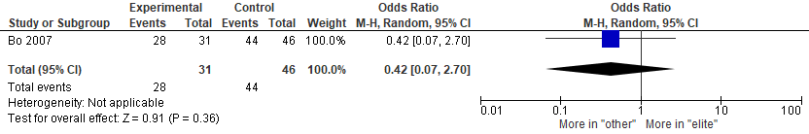
Online Supplement Figure 1: Effects of pre-pregnancy elite athletic experience vs. controls (active/sedentary) on initiation of breastfeeding. Data reported as odds ratio. Analysis conducted using a random-effect model. IV; inverse variance; CI; confidence interval

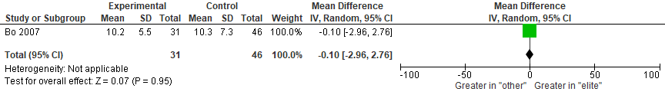
Online Supplement Figure 2: Effects of pre-pregnancy elite athletic experience vs. controls (active/sedentary) on duration of breastfeeding. Data reported as odds ratio. Analysis conducted using a random-effect model. IV; inverse variance; CI; confidence interval
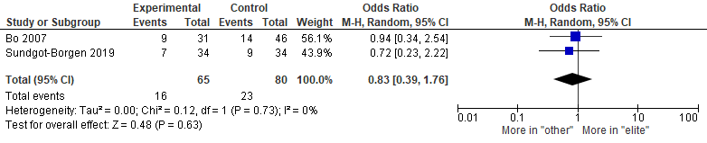
Online Supplement Figure 3: Effects of pre-pregnancy elite athletic experience vs. controls (active/sedentary) on stress incontinence Data reported as odds ratio. Analysis conducted using a random-effect model. IV; inverse variance; CI; confidence interval

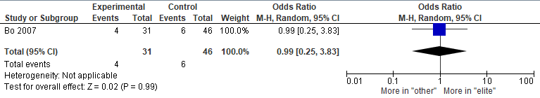
Online Supplement Figure 4: Effects of pre-pregnancy elite athletic experience vs. controls (active/sedentary) on urge incontinence Data reported as odds ratio. Analysis conducted using a random-effect model. IV; inverse variance; CI; confidence interval

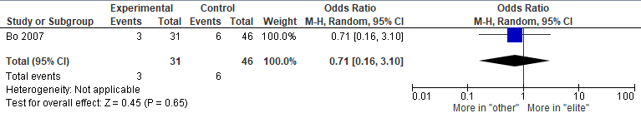
Online Supplement Figure 5: Effects of pre-pregnancy elite athletic experience vs. controls (active/sedentary) on mixed urinary incontinence Data reported as odds ratio. Analysis conducted using a random-effect model. IV; inverse variance; CI; confidence interval

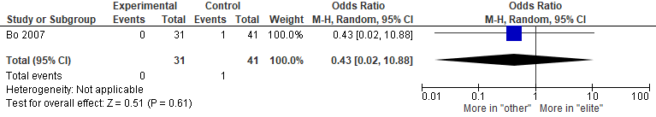
Online Supplement Figure 6: Effects of pre-pregnancy elite athletic experience vs. controls (active/sedentary) on fecal incontinence Data reported as odds ratio. Analysis conducted using a random-effect model. IV; inverse variance; CI; confidence interval

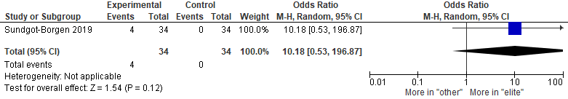
Online Supplement Figure 7: Effects of pre-pregnancy elite athletic experience vs. controls (active/sedentary) on risk of injury. Data reported as odds ratio. Analysis conducted using a random-effect model. IV; inverse variance; CI; confidence interval

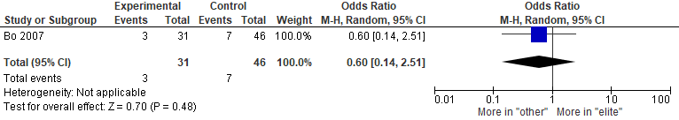
Online Supplement Figure 8: Effects of pre-pregnancy elite athletic experience vs. controls (active/sedentary) on low back pain. Data reported as odds ratio. Analysis conducted using a random-effect model. IV; inverse variance; CI; confidence interval

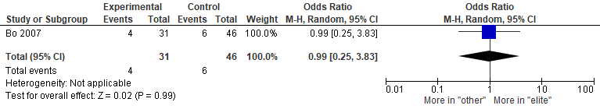
Online Supplement Figure 9: Effects of pre-pregnancy elite athletic experience vs. controls (active/sedentary) on low back pain with radiation. Data reported as odds ratio. Analysis conducted using a random-effect model. IV; inverse variance; CI; confidence interval

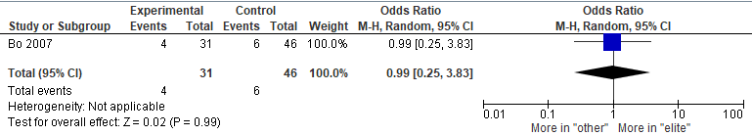
Online Supplement Figure 10: Effects of pre-pregnancy elite athletic experience vs. controls (active/sedentary) on pelvic girdle pain (sacroiliac joints). Data reported as odds ratio. Analysis conducted using a random-effect model. IV; inverse variance; CI; confidence interval

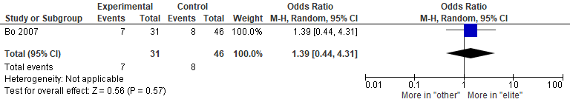
Online Supplement Figure 11: Effects of pre-pregnancy elite athletic experience vs. controls (active/sedentary) on pelvic girdle pain (pubic symphysis). Data reported as odds ratio. Analysis conducted using a random-effect model. IV; inverse variance; CI; confidence interval

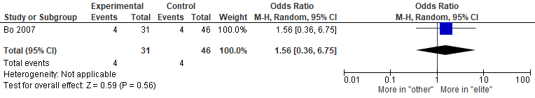
Online Supplement Figure 12: Effects of pre-pregnancy elite athletic experience vs. controls (active/sedentary) on pelvic girdle pain (sacroiliac joint and pubic symphysis). Data reported as odds ratio. Analysis conducted using a random-effect model. IV; inverse variance; CI; confidence interval

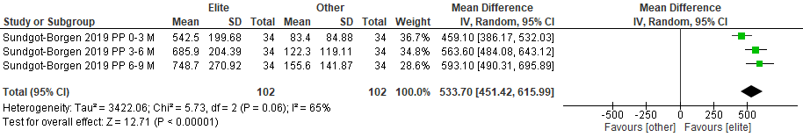
Online Supplement Figure 13: Effects of pre-pregnancy elite athletic experience vs. controls (active/sedentary) on endurance training volume postpartum (minutes/week). Data reports as mean difference. Analysis conducted using a random-effect model. IV; inverse variance; CI; confidence interval.

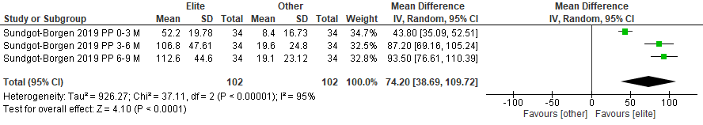
Online Supplement Figure 14: Effects of pre-pregnancy elite athletic experience vs. controls (active/sedentary) on strength training volume postpartum. Data reports as mean difference. Analysis conducted using a random-effect model. IV; inverse variance; CI; confidence interval.

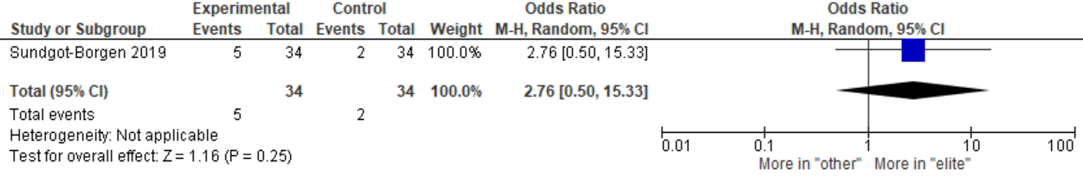
Online Supplement Figure 15: Effects of pre-pregnancy elite athletic experience vs. controls (active/sedentary) on improved performance postpartum. Data reported as odds ratio. Analysis conducted using a random-effect model. IV; inverse variance; CI; confidence interval
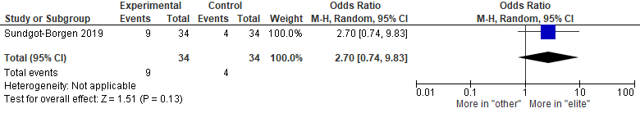
Online Supplement Figure 16: Effects of pre-pregnancy elite athletic experience vs. controls (active/sedentary) on reduced performance postpartum. Data reported as odds ratio. Analysis conducted using a random-effect model. IV; inverse variance; CI; confidence interval

SEARCH STRATEGY
MEDLINE = 249
- exp Athletes/ or athlete*.mp. or exp sports/
- ((athlet* or player* or sport*) adj5 (recreation* or amateur* or compet* or elite* or profession* or “highly active”)).ti,ab,kf.
- (marathon*).ti,ab,kf.
- (("highly active*" or recreation* or amateur* or compet* or elite* or profession*) adj3 (running or weight training or resistance training or swim* or sport* or (track and field) or runner* or marathon*)).mp.
- ((“Low intens*” or “high intens*”) adj3 (train* or activ* or exercis* or sport*)).ti,ab,kf.
- (return* adj3 (sport* or train*)).ti,ab,kf.
- (weight* adj2 lift*).ti,kf. or ((muscle or muscular or strength*) adj2 conditioning).ti,kf.
- or/1-7 = 223501
- Pregnancy/ or exp Pregnancy Complications/ or or pregnant women/ or Pregnancy Outcome/ or exp Pregnancy Trimesters/ or Peripartum Period/ or Postpartum Period/ or pregnan*.hw. or (pregnan* or perinatal or postnatal or postpartum or post partum or puerper* or primigravid* or primiparous or multiparous or nulliparous or multigravid* or trimester* or obstetric*).ti,kf.
- Uterine Cervical Incompetence/ or (incompeten* adj2 (uterine or uterus or cervix or cervical)).ti,ab,kf.
- Exp urinary incontinence/ or urinary bladder, overactive/ or (incontinen* adj3 (mixed or urge or stress*)).ti,ab,kf.
- Obstetrical forceps/ or (forcep* or vacuum or c?section or c?esarian).ti,ab,kf. Or exp delivery, obstetric/
- exp birth weight/ or fetal weight/
- infant, low birth weight/ or infant, small for gestational age/ or exp infant, very low birth weight/ or infant, postmature/ or exp infant, premature/
- (birth weight or birthweight or macrosomia or gestational age or lga or sga or preterm or (prematur* adj2 (infant* or neonat* or newborn* or birth or labo?r))).ti,ab,kf.
- ((preterm or pre matur* or prematur* or post matur* or postmatur*) adj2 birth).mp.
- Fetal Growth Retardation/ or fetal hypoxia/ or fetal macrosomia/
- exp delivery, obstetric/ or exp Obstetric Labor, Premature/ or ((premature or preterm or pre-term) adj2 (labo?r or birth)).ti,ab,kf.
- or/10-18
- 8 and 9 and 19
- animals/ not (animals/ and humans/)
- 20 not 21

= 249

EMBASE
- exp Athletes/ or athlete*.mp. or exp sports/
- ((athlet* or player* or sport*) adj5 (recreation* or amateur* or compet* or elite* or profession* or "highly active")).ti,ab,kw.
- marathon*.ti,ab,kw.
- (("highly active*" or recreation* or amateur* or compet* or elite* or profession*) adj3 (running or weight training or resistance training or swim* or sport* or (track and field) or runner* or marathon*)).mp.
- (("Low intens*" or "high intens*") adj3 (train* or activ* or exercis* or sport*)).ti,ab,kw.
- (return* adj3 (sport* or train*)).ti,ab,kw.
- ((weight* adj2 lift*) or ((muscle or muscular or strength*) adj2 conditioning)).ti,hw,ab.
- 1 or 2 or 3 or 4 or 5 or 6 or 7
- Pregnancy/ or exp Pregnancy Complications/ or pregnant women/ or Pregnancy Outcome/ or exp Pregnancy Trimesters/ or Peripartum Period/ or Postpartum Period/ or pregnan*.hw. or (pregnan* or perinatal or postnatal or postpartum or post partum or puerper* or primigravid* or primiparous or multiparous or nulliparous or multigravid* or trimester* or obstetric*).ti,kw,ab.
- Uterine Cervical Incompetence/ or (incompeten* adj2 (uterine or uterus or cervix or cervical)).ti,ab,kw.
- exp urinary incontinence/ or urinary bladder, overactive/ or (incontinen* adj3 (mixed or urge or stress*)).ti,ab,kw.
- Obstetrical forceps/ or (forcep* or vacuum or c?section or c?esarian).ti,ab,kw. or exp delivery, obstetric/
- exp birth weight/ or fetal weight/
- infant, low birth weight/ or infant, small for gestational age/ or exp infant, very low birth weight/ or infant, postmature/ or exp infant, premature/
- (birth weight or birthweight or macrosomia or gestational age or lga or sga or preterm or (prematur* adj2 (infant* or neonat* or newborn* or birth or labo?r))).ti,ab,kw.
- ((preterm or pre matur* or prematur* or post matur* or postmatur*) adj2 birth).mp.
- Fetal Growth Retardation/ or fetal hypoxia/ or fetal macrosomia/
- exp delivery, obstetric/ or exp Obstetric Labor, Premature/ or ((premature or preterm or pre-term) adj2 (labo?r or birth)).ti,ab,kw.
- or/10-18
- 8 and 9 and 19
- animals/ not (animals/ and humans/)
- 20 not 21

= 503

CINAHL
S1 ( MH Athletes+ or MH sports+ ) OR TI athlete* OR AB athlete*
S2 TI ( (athlet* or player* or sport*) n5 (recreation* or amateur* or compet* or elite* or profession* or “highly active”)) ) OR AB ( (athlet* or player* or sport*) n5 (recreation* or amateur* or compet* or elite* or profession* or “highly active”)) )
S3 TI marathon* OR AB marathon*
S4 TI ( ("highly active*" or recreation* or amateur* or compet* or elite* or profession*) n3 (running or weight training or resistance training or swim* or sport* or (track and field) or runner* or marathon*) ) OR AB ( ("highly active*" or recreation* or amateur* or compet* or elite* or profession*) n3 (running or weight training or resistance training or swim* or sport* or (track and field) or runner* or marathon*) )
S5 TI ( ((“Low intens*” or “high intens*”) n3 (train* or activ* or exercis* or sport*)) ) OR AB ( ((“Low intens*” or “high intens*”) n3 (train* or activ* or exercis* or sport*)) )
S6 TI ( return* n3 (sport* or train*) ) OR AB ( return* n3 (sport* or train*) )
S7 TI ( (weight* n2 lift*) or ((muscle or muscular or strength*) n2 conditioning) ) OR AB ( (weight* n2 lift*) or ((muscle or muscular or strength*) n2 conditioning) )
S8 S1 OR S2 OR S3 OR S4 OR S5 OR S6 OR S7
S9 MH ( Pregnancy or Pregnancy Complications+ or pregnant women or Pregnancy Outcome or Pregnancy Trimesters+ or Peripartum Period or Postpartum Period ) OR TI ( pregnan* or perinatal or postnatal or postpartum or post partum or puerper* or primigravid* or primiparous or multiparous or nulliparous or multigravid* or trimester* or obstetric* ) OR AB ( pregnan* or perinatal or postnatal or postpartum or post partum or puerper* or primigravid* or primiparous or multiparous or nulliparous or multigravid* or trimester* or obstetric* )
S10 MH cervix incompetence OR TI ( incompeten* n2 (uterine or uterus or cervix or cervical)) ) OR AB ( incompeten* n2 (uterine or uterus or cervix or cervical)) )
S11 MH ( urinary incontinence+ or overactive bladder ) OR TI ( (incontinen* n3 (mixed or urge or stress*)) ) OR AB ( (incontinen* n3 (mixed or urge or stress*)) )
S12 MH ( Obstetrical forceps or delivery, obstetric+ ) OR TI ( forcep* or vacuum or c?section or c?esarian ) OR AB ( forcep* or vacuum or c?section or c?esarian )
S13 MH birth weight or fetal weight
S14 MH infant, low birth weight or infant, small for gestational age or infant, very low birth weight+ or infant, postmature or infant, premature+
S15 TI ( (birth weight or birthweight or macrosomia or gestational age or lga or sga or preterm or (prematur* n2 (infant* or neonat* or newborn* or birth or labo?r))) ) OR AB ( (birth weight or birthweight or macrosomia or gestational age or lga or sga or preterm or (prematur* n2 (infant* or neonat* or newborn* or birth or labo?r))) )
S16 TI ( ((preterm or pre matur* or prematur* or post matur* or postmatur*) n2 birth) ) OR AB ( ((preterm or pre matur* or prematur* or post matur* or postmatur*) n2 birth) )
S17 MH Fetal Growth Retardation or fetal anoxia or fetal macrosomia
S18 MH delivery, obstetric+ or Labor, Premature+
S19 TI ( ((premature or preterm or pre-term) n2 (labo?r or birth)) ) OR AB ( ((premature or preterm or pre-term) n2 (labo?r or birth)) )
S20 S9 OR S10 OR S11 OR S12 OR S13 OR S14 OR S15 OR S16 OR S17 OR S18 OR
S19
S21 S8 AND S9 AND S20
S22 ( S8 AND S9 AND S20 ) NOT MH animals

= 650

SportDiscus = 163

Scopus
( ( TITLE-ABS-KEY ( athlete* OR marathon OR "professional sport*" OR "elite sport*" OR "competitive sport*" ) OR TITLE-ABS-KEY ( "weight train*" OR "musc* train*" OR "musc* condition*" OR "weight lift*" OR "strength train*" OR "strength condition*" OR "high intensity" OR "low intensity" ) ) ) AND ( TITLE-ABS-KEY ( pregnan* OR perinatal OR postnatal OR postpartum OR post AND partum OR puerper* OR primigravid* OR primiparous OR multiparous OR nulliparous OR multigravid* OR trimester* OR obstetric* ) ) AND ( ( TITLE-ABS-KEY ( "mixed incontinen*" OR "urge incontinen*" OR "stress incontinen*" OR "uterine incompeten*" OR "cervix incompet*" OR "cervical incompet*" ) OR TITLE-ABS-KEY ( forcep* OR vacuum OR c-section OR cesarian OR caesarian OR "birth weight" OR "fetal weight" ) OR TITLE-ABS-KEY ( birthweight OR macrosomia OR gestational AND age OR lga OR sga OR preterm ) OR TITLE-ABS-KEY ( "preterm birth" OR "pre matur* birth" OR "prematur* birth" OR "preterm labor" OR "pre matur* labor" OR "prematur* labor" OR "fetal anoxia" OR "fetal hypoxia" ) ) )

= 287

Web of Science = 189

Cochrane = 0; trials = 150

Clinicaltrials.gov = 4

Scopus search (citation chaining) = 141

Web of Scienece (citation chaining) = 89

Proquest Theses / Dissertations Global = 8

List of authors who were sent letters requesting additional information:
- Dr. Sundgot-Borgen
Sundgot-Borgen, J., et al., Elite athletes get pregnant, have healthy babies and return to sport early postpartum. BMJ Open Sport Exerc Med, 2019. 5(1):e000652.

- Dr. Tenforde
Tenforde, A.S., et al., Running habits of competitive runners during pregnancy and breastfeeding. Sports Health, 2015. 7(2): p. 172-6.

- Dr. Beilock
Beilock, S.L., D.L. Feltz, and J.M. Pivarnik, Training patterns of athletes during pregnancy and postpartum. Res Q Exerc Sport, 2001. 72(1): p. 39-46.

List of authors who responded to the request for additional information:
- Dr. Sundgot-Borgen
Sundgot-Borgen, J., et al., Elite athletes get pregnant, have healthy babies and return to sport early postpartum. BMJ Open Sport Exerc Med, 2019. 5(1):e000652.

- Dr. Beilock
Beilock, S.L., D.L. Feltz, and J.M. Pivarnik, Training patterns of athletes during pregnancy and postpartum. Res Q Exerc Sport, 2001. 72(1): p. 39-46.

