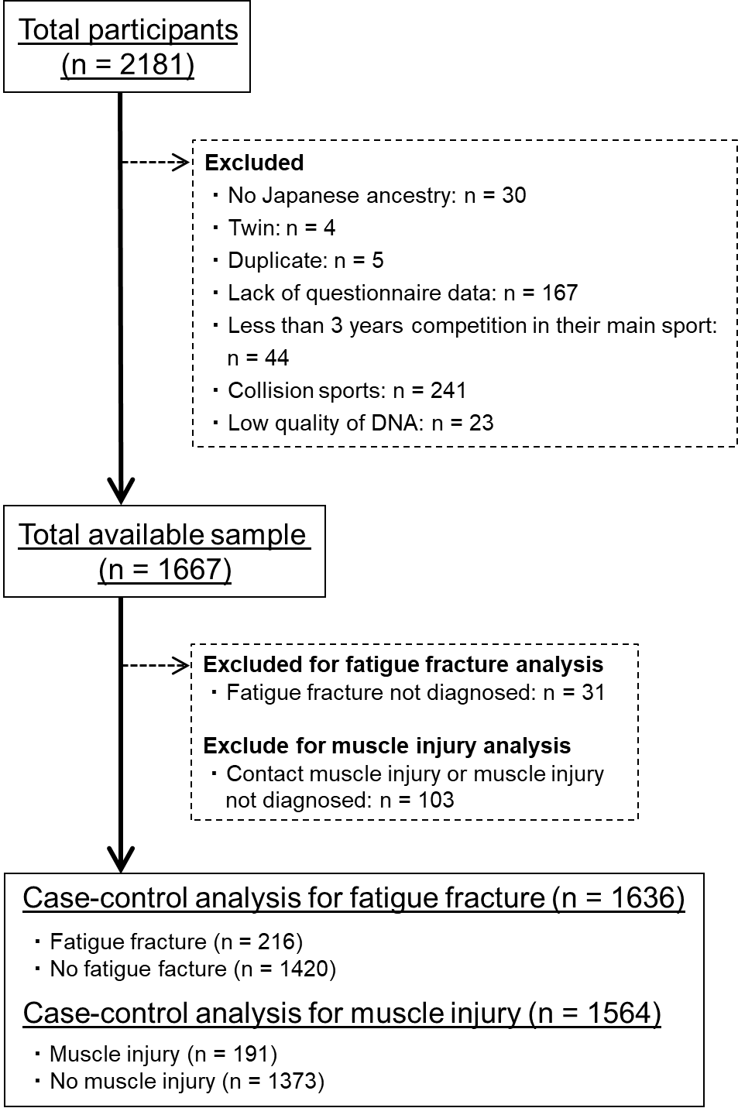

Supplemental Digital Content 1. Flow diagram of subject selection in stage-one analysis

