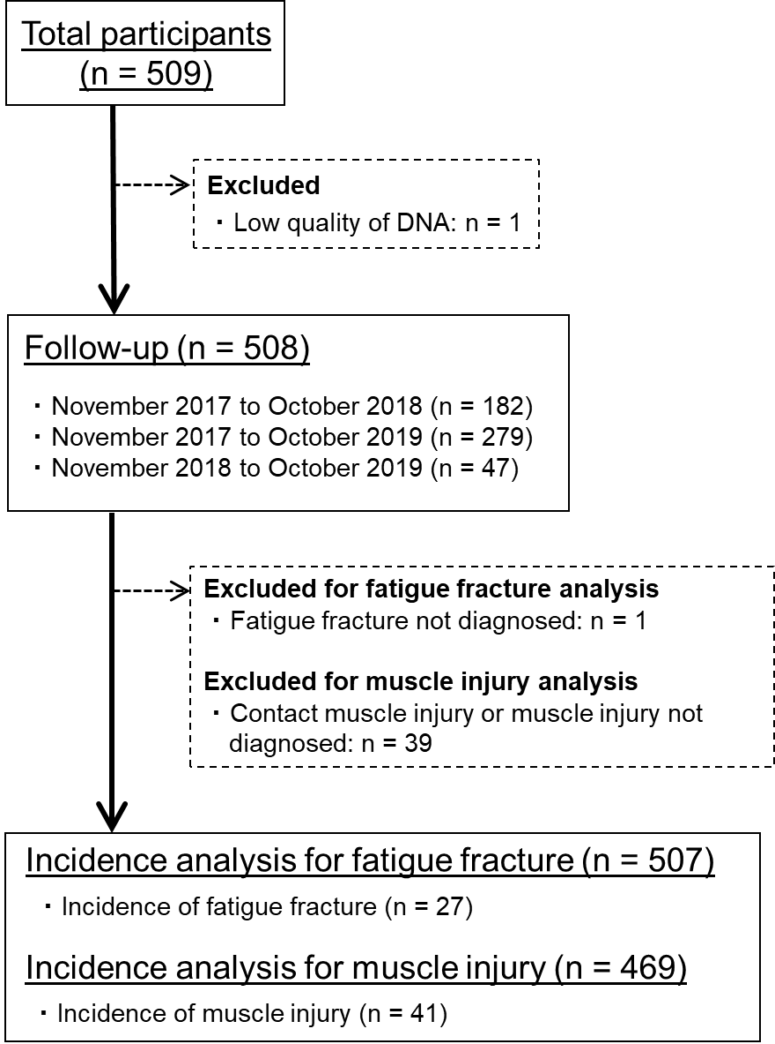

Supplemental Digital Content 4. Flow diagram of subject selection in stage-two analysis

