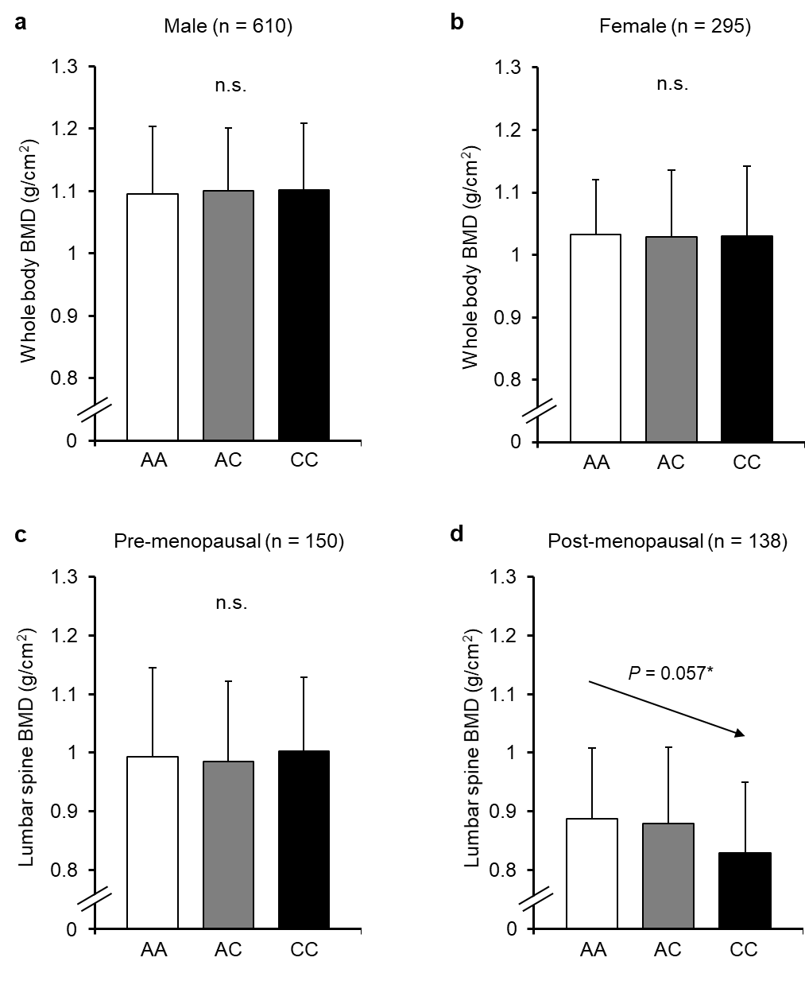
Supplemental Digital Content 9. Association of the COL1A1 rs1107946 polymorphism with BMD in males (a), females (b), pre-menopausal females (c) and post-menopausal females (d). *Additive model, P-value by ANCOVA after adjustment for age and body mass index. BMD, bone mineral density. The error bars show SD.

