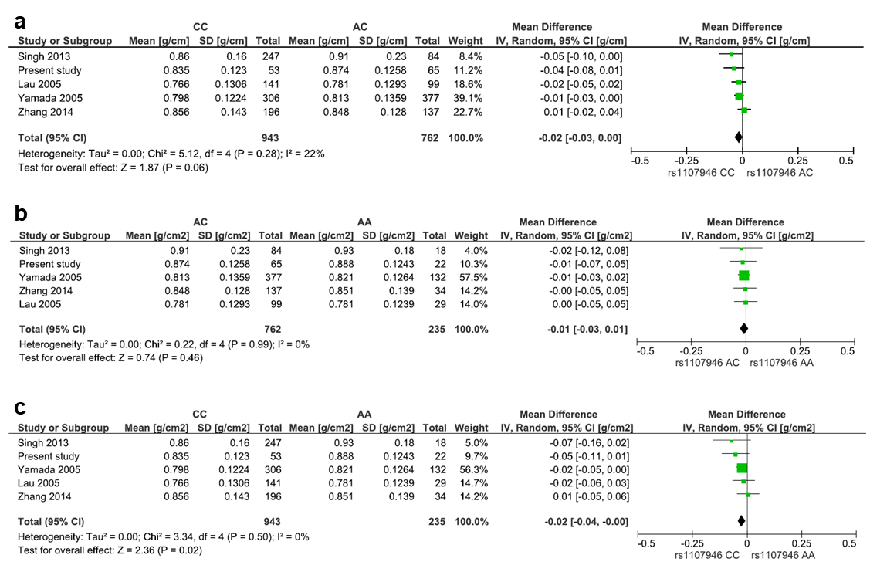
Supplemental Digital Content 10. Forest plot of the COL1A1 rs1107946 polymorphism and lumbar spine bone mineral density for CC vs. AC (a), AC vs. AA (b), and CC vs. AA (c). Heterogeneity among the study was assessed using the I² statistic. The pooled mean differences of bone mineral density between the genotypes were examined by the inverse variance method and the random-effects model.

