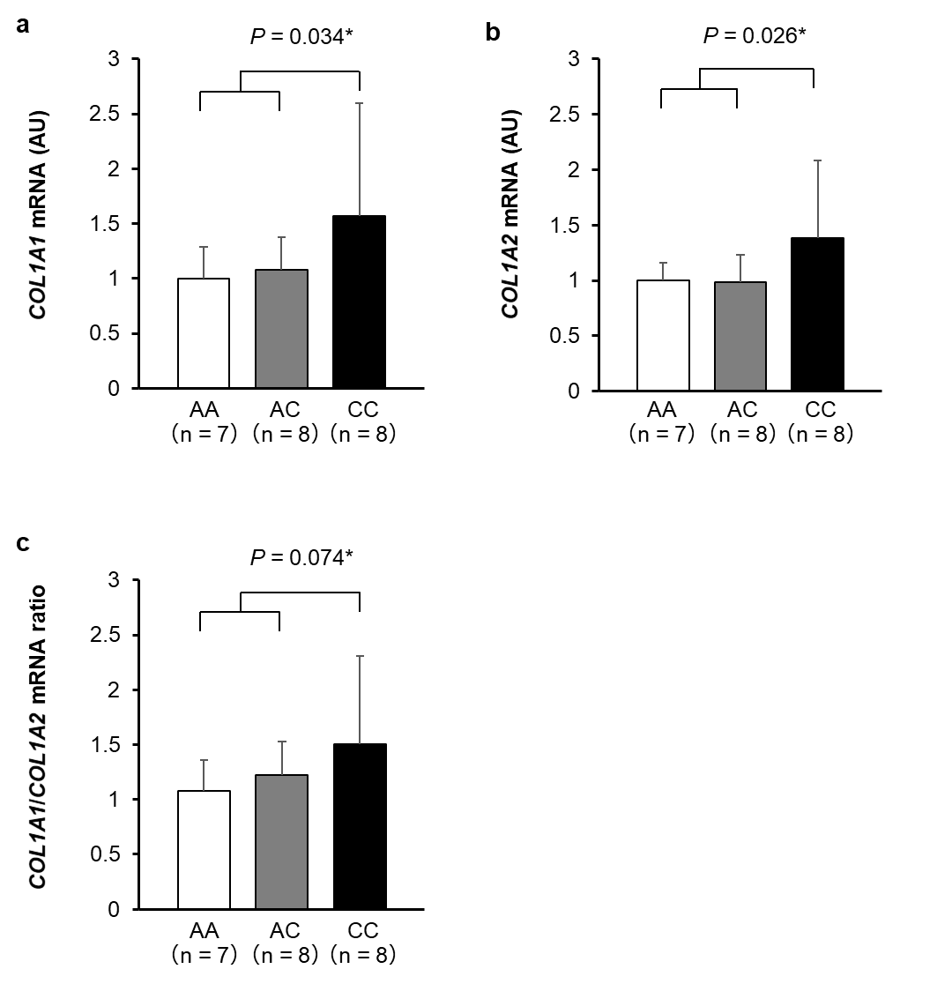
Supplemental Digital Content 11. Association of the COL1A1 rs1107946 polymorphism with COL1A1 (a), COL1A2 (b), and the ratio of COL1A1/COL1A2 mRNA expression in skeletal muscle. *: C-recessive model, P-value by unpaired t-test.

