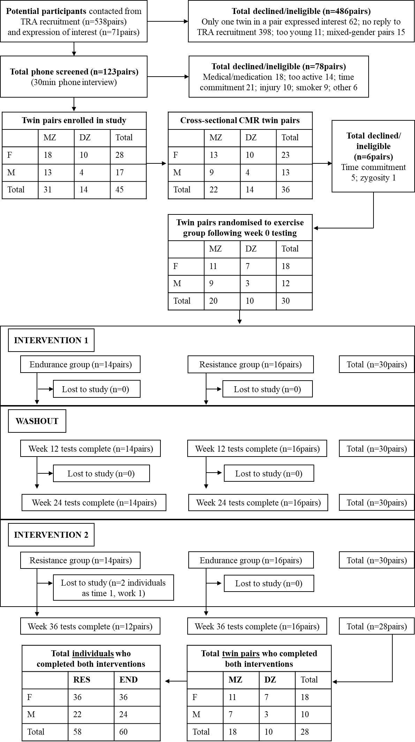
Supplementary Digital Content 1. Consort diagram of participant recruitment and inclusion in the study. TRA, Twins Research Australia; MZ, monozygotic; DZ, dizygotic; F, female; M, male.

