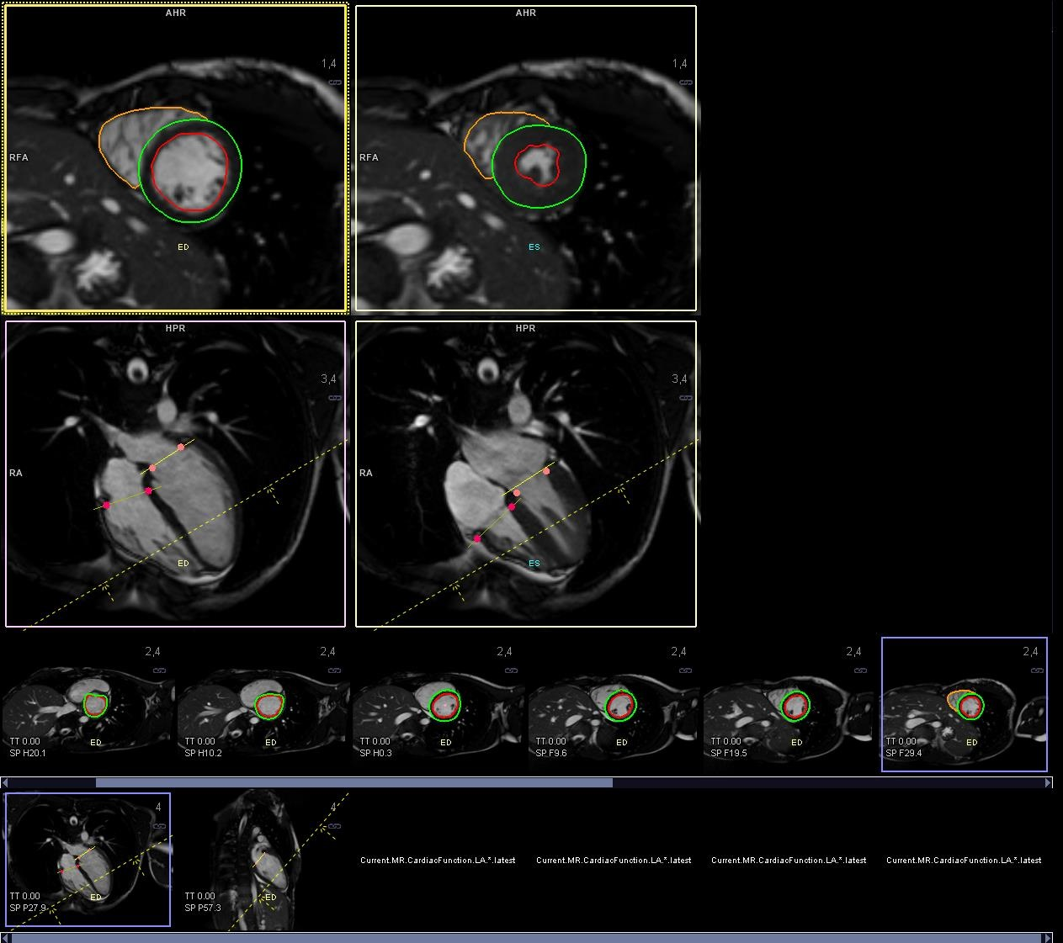

Supplementary Digital Content 2. Analysis of the left ventricle in end-systole and end-diastole in the short and long axis views with tracings of the endo- and epicardial borders.

