Supplemental Figure 1. Flow chart

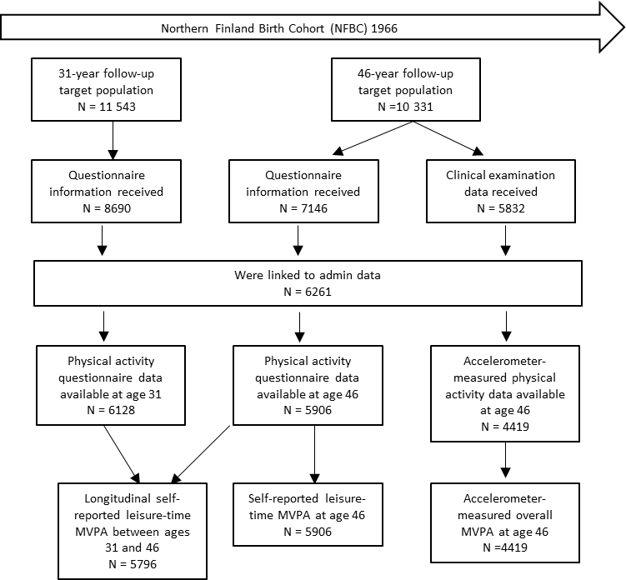

Supplemental Table 1. Questions on leisure-time physical activity:
How often do participate in physical activity/ exercise during your leisure-time?
 | once a month or less often | 2-3 times a month | once a week | 2-3 times a week | 4-6 times a week | daily
a) Light physical activity (no sweating or breathlessness) | 1 | 2 | 3 | 4 | 5 | 6
b) Brisk physical activity (at least some sweating and breathlessness) | 1 | 2 | 3 | 4 | 5 | 6
How long do you participate in physical activity/ exercise at a time?
 | not at all | less than 20 minutes | 20-39 minutes | 40-59 minutes | 1-1.5 hours | more than 1.5 hours
a) Light physical activity (no sweating or breathlessness) | 1 | 2 | 3 | 4 | 5 | 6
b) Brisk physical activity (at least some sweating and breathlessness) | 1 | 2 | 3 | 4 | 5 | 6

Supplemental Table 2. The individual level productivity costs in Euros based longitudinal self-reported leisure-time MVPA between ages 31 and 46.

 | HCA  with poor perceived health in 1997 and 2012, years 2012–2020 |  | HCA  with low level of education,  years 2012–2020
 | N | PC | N | PC
Panel A: Pooled
Stable active | 29 | 18600 | 425 | 6100
Stable inactive | 757 | 16400 | 2259 | 10700
Increasingly active | 90 | 19000 | 662 | 7600
Decreasingly active | 81 | 7000 | 476 | 7300
Panel B: Males
Stable active | 18 | 21100 | 214 | 4600
Stable inactive | 344 | 17100 | 1003 | 10900
Increasingly active | 33 | 12800 | 261 | 6700
Decreasingly active | 47 | 4300 | 242 | 5500
Panel C: Females
Stable active | 11 | 14600 | 211 | 7700
Stable inactive | 413 | 15800 | 1256 | 10600
Increasingly active | 57 | 22700 | 401 | 8200
Decreasingly active | 34 | 10800 | 234 | 9100
Notes: Physical activity groups between ages 31 and 46 years were formulated accordingly: 1) stable inactive if MVPA<150 min/week at both ages; 2) decreasingly active if MVPA≥150 min/week at age 31 but <150 min/week at age 46; 3) increasingly active if MVPA≤150 min/week at age 31 but >150 min at age 46; and 4) stable active if MVPA ≥150 min/week at both ages.

Supplemental Table 3. The individual level productivity costs in Euros based on accelerometer-measured overall MVPA at age 46.

 | HCA  with poor perceived health, years 2012–2020 |  | HCA  with low level of education,  years 2012–2020
 | N | PC | N | PC
Panel A: Pooled
Low level of MVPA | 584 | 17600 | 1008 | 11800
Medium level of MVPA | 409 | 13700 | 925 | 8700
High level of MVPA | 319 | 12600 | 949 | 6400
Panel B: Males
Low level of MVPA | 226 | 21300 | 347 | 13700
Medium level of MVPA | 186 | 15700 | 401 | 10000
High level of MVPA | 166 | 7100 | 491 | 5200
Panel C: Females
Low level of MVPA | 358 | 15300 | 661 | 10800
Medium level of MVPA | 223 | 12000 | 524 | 7700
High level of MVPA | 153 | 18600 | 458 | 7600
Notes: Participants were divided into tertiles according to their accelerometer-measured overall MVPA-time: Low level of MVPA, Medium level of MVPA, and High level of MVP

