Figure, SDC 2, Activ8sit, a customized activity monitor
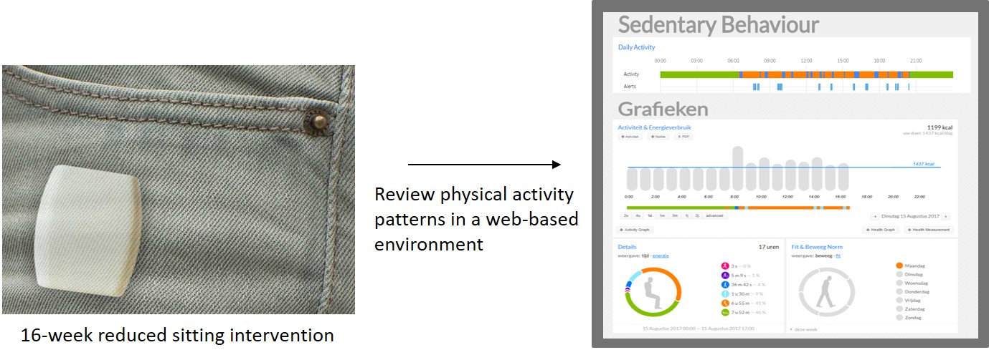
A customized activity monitor (Activ8sit, 2M Engineering, Valkenswaard, the Netherlands) was developed for the 16-week reduced sitting intervention. See eMethods for detailed information.

