Figure, SDC 5: Flowchart of study participation
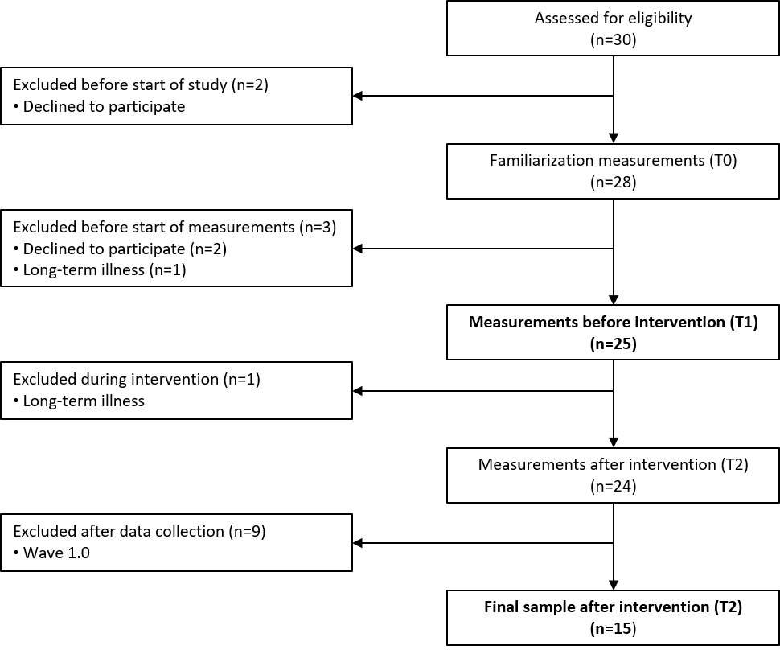
30 Individuals were assessed for eligibility. 25 Individuals participated in the acute sessions before intervention (T1; n=25 for vascular measurements and n=24 for cerebrovascular measurements) and 24 individuals fulfilled the 16-week reduced sitting intervention (T2; n=24 for vascular measurements and n=23 for cerebrovascular measurements). However, after exclusion of wave 1.0, the final intervention sample consisted of n=15 for vascular measurements and n=14 for cerebrovascular measurements.

