Supplemental Digital Content Table: Name Pronunciation Tools Examples
Tool | Example
Name Coach in Email Signature | 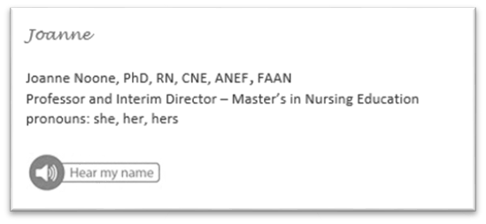
Learning Management System (LMS) Roster Tool | Directions: In your profile, please add a photo, complete the name pronunciation section by recording how your name is pronounced and adding the phonetic pronunciation, and configure the privacy settings so faculty and classmates can see the information you posted.  