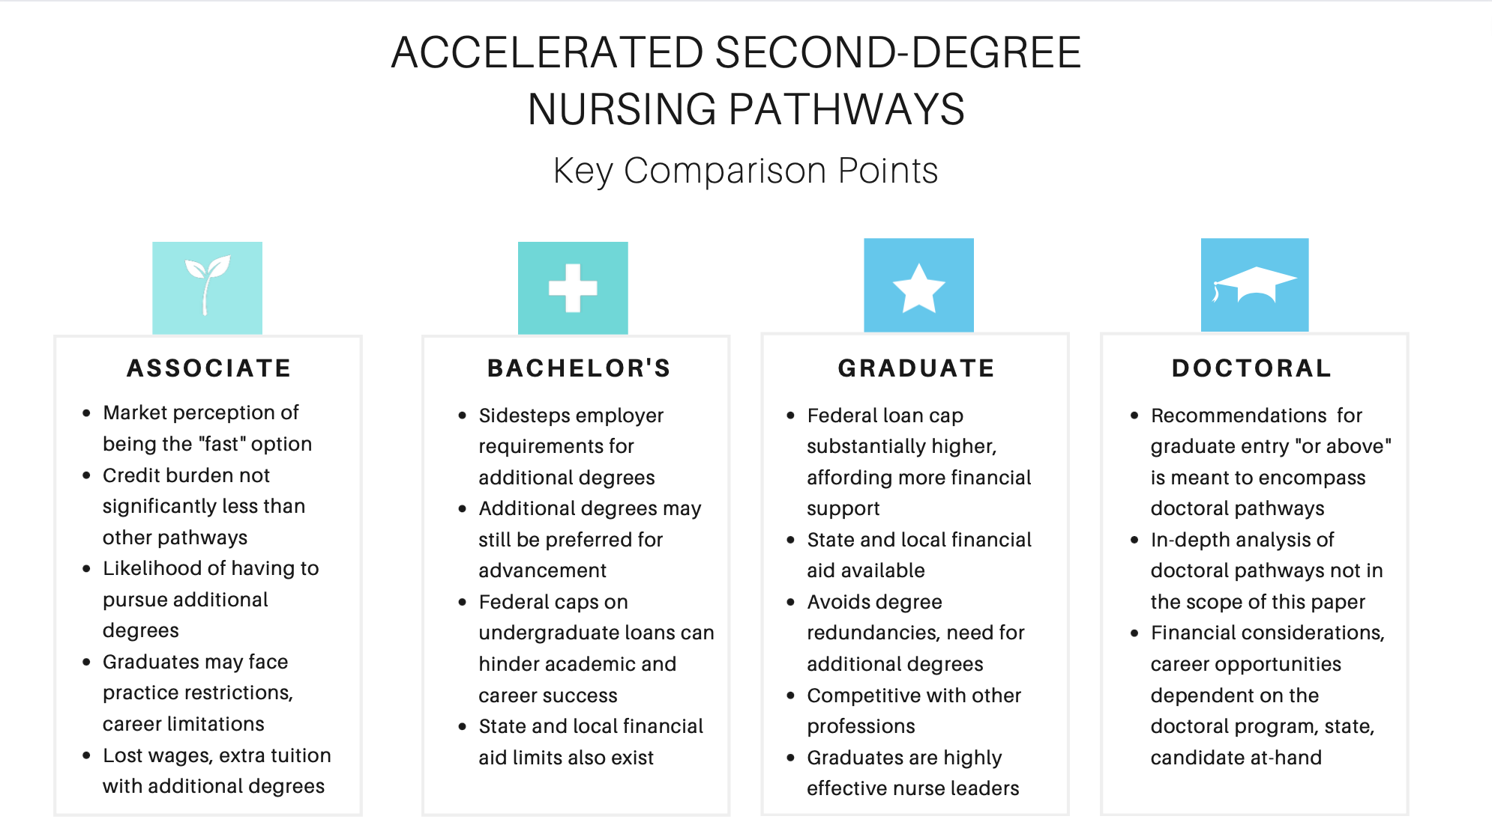

Supplemental Digital Content, Table #1: Accelerated Second-Degree Nursing Pathways, Key Comparison Points

