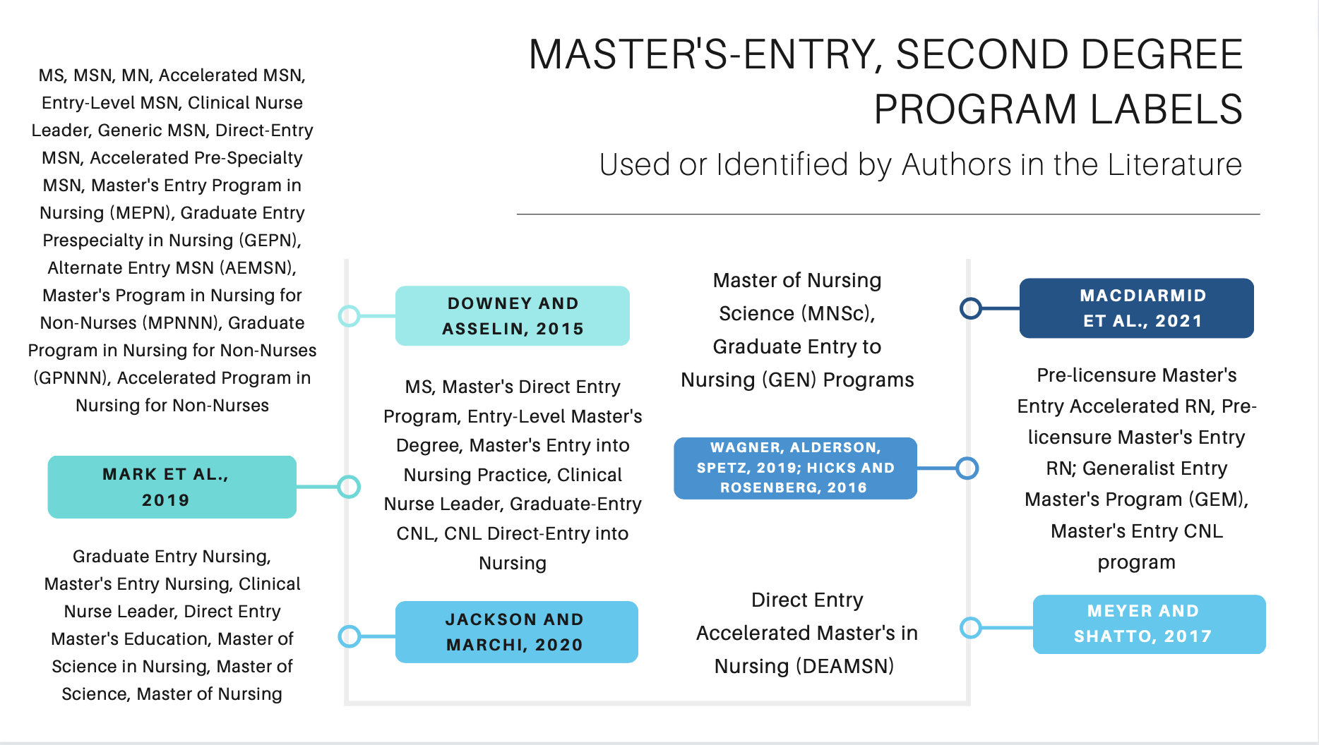
Supplemental Digital Content, Table #2. Master’s-Entry, Second-Degree Program Labels Used or Identified by Authors in the Literature

