Figure: Cause and Effect Diagram of 10 Contributing Factors to Near Miss Incidents

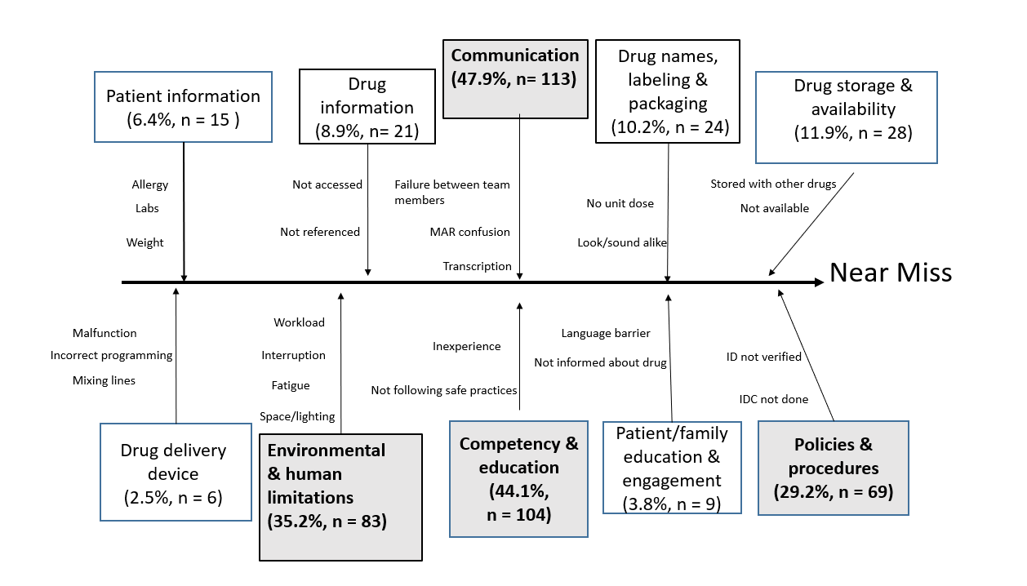
Cause effect (fishbone) diagram of 10-Factors and some of the most frequently reported categories and sub-categories. The four shaded/ bolded factors contributed most frequently to near miss incidents.
% = percent; n = number of incidents
Note: Multiple factors usually contribute to each near miss incident

